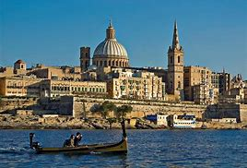
Malta’s Natural Heritage - Valletta
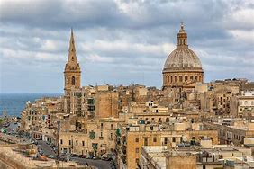
- Valletta is Malta’s capital city, and was built by the Knight’s of St. John under the rule of the Grandmaster La Vallette in the 16th century.
- The name was given in commemoration of the Grandmaster to appreciate his work.
- Valletta was not always Malta’s capital city, but Mdina was before it.
- The city is surrounded by fortifications to protect it from invasions or attacks which were often due to Malta’s strategic location in the Mediterranean sea.
In its day, Valletta was a fine example of modern city planning. Designed on a grid system, now common in other large cities, the city was carefully planned to accommodate water as well as sanitation and to allow for the circulation of air. Most towns and cities evolved over centuries, but Valletta, in contrast, was one of the first European cities to be constructed on an entirely new site.
Valletta was the first place in Malta to have running water from the aqueduct system, and also the first place to have a sewage system. It was built using globigernina limestone, which is a locally sourced sedimentary rock. This rock helps to keep houses cool in summer and warm in winter due to the high humidity. A lot of the houses are equipped with a well, and also a shrine, so as to decorate the city.
The city has over 25 churches, and the largest one is St. John’s cathedral, which is built with renaissance style on the outside and baroque on the inside. The church is dedicated to the patron saint of the Order of St. John.
The city ios built on top of the grand harbour, which is the main harbour of Malta. In the city, there are the Barrakka gardens, which overlook the harbour. This garden is characterised by its large variety of different flowers and plants, such as Widnet Il-Bahar, which is the national plant of Malta. Another common plant in Malta is il-Lellux, which is a yellow flower which can grow in any environment.
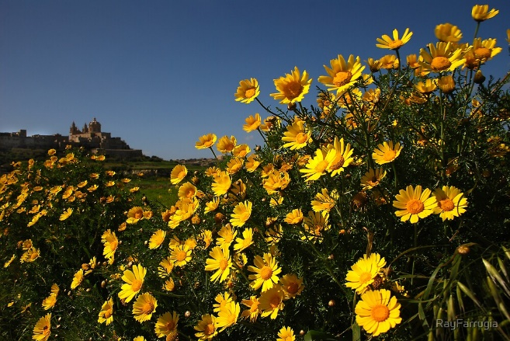
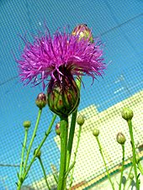

Lellux
Widnet il-Bahar

Valletta was voted the European Capital of Culture in 2018, which lead to refurbishment and reconstruction of various buildings, such as the roofless theatre, the parliament and Bieb Il-Belt.
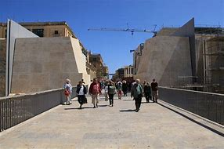
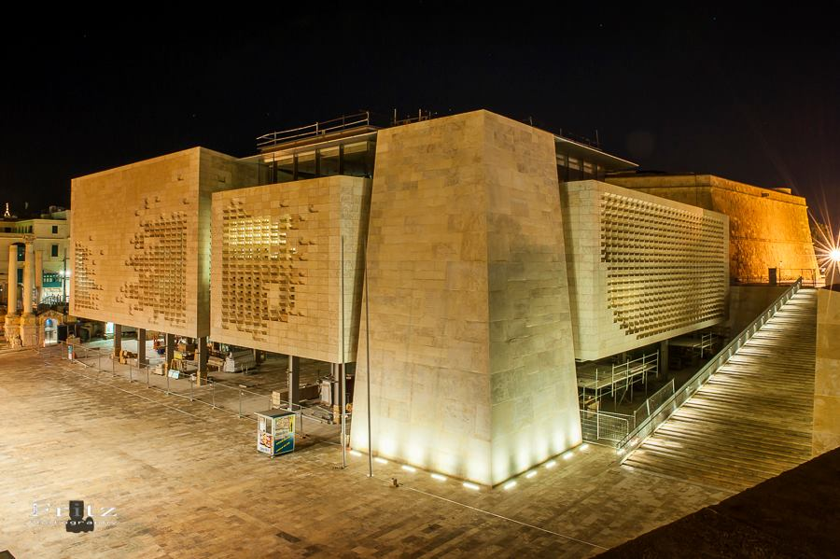
Bieb il-Belt
The Parliament

