GREEN TARANTO
“CYCLING ON THE FOOTPRINTS OF TARAS” ANCIENT SPRINGS .
ITINERAY: GALESO RIVER. ST MARY OF GALESO TARA. PATEMISCO- LATO
The convergence of geographic factors (the low altitude),the weather ,the lack, seasonality and irregularity of rainfall) and the country geology (karst nature) are the factors contributing to determine the lack of development of the hydrography of the surface of the Taranto territory .
The same karst nature is also the source of a rich underground hydrography, both superficial and deep.
For a variation of pressure and the process of stratification of layers of ground with different permeability, the deep ground water becomes superficial at the coastline, where it rises on the surface in karst springs , giving life to real waterways such as the Side, the Lenne, the Patemisco, Tara, the Galeso, Cervaro, the Borraco, the Chidro and the several small streams that wet the ravines located along the coastline to the East of the city.and flow into MAR PICCOLO (the citri in the Mar Piccolo)
These rivers , perennial, but with variable flow rate, after a short route (from a few kilometers to a few tens of metres), pour into the sea.
The most important river mouth, the Galeso river, is located in the First Inlet with a flow ranging between 350 and 700 l sec-1 according to the seasons. In the First Inlet, the most important freshwater springs are the “Citro Galeso” (mean flow: 600 l sec-1) and the “Citro Citrello” (mean flow: 350 l sec-1). In the Second Inlet, the most important freshwater spring is the “Citro Le Kopre” (mean flow: 100 l sec-1)
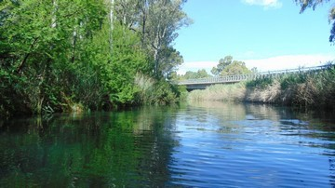
THE RIVER GALESO
The Galeso, which has Karst topography, is the source of a pond between Cavello and Statte and pours its waters into the Mar Piccolo.. It is one of the shortest rivers in the world: it is about 900 meters , has an average depth of 0.5 metres,,reaches at certain points a width of 12-14 meters and has a capacity of 4,000 litres per second . The Chadwick fresh water spring-is 13 meters deep.

The origin of the name Galeso is not clear; the Greek historian Polybius, in Res Italicae, says the Tarantini used to call this river “ Eurotas”, remembering the river that flew near the town of Sparta, the most important city of ancient Greece. Many were the classical authors who mentioned the river Galeso in their works, including Virgil ,Horace and Martial.

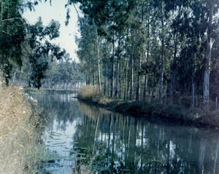
In ancient times this River was an important source of water for the communities of the area. In the classical age in the vicinity of the Chadwick, the quarter called Ebalia, with its famous "rocca Ebalia" would be mentioned by Virgil in the fourth book of the” Georgics”.
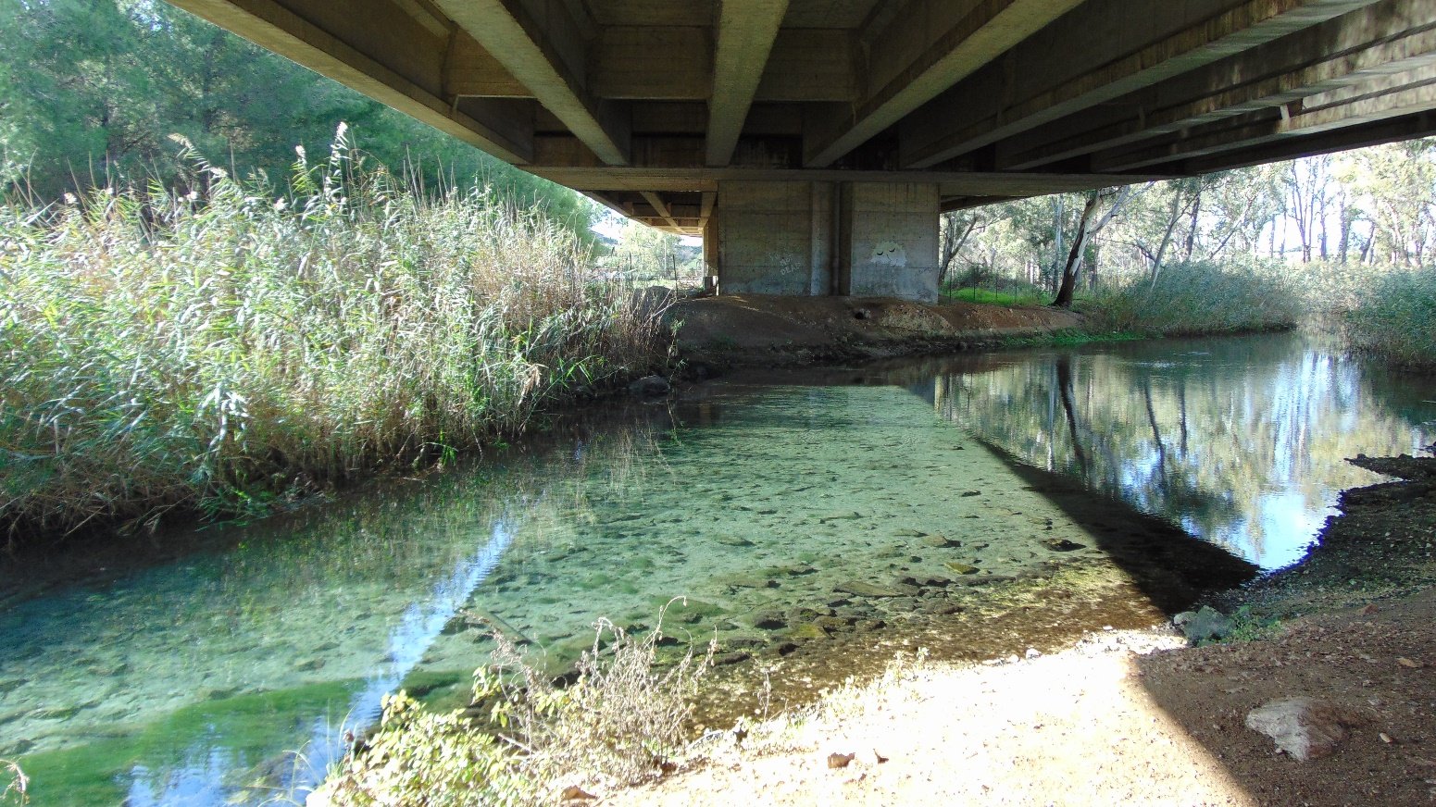
The waters of the Galeso were used until the beginning of the last century to wash the fleeces, namely the cloaks of the sheep because the minerals of Galeso waters had the power to make the wool soft and white. The polished Romans appreciated the fine wool of the sheep that were grazed here.
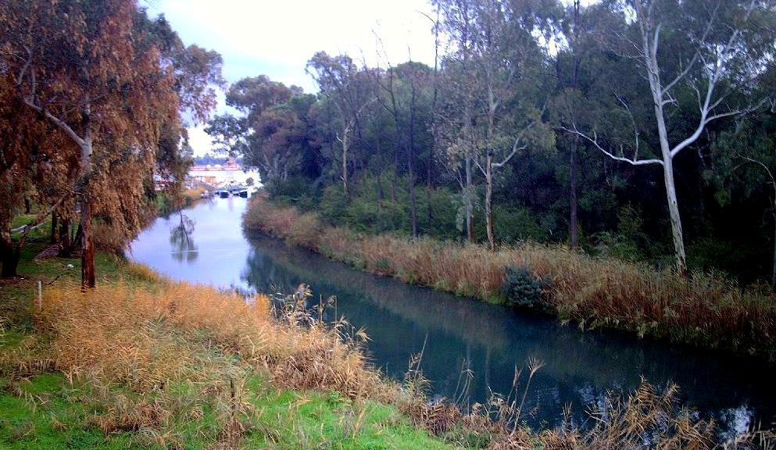
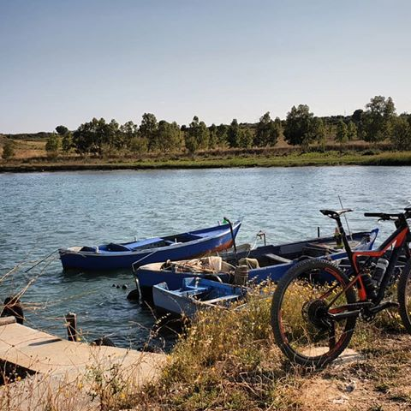
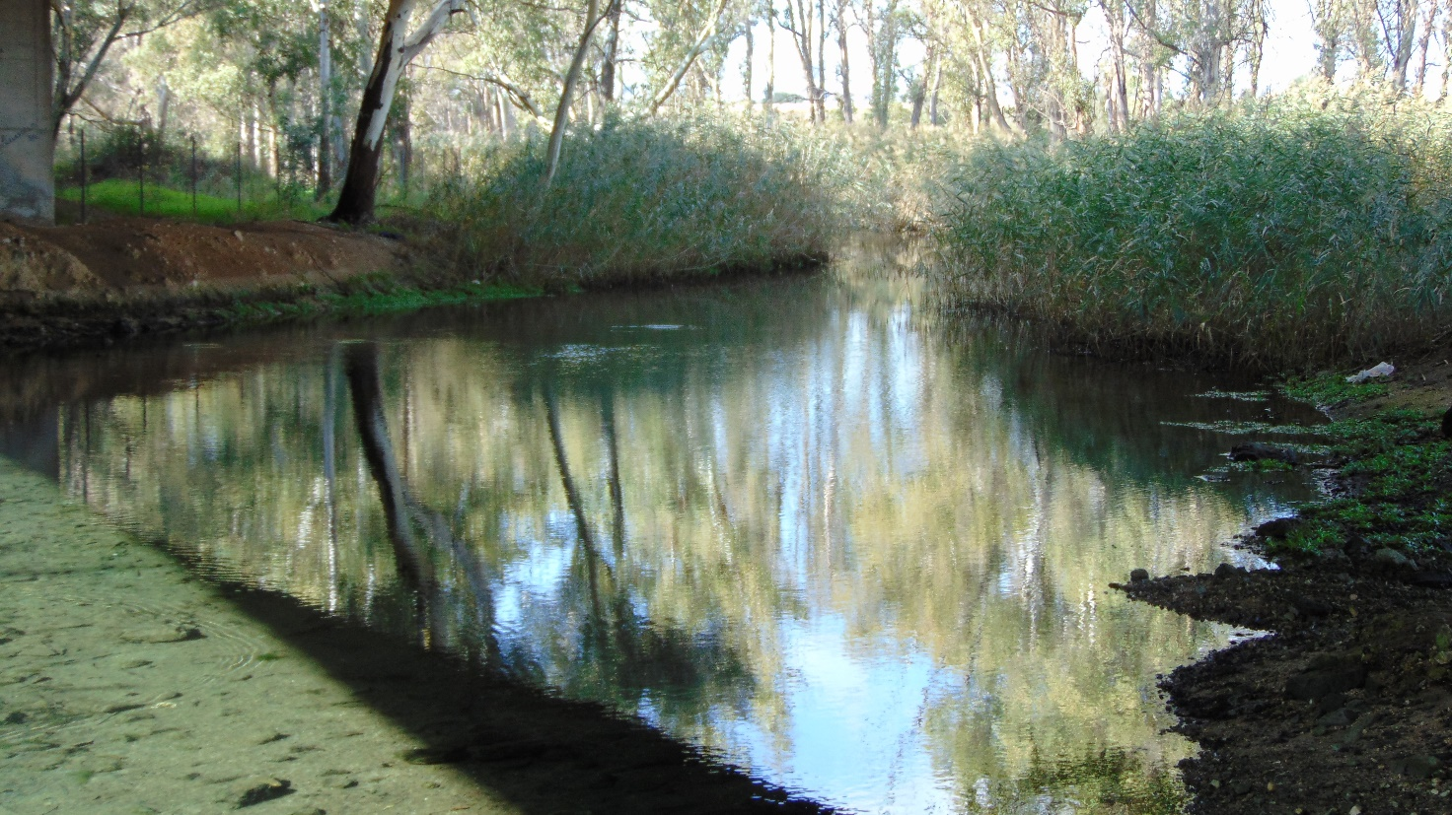
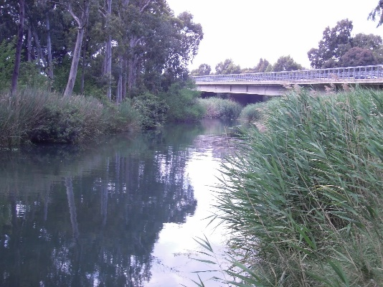

Near the River, the Abbey of Santa Maria del Galeso built by Baron Raymond of Taranto when he returned from the first crusade in the 12th century., Now it is privately owned.
As for the ground around and for the climate Horace wished he could end his days there.
S. MARIA DEL GALESO
Street direction
The Church of Santa Maria del Galeso is located on an enchanting hill, , not far from the river of the same name, beyond the exit of the 3-684 of the railway line Taranto – Brindisi (about 3 km from Taranto).
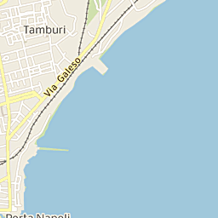
You can reach it along the road which connects the quarter “ Tamburi” to Martina Franca, a few Km from the exit on the right to Statte- You can follow the signs that lead to a paved road after about 500 metres, . In this point, on the left you notice a large gate opening-.Simply ring the bell and ask politely to the Fathers to visit the church, preferably on weekdays.

Historical hints
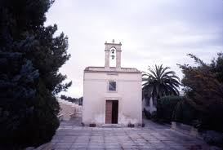
The church of S. Mary of the Galeso was commissioned by the noble tarantino, Riccardo Capitignano, and was consecrated in 1169, as attested by a tombstone still there. It is located close to the homonymous river, has been recently restored and is currently run by the Passionist Fathers. Nothing remains, unfortunately, of the ancient monastery which in 1195 was allotted to a community of Cistercian monks from the abbey of S. Maria della Sambucina in Calabria.

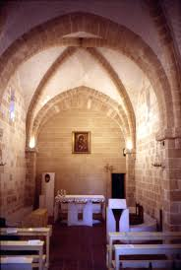
The interior space is divided by a pointed arch of two spans, with a square base and two cross-vaults . The interior decoration is represented by simple shelves with floral motifs and shells, placed at the base of the arches.
To the left of the entrance you can admire the Latin inscription testifying to the date of the consacration of the Church
. Some of the fragments of a mosaic floor from the original norman building are still visible in the corner, near the left pillar of the arch.
On the bottom there is a second arch, similar to the first, which testifies to the presence in the original construction of a third span with a cross vault that housed the choir. Today, however, there is a wall of recent construction and beyond which, in the place of the choir there is the sacristy; this is rectangular in plan with a barrel vault.
Link a https://www.youtube.com/watch?v=Fbaz5QwCAAg

The Tara.River
https://www.youtube.com/watch?v=6sBnoR9Ey-4 video
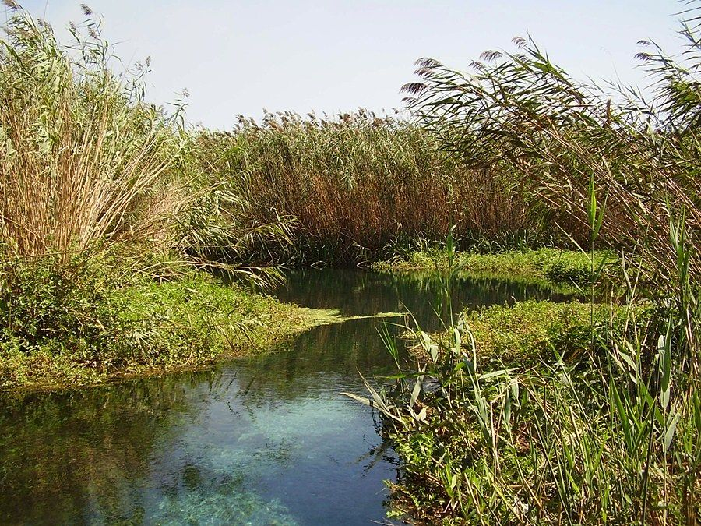
This small river has its source near the Gravina di Eucaspide, in the countries of Statte, 10 kms far from Taranto
According to the legend Taras founded here in the night of time the first nucleus of the city, before disappearing in the same waters of the river.
Another legend tells about a sick donkey who had been left to die by the banks of the river. A passer by covered it with the river mud and the donkeyhealed by thewaters the donkey recovered. Since then The waters of Tara have always been considered miraculous and curative, producing beneficial effects for the treatment of arthrosis, neurological, muscular diseases and for the toning of the body. Even today in summer people go to the river to bathe with mud. The river, considered sacred, is a destination for pilgrimages and religious practices, both Christian and Buddhist
Nowadays This river influences the economy being used for the irrigation of fields on which citrus, olive trees and vegetables are grown; On the banks The rush grows spontaneously,. Since a few years in the neighboring areas a particular species of Japanese pomegranate has been succesfully cultivated
The Lato
The Lato is a river in the province of Taranto
Its source is north of Laterza near the border with the province of Bari. The river flows south near Laterza and Ginosa before curving southeast. It flows near Case Perrone before flowing into the Gulf of Taranto near Castellaneta Marina.
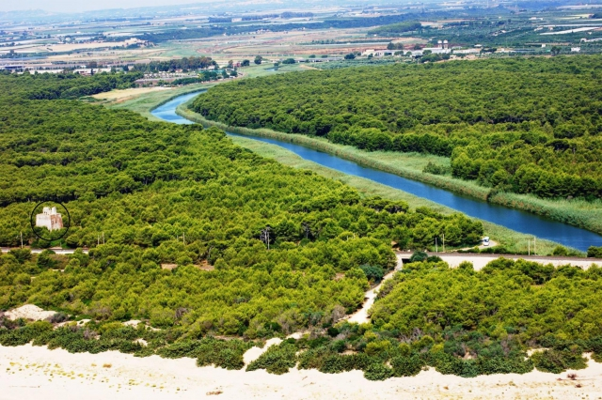

The Patemisco
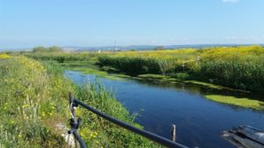
The Patemisco is a river characterized by a short course, which is located in the territory of Massafra (Ta). It is a Karst phenomenon , typical of the Murgia, in fact, it flows under the Ravine of the Madonna della Scala, and throws its waters into the Mar Grande ( Great Sea.) It takes its name from the Greek word “Potamisco” that is “little river”.
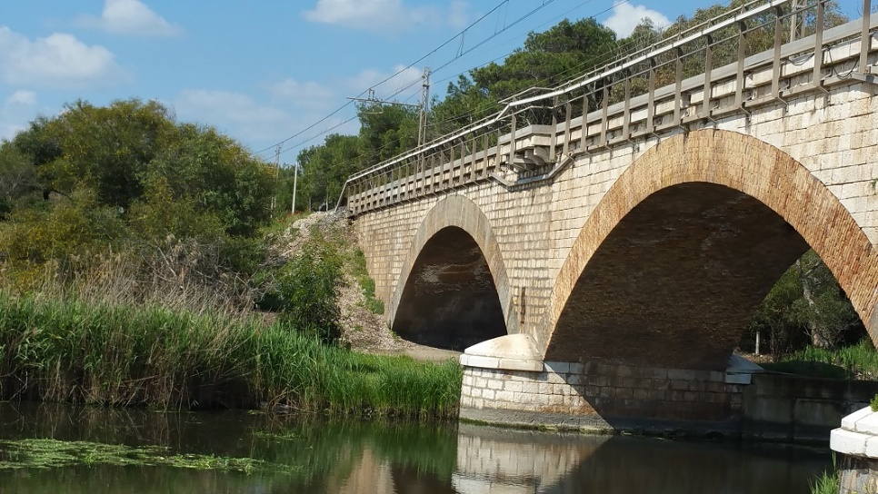
Once this river was rich in river clams but in 2008 there was a ban on bathing because of pollution.. Today, after the analysis made by Goletta Verde the river is considered within the limits of the law for the pollution of the waters and the area has been reopened as a sea resort.

