GREEN ITINERARIES IN APULIA
TORRE GUACETO NATURAL RESERVE
The Torre Guaceto State Natural Reserve is a state nature reserve located on the Adriatic coast of the high Salento, 17 km from Brindisi.
In this beautiful nature reserve you can observe and learn about several species of animals and plants, some unique of the place. There is no place in Europe and in the world that encloses such a vast ecosystem in such a restricted environment, making this place a perfect example of biodiversity, needless to say that the environment is absolutely unspoiled
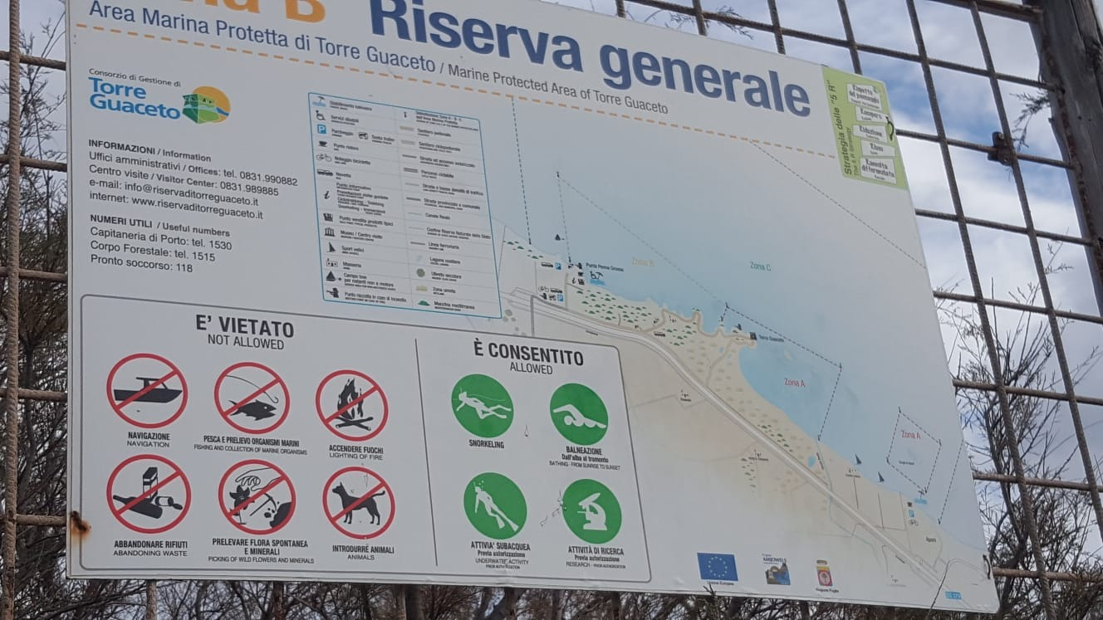
The Natural Reserve of the State of Torre Guaceto extends for about 1,200 ha presenting a sea front that develops for 8,000 m The area is configured as a more or less regular rectangle, with an average depth of 3,000 meters, crossed and divided by the road state 379.
FLORA
The territory of the State Nature Reserve is characterized by three main natural environments: the coast, the Mediterranean vegetation and the wetland.
In the Mediterranean scrub we can find plants like the Lecce oak
(quercus ilex),
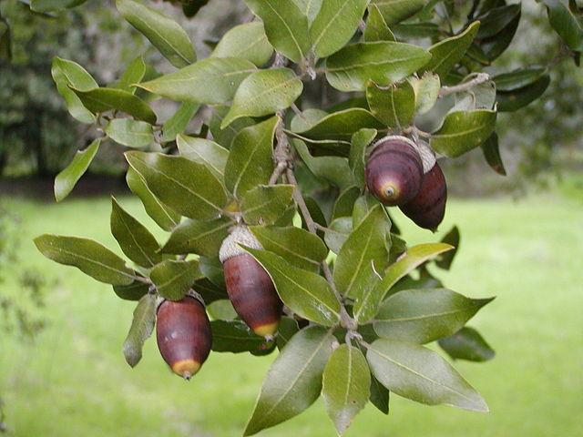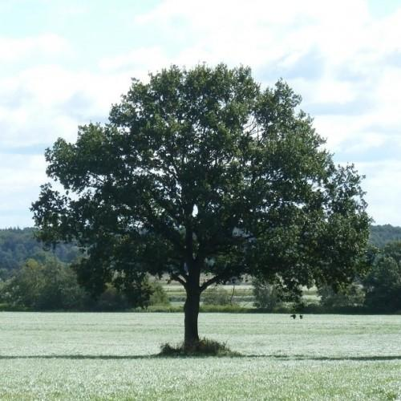
From which we produce products such as feed for farms (taken from acorns) or wood can be used for the construction of, for example, wine barrels
ll timo(timus capitatus) 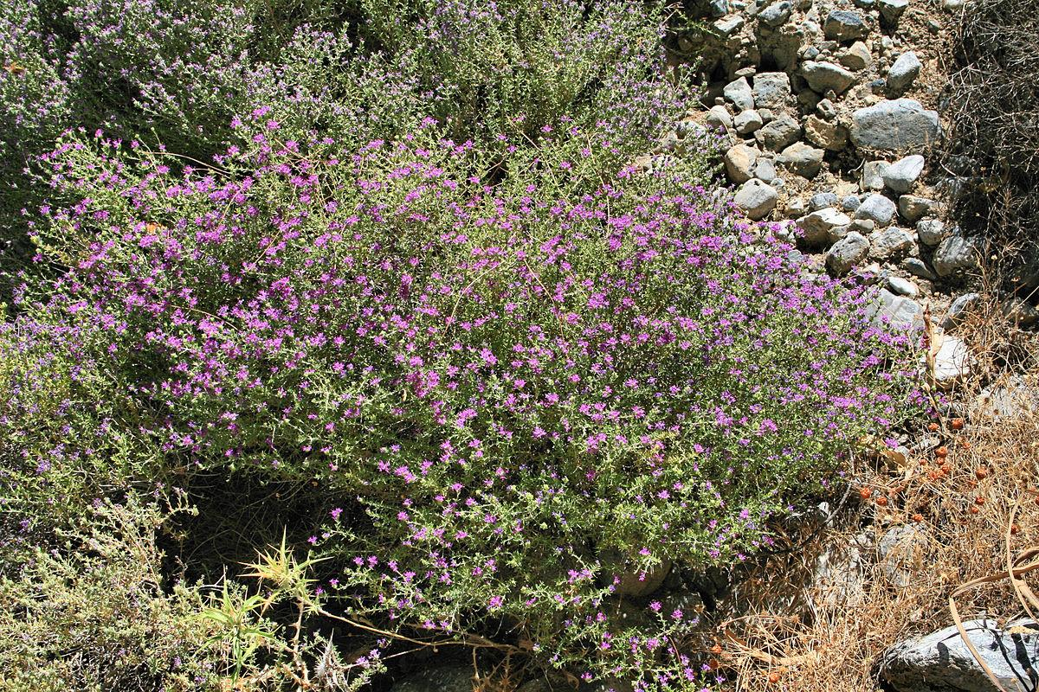
il mirto (mirtus comunis)
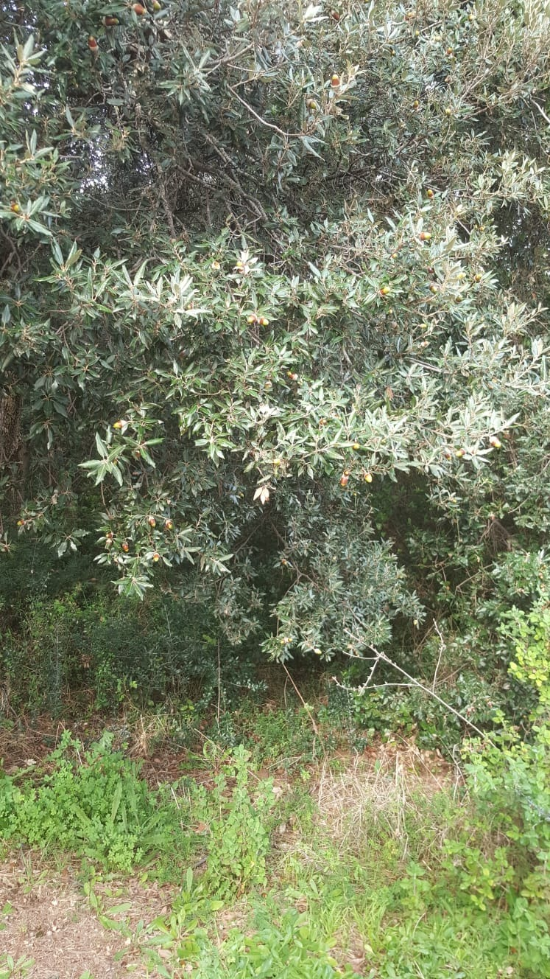
From which products such as cough syrup and liqueur are obtained.
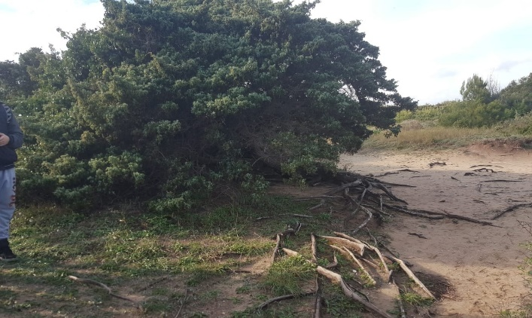
And the mammoth tree of "grandfather Gino", a 600-year-old male juniper. This big tree has been saved from a tragic fate a few years ago a man, perhaps in search of visibility,

Starting from the coast line, stretches of sand alternate with stretches of cliff where, among the salt water pools, you can find
the sea fennel (Crithmum maritimum),
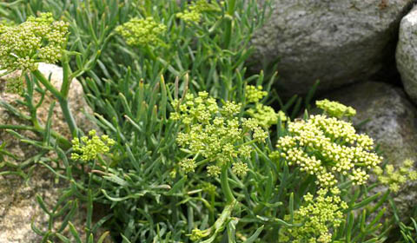
la salicornia (Salicornia europaea) 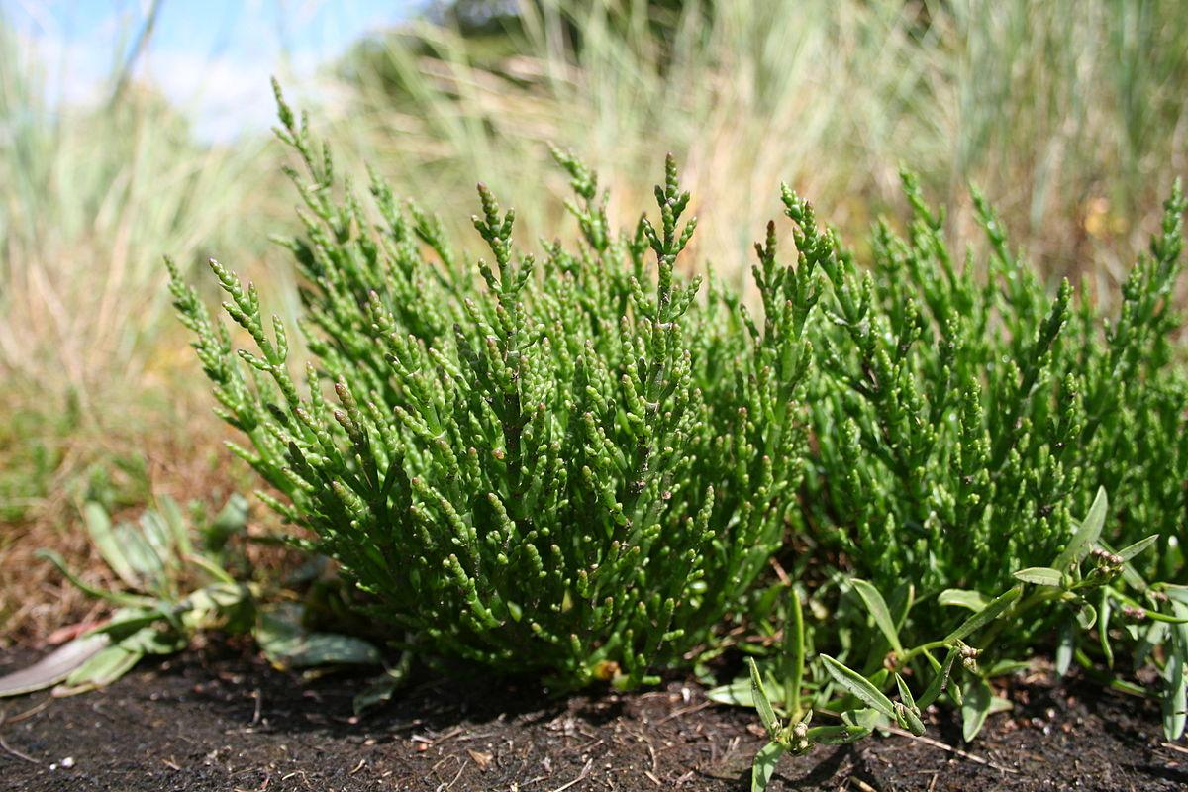 ed il limonio pugliese (Limonium apulum). 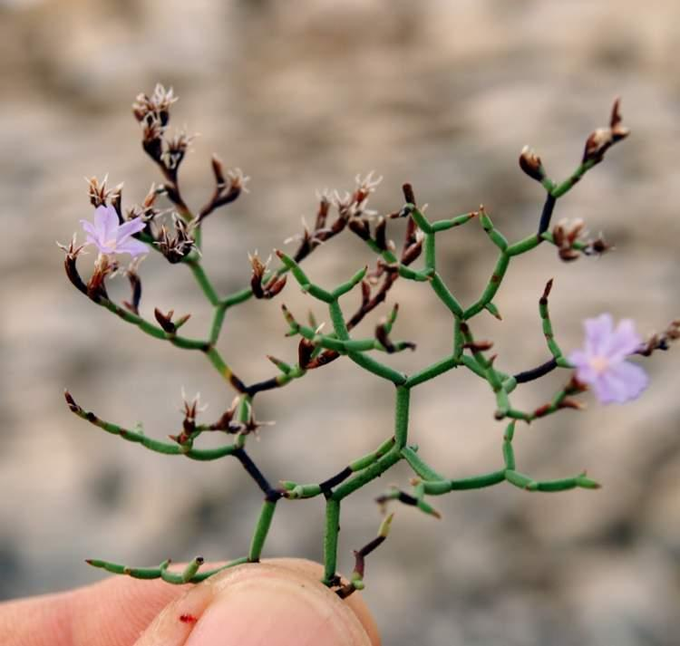
in the wetland the phragmite crystalis from which tachypyrin is obtained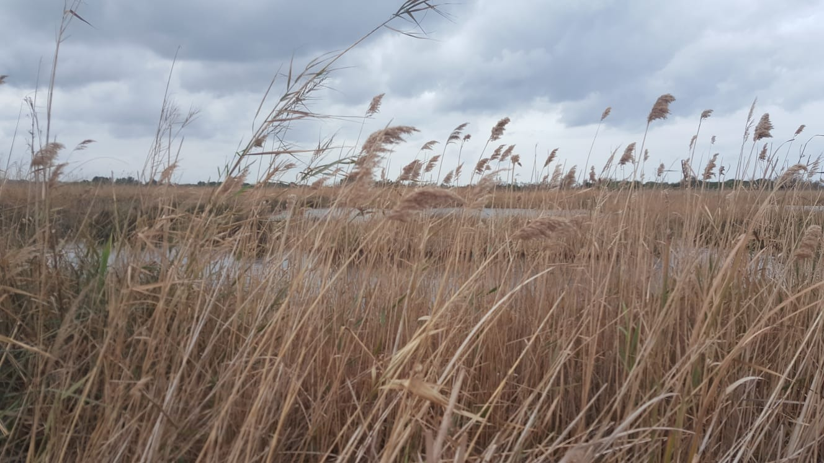
FAUNA
In addition to the presence of slightly more common animals such as badgers or small snakes

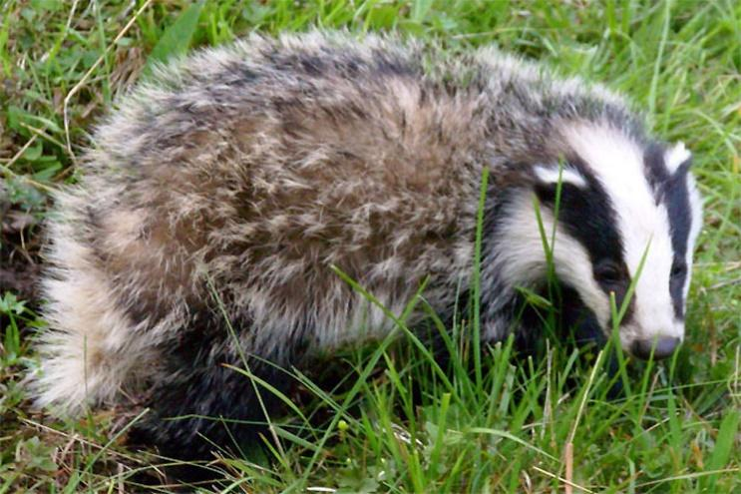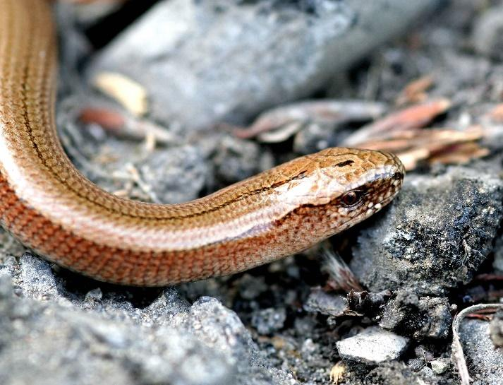
Or also the various species of ducks in the marshy area or wet area of torre guaceto
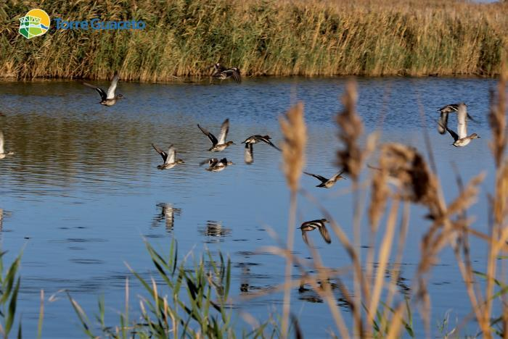
Torre Guaceto an important area of transit and wintering for migratory birds. To mention some specimens we find anatids including the "Anas clypeata", the "Anas crecca", the "Aythya ferina" and the "Anas strepera".
Very significant is the presence of "Aythya nyroca" snakes and Turkish "Netta rufina", extremely rare species and every year more constant in the presence. These are just some of the 300 species of birds
THE AREA OF THE COAST
The coastal area of Torre Guaceto is divided in 3 three zones:
Zone A
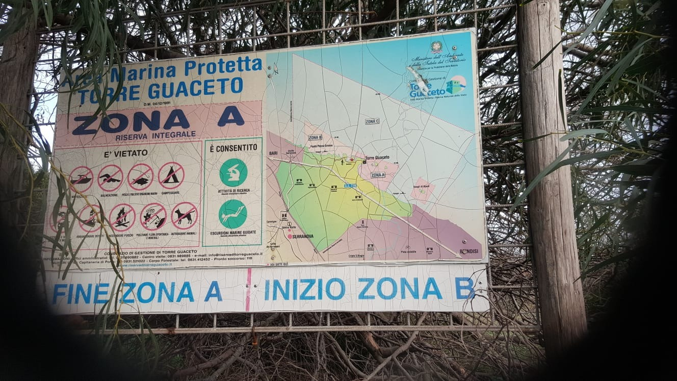
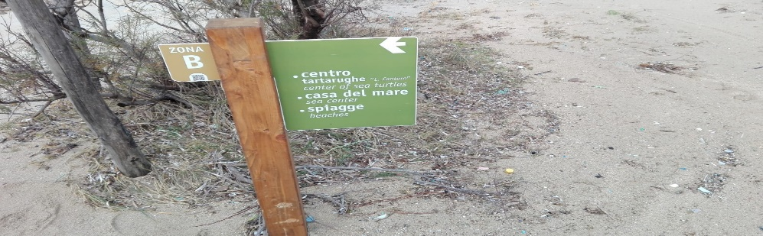
Zone B
Where there is the turtle beach

Zone C

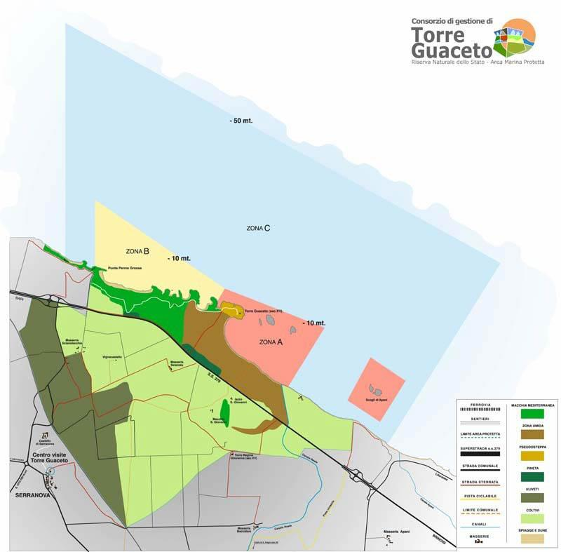
Where the Aragonese tower is located.

THE BEACH OF THE TURTLES
The turtles lay their eggs on one of the beaches of Torre Guaceto where every 30 years they take many of these puppies and many mothers come back to that beach to lay their eggs and start the life cycle again.
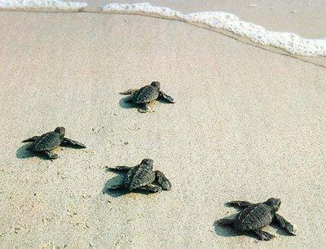
ARAGONESE TOWER
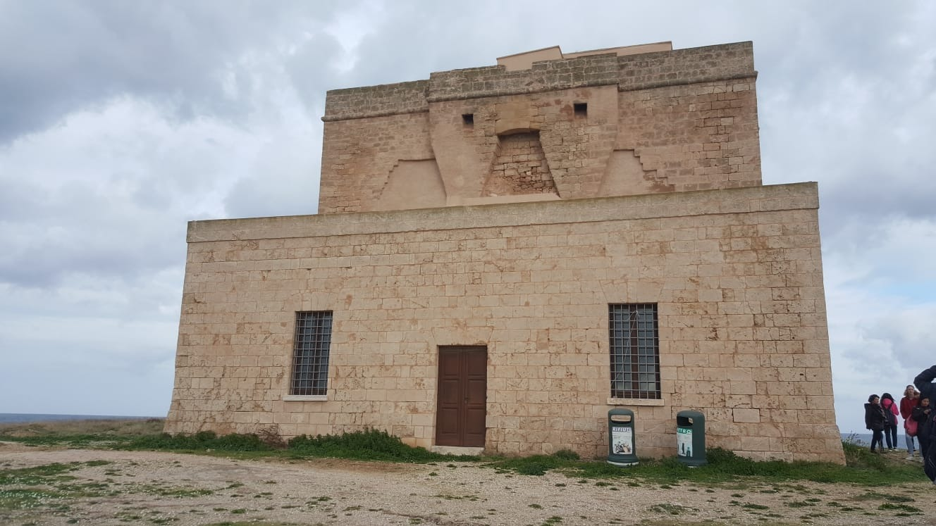
The beginning of the construction of the Aragonese tower dates back to 1483 while the construction ends in 1532. It played a defensive role, it was used as a lookout tower
Inside you can find a perfect reproduction (built with the same techniques of the past) of a boat, used for trade, containing authentic vases dating back to that period
