Mdina Malta
The History
- The history of Mdina traces back more than 4000 years.
- Referred to as "the silent city"
- Mdina is fascinating to visit for its timeless atmosphere as well as its cultural and religious treasures.
- The city was founded as Maleth in around the 8th century BC by Phoenician settlers, and was later renamed Melite by the Romans. Ancient Melite was larger than present-day Mdina, and it was reduced to its present size during the Byzantine or Arab occupation of Malta. During the latter period, the city adopted its present name, which derives from the Arabic word medina. The city remained the capital of Malta throughout the Middle Ages, until the arrival of the Order of St. John in 1530, when Birgu became the administrative centre of the island. Mdina experienced a period of decline over the following centuries, although it saw a revival in the early 18th century. At this point, it acquired several Baroque features, although it did not lose its medieval character.

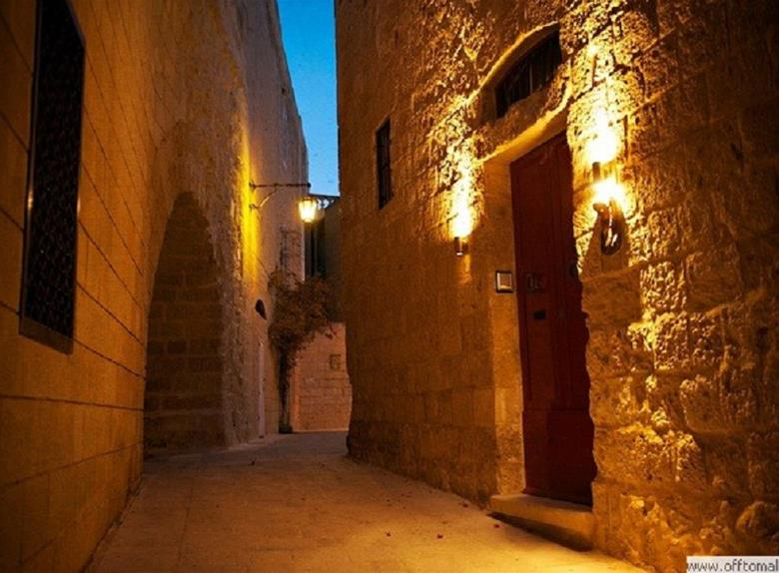

Mdina Architecture

The fortifications of Mdina are a series of defensive walls which surround the former capital city of Mdina, Malta. The city was founded as Maleth by the Phoenicians in around the 8th century BC, and it later became part of the Roman Empire under the name Melite. The ancient city was surrounded by walls, but very few remains of these have survived.

As part of it’s defensive mechanism, Mdina is composed of 3 types of walls;
- Punic-Roman Walls
- Medieval Walls
- Hospitaller Walls

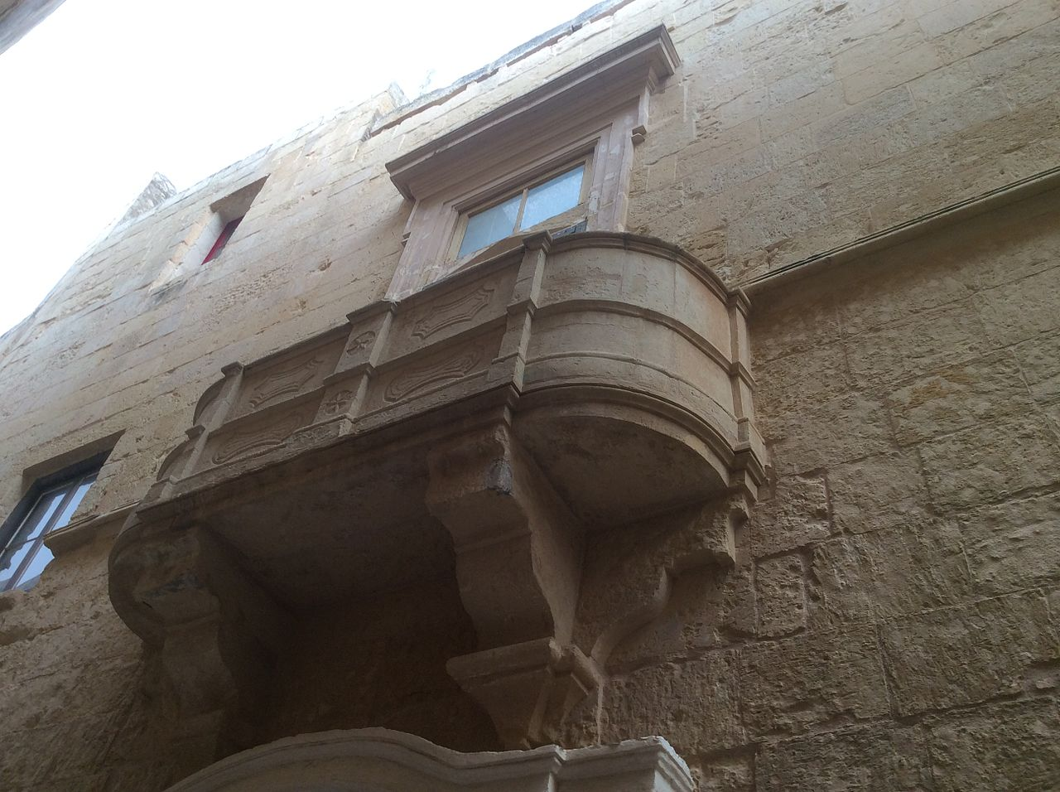
Traditional Medieval Balcony

The main tourism impacts on the city through economic, social and cultural aspects.
- An examination of various aspects underlines how tourism has impacted the city in the past 20 years and demonstrates that residents in Mdina have, over time, adapted to tourism activity.

- Such activity leads to particular effects such as positive proceeds which in turn prompts the tourism enterprises within the city to do their best to become more accessible to visitors especially through the use of ICT. This helps the city to become more sustainable..

