GREEN TARANTO: WALKING TOUR ALONG THE”MAR PICCOLO” COASTLINE
ST MARIA DELLA MUTATA ( now Relays Histò) -RIVER CERVARO--CONVENTO DEI BATTENDIERI-
CIRCUMMARPICCOLO
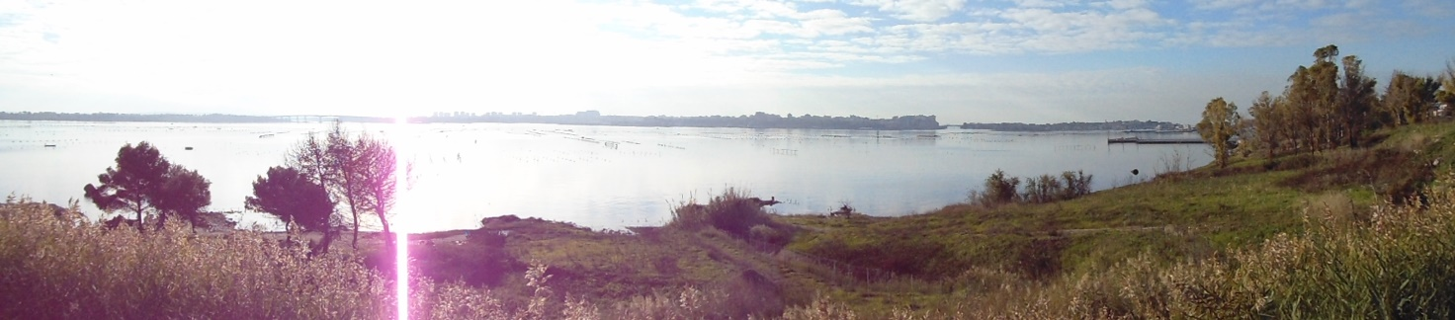
The landscape is varied and complex with its coast rising irregularly towards the Murge and overlooking the amazing Mar piccolo Basin, with its unique hydro-geological characteristics. The land is crossed by several streams and rivers and once was covered by the old “Forest of Taranto” which has been deeply affected by the industrial area which has been set in the area.
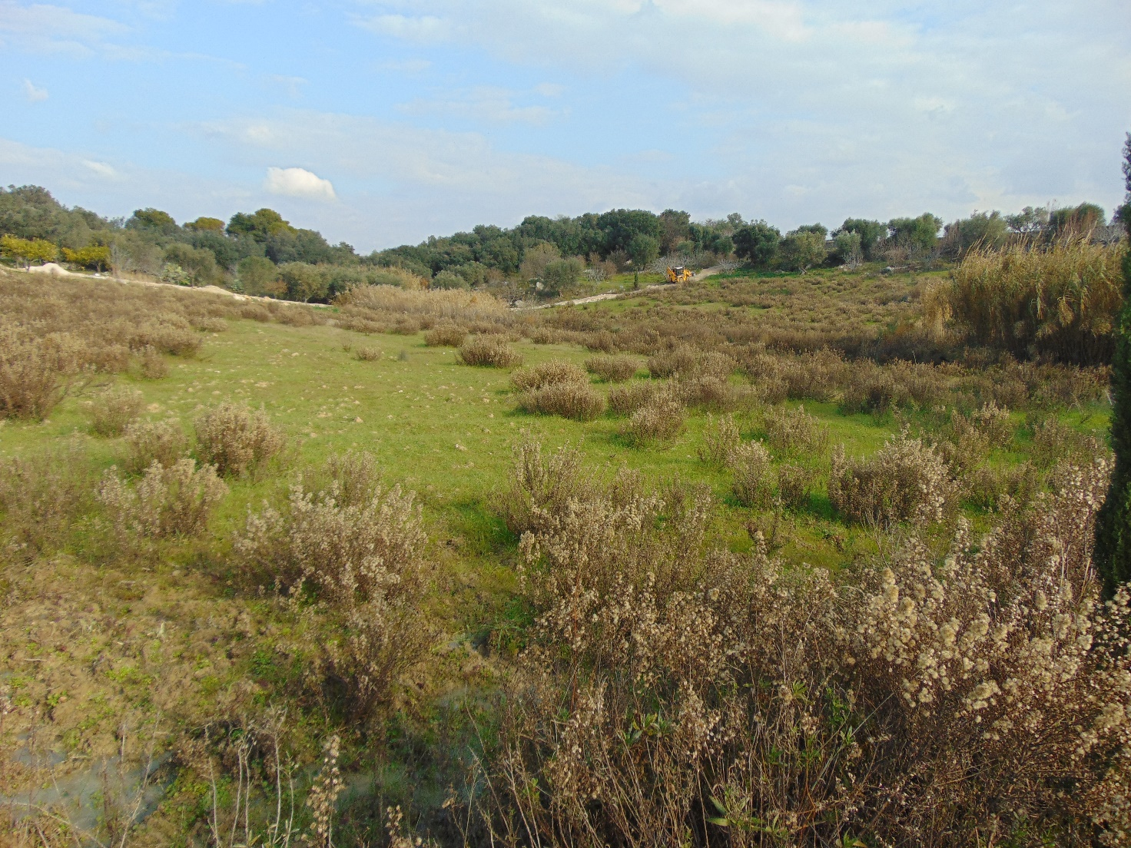

The River CERVARO
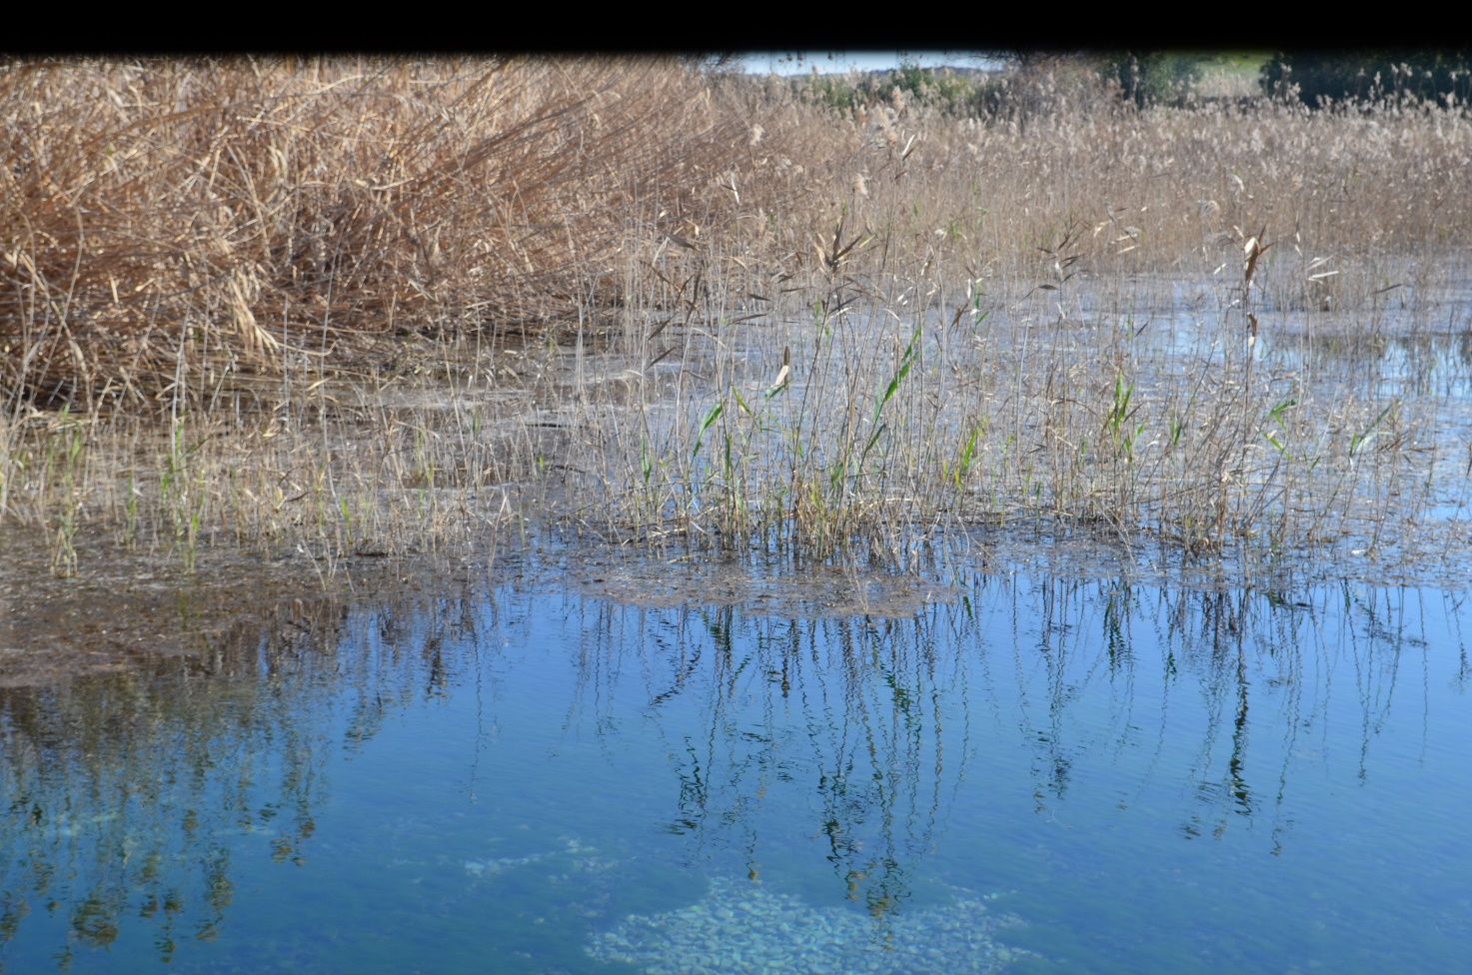
The ancient springs on the Mar Piccolo are located within the complex of the monastery of Battendieri, just next to the Regional Natural reserve oriented Palude La vela and at about 500 mt from the Masseria San Pietro (Relais Histò) on the road Circumarpiccolo direction q.re PaoloVI.
These springs give source to the karstic River Cervaro. The river Cervaro takes its name from the remains of a temple dedicated to the goddess Diana discovered nearby
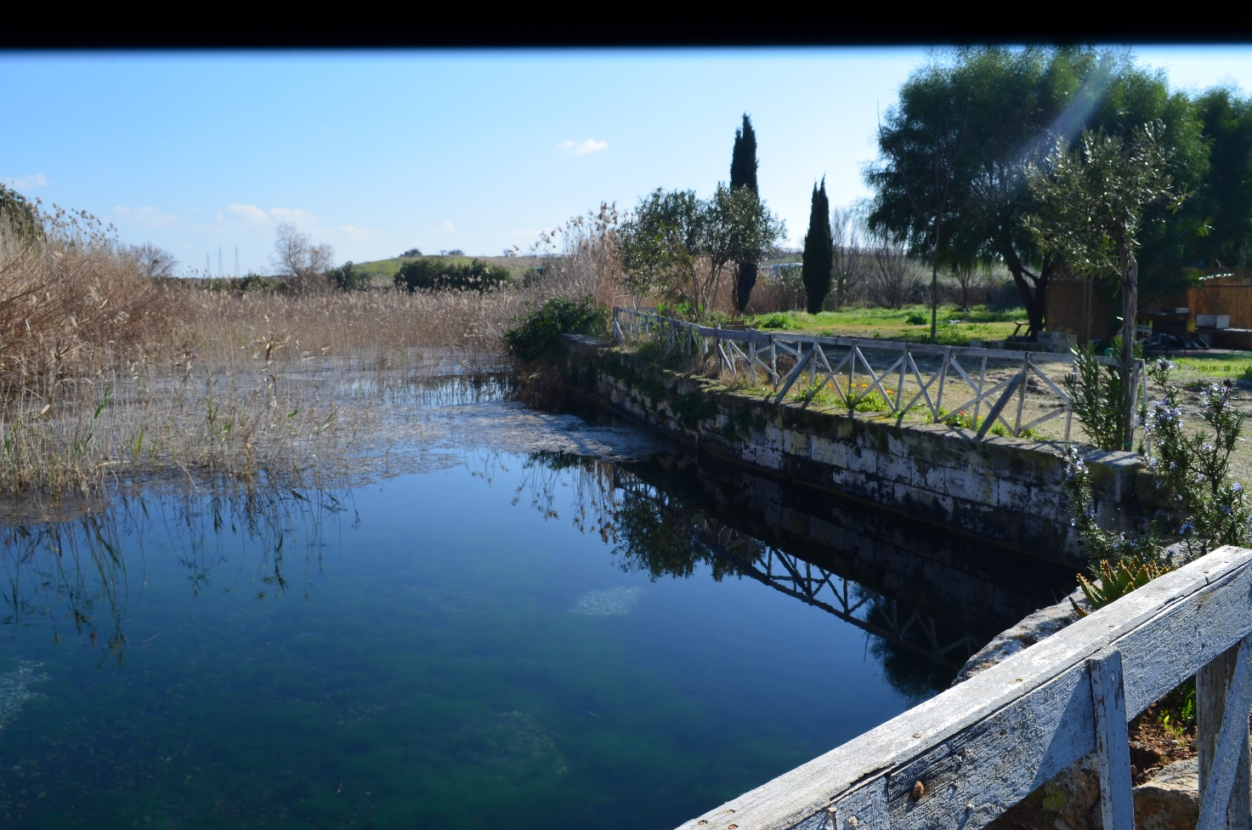
The Cervaro River flows into the nearby Mar Piccolo (Little Sea), whose waters today are particularly suited for the mussel farming. In fact, due to the effect of the continuing inflows of fresh water from the rivers, the waters of Mar Piccolo are less salty than usual. The river has the form of rather wide source eye, surrounded by plants of Typha latifolia (herbaceous perennial, also known as reeds or Mace sorda, common in swampy areas, up to 3 m.)
The source of the river is in the limestone rocks of Murgia and on its way to the sea its waters are enriched by calcium carbonate. Near the spring there are also many reeds (fragmites), which add oxygen to the waters.
Entering these waters means regenerating mind and body. Swimming in these ancient pure waters gives you a sensation of great energy so that. they are used as thermal spring with healing purposes.
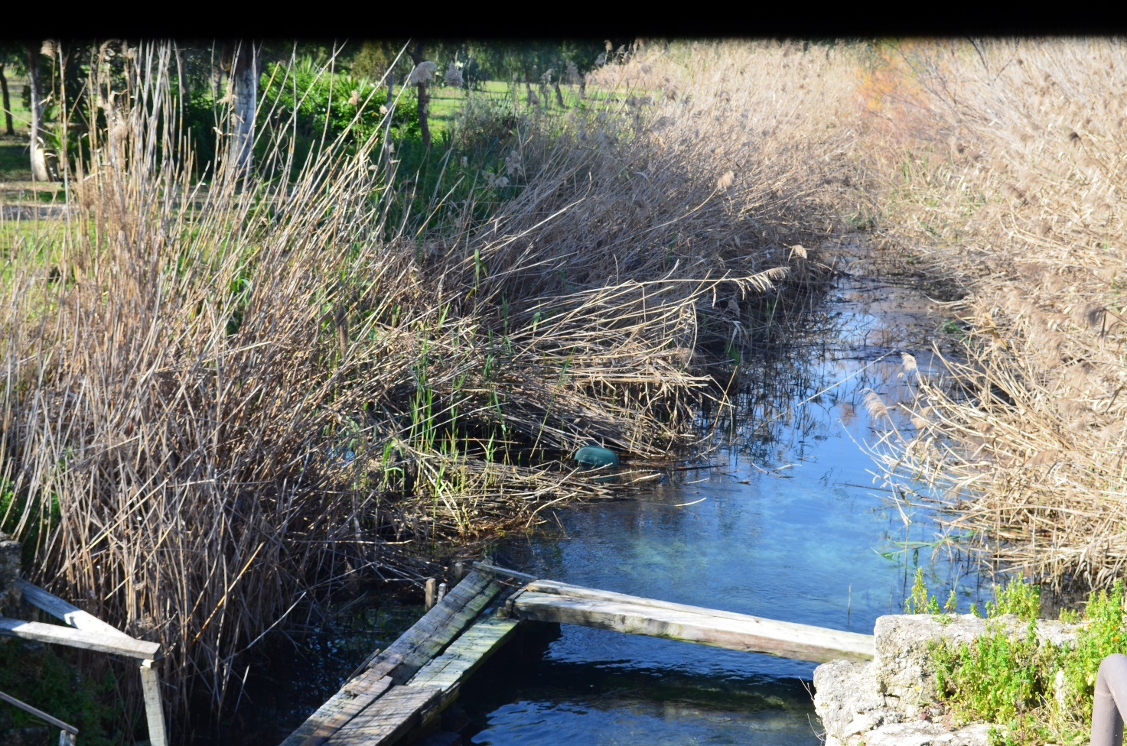
Here, Capuchins Friars of the Monastery of Battendieri used to wash the wool by fulling it within the fulling mill, then it was processed in the workplaces located at the ground of the Convento dei Battendieri. A machine driven by a water wheel with hammers pounded the cloth. Fulling consisted of a softening of the wool cloth.

Convento dei Battendieri
The Monastery of Battendieri is located in the area immediately north the second Inlet of Mar Piccolo ( small sea)
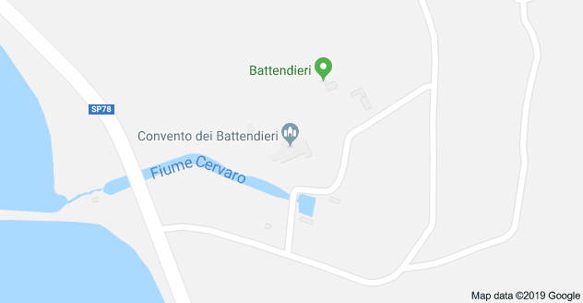
Driving directions: From Taranto take the S. Giorgio S / S 7b, turn at the junction of Circummarpiccolo SP 78 and after 4.1 km turn right. The Convent is located at 130 m distance on the left .

The Monastery of “Battendieri”
The Monastery of Battendieri is one of the most representative monuments of the territory of Taranto, both for the importance of its historical layers, both for its architectural and landscape value.
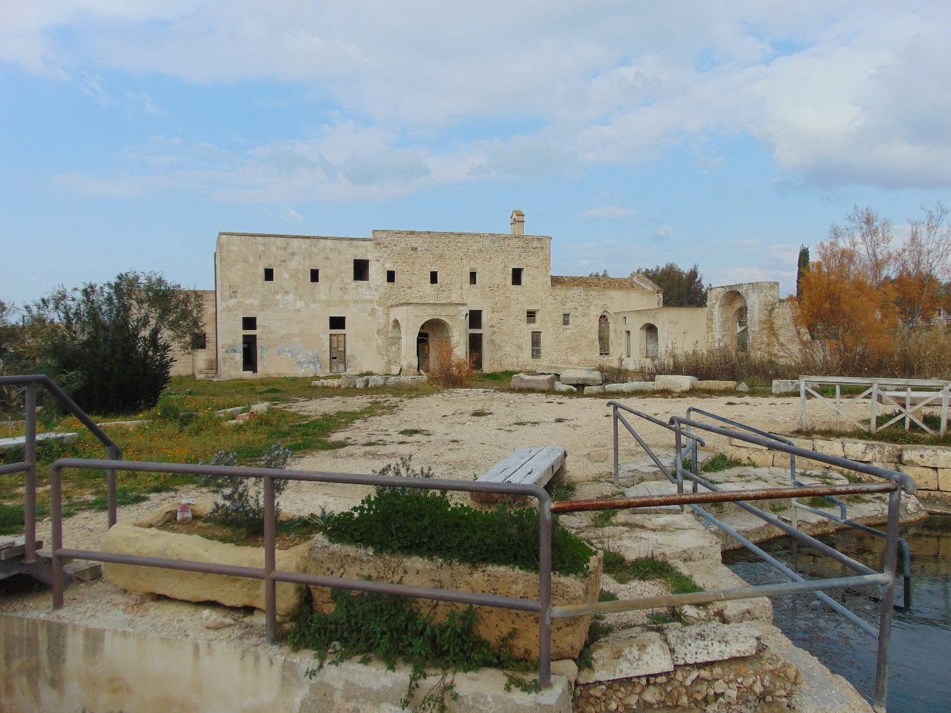
The “Convento dei Battendieri” ( Monastery of the Chapucins friars ) is an ancient monastic building, with the homonymous Church, near the Mar Piccolo just a few metres from Saint Peter's, alias Masseria Relais HisIn the area in the Hellenistic period (V-III century BC.), findings of votive statues about a rural sanctuary dedicated to Artemis Bendis and a necropolis have been found.
The Monastery was built in 1597 by the Capuchin Friars on the ground donated by the nobleman Francis Maddox,

They built a very simple church dedicated to St. Lawrence and St. George, gabled, with a barrel vault, and , small rooms with sacristy, the refectory, kitchen, workshops for the production of wool, eight cells upstairs and other small premises.. The site is characterized by the presence of the small river, Cervaro of pre- and proto-historic origin.
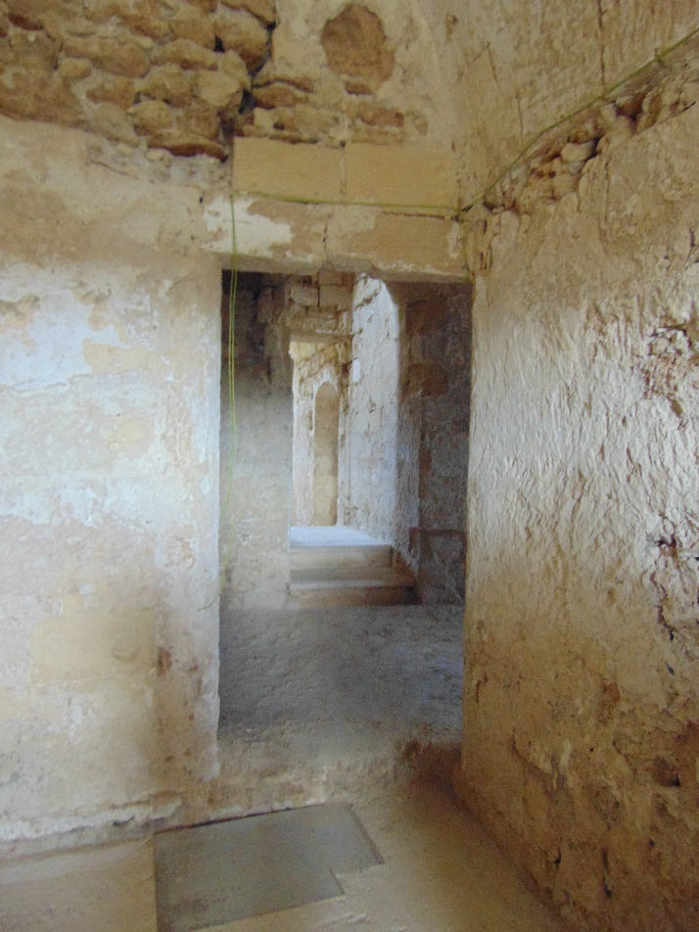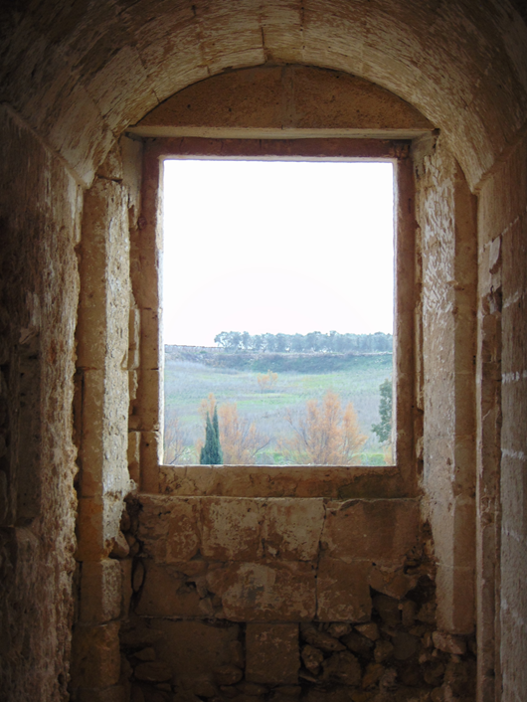
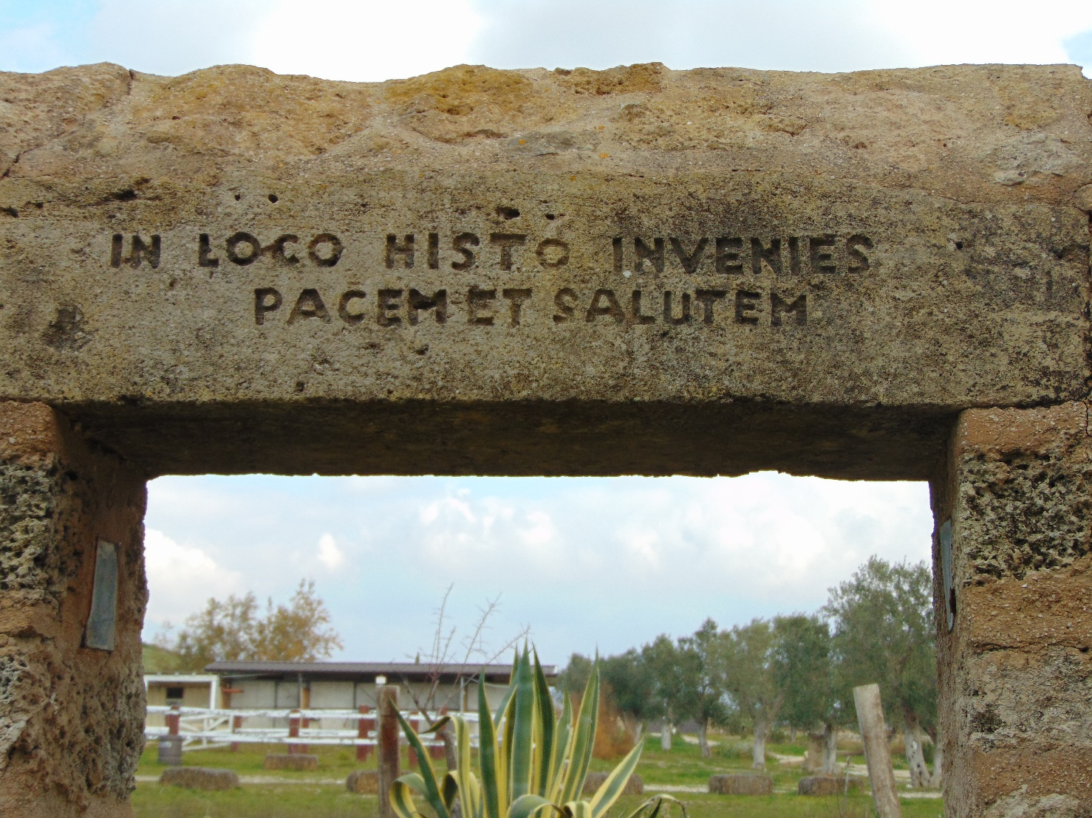

The large cistern was probably built two and a half centuries later after the Capuchins abandoned the monastery in 1867 when it became a privately owned farm.
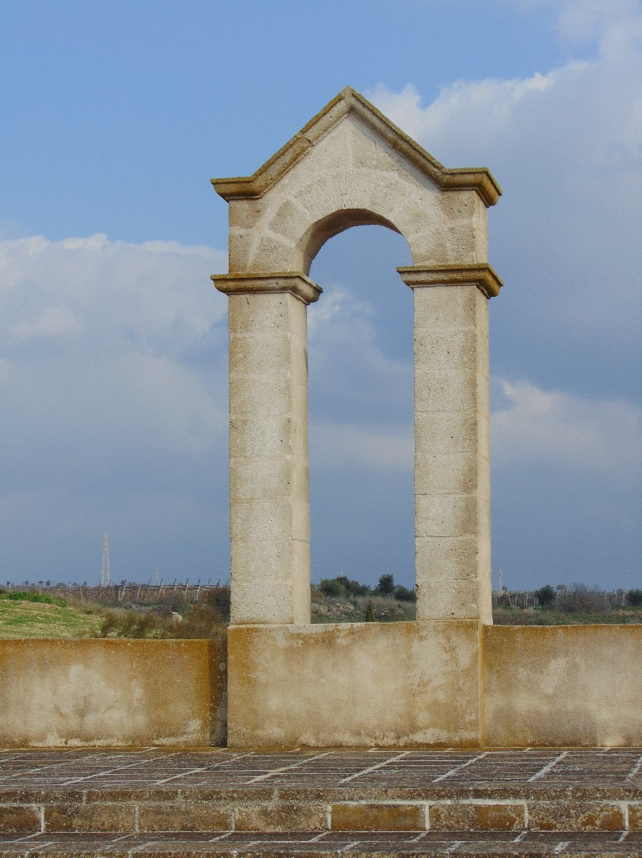
The entire complex was encased in a dry wall interrupted by the façade of the church and by an arch portal.
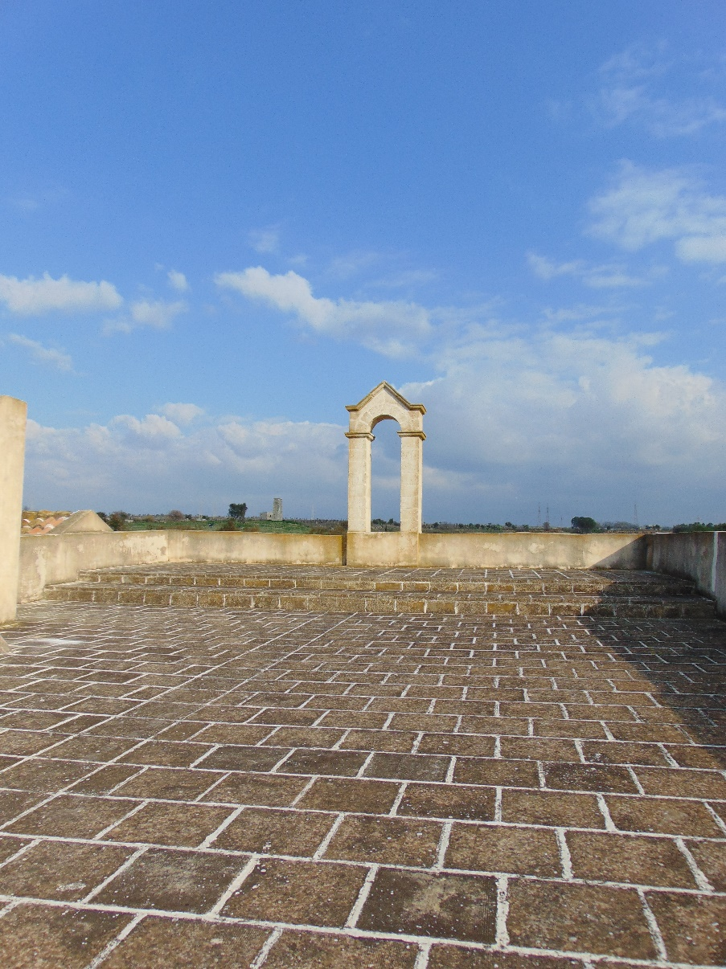
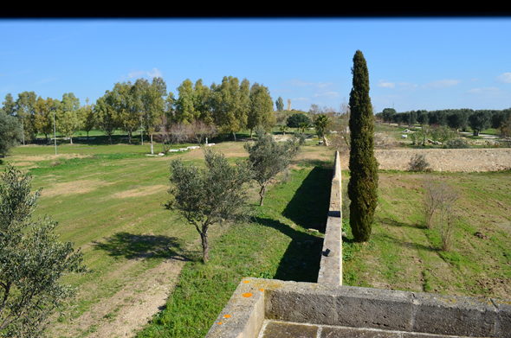
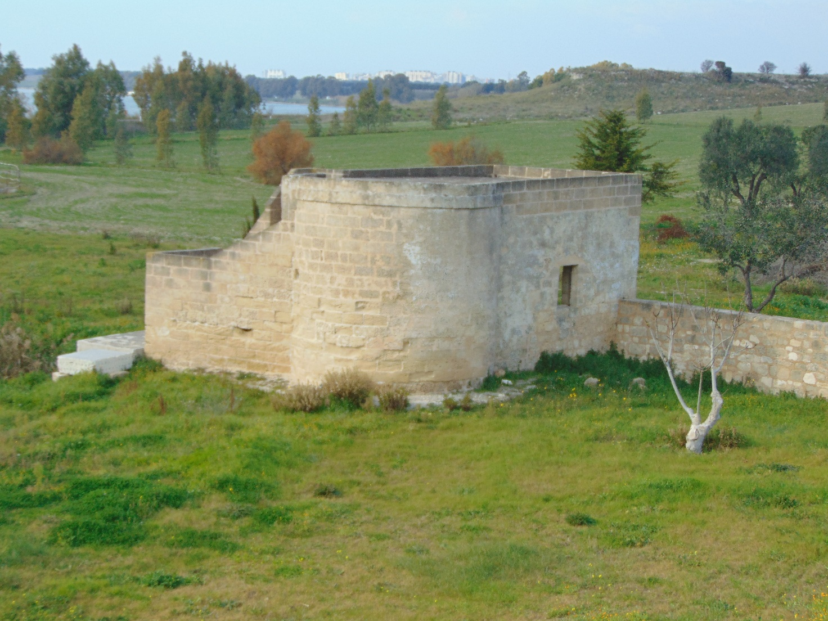
Detached from the convent, there was the fulling mill, attached to a circular tower pit on a pool of spring water, with windows and a ladder for access to the top
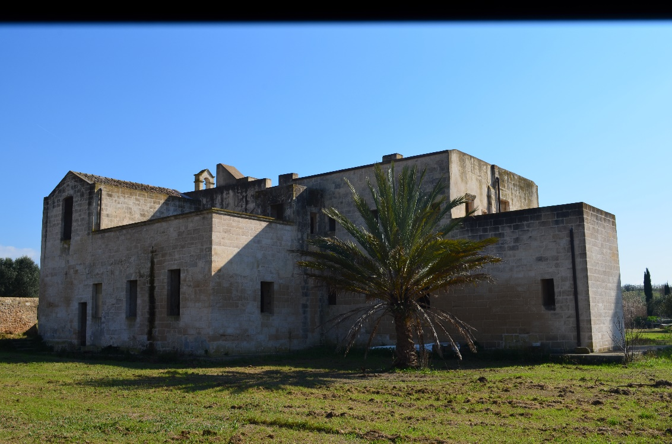
The processing plant of clothes included a number of tanks and mills for the use of water of the river and also a second source located near the mouth
Inside the convent, which is still preserved in his original form and architecture, you can visit the machine to beat the lane, the fulling mill.

The ancient masseria San Pietro della Mutata
Continuing on the coast of the second Inlet of the Small Sea, about a km from the convento Battendieri, not far from the coast line, in the locality of Marrese, you can visit the impressive series of buildings o.
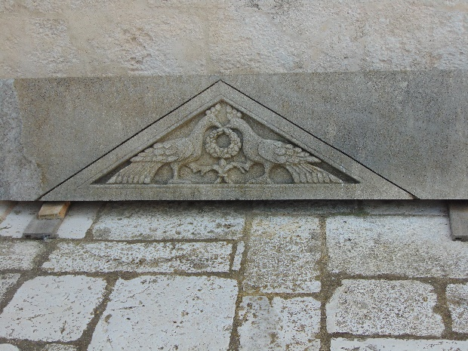
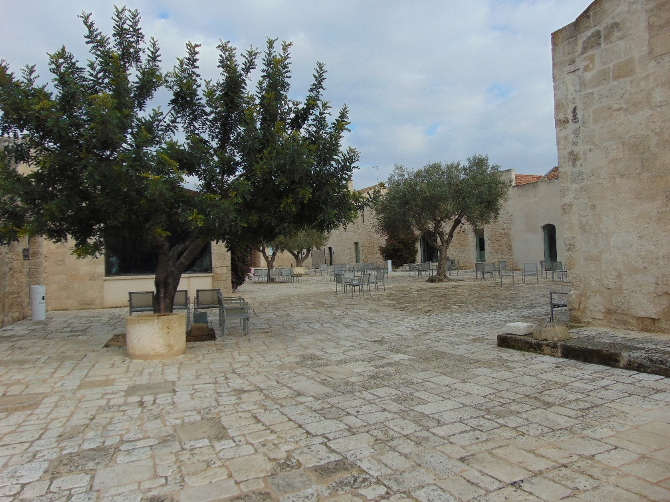
The ancient masseria San Pietro was already inhabited in roman times, standing on a hill which still overlooks the second Inlet of the Mar Piccolo.
Today, the masseria has become a private structure , the Relais Histò
Inside, in addition to the beautiful trees of the carob tree, loaded with olives and huge arbutus, it is possible to visit the basilica of San Pietro in Mutata, which dates back to 1392, a former roman villa and monastery in the land of the remote Taras.
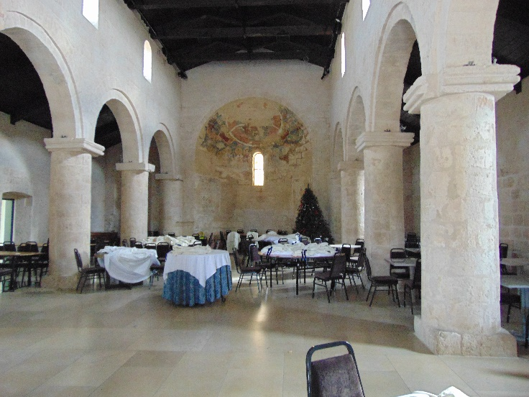
The Basilica, which still preserves its charm and its history. In the complex there is also a medieval olive mill with ancient presses.
In addition to Masseria San Pietro, we recommend visiting the roman aqueduct underground on the Small Sea, whose peculiarity is the fact that it was the result of an intense ancient blows of a pickaxe.

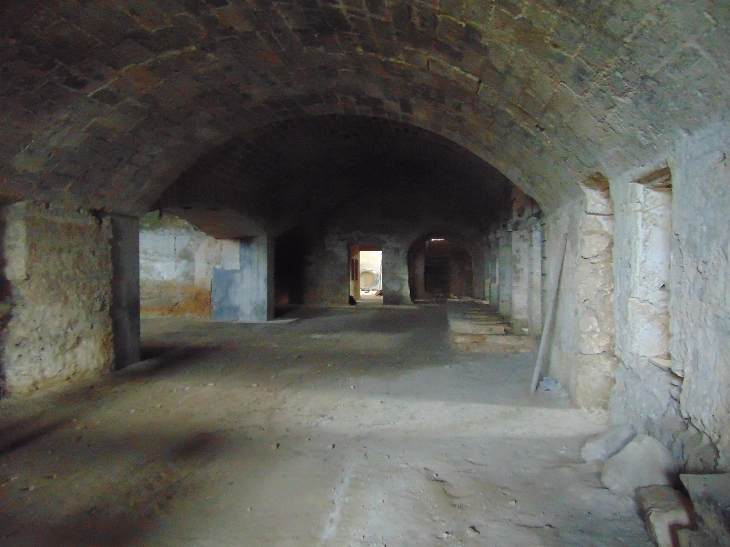
THE ANCIENT HYPOGEAL OIL MILL

