PROTECTED NATURAL AREA “LES MADRIGUERES”
ENDANGERED SPECIES

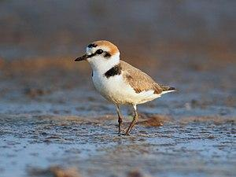KENTISH PLOVER
The Kentish plover is a small cosmopolitan shorebird (40-44 g) of the family Charadriidae that breeds on the shores of saline lakes, lagoons, and coasts, populating sand dunes, marshes, semi-arid desert, and tundra. Its scientific name is Charadrius alexandrinus. Les Madrigueres is a key place for the conservation of this endangered species which has on the beaches of Baix Penedès the third largest population in Catalonia.

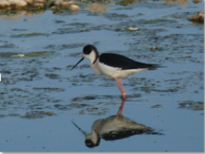BLACK WINGED STILT
Its scientific name is Himantopus himantopus. They have extremely long legs, hence the group name and thin bills. Stilts typically feed on aquatic insects and other small creatures. They live in wetlands. They nests in Les Madrigueres since 2016, before then there was no evidence of its reproduction in Baix Penedès.

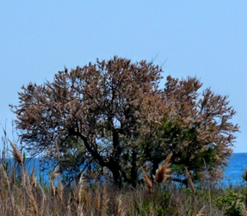 TAMARISK or SALT CEDAR
Its scientific name is Tamarix sp. They are large shrubs or small evergreen trees that reach 6 to 8 meters high. The leaves are alternately disposed, flake-shaped, lanceolate grey-blue. It blooms from April to June. The flowers are white or pink in compact cylindrical spikes of 4 to 5 cm. They are species adapted to live by the sea, since they tolerate salinity well. The generic name originated in Latin and may refer to the Tamaris River in Hispania Tarraconensis. In Les Madrigueres we can find two species African Tamarix and Canariensis Tamarix and they are the biggest in all this zone called Baix penedès.

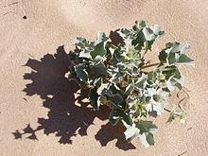SEA THISTLE
This plant grows to a height of 20 to 60 cm. Its scientific name is Eryngium maritimum. It’s a dune plant. They are usually on the European coastlines. Its flowers are burr-shaped and its colour is metallic blue or mauve. We can see them on Les Madrigueres dunes.

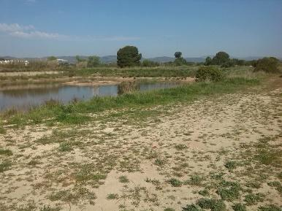 BERMUDA GRASS
Its scientific name is Cynodon dactylon. It grows on the dunes above the beach. By anchoring shifting sand and cutting coastal winds, it creates a place where other plants can grow more easily. It is not an endangered species but we highlight it because that is all these beaches were before the tourism boom.

