GREEN TARANTO CHASING THE LANDING PLACES OF TAPAS
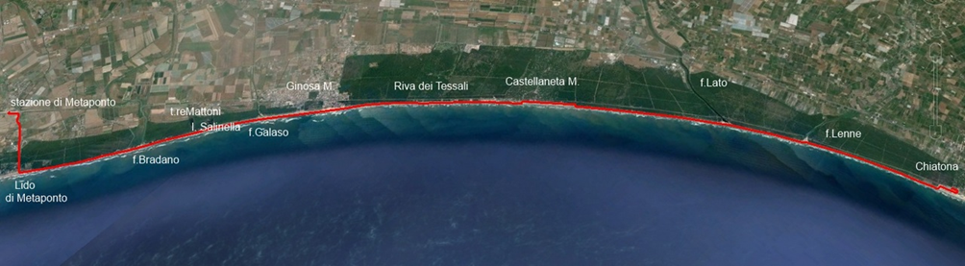
Trekking along the beach from Metaponto to Chiatona

The west coast of the Gulf of Taranto (i.e., west of the city) is a long beach that runs almost continuously, along four provinces (Taranto, Matera, Cosenza and Crotone) and three regions (Puglia, Basilicata and Calabria).
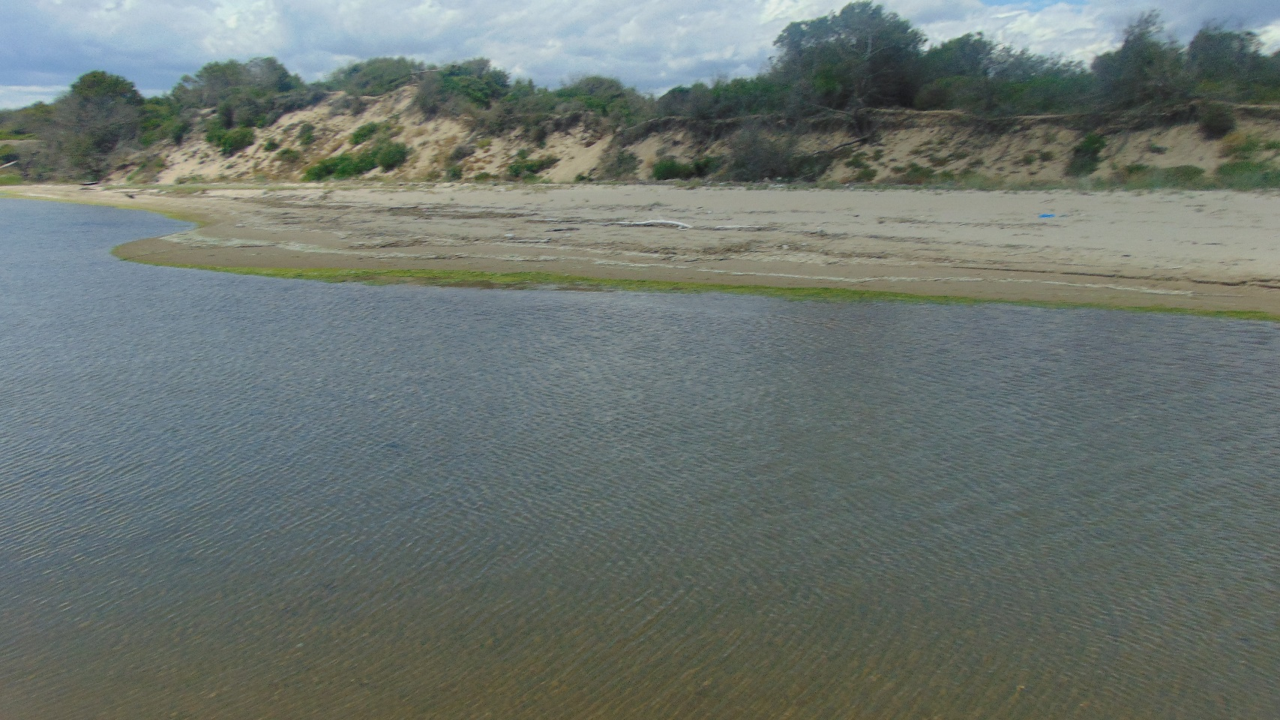
Its first 35 kilometers, between the port area of Taranto and Metaponto Lido, are characterized by little or no presence of settlements, and by the protection offered by a lush pine forest that extends to the interior, beyond the coastal dune, for up to 2 km, and never less than 800 m. There is a coastal road, highway nr. 106 "Jonica", but this runs inside, farther than the pine forest, and a first band of agricultural land planted with vegetables and orchards.
For this reason, the sea and the beach are accessible only through the few roads that connect the national road with the few coastal settlements, only in their vicinity: Lido Azzurro, Marina di Ferrara, Chiatona, Castellaneta Marina, Ginosa Marina, Metaponto Lido.
The result of this isolation is the preservation of an environment which is surprisingly wild, with little or no contamination, and populated by a variety of resident and migratory birds. This site is little known or utterly unknown, and target of unexplained bias of much of the local people who largely prefer the crowded eastern coast, the so-called "litoranea" (coast road), for Taranto's people, simply, 'a litorania (this vernacular term meaning either the coast or the road that runs along it)

.This itinerary is dedicated to the western coast, properly said, because the coastal road – as above mentioned – runs much more inward.
Just on this magnificent extension of sand, skirted by the green pine forest as well as by the blue sea, under a shimmering sky, you can go on one of the most beautiful and original excursions that can be made in the Ionian land.

The long walk on the beach starts from Metaponto Lido. THE Beach is wide and deep.The weather is always beautiful, the sky clear, there is no wind, and the beach looks smooth and compact. The view stretches eastward up to the mouth of the river Bradano, recognizable from here only through the artificial reef built in its protection, which stretches out to sea for a hundred meters. It appears on the horizon as a dark stripe on the sea. Further on, the coast has a bight, and the rest of the path is hidden to the sight by the dune and the pinewood.
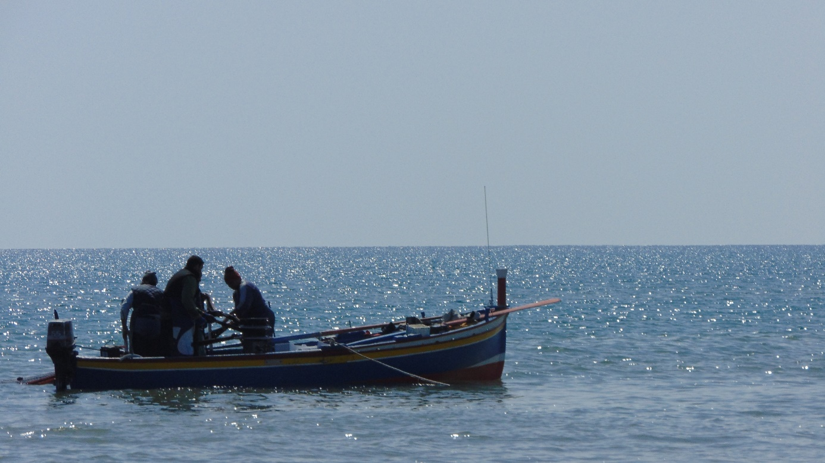

Trekking Gravina di Montemesola the ”Marquis’ Gravina”( Ravine)
Montemesola is located on a hill at 180 meters above sea level, lying isolated between plains and valleys,from east to west in the form of two long rectangles,. Its name originates from the Latin "Montis-Mensulae".(Mountain shelves) referring to this topographical position
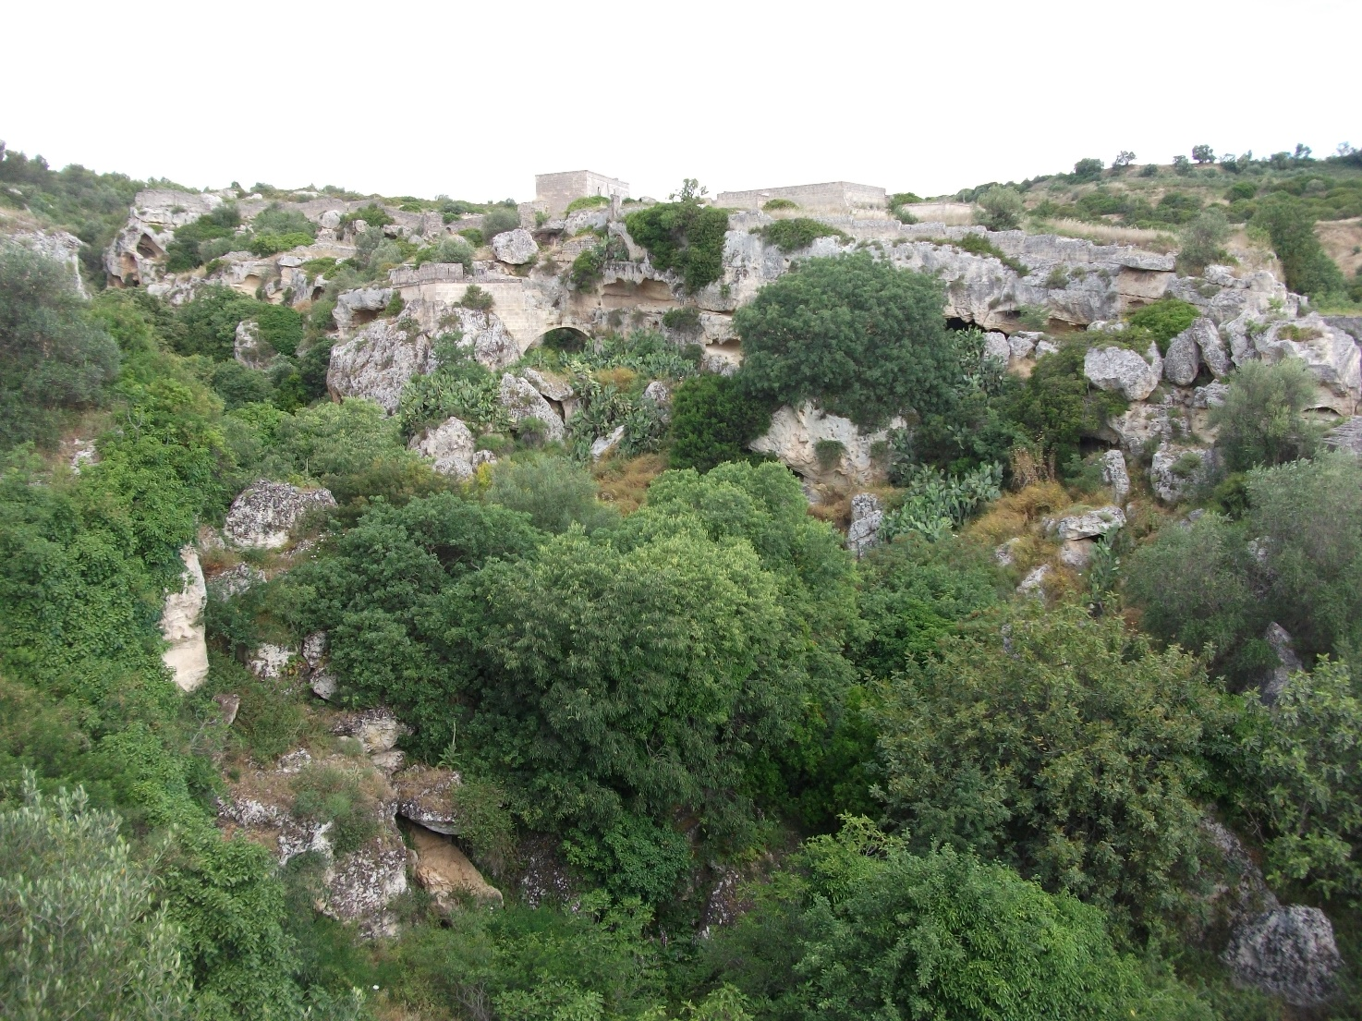
The historical center of the village, ,stretching on the hill of the relief of the “Murge” ,is still enclosed in the elliptical circle of the eighteenth century walls wanted by the feudatory Marquis Andrea Saracino.
Monemesola enjoys a beautiful panorama that includes the Gulf of Taranto, the valley from Grottaglie to San Giorgio Jonico and the wide plains in which we find Pulsano, Leporano and Talsano.
At a first glance, the village seems a fortress which was initially accessed by four doors: to the north by San Martino’s door , to the west by San Gennaro’s door, to the east by San Francesco da Paola’s one and to the south the fourth, then demolished,, the “Porticella” (little door).
In the city center ,the elegant semicircular square overlooked by the most beautiful palaces including that of the Marquis , is the main crossroad of the main streets. The City Hall is hosted in the former “ Convent of the Sacramento.
in the old town St.Michael Church, the Virgin of the SS.Rosario Church, the Santa Maria della Croce Church are worth a visit.

THE MARQUIS’. RAVINE
About a couple of kilometers south-west from the town, The Gravina del Marchese (Ravines) develops following a long axis just 700 meters long.
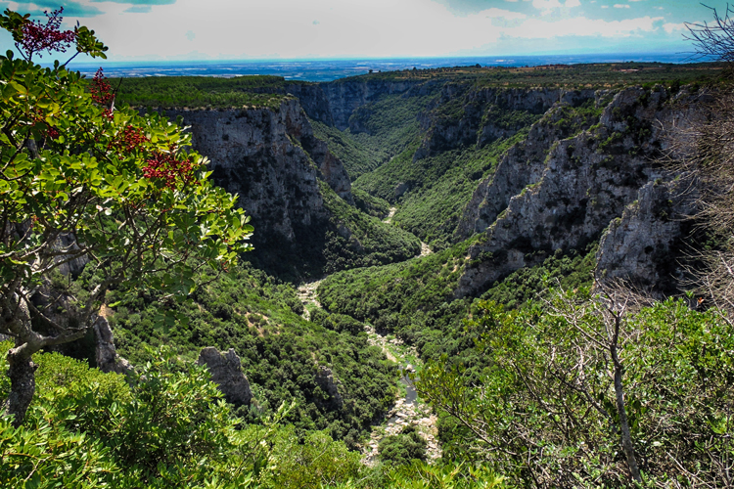
The Gravina, , is a deep and jagged depression in tufflime stone that constitutes a wonderful area characterized by a rich natural biodiversity.
A thick, Mediterranean woodlands Vegetation from lush green ,dotted with tall trees that cover the hill flanks and bottoms surrounds it.

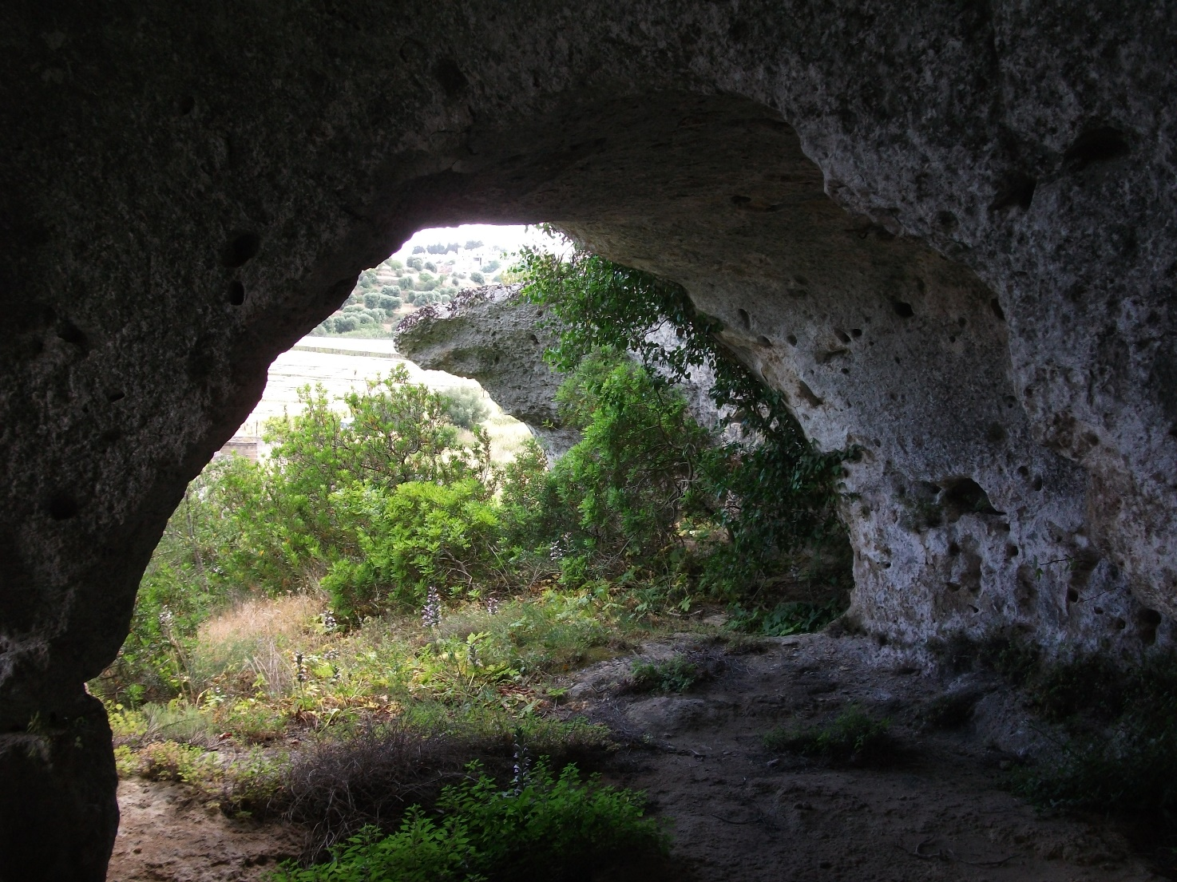
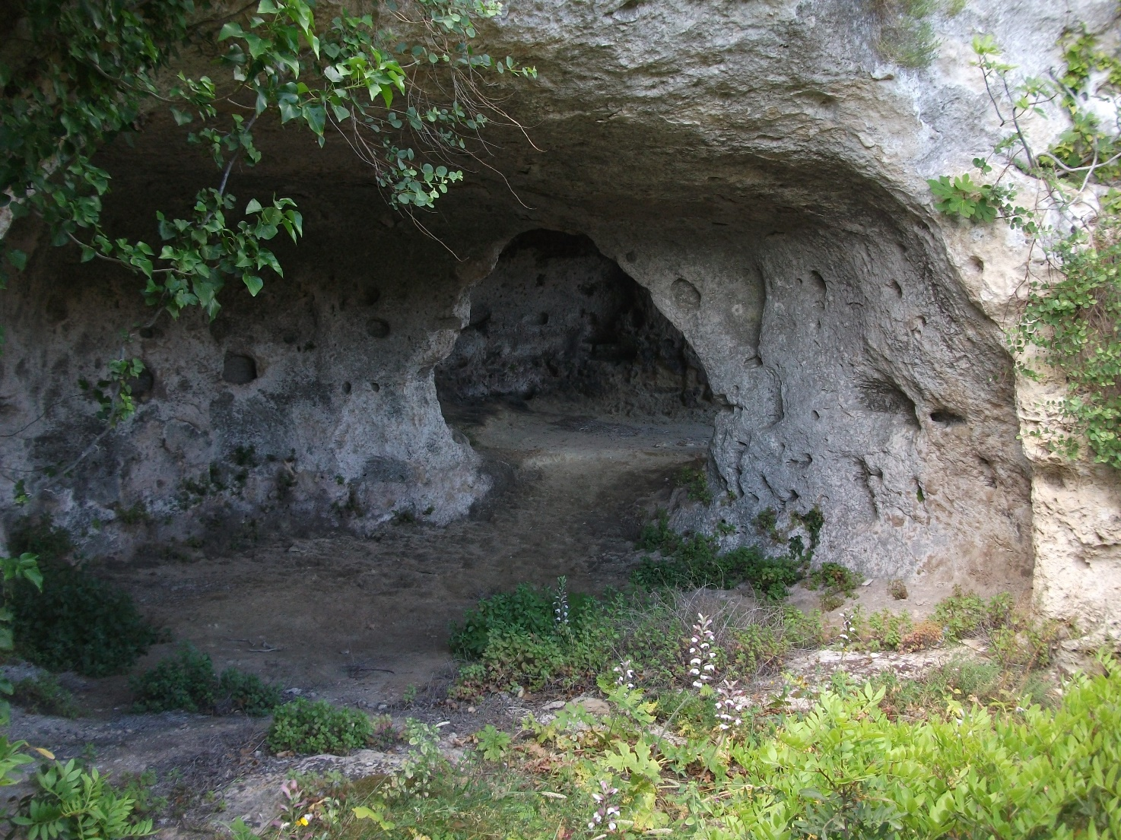
The, rainwater is naturally conveyed in the Gravina by a small but scenic waterfall, located on the Northern rim, active only in case of heavy rains.

The Gravina also houses a hypogeal Oil Mill and the remains of ancient cave settlements inhabited in the ancient past.
At the beginning of the nineteenth century , on the initiative of the Marquis Saracino the area was affected by a vast plan of rebuilding so that since that moment it has been called the ”Marquis’ Gravina”.
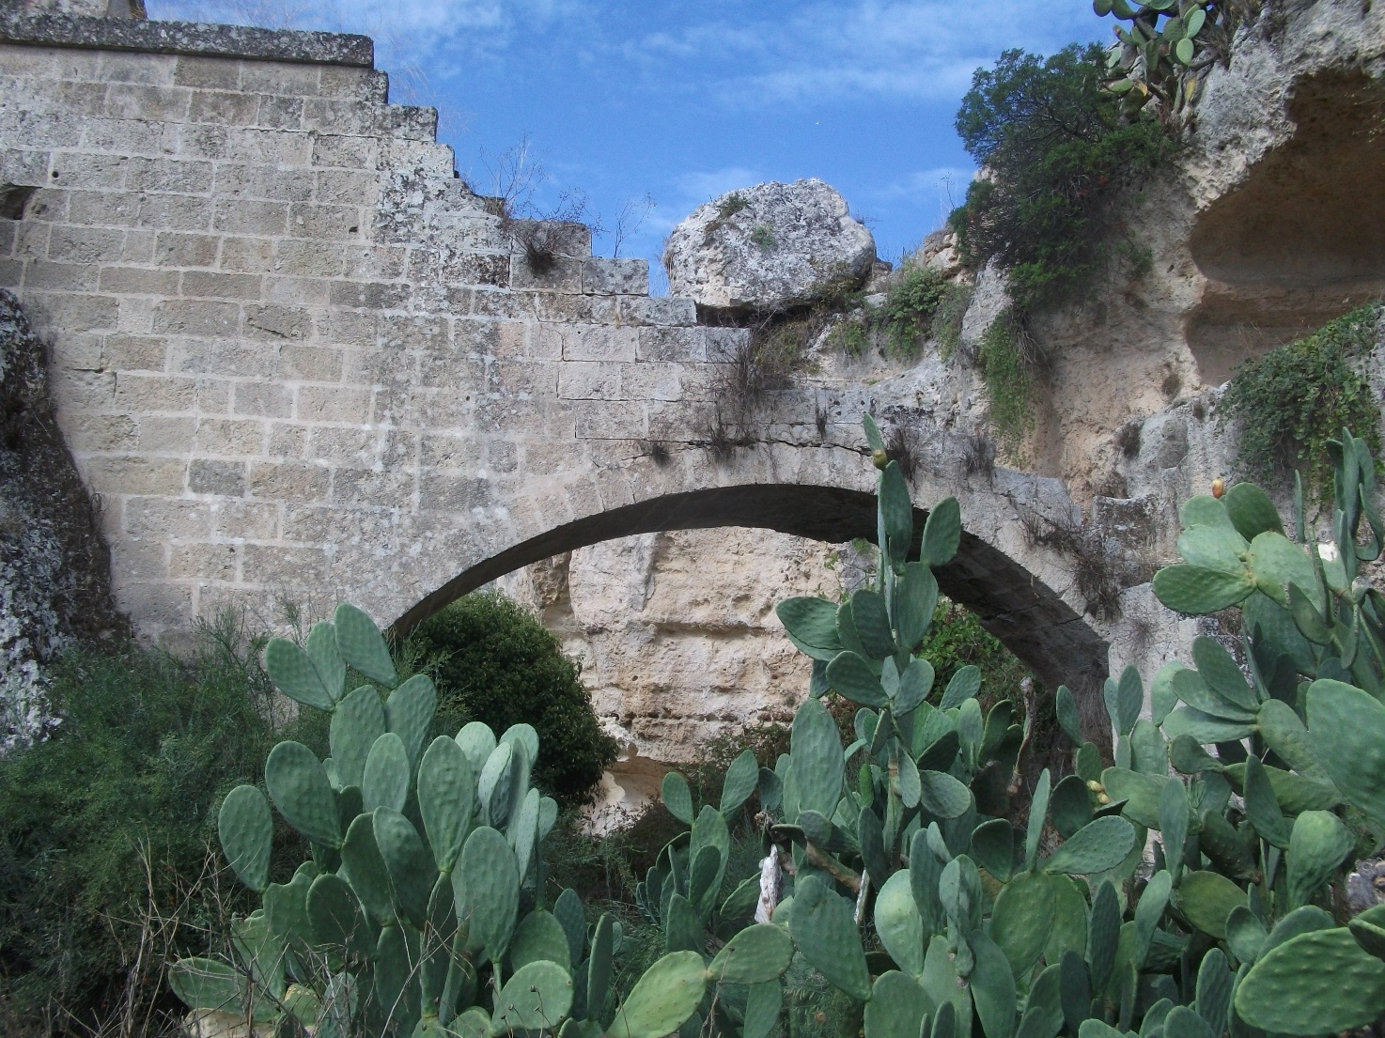A high wall, in which a monumental door was opened, was erected to enclose the land , a small castle called “Don Ciro Castle”-was bulit with a garden enriched by ornamental trees and fruit,–-which is still accessed through a stair case on rampant Arch. The fountains were served by large cisterns.
Some pre-existing caves were cleaned up of their ancient origin, to allow the reception of visitors and hikers, , who arrived here in search of refreshment and peace,in the long and hot summer days.
A large Fresco, unfortunately now almost completely lost, covers the walls of a cave placed on the west of the Gravina. The scene depitcs a fantastic urban landscape of houses, bridges and castles, with in the foreground unydentifiable human figures.
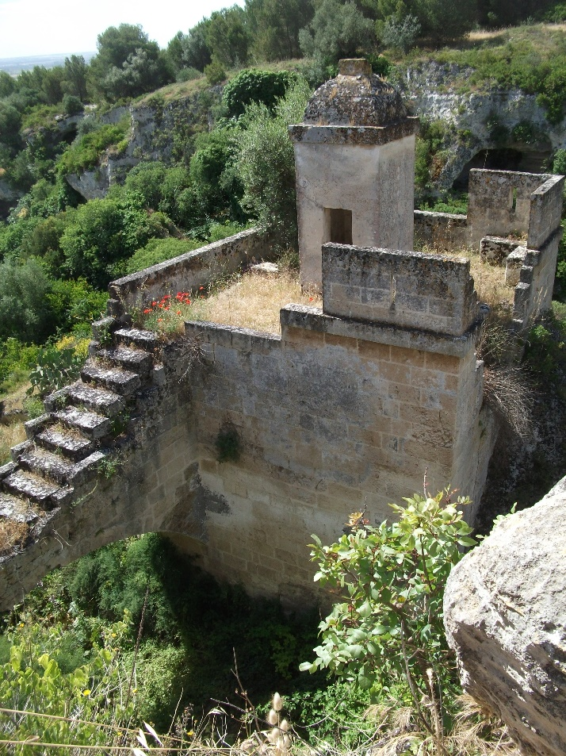
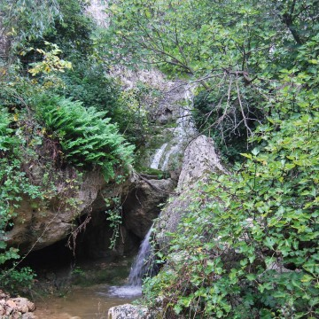
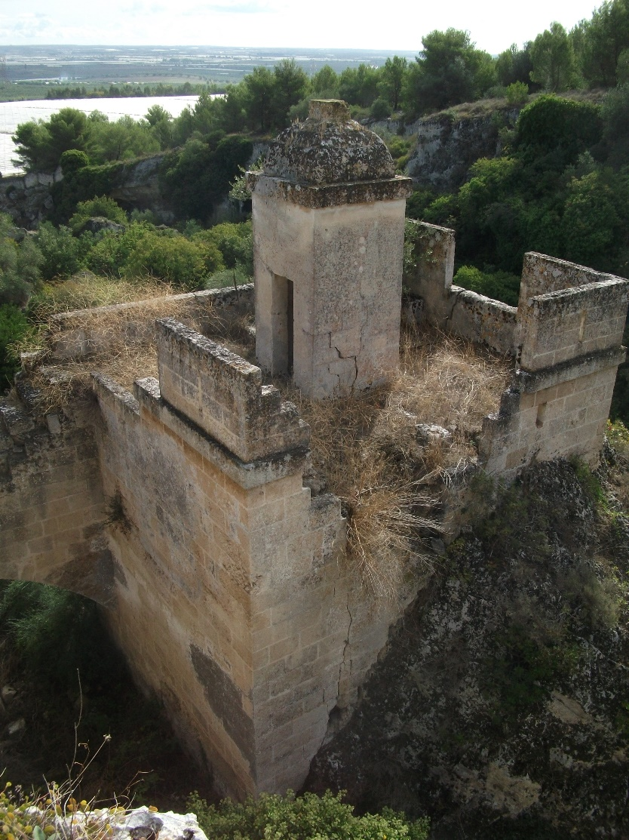

THE MARQUIS’ TOWER

The hypogeal Oil Mill
On the plateau overlooking the Gravina, in the tufaceous bench marked by ancient quarries and by deep “carrareccie” (sheep tracks), you can admire a large hypogeal oil mill that still preserves the premises of storage of olives, the barn and the accommodation of workers.
The Grindstones , on the other hand, have been lost, except for one of small dimensions-incorporated in a dry wall.
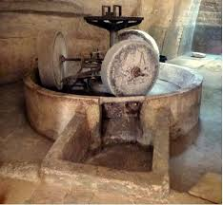
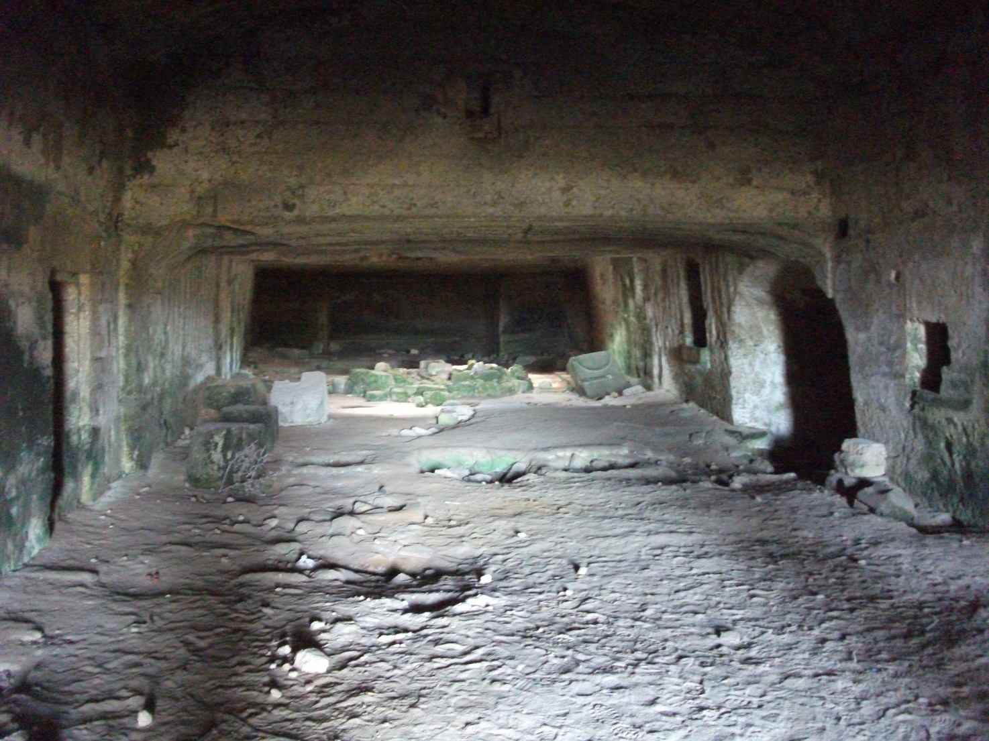
The context, is of great archeological interest, and a research conducted there has allowed to identify a series of pottery fragments dating back to the Neolithic.
