THE OLD TOWN BACK THROUGH HISTORY, ART AND RELIGION
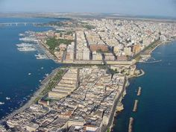
Crossing the Swing Bridge which connects The Old taranto to the New Taranto, our walking tour starts from the Piazza Municipio ( Town Square) with its Doric Columns. and The Aragonese Castle. Walking down Duomo Street you can admire the noble palaces , the ancient Churches and the Hypogeal environments that constitute the Taranto Underground.

INTRODUCTION
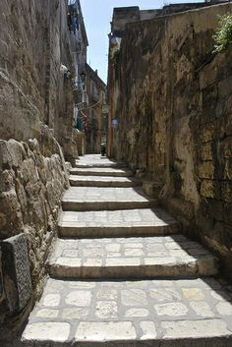
The Old Town with the signs of the glorious ancient Spartan origin, the Hypogea, the Churches The Noble Palaces,,the Old Cathedral and the narrow streets and alleys, arise in the visitor mixed feelings.with its beauty and its poetry, with the small flower-filled balconies , overlooking the seafront crowded with merchant ships at anchor, fishing boats and the amazing views on the Ionian Sea.
The Old Town lives perched on an island. The ancient town is currently the object of a large renovation work aimed at the restoration of buildings designated for cultural and social activities.
The total destruction of Taranto by the Saracens dates back to 927, when they besieged and con quered it, enslaving its inhabitants, who attempted to defend their homeland. Therefore it was necessary to defend the city: new invaders would eventually be able to cross the threshold of the sea and attack the town. In 967, with the reconstruction of the city by Nicephorus Phocas, the old town ac-quired its current appearance, marked by a wide network of streets and alleys.
The streets, the bright squares, the houses and roads are livened up by a constant swarm of life, made of roars of motorcycles, words whispered and shouted, noises and snaps of the uncapped beers. Moving then to the bottom of the island, you will find the ancient fishing village, occupied even to- day by fishermen, who return with their vessels and unload their fishes directly to the market that takes place every day in Via Garibaldi.
The island, ideally separated from the central Via di Mezzo, seems divided in a “higher” area, characterized by palaces overlooking the Big Sea, and a “lower” area, characterized by the presence of public housing overlooking, instead, the Little Sea.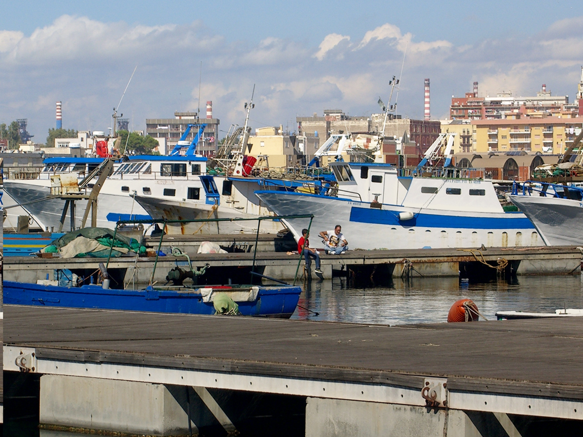
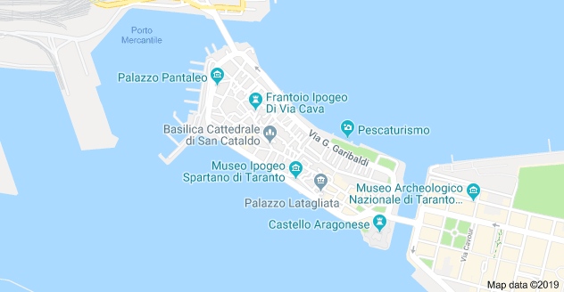

ITINERARY: The Aragonese castle- Via Duomo- Saint Cataldo Cathedral – hypogea via Cava- San Domenico church-Palazzo Pantaleo- THE MarTA Archeological Museum
- The Doric Temple
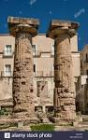
The great Doric temple of the archaic age, rising in the area of Piazza Castello, is an extraordinary monument of the Greek period of Taranto, the remains of which were enclosed until the 1970’s between the walls of the church of ‘’ Trinità’’ and the ‘’Celestinis’ Convent ’’. Originally, the building was characterized by the presence of thirteen columns on the long side and six on the short one. Of the majestic Doric temple, remain, unfortunately, only two columns and the base of a third. There are different hypothesis about the divinity worshipped in the temple: from the first concerning the worship of Artemis. The most scientifically plausible is the one elaborated in 1966 which retains that the temple was dedicated to a female divinity: Persephone, queen of the Underworld.

- The Aragonese Castle
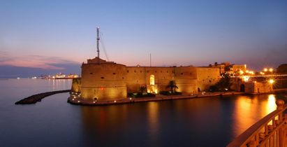

The Aragonese castle was built between 1487 and by the Siena architect Giorgio Martini next to a natural rocky subsidence at the Eastern end of the old village, including a previous fortification of Norman-Swabian age. According to king Ferdinand of Aragon’s will, the kingdom above all against the constant Turkish threat.
It was characterized by five circular, massive towers named St.Cristopher, St. Laurence, St. Angel that overlook the channel and Annunziata and Bandier towards the old town. At the beginning, the castle was surrounded by a wide moat full of water where two draw bridges were positioned: Succors, on the East side and Avanade towards the old town.
The tower of St. Angel and the two bridges were destroyed in 1883 in order to build the channel. Currently the ditch is a garden. The inside of the castle consists of a large yard with the vestibule, on the left side of which the chapel opens in honor of St. Leonard.
The Archeological Board of Apulia, in cooperation with the Italian Navy have been carrying out research for many years and discovered archeological finds dating back to the Magna Grecia period and subsequent settlement phases. In 1407 the wedding between Maria d’Enghien and Ladislao, King of Naples, was celebrated in the chapel; it was later transformed into a stable only to be rededicated in 1933.
Previously used as a prison from 1887, the castle is now home to the Italian Navy.

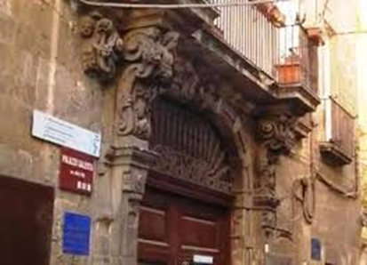
- Galeota Palace
Going along via Duomo, the main road of the ancient borgo, you meet the mighty Galeota palace, a wonderful example of an aristocratic eighteenth century building.
Built at the beginning of the enlightenment according to Vicenzo Cosa’s XXVIII century, and it is a result of the amalgamation of various existing buildings which, through different moments of renovation, have become a unique architectural structure. After the death of the first owner, the building passed on the Calò family and in the 19th century to Luigi Galeota, whose initials are engraved on the main door.
The building was restored in 1977 with funds from the Taranto Municipality and it is a refined example of renovation of living spaces, characterized by large and bright rooms. The entrance hall is characterized by the presence of beautiful typical stone baroque portals, surmounted by high banel vaults decorated with frames. One wide stairs leads to the two upper floors.
All the architectural elements, starting with the majestic entrance derive from both the architectural culture of the Neapolitan area, and to that of Lecce baroque.
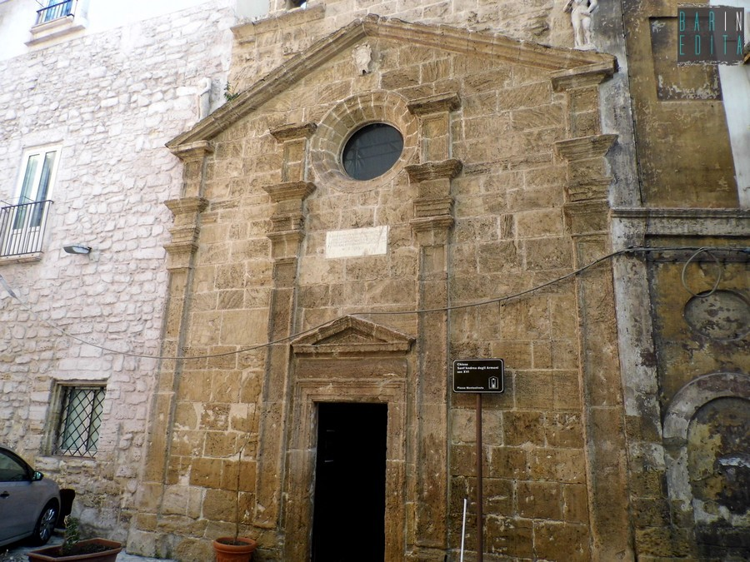
- The small Church of St. Andrew of the Armenians
The small church of St. Andrew of the Armenians is in the ancient village of Taranto in Monteoliveto square. The first nucleus of the church dates from the fourteenth century, as a reference point of the Armenian community stationed in the heart of the city of Taranto and probably arrived in the eleventh century after being recruited, which ranks, by the Byzantines.
The block had, in addition to the church, a place orchard behind the apse, a hospice (used as an inn) and a number of houses made up of a single plan.
At the end of the fourteenth century (1399) the original structure of the church was “bombarded” during the siege of the city controlled by Ladislaus of Durres.
In 1573 the abbot Scipione de Aricia decided to demolish the medieval structure of the church and reconstruct a new, along with the three places residential areas next to it.
Marble inscription, placed between the central rosette, triple splay and the front door, remember to fundamentis reconstruction of the church in the sixteenth century.
- The Cathedral of Saint Cataldo
Down the Via di Mezzo, stands in the heart of the old town there is the cathedral dedicated to Saint Cataldo. Patron of Taranto, with Irish descent, he seems to have been the performer of a series of miracles. He died in Taranto in the fifteenth century.
The Cathedral of San Cataldo is one of the oldest Romanesque churches in Apulia.
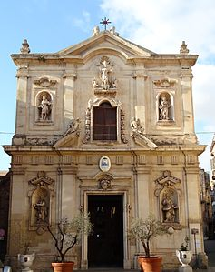
Restructured, modified and burnt down several times through the centuries, the cathedral has a baroque facade of the early XVIIIth century. This building was destroyed, in fact, during the siege of the Saracens in 927, and its reconstruction already began during the massive restoration project of the city started by emperor Nicephorus II Phocas. The body of the saint who gave the name to the Cathedral of Taranto was found there during the reconstruction work. The architect Mauro Mainer from Lecce was the creator of the Baroque facade, added in 1713.
The external facade
The external walls, of simple style, are decorated with a series of mirrored arches, inside which there were two-colored pieces that create geometric figures. Probably three Romanesque portals had to be opened here. Two other portals were opened along the side walls.
In the twelfth century the Norman bell tower was erected after the earthquake of 1456 and replaced during the restoration of Schettini in 1952 with the current, which takes the form of the oldest. The current eighteenth-century façade is cut horizontally by a broken baroque-style lintel. On the stumps are placed two angels that look at the rectangle of the central window on which stands the stone statue of San Cataldo.
At the bottom there is the large portal on whose trabeation is the emblem of the archbishop Gian Battista Stella. On the two lateral bands divided into rectangular fields there are four niches containing the statues of St. Peter the Apostle and St. Mark placed at the bottom of the portal, and of St. Rocco and St. Irena in the upper ones. The niches are surmounted by medallions culminating in a shell. The window is surrounded by floral ornamentation and flanked by two twisted columns. Two adoring little angels flank the statue of San Cataldo, which surmounts the large window. On the architrave of the great portal the coat of arms of the archbishop Stella is sculpted that promoted the realization of the work.
In the interior The Baptismal font is surmounted by a XVth century canopy. the impressive interior is characterized by a wide navy and two aisles supported by marble columns that are decorated by cared capitals (Romanesque, Arab, Bizantine, Longobard style).
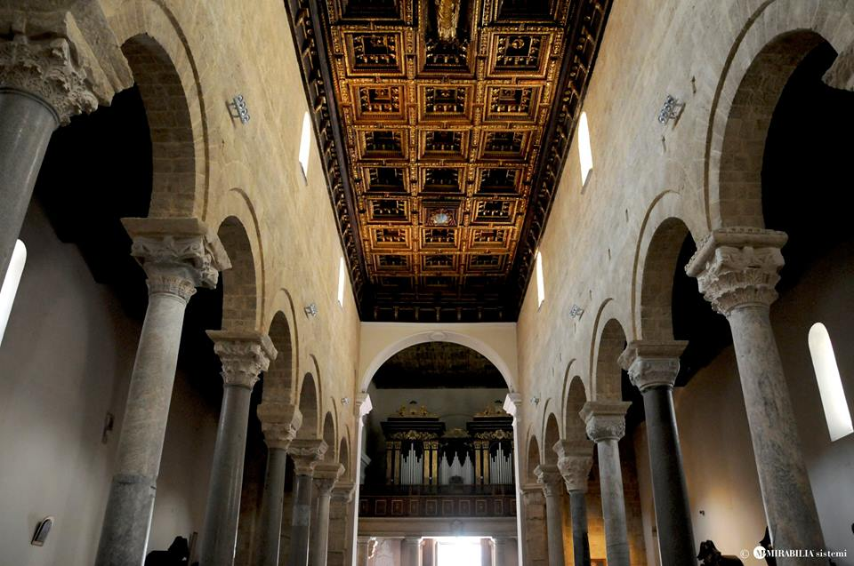
The beautiful wooden coffered ceiling of the seventeenth century, runs along the central nave and the floor still keeps some remains of its original mosaic paving. the central nave is covered by a beautiful wooden coffer ceiling from the XVIIth century

At the sides of the apse there are two baroque Chapels. Particularly valuable is the Chapel of Saint Cataldo, also called “Capellone”. It was rebuilt in 1657 and it is masterfully inlaid with marbles of great value and enriched with statues of saints produced by the most effective artists of the time.
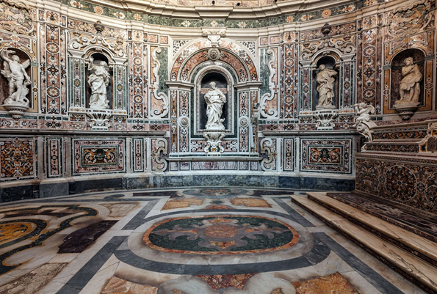

Elliptical in shape, the dome was frescoed by Paolo de Mattes with a scenic Glorification of Saint Catalo (1713). From the high altar of the church it’s possible to reach the Byzantine Crypt, whose vaults are supported by short columns dated back to the founding of the church. In the two aisles you can see some remnants of frescoes (XIII-XV century).
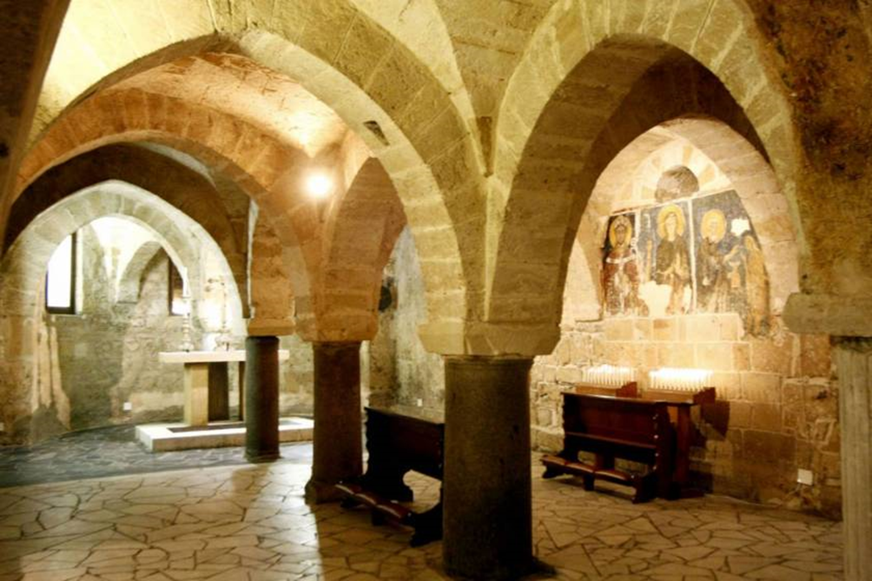

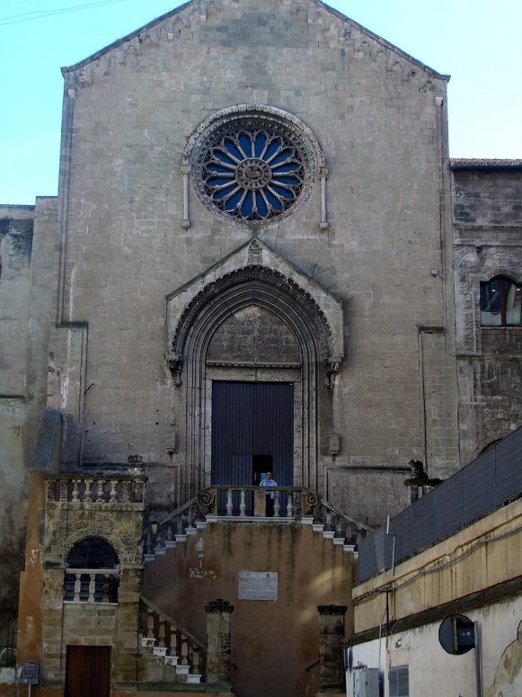
- San Domenico Church This church was built in the year 1302 by the feudatory Giovanni Taurisano. You can see the family Taurisano’s coat of arms and the construction date on the tympanum over the portal. The façade is prevalently Romanesque but has also Gothic elements.
The most striking part of the façade is the rose window. It is Romanesque but has some Gothic elements. In its middle there is the Easter Lamb in full relief. Sixteen little columns bear small ogive arches. The rose window is adorned with acanthus leaves and palmettes. On its left and right there are two little columns, on which two lions are sitting: the latter bear a half arch with leaves decoration.
The double stairs case is Baroque . The interior has the shape of a Latin cross. It keeps five Baroque altars and the statue of “Our Lady of Sorrows”. The believers carry her in a picturesque procession through the town on Holy Thursday.
- Pantaleo Palace
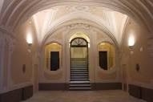The Pantaleo Palace is situated on the Western side of the island, near the little port overlooking the Mar Grande. The palace was built from scratch in the second half of the eighteenth century.
The building, with decorative elements in Baroque style, has a different architectural configuration compared with typical residential constructions of the period, by not having a central internal courtyard.
The entrance hall, decorated with beautiful stucco, is characterized by an elegant staircase with single and them double ramps, screened by three openings: a portal and two framed loggias.
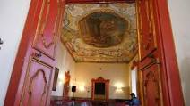
The ornamental decorations in stucco underline some important architectural elements such as doorways, windows and geometric shapes that give the structure a refined elegance. The shed, tack room, barn and finally the cellars are of particular interest. On the main floor, the central point of the house with its representative functions, an altar can be seen in a recess of the antechamber, hidden by two wooden doors; other rooms are characterized by beautiful paintings or finely decorated ceilings.
The second floor has a regular development with the various rooms arranged around a stairway lit by a skylight.
The building configured in this way, was conceived and built as a whole in order to fulfill the needs of everyday life and those of most demanding representation.
The Ethnographic Museum "Alfredo Majorano" is located on the third floor of the Palace
In the museum there are several testimonies of the popular traditions of the city of Taranto and its province collected by the scholar Alfredo Majorano (1902-1984) and his wife Elena Spinelli.
Much of the material was donated by the scholar to the Commune of Taranto from 1978 and then by the widow in recent years. The rich collection focuses on the magical-religious ritual in the tarantino
The museum collects important documentation of intangible cultural heritage, such as the recordings made by Majorano in the 50 years and other testimonies on the phenomenon of tarantism, studied by Ernesto De Martino
TARANTO UNDERGROUND
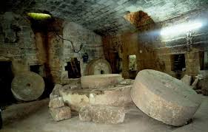
The Taranto Undergrounds are hypogeal environments that are the result of the ancient tendency to obtain homes, places of worship and productive environments by digging the calcarenic bench. Many of the palaces that we can admire today in the ancient village of Taranto have been made thanks to the materials excavated in the rock just below them. Those excavations became cellars, crushers, shelter environments and grain, coal deposits and much more.
Promotion, development, knowledge and constant public enjoyment of the complex hypogeal reality would certainly have a significant impact on the tourist-cultural offer. Hypogeal environments tell us of revisions, transformations, but also of their continuity of use and of "urban planning" that have been lost.
The hypogeal environment are so numerous that they form a vast underground network a complex system underground culverts which link them to the sea. The Old Town is crossed by a lot of holes spreaded under many noble palaces, convents and churches. Most of them came back to the Greek period often quarry areas dating back to this historic period that might be interesting to locate wall sections, foundations of buildings or public areas, temple areas and ancient road axes and historical periods, specific primary and current features. There are many but some of them are surrounded by mystery.
The Hypogea form a vast network of underground environments and a complex system of walkways interconnected in a network of narrow paths with access to the sea.
Via Cava, in the heart of the ancient town, is very interesting from the point of view of the history of the settlement in the old city between the Byzantine age and the Middle Ages.
As its name suggests, "La Cava" ( stone querry) indicates the former exploitation of the place for”Carparo Stone “mining activities . Originally, therefore, via Cava was a depression whose morphology was further determined by the action of meteoric waters.
A series of documents indicate its ascent in the centuries to a road path of great importance.
At the end of the fourteenth century the site became an area of strong urban development and was defined as “Via Publicam” on which the Hypogea hosted Furnaces, Cellars, Crushers and other services, facing.the street.In the following centuries it was used for several functions ( residential, commercial, handcraft ) and the aces of a bakery plant are still residual
Thus the street was characterized by a complex productive environment, mainly for craftmen’s activities which flourished in the medieval Taranto.
Later these Hypogeums were incorporated in the nobles Palaces which were built in the area
2. The Hypogeum of Via Cava 99
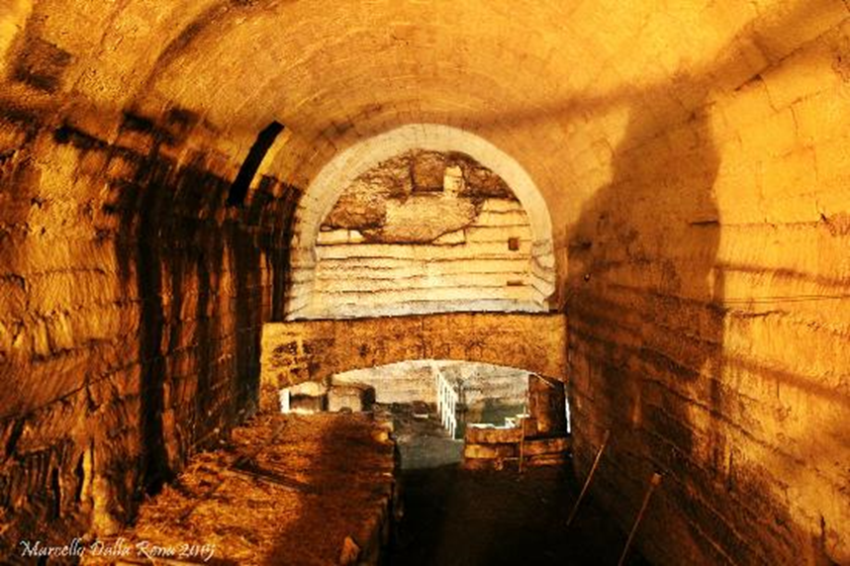
One of the most interesting Hypogea is certainly the site at number 99.
It consists of two large rooms. The first one, completely carved in the rock, is about two meters below the street level / the ground. Imposing quarry cuts dating back to the Greek period are still visible
A series of arches lead to the slightly smaller second room which was probably used as a shelter for animals as deducted from the bays along the rocky wall. The two openings on the walls gave access to pathways which linked it to the other several Hypogea areas scattered around the Old Town.
In the rear of the Via Cava 99 Hypogeum the stratification of different structures allows to reconstruct at least three historical periods between the Middle Age and the Eighteenth century when the walls were made of tuff and barrel vaults.
On the side fronts two lowered openings constitute cumulative graves probably dating back to the Paleochristian period ( IV-VI century after Christ).
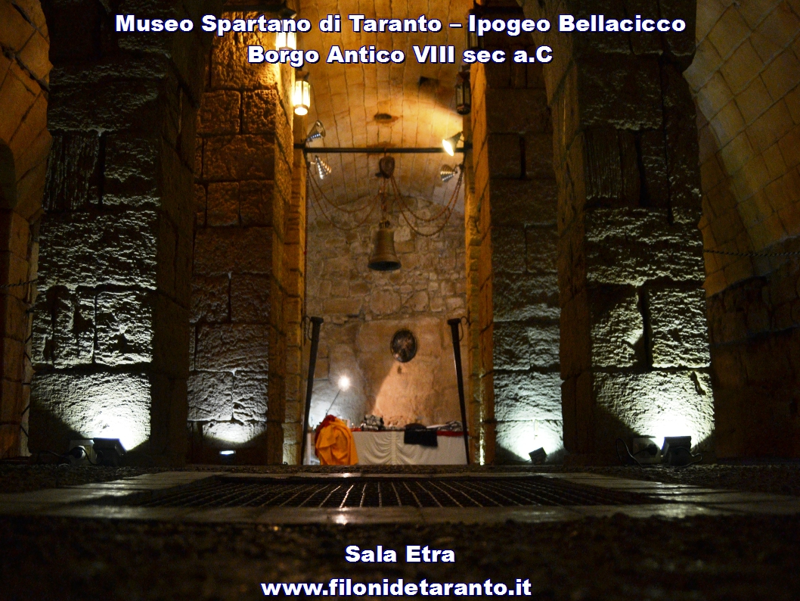
3. Hypogeum de Beaumont Bellacicco
The Hypogeum , consisting of a series of enclosed spaces which originated from the work of the extraction of the Carparo stone used by the Spartans settlers during the building of the Greek City , is one of the largest ones in old Taranto.
These huge underground settings served different functions in the following centuries but after the 1600 they were left empty and neglected for a long time after the de Beaumont Bonelli noble family had moved to another premise.
The Hypogeum hosts the Spartan Museum, dedicated to the Greek Deities Etra,,Falanto’s wife Taranto Philonide and Persephone.
The archeological finds are displayed in four halls, each on a ground level with an extension of about 800square meters and a depth of 16 meters under the street level and four meters below the sea.
SPARTAN MUSEUM: Etra's room
The room is dedicated to Etra that was the wife of Falanto, Taranto's founder. In “Etra room”the walls still keep the signs of the different ages and different styles.
On the south side of the room you can admire the rests of the former City walls that enclosed the Greek town. In the limestone blocks that make up the northern wall there are some fossils that give evidence that in the Greek period the environment was under the sea level

THE NATIONAL ARCHEOLOGICAL MUSEUM MarTA
http://www.museotaranto.beniculturali.it/web/index.php?area=1&page=home&id=0&lng=it
Proceeding from the Swing Bridge back to the New Town and keeping the Big Sea on your right, you can admire the Promenade Victor Emmanuel III (Lungomare Vittorio Emanuele III), an ideal panoramic view of the gulf; then walk towards Piazza Ebalia, with its monumental Wind rose fountain.

To complete the exploration of the area, have a walk in the airy Maria Immacolata Square, until you reach the other side facing the Small Sea, where there is the green lung of the Village, Villa Peripato; it offers a pleasant and well-deserved rest and also a picturesque view of the sea.
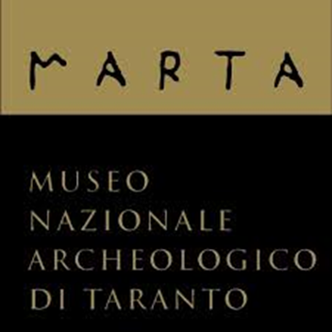
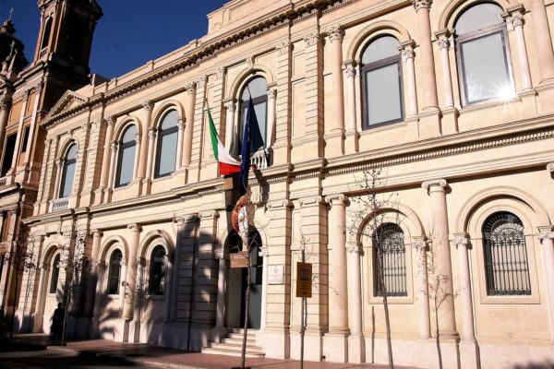
A little farther from the Villa, you have an incredible opportunity to make a memorable blast from the past, visiting the MARTA Museum (The National Archaeological Museum of Taranto). It includes unique archaeological finds attesting the glory of ancient Greece

it was founded in 1887, and during the summer of 2016 its restoration ended, offering the city a museum with a modern interactive structure and enriched with all kinds of evidence of the wonderful history of this ancient land. In the entrance hall of the museum there is a copy of the head of Heracles , a bronze colossus for Lisippo at the end of sixth century.
Following the new exhibition, you will learn the history of the Ionic capital and its territory in a chronological sequence (Prehistory and Proto-history, Greek Period and Roman Age, Late Antiquity and Middle Age).In the museum there are three floors, each dedicated to different themes : the ground floor is used for temporary conferences and exhibitions. The first floor exhibits the finds of ancient Greece and of the Roman age relative to the city of Taranto, while in the second one can see the remains of the era of the Paleolithic and the Bronze Age.
All exhibits have captions and all rooms are equipped with touch-screen monitors interfaced with the exhibits. MarTA is one of the richest museum in the south of Italy with a large collection of mosaics, monumental tombs, ceramics, everyday objects, jeweler and sculptures, friezes, pediments and metaphones made of carparo. Our Museum has become very famous for the exibition of its jewellery in Paris, Milan and Tokyo.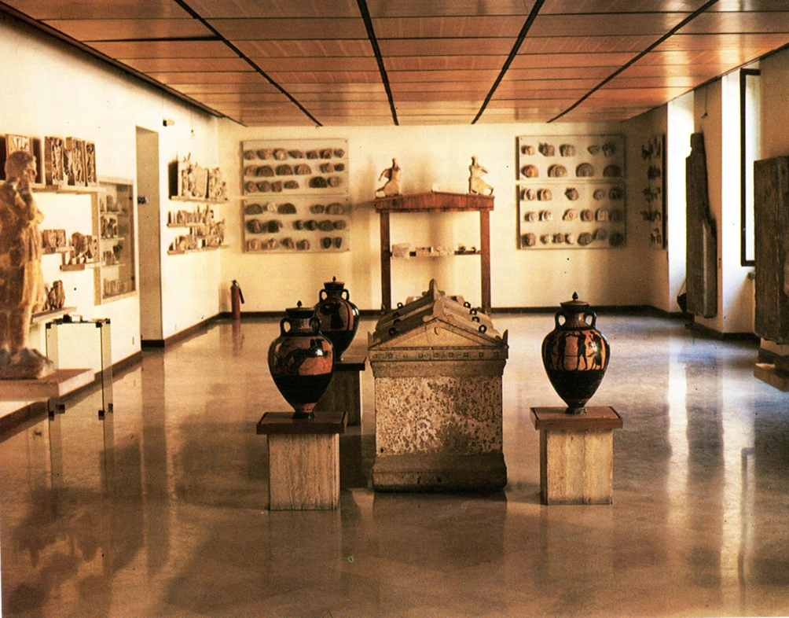

By Antonio Quaranta , Antonio Cusano , Cosimo Donadei, Marco Stasi, Nicolò Limone
IISS AUGUSTO RIGHI TARANTO

