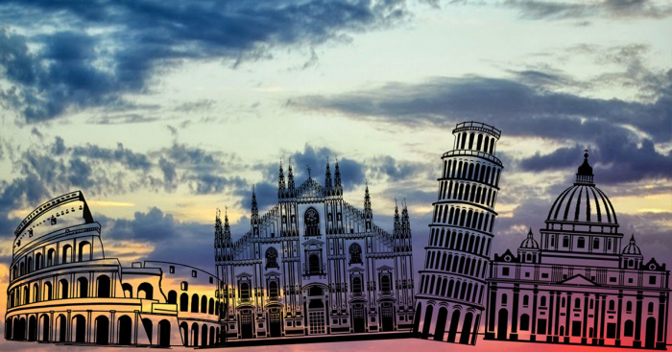
ITALY- MONUMENTS

The top 5 monuments you should visit in ITALY.

The Colesium

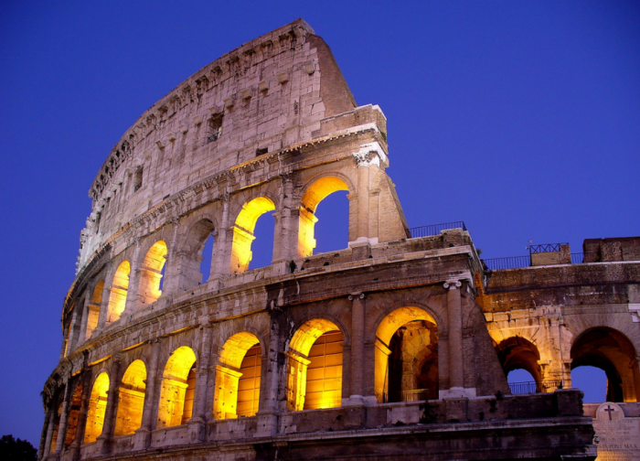
The Coliseum has a prominent place among these famous landmarks and is the most visited of Italy. Built in the 1st century Bc, remains one of the great symbols of the Roman Empire. The interior is your huge and imposing, that lets visitors relive part of the glory of the largest empire in history.

La Fontana di Trevi 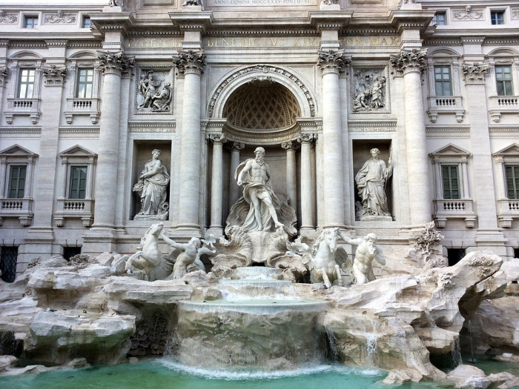The Trevi Fountain was designed in 1732 by Nicola Savi, is one of the most beautiful fountains of the world. This spectacular and surprising work of Salvi keeps your original charm and was the scene of several films, such as "La Dolce Vita" by Fellini, "Roman Holiday" with Audrey Hepburn and Gregory Peck or the classic Italian "62 Totòtruffa", in which a Neapolitan comedian sells the font to a Rico and naive American tourist.

A Ponte Vecchio – Florença
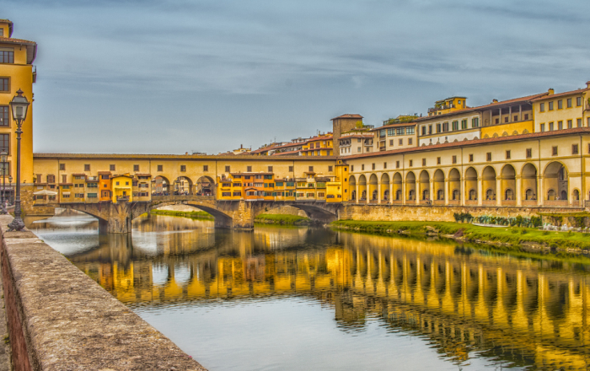
The Ponte Vecchio is one of the symbols of Florence/FlickPonte Vecchio ("old bridge" in Italian) is the oldest bridge in Florence and the only one to cross the River Arno until 1218. Among its most important features we highlight the fact that I look like a convencial bridge, the craft shops that are found along the bridge and the secret entrance, used in the 16th century by the Medici. The shops of Ponte Vecchio have a single window and thick wooden doors, that open to your central entry

The tower of Pisa
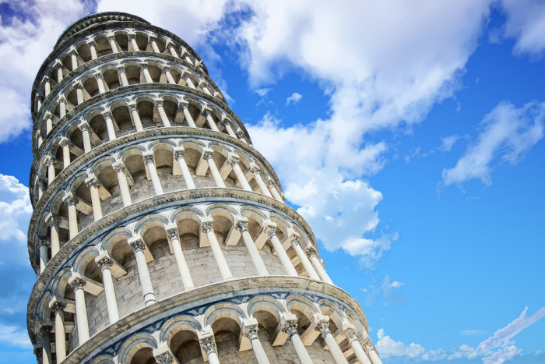

The Torre di Pisa Italy, the Belpaese or "beautiful country", is an authentic open-air museum and represents a substantial part of world art. For this reason, we present you the top 5 of the works you should visit at least once in your life. Comparison between historical monuments, which are present in the lists of "must-see" to tourists from all over the world.

O Duomo - Milan
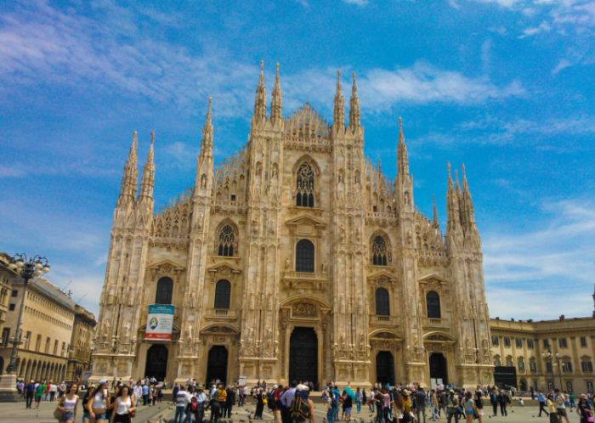
The Duomo di Milano, the imposing Gothic Cathedral of Milan, was built with white-pink marble of Candoglia mines and has a capacity of 40,000 people. In this impressive scenery, in the square with the same name, you can admire the statue of the Madonnina, situated on higher.

