Education in Italy

Education in Italy is compulsory from 6 to 16 years of age. All children go through kindergarten, primary school, lower secondary school and upper secondary school. Education is free for all the inhabitants of Italy, even those of other nationalities can attend these schools. In this country there are also public and private schools.

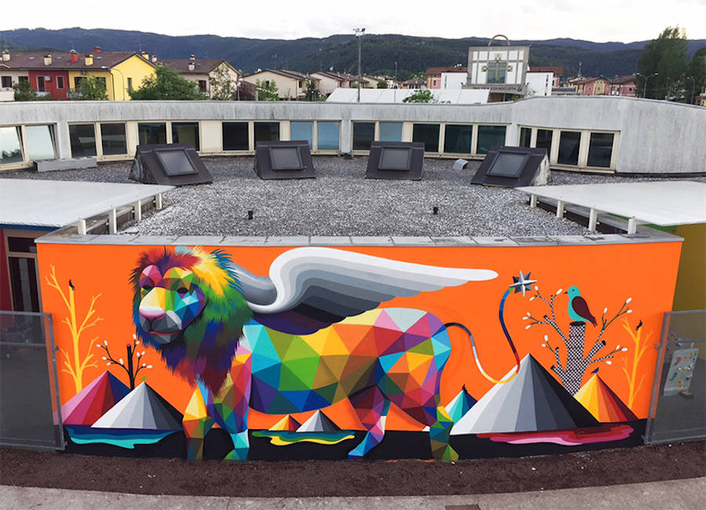
Kindergarten Primary school
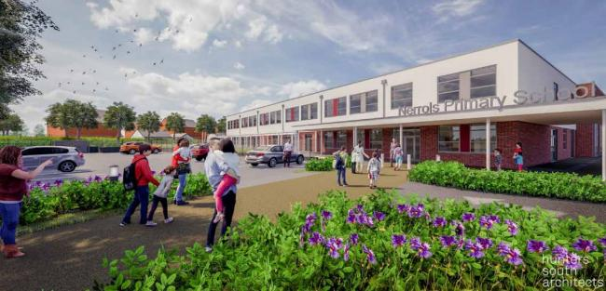
3 to 5 years of age 5 to 11 years of age

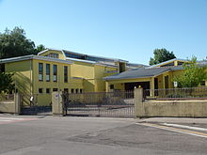
Lower secondary school Upper secondary school
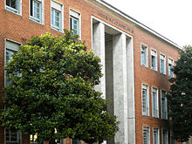
11 to 14 years of age 14 to 16 years of age

Ana Alves Nº1 7ºD

