Italian musicians
Italy is a country with a lot of musical history and many artists that I will present.
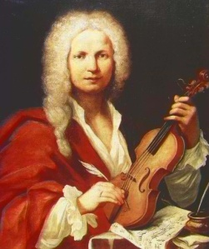 | Antonio Vivaldi was a great late Baroque composer and musician from the Republic of Venice, Italy. He had composed 770 works, among which 477 concerts and 46 operas. He was born on the 4th of March, 1678 in Venice and died on the 28th of June, 1741 in Viena. Source: Wikipédia  Watch a video
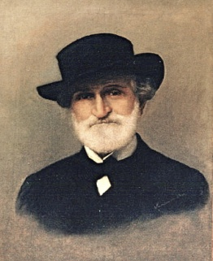 | Giuseppe Verdi was an Italian opera composer of the Italian romantic period, at the time he was considered the greatest nationalist composer of Italy. He was born on the 10th of October, 1813 in Roncole. Verdi died on the 27th of January, 1901 in Milan. Source: Wikipédia  Watch a video

Italian contemporary musicians
Laura Pausini is an Italian singer and composer. She began her professional career in 1983, after she won the Sanremo Festival in “New Talents” category, with the song "La Solitudine". She was born on the 16th of May, 1974 in Faença, Italy. Source: Wikipédia
Watch a video
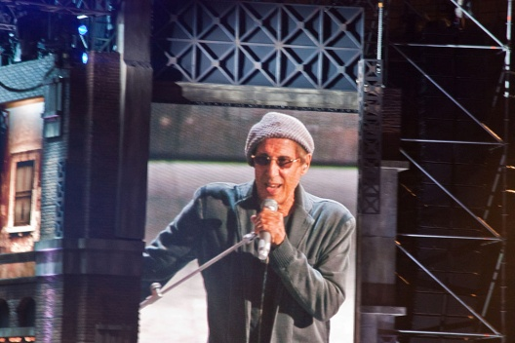 | Adriano Celentano is an Italian singer, composer, comedian, actor and film-director. He was born on the 6th of January 1938 in Greco. Source: Wikipédia  Watch a video
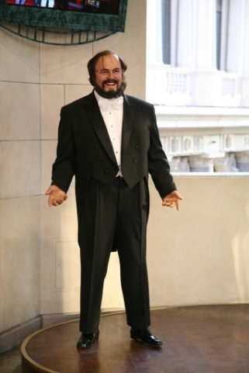 | Luciano Pavarotti was an Italian singer, great interpreter of Donizetti, Puccini and Verdi, among others in his great repertoire. It is recognized like the tenor that popularized opera world-wide. Pavarotti began his professional career as lyrical tenor in 1961 in Italy. He was born on the12th of October, 1935 and dies on the 6 th of September, 2007 in Modena. Source: Wikipédia  Watch a video
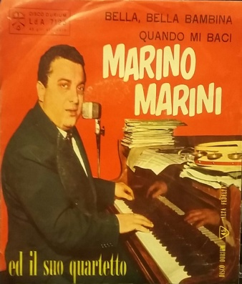 | Marino Marini was an Italian musician who achieved international success in the 1950s and 1960s. He was born on the11th of May, 1924 in Seggiano and dies on the 20th of May, 1997 in Milan. Source: Wikipedia  Watch a video
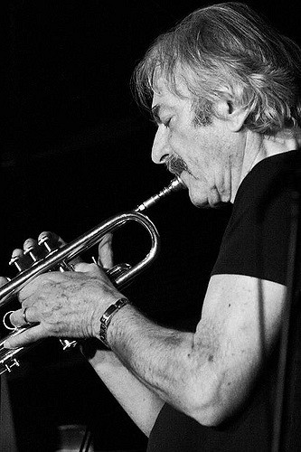 | Enrico Rava is an Italian jazz trumpeter. He started playing the trombone, then switched to the trumpet after listening to Miles Davis. His first commercial work was as a member of the Italian quintet of Gato Barbieri in the mid-1960s; in the late 1960s, he was a member of the Steve Lacy’s group. He was born at on the 20th of August, 1939 in Trieste. Source: Wikipedia  Watch a video
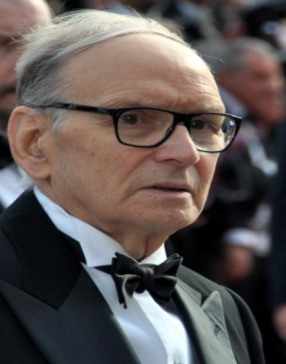 | Ennio Morricone is an Italian composer, arranger and conductor. Throughout his career he is responsible for the composition and arrangement of more than 500 films and television programs. He was born at on the 10th of November, 1928. Source: Wikipédia  Watch a video
This work was carried out by Simão Gonçalves nº26 of 7ºD

