Who we are
We are a confectionery company called SWEET CUPCAKE which will offer a variety of pastries but not only that…

What makes us different that a typical cafe

- Fresh Products
- Live Music
- Hand-decorated pastries
- Home-made cakes
- Home Delivery
- Childrens
- Qualified Service
- Home Atmosphere
- Low Prices

Financial analysis

The costs of building or renting premises will definitely be high.
The risk of lack of interest because of quite big competition is also
a danger for us. We plan to start our business with the help of our families, who will work with us to create a well-known and reliable trade. We are also considering a bank loan.

Market analysis
There is a lot of companies like ours, but only at first glance. Our confectionery is innovative and this will be its strength. We will be different than other companies because we will use only fresh and good quality products, home recipies, traditional recipies and modern ones too. According to our analysis and observation, most companies offer the same pattern, mass products, often their cakes and pastries are not free from additives. We will focus on natural and ecological products. We will cater for all needs, individual orders available. We will cooperate with experienced confectionery and catering companies. Lots of competition in the neighborhood and lack of experience will motivate us to make us create individual and original offer, which will be outstanding and successful.

Advertising strategy

Menu

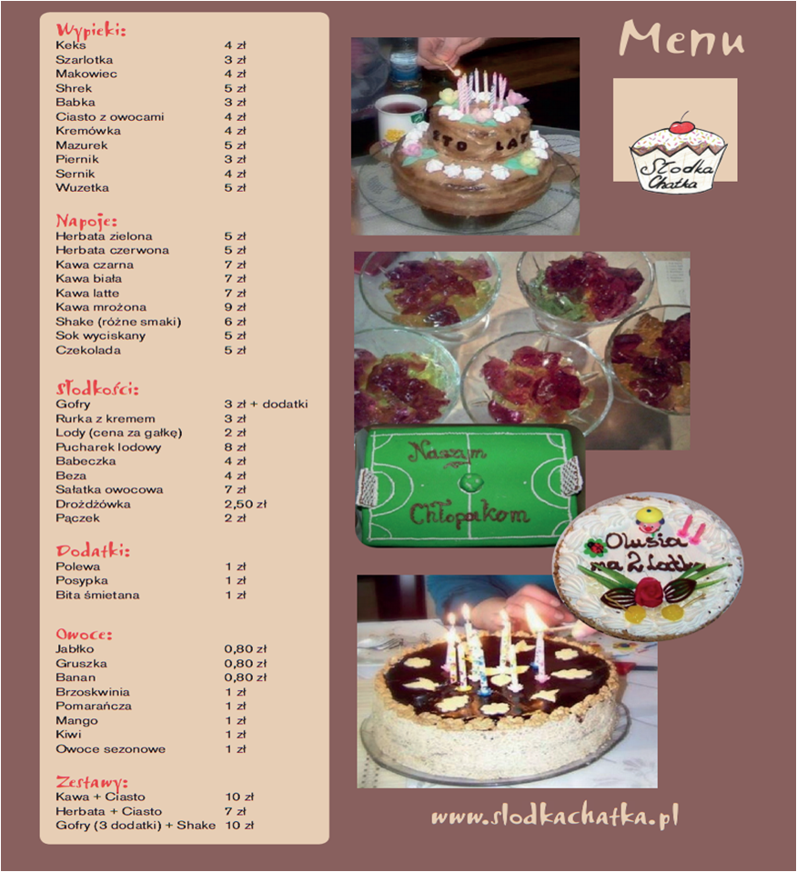

We will advertise in various ways
Facebook, Instagram, leaflets, advert in papers, free degustation on local festivals.

Costs and financial input
COMERCIAL | 7000zł
COSTS OF PRODUCTS | 5000zł/month
Rent | 5000zł/month
Personal costs | 4000zł/month
Equipment | 20000-30000zł /once
Maintenance | 5000zł/month

What is our offer
We’re baking pies, cookies, cakes and many other sweets. In our place it is also possible to eat waffles and drink hot chocolate.
When the weather’s hot customers can find in our bakery some sweet cold stuff.

Whom is our offer to
Everybody, no age limit, young people who like to listen to live music while having coffee, families with kids welcome.
We are great for meetings, parties, celebrations.

Recruitment
Our staff is going to be well qualified also we will employ bartenders, waitresses and waiters. Experience welcome. We will check references and pay attention to competences like ability to work in a team, dealing with customers, communication. English language skills and other languages preferable.

Why we are expecting success
We are really good at what we do.
We can work together.
We expect to make a well-known and reliable company
within a few years.
Open new places in other towns.

Julia Bakalarz
Natalia Mietla
Dominika Nawrot
Dominika Ramza
Kamila Adamiec

