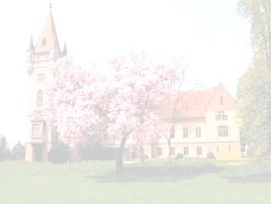

**School:**

OŠ Vožd Karađorđe Aleksinac Serbia

**Teacher:**

Snežana Bogavac Mihajlović

**eTwinning project Explore Scratch**

2017/2018

SCRATCH STUDIOS (11):

EU Code Week

2017

:

<https://scratch.mit.edu/projects/178637399/>

[/](https://scratch.mit.edu/studios/4341676/)

[/](https://scratch.mit.edu/studios/4341677/)

https://scratch.mit.edu/studios/4542016

[/](https://scratch.mit.edu/studios/4341680/projects/)

https://scratch.mit.edu/studios/4368725

[/](https://scratch.mit.edu/studios/4341681/)

https://scratch.mit.edu/studios/4349230

Scratch studio “Digital Learning Day”:

[/](https://scratch.mit.edu/studios/4377390/)

https://scratch.mit.edu/studios/4828182

Hour of Code

2017

:

https://scratch.mit.edu/studios/4532894

[/](https://scratch.mit.edu/studios/4528881/)

[/](https://scratch.mit.edu/studios/4528886/)

https://scratch.mit.edu/studios/4349230

Animated stories

about our school and village

:

[/](https://scratch.mit.edu/studios/4541356/)

https://scratch.mit.edu/studios/4570678

Happy New Year:

https://scratch.mit.edu/studios/4591918

[/](https://scratch.mit.edu/studios/4554811/)

[/](https://scratch.mit.edu/studios/4584833/)

https://scratch.mit.edu/studios/4565453

Rosadigitale Week 2018

–

Serbia:

https://scratch.mit.edu/studios/4880774/projects/

/

Scratch games:

<https://scratch.mit.edu/studios/5058247/projects>

[/](https://scratch.mit.edu/studios/5055169/projects/)

