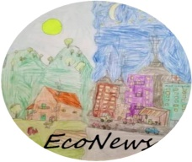
Go to the TwinSpae of the Project https://twinspace.etwinning.net/94326/pages/page/720855 and write the materials used to create the following terrific Eco-witch and wizards:

ECO-WEEN | MATERIAL
