$$f\left(x\right)A=πr^{2}x=\frac{-b±\sqrt{b^{2}-4ac}}{2a}=a_{0}+\sum_{n=1}^{∞}{\left(a_{n}\cos{\frac{nπx}{L}}+b_{n}\sin{\frac{nπx}{L}}\right)}e^{x}=1+\frac{x}{1!}+\frac{x^{2}}{2!}+\frac{x^{3}}{3!}+…, -∞<x<∞\sin{α}±\sin{β}=2\sin{\frac{1}{2}\left(α{\left(1+x\right)}^{n}=1+\frac{nx}{1!}+\frac{n\left(n-1\right)x^{2}}{2!}+…±β\right)}\cos{\frac{1}{2}\left(α∓β\right)}$$

2nd JUNIOR HIGH SCHOOL OF RETHYMNO

Made by Mylonas Kyriakos

12/5/2021

THIS IS THE MAIN ENTRANCE AND BASICALLY THE FIRST THING YOU FACE WHILE ENTERING THE SCHOOL
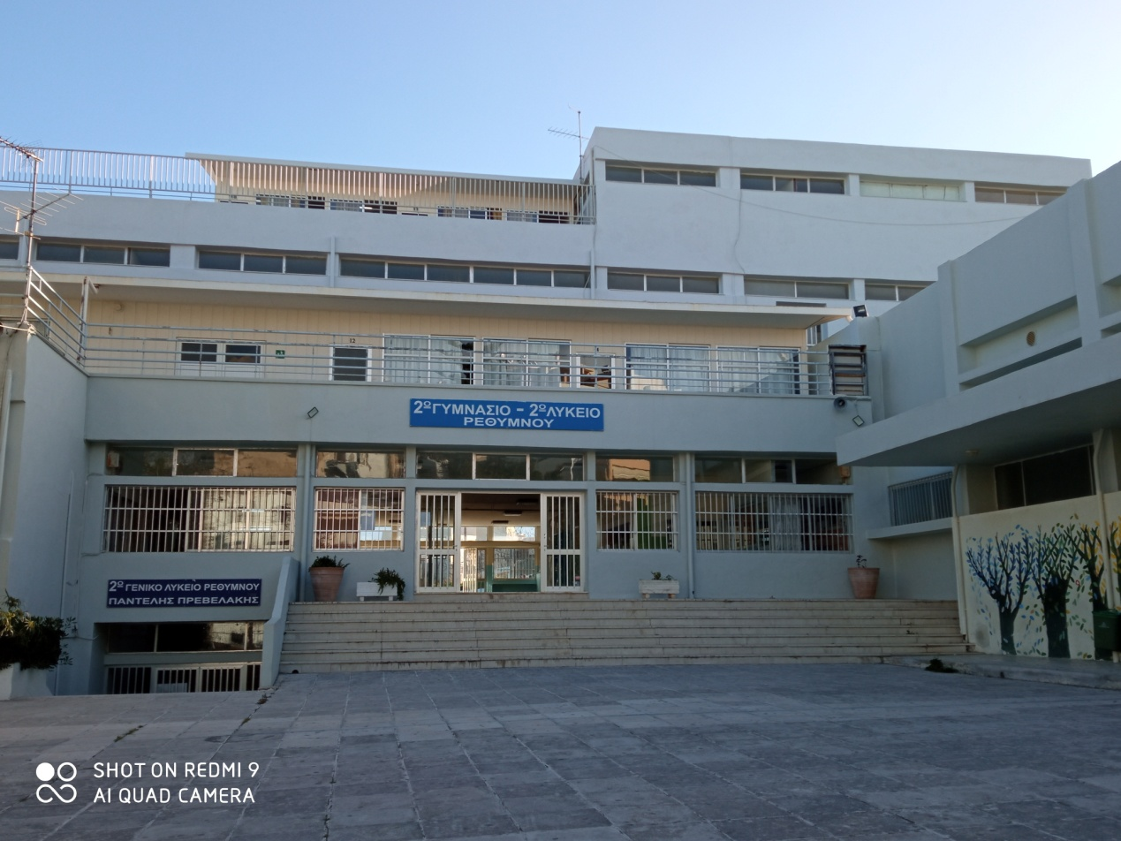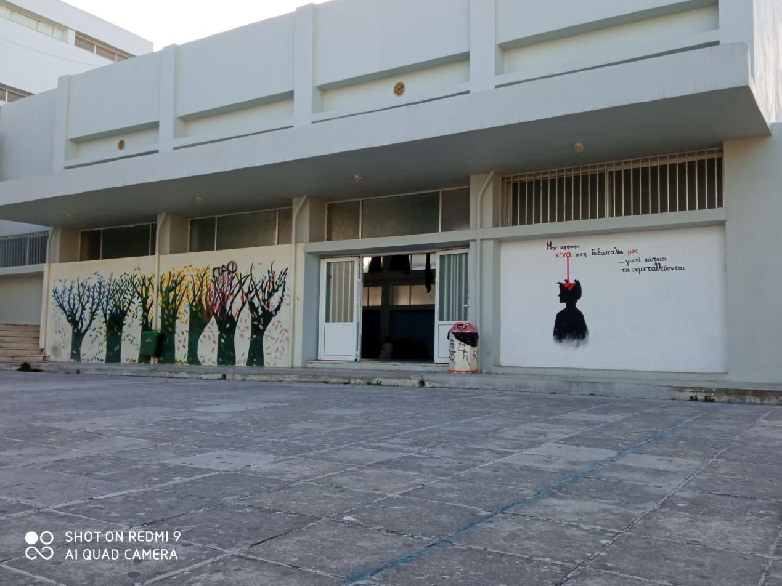

THE SCHOOL HAS 21 CLASSROOMS WHILE IT HAS AROUND 400-450 STUDENTS
- WE HAVE A MUSIC CLASSROOM
- A TECHNOLOGY CLASSROOM
- 2 COMPUTER CLASSROOMS
- 5 SPECIAL EDUCATION CLASSROOMS
- A LABORATORY
- A CANTINE
- A GYM
OUR SCHOOL IS DEVIDED. WE SHARE THE SCHOOL WITH THE 2nd HIGH SCHOOL. WE GET ALONG VERY WELL ACTUALLY.
THE SCHOOL IS KNOWN FOR SEVERAL THINGS.
FOR INSTANCE:
- OUR TEACHERS
- OUR BIG SCHOOL YARDS. (we have 2)
- OUR COMPETITIONS SUCCESIONS
- OUR STUDENTS
- etc.
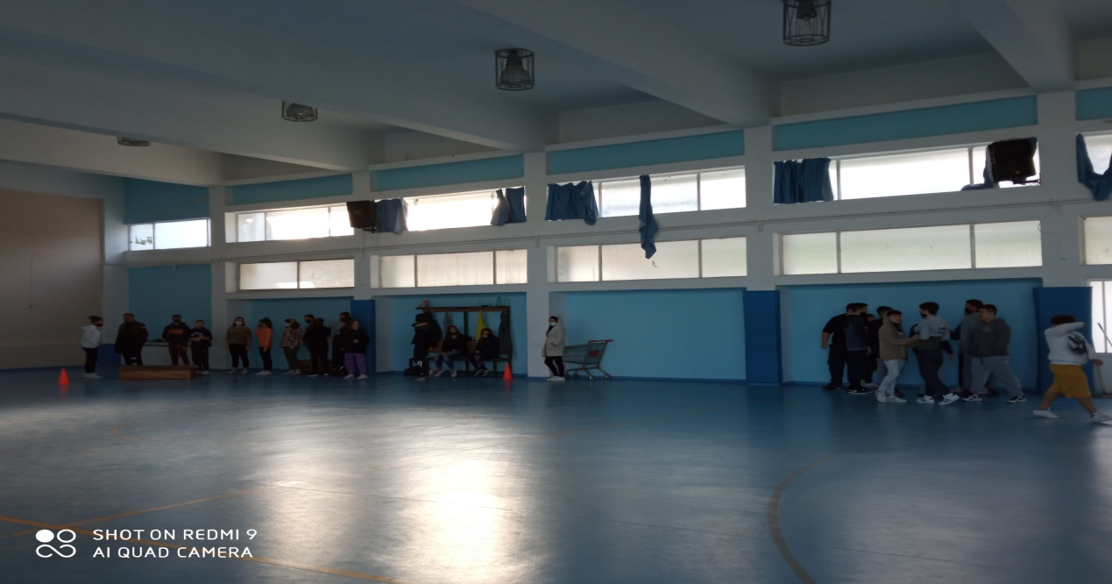

OUR GYM

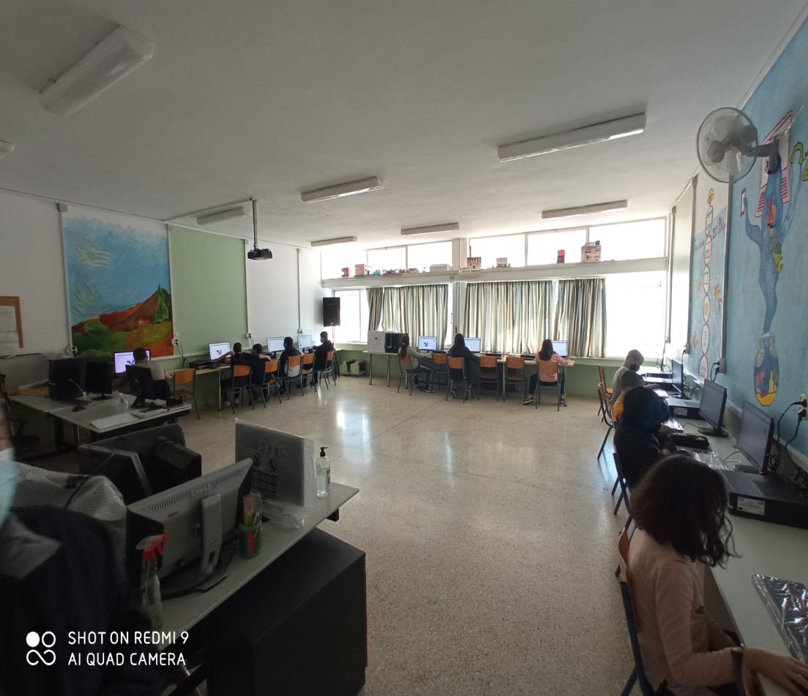

ONE OF OUR COMPUTER CLASSROOMS

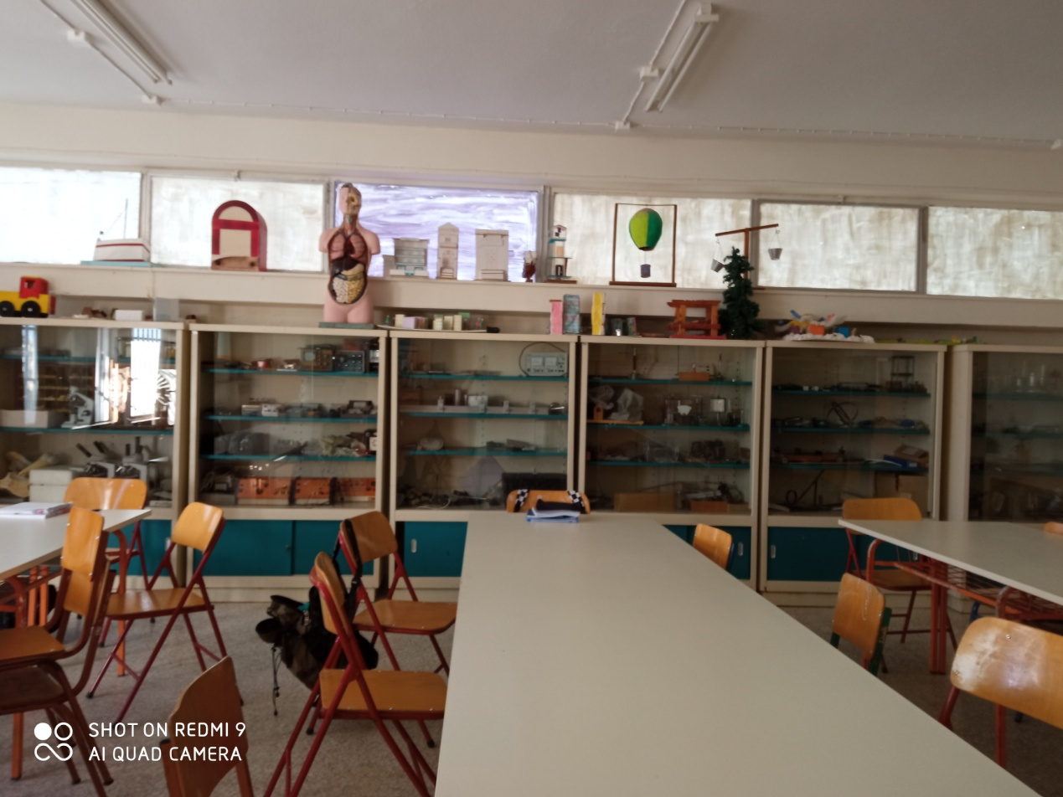

OUR LABORATORY

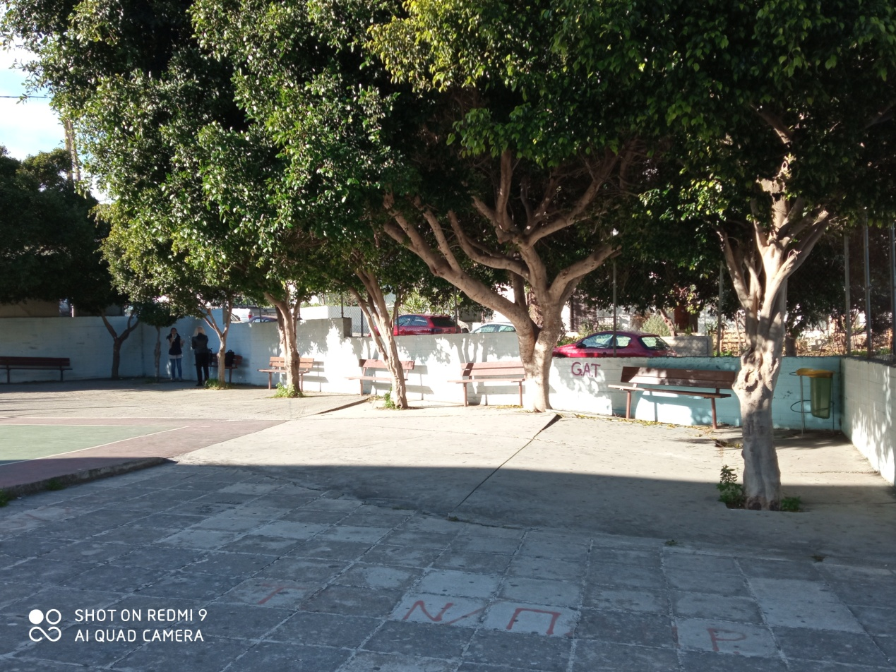

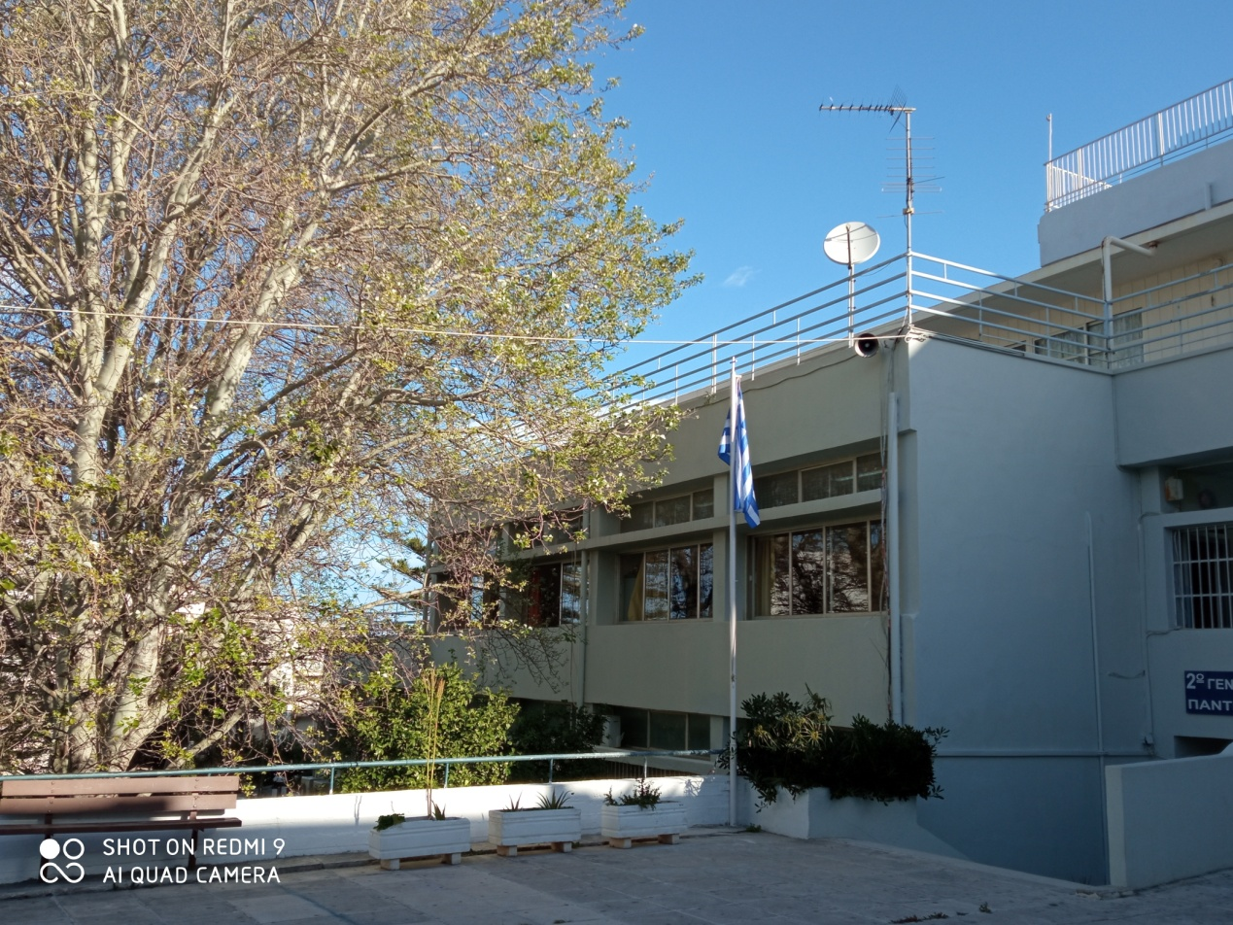

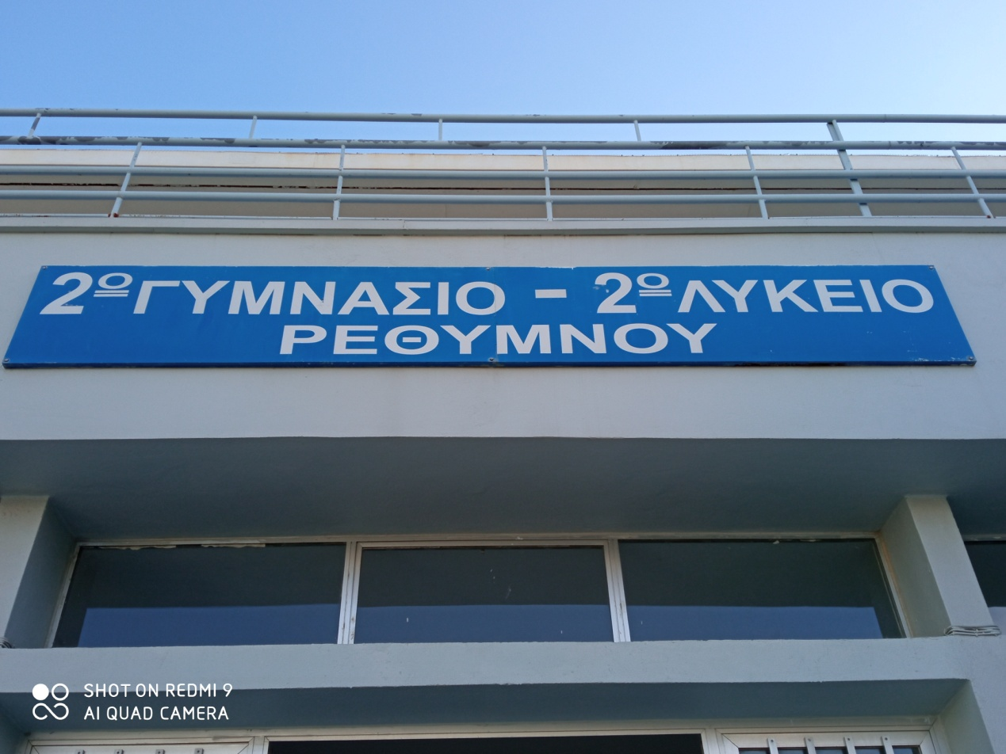

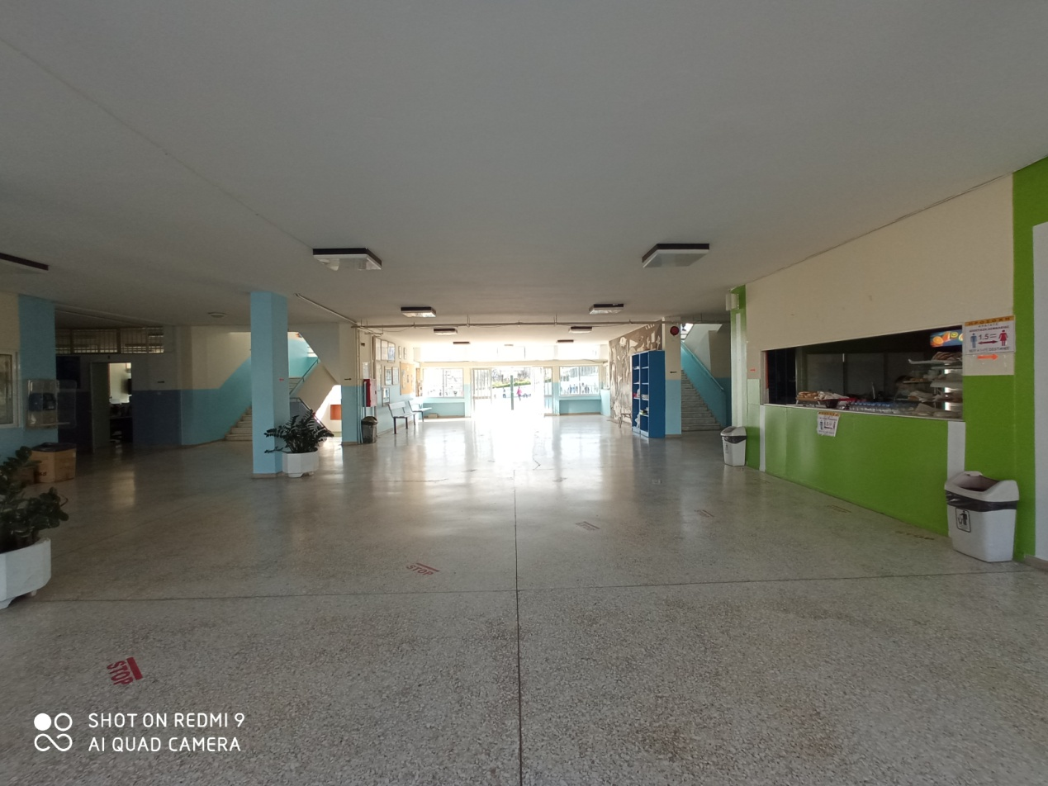

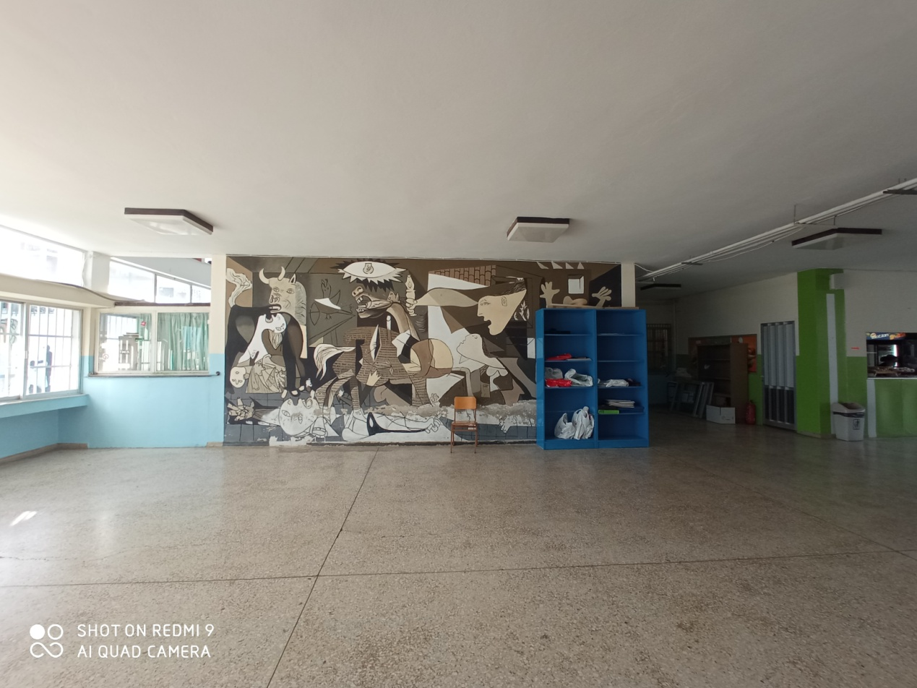

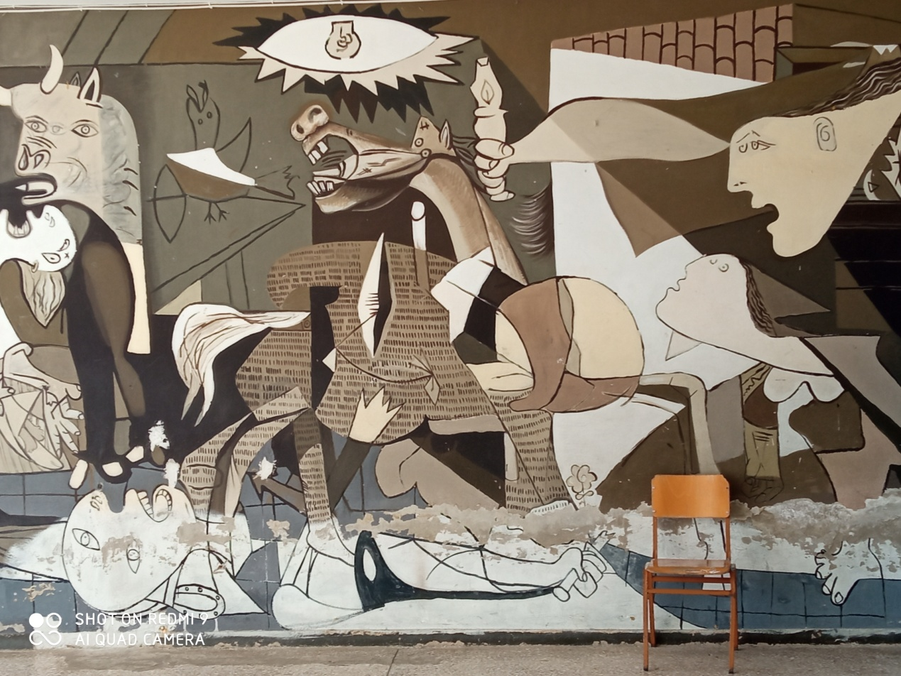

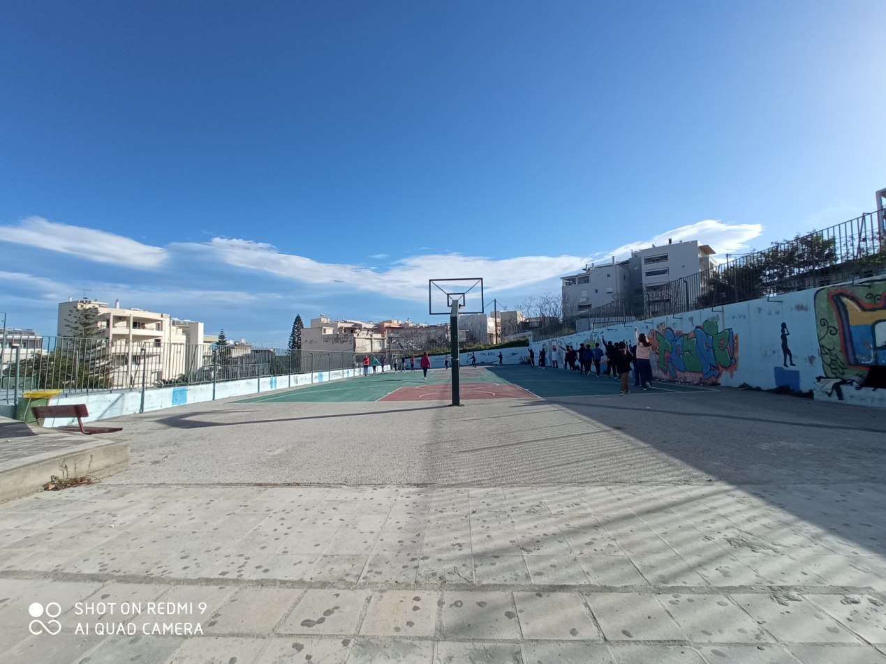

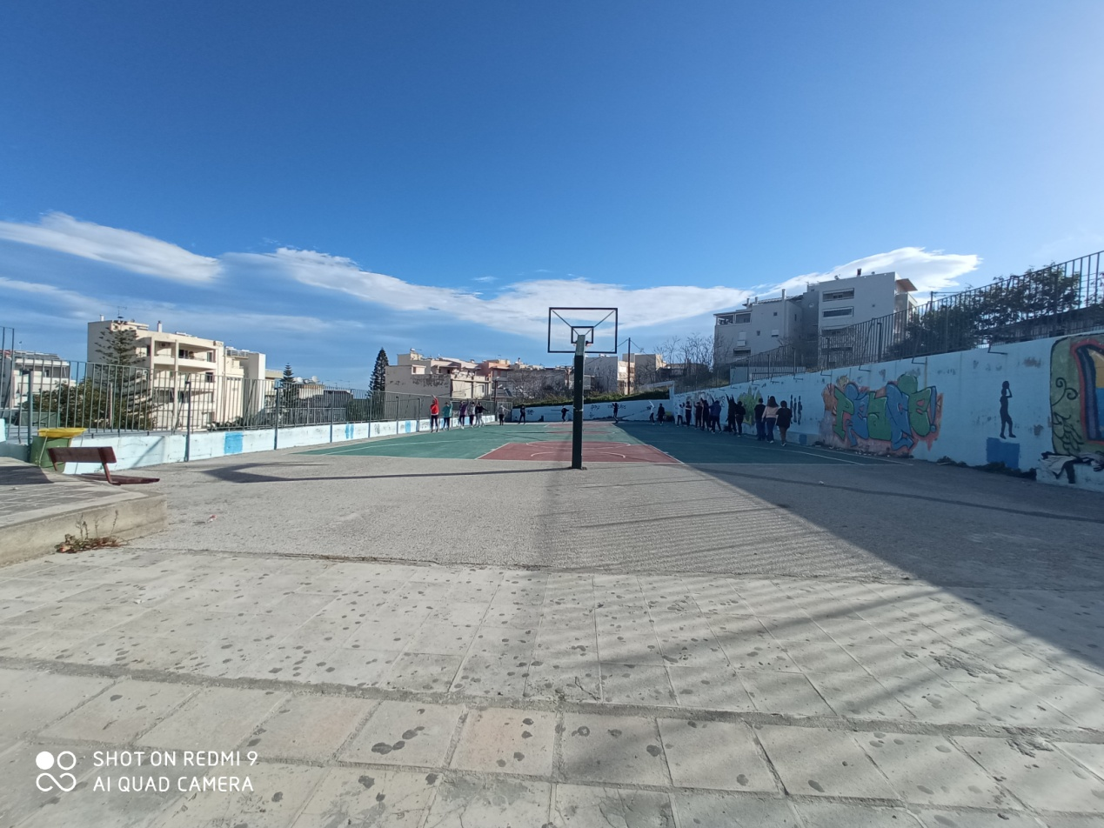

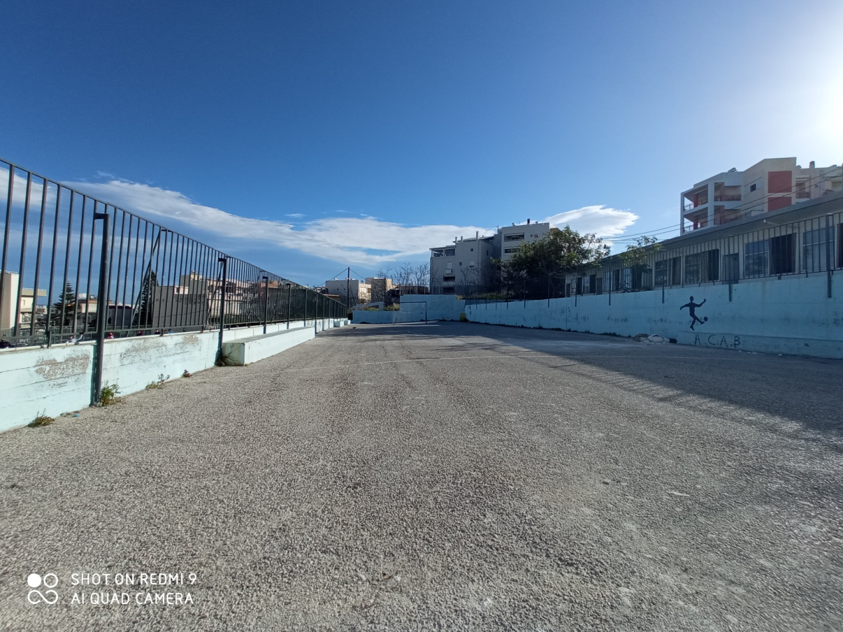

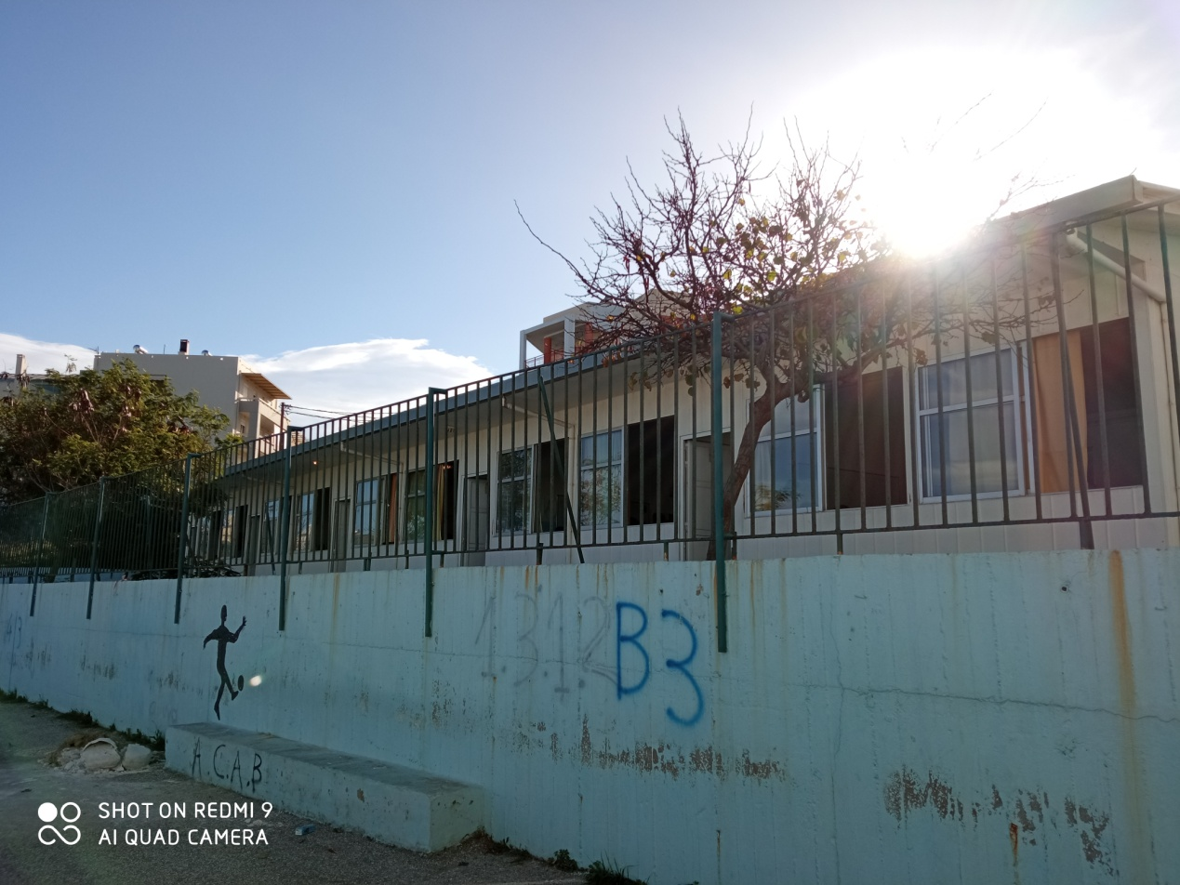

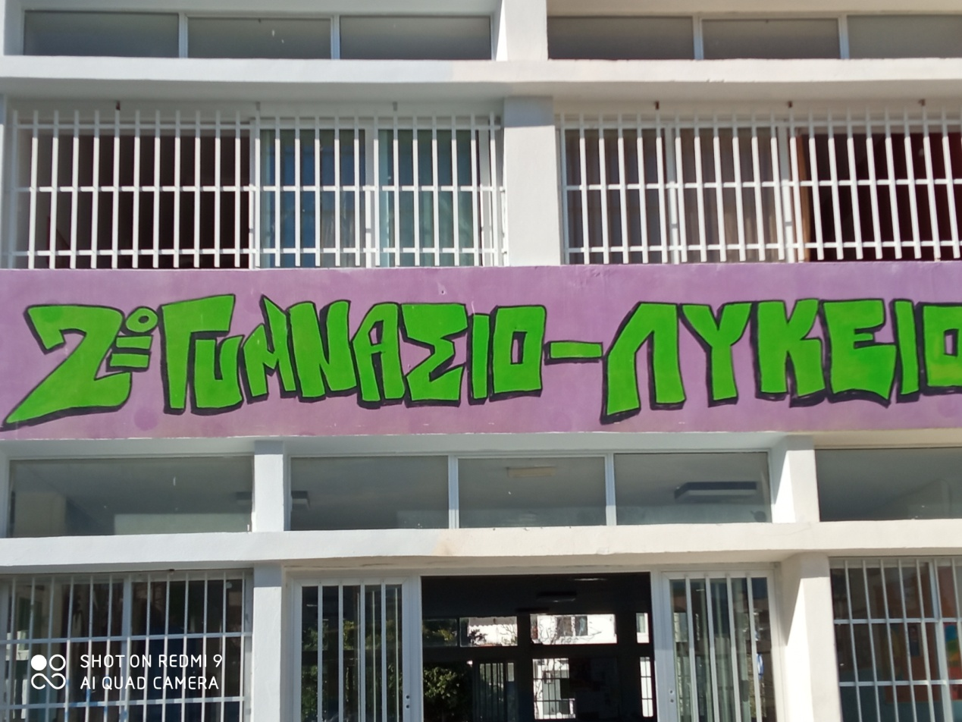

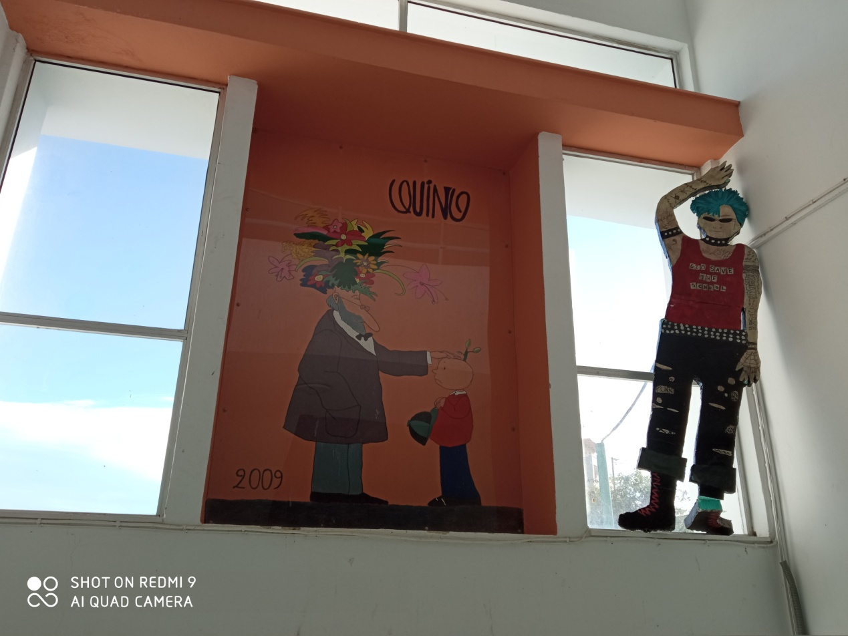

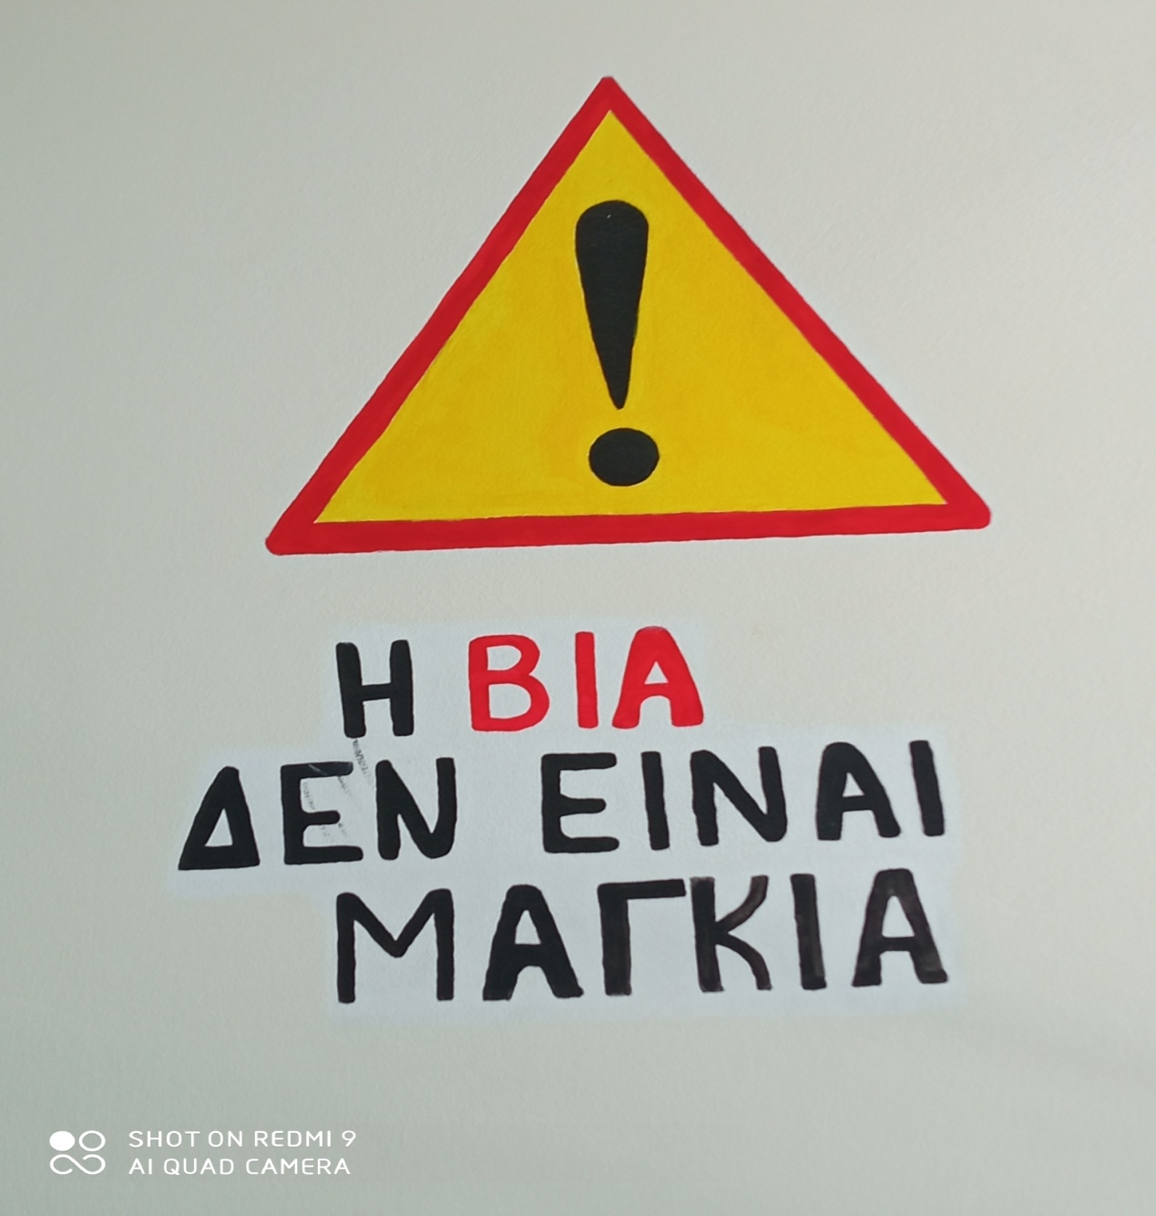

VIOLENCE IS NOT A YEAST
