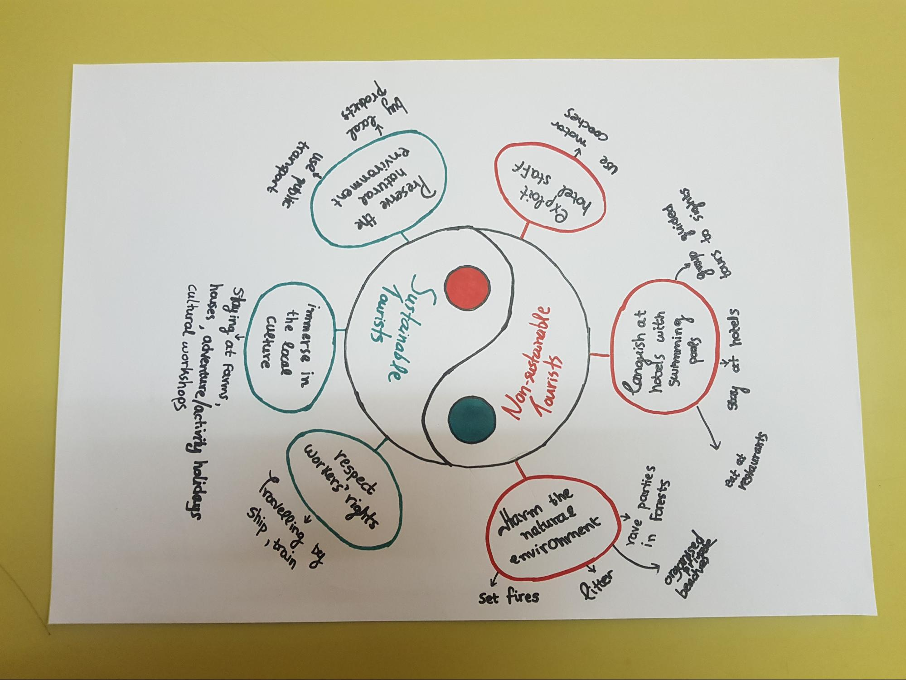
spapou to
squars og sunog
р
Saeos
hourlemans
papnl cheal
uzim spoon
Sysajos sayod ander
u!
70 us: bourg
use
coaches
motor
Oil
hotel staff
exploit
apgaunotsns-hon
StS!INOL
attarm the
natural
environment
Set fires
Sustainable
Tourists
Porno 573npord
goooy
quo Muglinud
natural reserve the
use public transport
immerse in
respect Workers' rights
the local culture
Travelling by
ship train
Staying at farms,
houses, adventure activity holidays cultural workshops

