The Master of the game gives envelope 1:

Envelope 1 Write! Students must decode a Caesar letter. The answer corresponds to the name of a school item where you hide envelope 2.

1 Answer paper bin

Decode this letter! Example: b= a c= b etc

UIF PC KFDU ZPV BSF MPPLJOH GPS JT B TDIPPM PCKFDU ZPVDB OUISP XPMEQ BQFST JOJUZ PVDBO UISPX PMEUJ TTVFT JOJUZ PVDBO UISPX PMEDI FXJOH HVNJO JUJUJ TPOUI FGMPP SJUJT BQBQF SCJO

2. Answer book

Decode this letter! Example: b= a c= b etc

UIFPC KFDUZ PVBSF MPPLJ OHGPS JTBTD IPPMP CKFDU JUJTN BEFXJ UIQBQ FSUIF UJUMF JTQJF DFPGD BLFJU JTPOU IFUFB DIFST EFTLZ PVDBO SFBEJ OJU

3 Answer dictionnary

Decode this letter! Example: b= a c= b etc

UIFPC KFDUZ PVBSF MPPLJ OHGPS JTBTD IPPMP CKFDU JUJTN BEFXJ UIQBQ FSUIF SFBSF FOHMJ TIBOE GSFOD IXPSE TJOJU JUJTS FEBOE CMVFJ UJTPO UIFCP BSE

4 Answer pencil bag

Decode this letter! Example: b= a c= b etc

ZPVDB OQVUQ FODJM TJOJU ZPVDB OQVUQ FOTJO JUZPV DBOQV UTDJT TPSTJ OJUJU JTPOU IFUFB DIFST EFTL

5 Answer school bag

Decode this letter! Example: b= a c= b etc

ZPVDB OQVUC PPLTJ OJUZP VDBOQ VUDPQ ZCPPL TJOJU ZPVDB OQVUQ FODJM DBTFT JOJUJ UJTPO UIFGM PPSOF YUUPU IFUFB DIFST EFTL

Envelope 2

Read a description. Print drawings corresponding to the following description. Then pin them on boxed placed in different parts of the classoom. In the boxes you hide envelope 3.

1
Find a box! Read the description and find the corresponding picture on your suitcase!

It is a girl. She has got blue eyes. She has got long blond hair. She has got glasses. She has got a blue t-shirt.

2
Find a suitcase!a box! Read the description and find the corresponding picture on your suitcase!

It is a girl. She has got green eyes. She has got short blond hair. She hasn't got glasses. She has got a pink t-shirt.

3

Find a suitcase!a box! Read the description and find the corresponding picture on your suitcase!

It is a boy. He has got blue eyes. He has got brown hair. He has got glasses. He has got a blue t-shirt.

4

Find a suitcase!a box! Read the description and find the corresponding picture on your suitcase!

It is a boy. He has got brown eyes. He has got blond hair. He hasn't got glasses. He has got a yellow t-shirt.

5

Find a suitcase!a box! Read the description and find the corresponding picture on your suitcase!
It is a boy. He has got green eyes. He has got dark hair. He has got glasses. He has got a purple t-shirt.

Enveloppe 3 Listen!

Have them memorize the little poems . When they succeed doing it, give them envelope 4.

Listen . Then everyone must memorize 1 sentence. Repeat it to the teacher. The teacher will give you the next enveloppe.

Listen . Then everyone must memorize 1 sentence. Repeat it to the teacher. The teacher will give you the next enveloppe.

Listen . Then everyone must memorize 1 sentence. Repeat it to the teacher. The teacher will give you the next enveloppe.

Listen . Then everyone must memorize 1 sentence. Repeat it to the teacher. The teacher will give you the next enveloppe.

Listen . Then everyone must memorize 1 sentence. Repeat it to the teacher. The teacher will give you the next enveloppe.

Enveloppe 4 Read and find! Students read the plans descriptions and must find their secret rooms. You must place the numbers in the classrooms and hide envelope 5 behind. Put the darts and numbers according to your wishes on the plan.

1

Find your number in the classroom

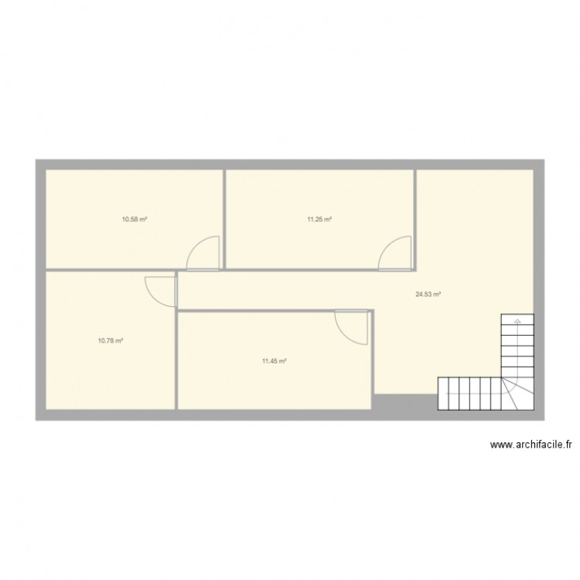
Read and place the rooms on the plan.
When you are at the entrance, the kitchen is on the left. The dining room is on the right. The living-room is behind the dining room.The guest room is opposite the living-room. The toilet is between the guest room and the living-room.
Your secret room is the kitchen. Look at the number and find it in the classroom. The enveloppe 5 is behind.

Find your number in the classroom

Read and place the rooms on the plan.
When you are at the entrance, the kitchen is on the left. The dining room is on the right. The living-room is behind the dining room.The guest room is opposite the living-room. The toilet is between the guest room and the living-room.
Your secret room is the dining room. Look at the number and find it in the classroom. The enveloppe 5 is behind.

Find your number in the classroom

Read and place the rooms on the plan.

When you are at the entrance, the kitchen is on the left. The dining room is on the right. The living-room is behind the dining room.The guest room is opposite the living-room. The toilet is between the guest room and the living-room.
Your secret room is the living-room. Look at the number and find it in the classroom. The enveloppe 5 is behind.

Find your number in the classroom

Read and place the rooms on the plan.

When you are at the entrance, the kitchen is on the left. The dining room is on the right. The living-room is behind the dining room.The guest room is opposite the living-room. The toilet is between the guest room and the living-room.
Your secret room is the guest room. Look at the number and find it in the classroom. The enveloppe 5 is behind.

Find your number in the classroom

Read and place the rooms on the plan.

When you are at the entrance, the kitchen is on the left. The dining room is on the right. The living-room is behind the dining room.The guest room is opposite the living-room. The toilet is between the guest room and the living-room.
Your secret room is the toilet. Look at the number and find it in the classroom. The enveloppe 5 is behind.

Enveloppe 5

Memorize the secret code. One word per person. Then go and recite it to the teacher.

1
Mr/ Mrs. / is / the most / beautiful / teacher!

2.

Mr/ Mrs. / is / the most / intelligent / teacher!

3

Mr/ Mrs. / is / the most / talented / teacher!

4

Mr/ Mrs. / is / the most / elegant / teacher!

5

Mr/ Mrs. / is / the most / creative / teacher!

