Title:

Oddity in Physical Education Curriculum

at Primary level.

Overview:

Primary school-age children love playing traditional games (the most of them are anaerobic games), but the fact is that students at primary level do not have such a good biological and physiological capacity to carry out that type of exercises (anaerobic games).
Students will gain knowledge and understanding of this open-ended problem found in trigger material and they will solve it by working in small groups.

Topic: Anaerobic versus Aerobic games in Primary School.

Subjects: Physical Education, Natural Science, Spanish, Arts and Craft and English.

Grade: Primary 5 & 6.

Length of time: two weeks.

Objectives:

Students will:
- Find out about the “oddity” of playing anaerobic games in the Physical Education classroom.

- Compare the main differences between aerobic and anaerobic cellular respiration.

- Measure heart rate after playing a traditional game.

- Identify anaerobic activities/games they enjoy.

- Classify traditional games being anaerobic or aerobic.

- Solve an open-ended problem found in trigger material.

Key competences: Competence in Linguistic Communication (in Spanish and English), Mathematical competence and basic competences in science and technology, Digital competence and Learning to learn competence.

Contents:
Heart rate measurement.
Aerobic cellular respiration.
Anaerobic cellular respiration.
Aerobic games.
Anaerobic games.

Measurable Learning Standards stated in Decree 103/2014 of June 10th, which established the Curriculum for Primary Education in Extremadura, Spain:

Physical Education:

EF 2.7.2. Identifica su frecuencia cardíaca y respiratoria, en distintas intensidades de esfuerzo. (CMCT)

EF 2.7.3. Adapta la intensidad de su esfuerzo al tiempo de duración de la actividad. (CPAA)

Natural Science:

CNAT 1.5.1. Realiza experiencias sencillas y pequeñas investigaciones: planteando problemas, enunciando hipótesis, seleccionando el material necesario, realizando, extrayendo conclusiones, y comunicando los resultados. (CMCT, CPAA, CCL)

CNAT 1.1.4. Desarrolla estrategias adecuadas para acceder a la información de los textos de carácter científico. (CMCT, CPAA, CD)

Spanish:

LCL 3.8.1. Usa con eficacia las nuevas tecnologías para escribir, presentar los textos y buscar información. (CCL, CD

LCL 3.7.1. Planifica y redacta textos siguiendo unos pasos: planificación, redacción, revisión y mejora. Determina con antelación cómo será el texto, su extensión, el tratamiento autor-lector, la presentación, etc. Adapta la expresión a la intención, teniendo en cuenta al interlocutor y el asunto de que se trata. Presenta con limpieza, claridad, precisión y orden los escritos. Reescribe el texto. (CCL, CPAA)

English:

ING 6r) Redacta un texto sobre algún tema conocido. (CCL)

Art and Craft:
PLA 1.2.5. Elabora carteles con diversas informaciones considerando los conceptos de tamaño, equilibrio, proporción y color, y añadiendo textos utilizando la tipografía más adecuada a su función. (CCL, CEC)

Teaching approach: Learner-centered Teaching and Cooperative Learning.

Methodology:
Problem-based learning (PBL) and Learning by Doing.

Material Resources:
Internet connection, computers, mobile phones, art tools, cardboards and Emaze software.

Classroom seating arrangement: Separate areas for working in small groups.

Procedure:

Opening to lesson using trigger material

. Children will start playing the traditional “Tag” game for 10 minutes at the gym.
. Just after stopping the game, each child will measure his/her heart rate by taking his/her wrist or neck pulse.

Teacher’s previous explanation: “You can take your pulse using your carotid artery in your neck or the radial artery in your wrist”.

. Pupils will/may conclude that their heart rate is about 180 beats per minute after a short and intense exercise, such as sprinting for up to 90 seconds.

PE Teacher will show them this warming poster as a trigger material:
WARNING
DO NOT SPEED UP YOUR HEART RATE MORE THAN 140-160 BEATS PER MINUTE!!

Body of lesson

Step 1: Understanding the open-ended problem found in the trigger poster.

. The Natural Science teacher will divide pupils into groups of 4 o 5. Each group will compare the main differences between aerobic and anaerobic cellular respiration by searching it on the internet.
. Whole class discussion about the most interesting differences between anaerobic and anaerobic cellular respiration and how to show/display these differences.

Step 2: Putting into practice the knowledge acquired in step 1.

. The PE teacher will divide pupils into 5 o 6 and after playing several traditional games:
- Student will identify anaerobic activities/games they enjoy.
- Student will classify traditional games being anaerobic or aerobic.

Step 3: Solving the open-ended problem found in the trigger poster.

. Whole class discussion about the possibility of turning common/traditional anaerobic games into aerobic games.
. The PE teacher will divide children into 4 o 5. Each group will choose three anaerobic games and discuss how to turn this games into aerobic games.

Step 4: Displaying the pupils’ outcomes and proposals.

. Each group will make posters in the Art and Craft classroom to display their findings and proposals in order to solve the “oddity” of playing anaerobic games at Primary level.
.Teacher/s will make an Emaze presentation to show the procedure followed in this lesson plan and for collecting the pupils’ outcomes and proposals to solve the “oddity”.

Assessment & Evaluation:

. Teacher's observations of student written work samples, student oral presentations and participation in group activities.
. Interview with students.
. The teacher will register on the personal evaluation sheet whether students fulfil the tasks or not.

Outcomes:

Posters that will explain aerobic and anaerobic cellular respiration:

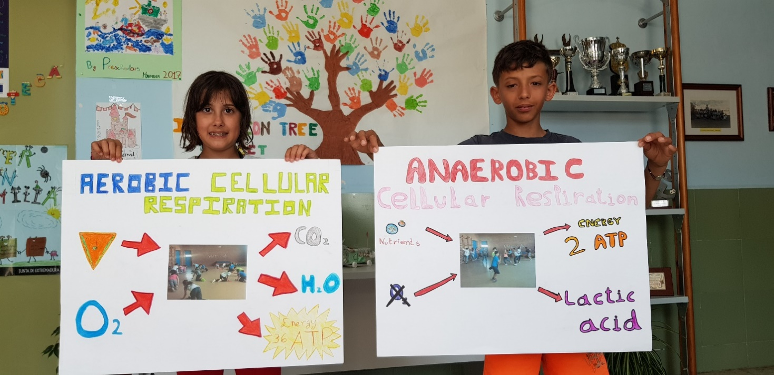

Posters that will explain how to transform traditional (anaerobic) games into aerobic games:

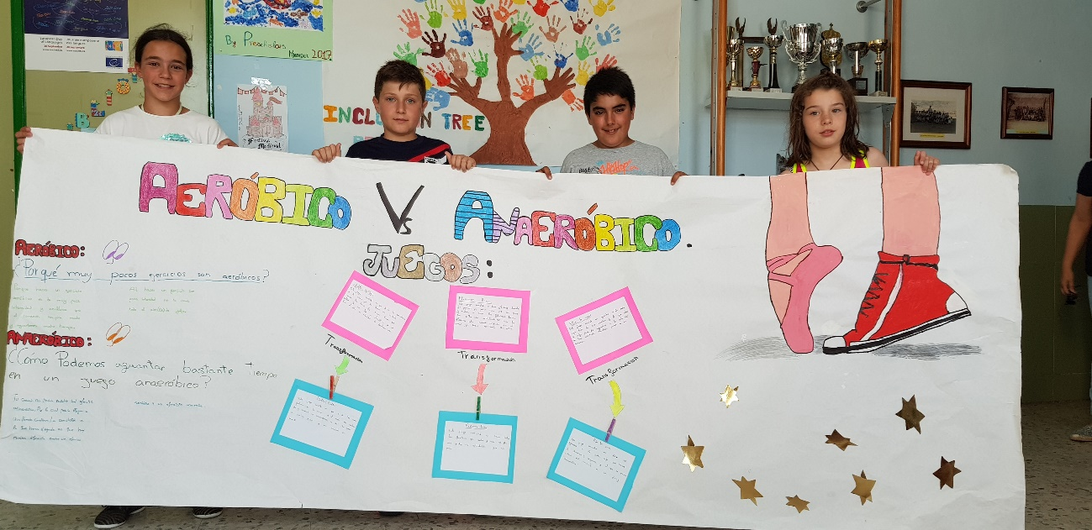

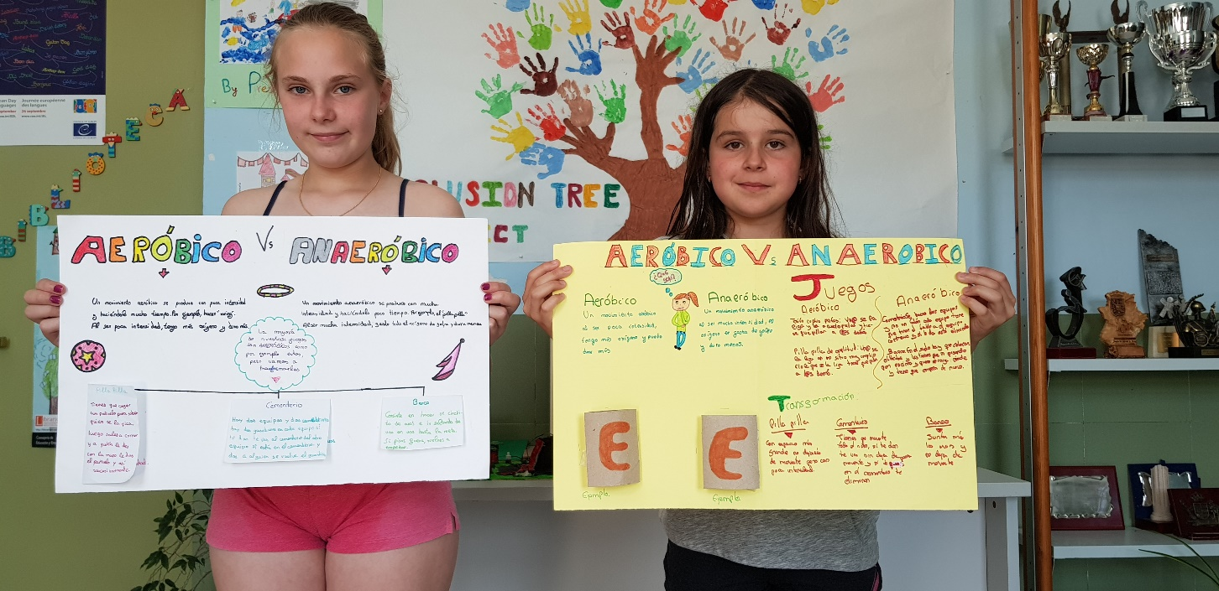

Emaze presentation collecting the pupils’ outcomes and proposals.

https://youtu.be/ZdS_xZ2Gl_4

Authors:

Teachers from CEIP “Ntra. Sra. Del Consuelo”, Logrosán, Spain.

June, 2018

