Title:

Architectural Barriers at My Town.

Overview:

For the physically disabled, barriers can range from blocked wheelchair ramps, to buildings without lifts, to inaccessible toilets, to shops without step-free access.

Primary school-age children will put themselves in the position of a person in a wheelchair and will encounter many and difficult architectural barriers to access to main buildings in their town.

Student will send a Petition Letter to the Major of their town, requesting the removal of some architectural barriers.

Topic: Architectural Barriers.

Subjects: Language, Social Science.

Grade: Primary 4, 5 & 6.

Length of time: 8-10 hours.

Objectives:

Students will:

- Define what an Architectural Barrier is.

- Identify some architectural barriers in their town.

- Assess the accessibility to public buildings for wheelchair users in their town.

- Evaluate what barriers need to be removed first.

- Know the format of a Petition Letter.

- Send a Petition Letter to the Mayor of their town, requesting the removal of some architectural barriers.

Key competences: Competence in Linguistic Communication, Social and Civic competence, Sense of Initiate and Entrepreneurship and Learning to learn competence.

Contents:

Architectural Barriers.
Examples of Architectural Barriers.
Petition Letter format.

Measurable Learning Standards stated in Decree 103/2014 of June 10th, which established the Curriculum for Primary Education in Extremadura, Spain:

Social Science:

CSOC 1.1.1. Busca, selecciona y organiza información concreta y relevante, la analiza, obtiene conclusiones, reflexiona acerca del proceso seguido y lo comunica oralmente y/o por escrito. (CCL, CPAA)

CSOC 1.5.2. Participa en actividades de grupo adoptando un comportamiento responsable, constructivo y solidario y respeta los principios básicos del funcionamiento democrático. (CPAA, CSCV)

CSOC 1.9.1. Muestra actitudes de confianza en sí mismo, sentido crítico, iniciativa personal, curiosidad, interés, creatividad en el aprendizaje y espíritu emprendedor que le hacen activo ante las circunstancias que le rodean. (CPAA, SIEE)

Language:

LCL 1.10.1 Utiliza de forma efectiva el lenguaje oral para comunicarse y aprender escuchando activamente, recogiendo datos pertinentes a los objetivos de la comunicación. (CCL, CPAA)

LCL 3.1.1. Escribe, en diferentes soportes, textos propios del ámbito de la vida cotidiana: diarios, cartas, correos electrónicos, etc. imitando textos modelo. (CCL, CPAA)

Teaching approach:

Learner-centered Teaching, Action Learning and Cooperative Learning.

Methodology:

Problem-based learning (PBL) and Learning by Doing.

Human Resources:

Mirian Alonso Corraliza, a woman with lower limbs disability.

José Carlos Calzada Morano, Technical Architect of the Town Hall of Logrosán.

Local Police.

Material Resources:

Wheelchairs, a pair of crutches, Internet connection, computers, Digital Board, mobile phones, a printer, sheets of paper and an envelope.

Classroom seating arrangement: Separate areas for working in small groups.

………………………

Procedure:

We will have the help of Mirian Alonso Corraliza, a woman with lower limbs disability, as a coach for promoting and facilitating learning, as well as encouraging the teams to be self-managing.

Opening to lesson with what students know (prior knowledge)

Timing: 1hour

Students will watch "Inside the Miriam's box" video_ https://youtu.be/TL1MbEYgr-g (February 1, 2018). It was a Disability Awareness and Sensitivity Seminar by Mirian Alonso Corraliza, a woman with lower limbs disability, in which, Pupils from CEIP "Ntra. Sra. del Consuelo" (Logrosán) wanted to show respect and sensitivity to people with disabilities.

After watching the video, Social Science Teacher will show them this question-poster as a trigger material:
Question:
What would a truly disabled-accessible city look like?

Body of lesson

Step 1: Understanding the open-ended problem found in the trigger poster.

(2 hours)

. The Natural Science teacher will divide pupils into groups of 4 o 5. Each group will give a proper/satisfactory definition of Architectural Barrier and some examples of Architectural Barriers which disabled people may encounter in a town or city, by searching them on the internet.

. Whole class discussion about the best definition of Architectural barrier and most common examples of Architectural barrier in a town or city.

Step 2: Putting into practice the knowledge acquired in step 1.

(2 hours)

We will be coached and supported by Mirian Alonso Corraliza, a woman with lower limbs disability, José Carlos Calzada Morano, Technical Architect of the Town Hall of Logrosán and the Local Police.

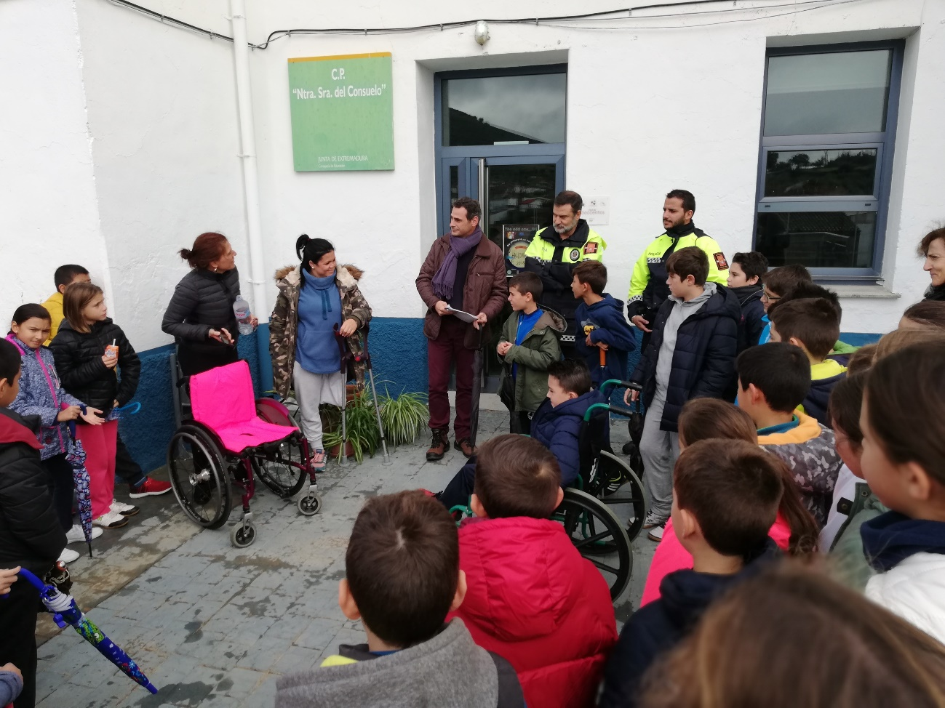

. Primary 4, 5 & 6 students will put themselves in the position of a person in a wheelchair and will encounter and describe many and difficult architectural barriers to access to main buildings in their town.

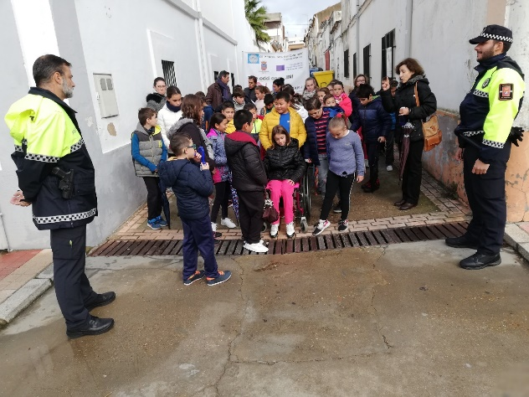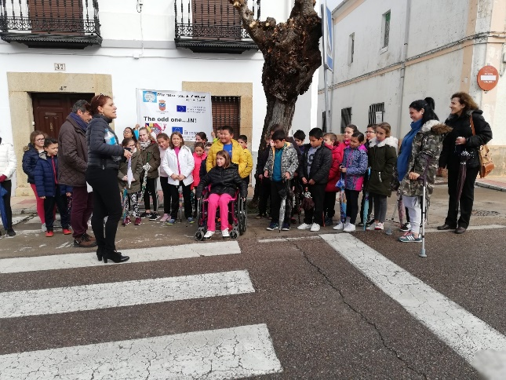

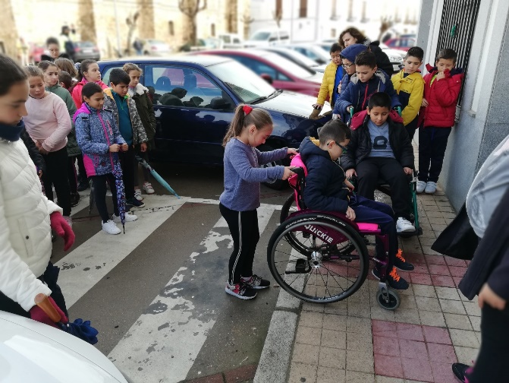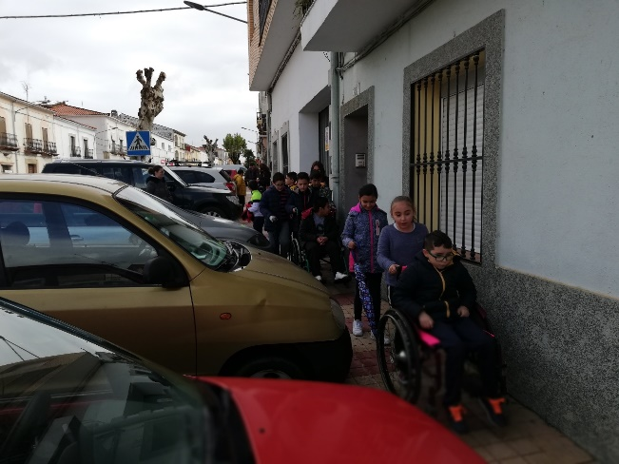

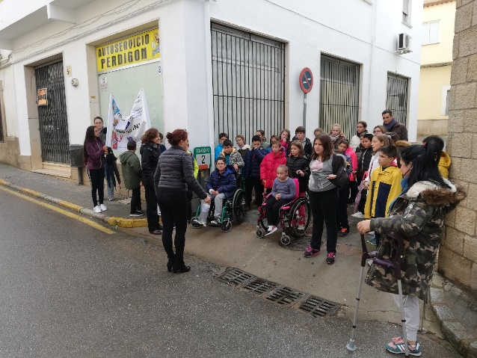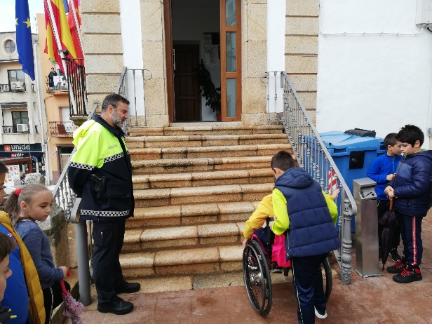

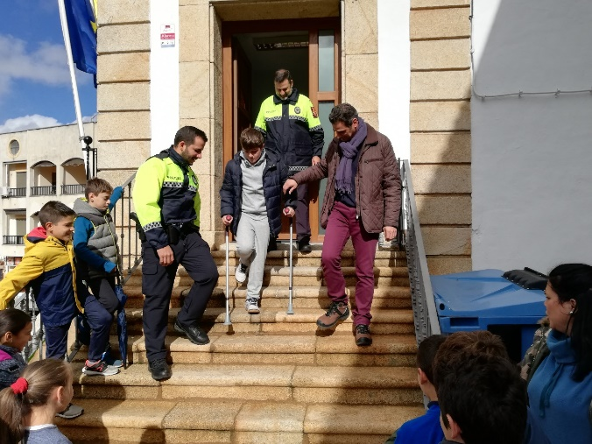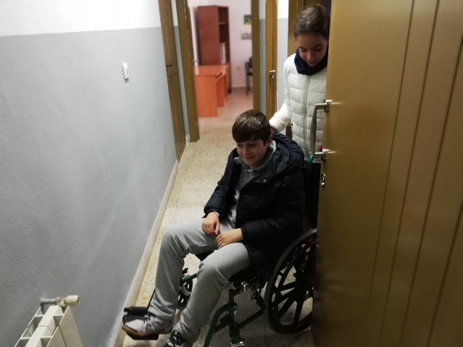

Step 3: Solving the open-ended problem found in the trigger poster.

(1 hour)

. Whole class discussion about the possibility of sending a Petition Letter to the Mayor of the town, requesting the removal of some architectural barriers.

. The Social Science teacher will divide children into 4 o 5. Each group will choose three or four architectural barriers which they may consider them a priority to be removed.

Step 4: Converting the pupils ‘proposals into action and, ultimately, a solution.

(2 hours)

. Language teacher will divide students into 4 o 5. Each group will search samples of Petition Letters on the internet.

. Each group will analyse the format of a Petition Letter.

. Whole class will write the Petition Letter to the Mayor following a model with the help of the Language Teacher and Mirian Alonso Corraliza.

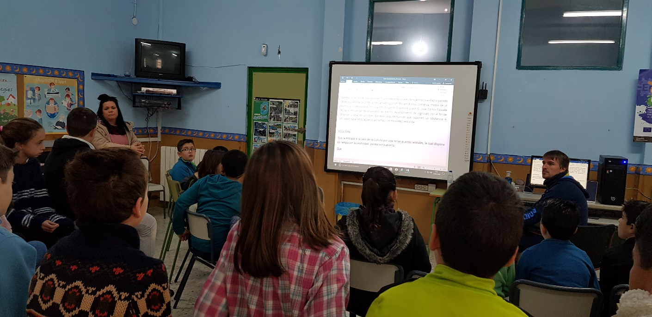

Assessment & Evaluation:

. Teacher's observations of student written work samples, student oral presentations and participation in group activities.
. Interviews with students.
. The teacher/s will register on the personal evaluation sheet whether students fulfil the tasks or not.

Outcomes:

- Pupils’ Petition Letter to the Mayor of Logrosán, Spain (Appendix I).

- Mayor’s letter in response to pupils’ petition letter (Appendix II).

Authors:

Teachers from CEIP “Ntra. Sra. Del Consuelo”, Logrosán, Spain.

December, 2018 – January, 2019

Appendix I

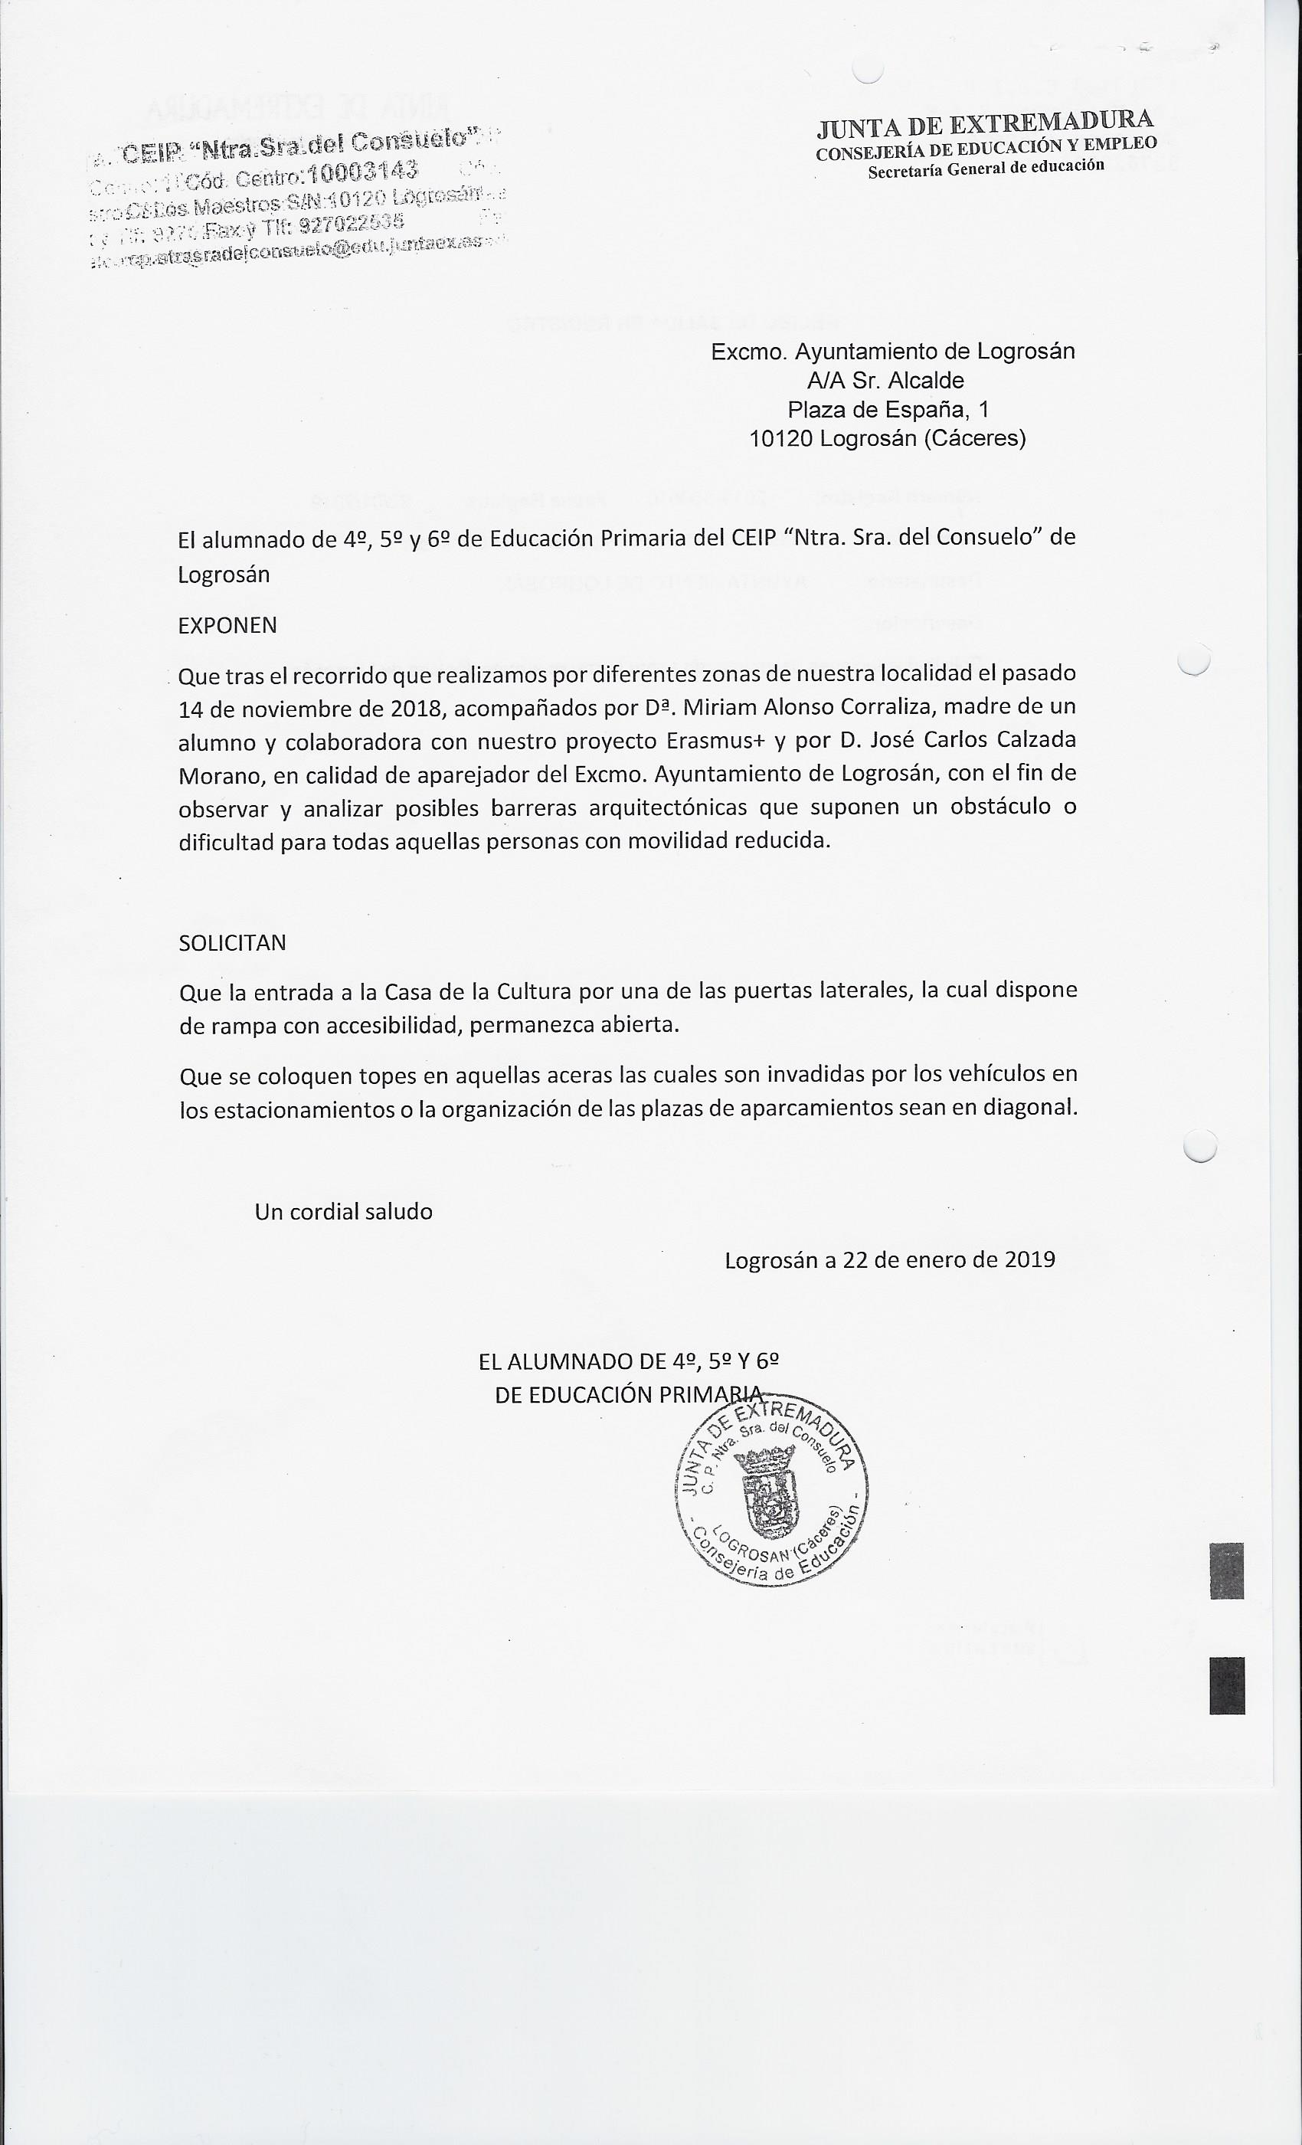

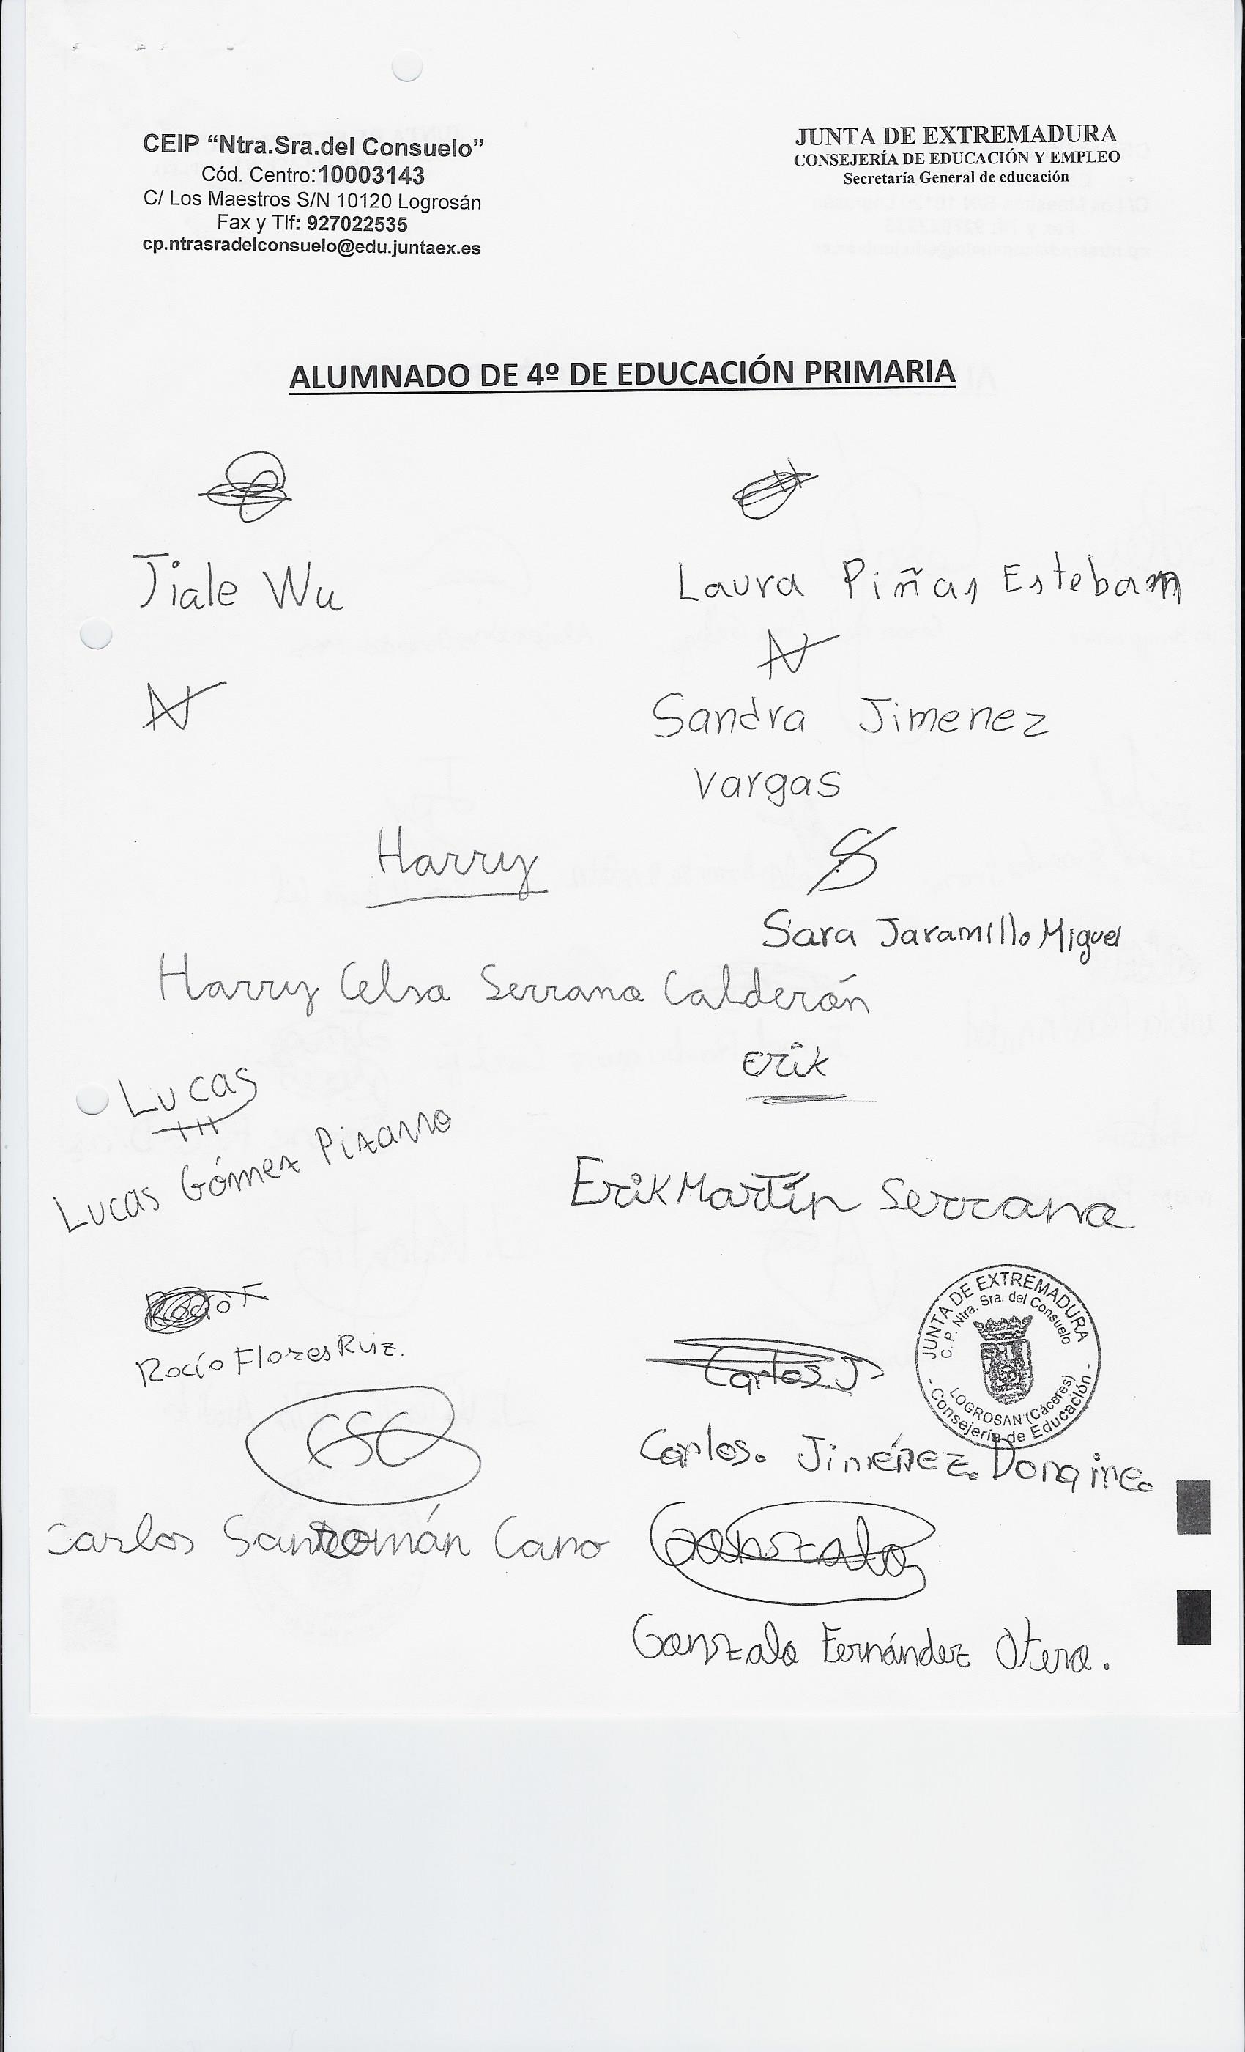

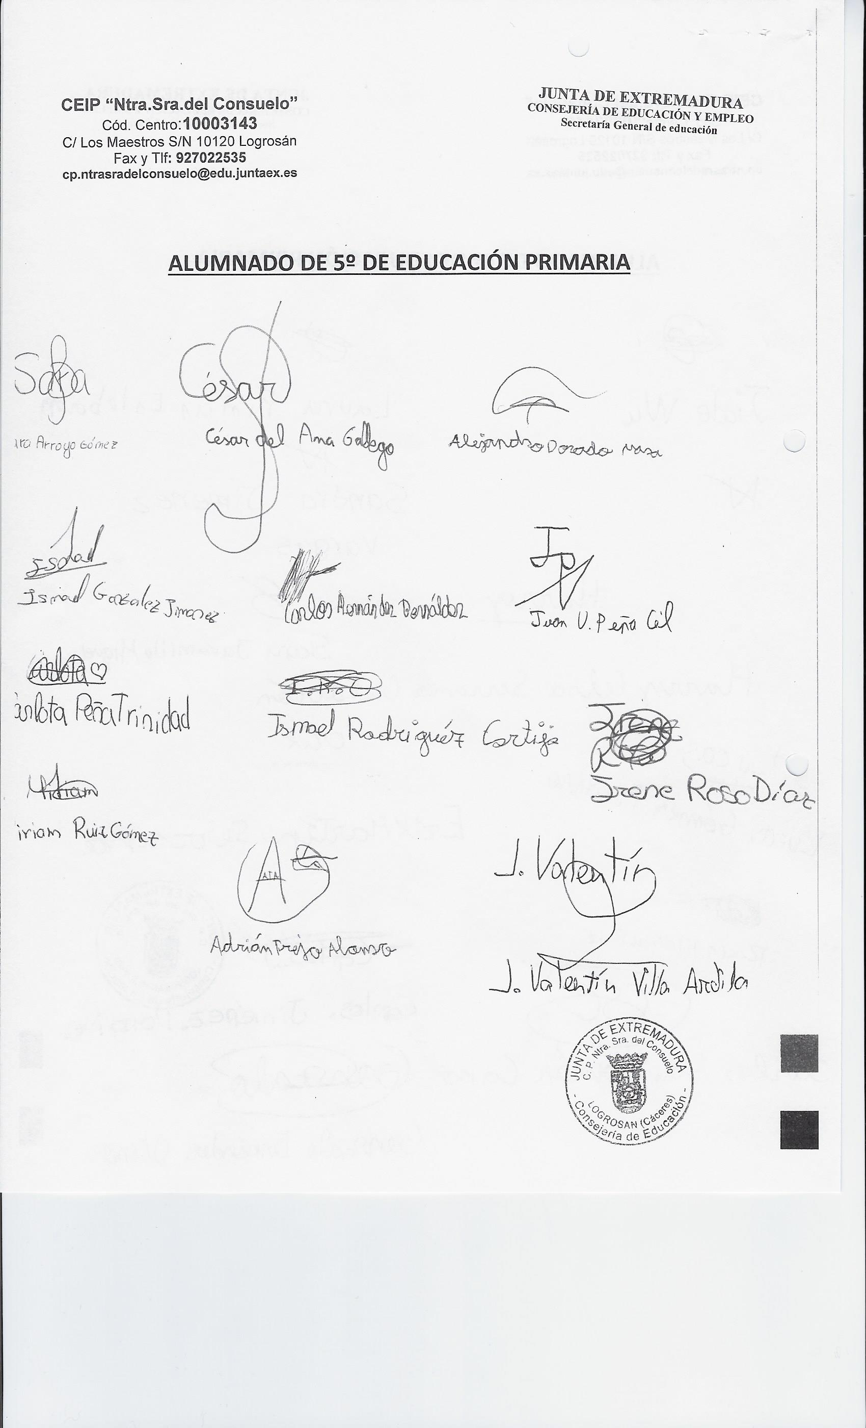

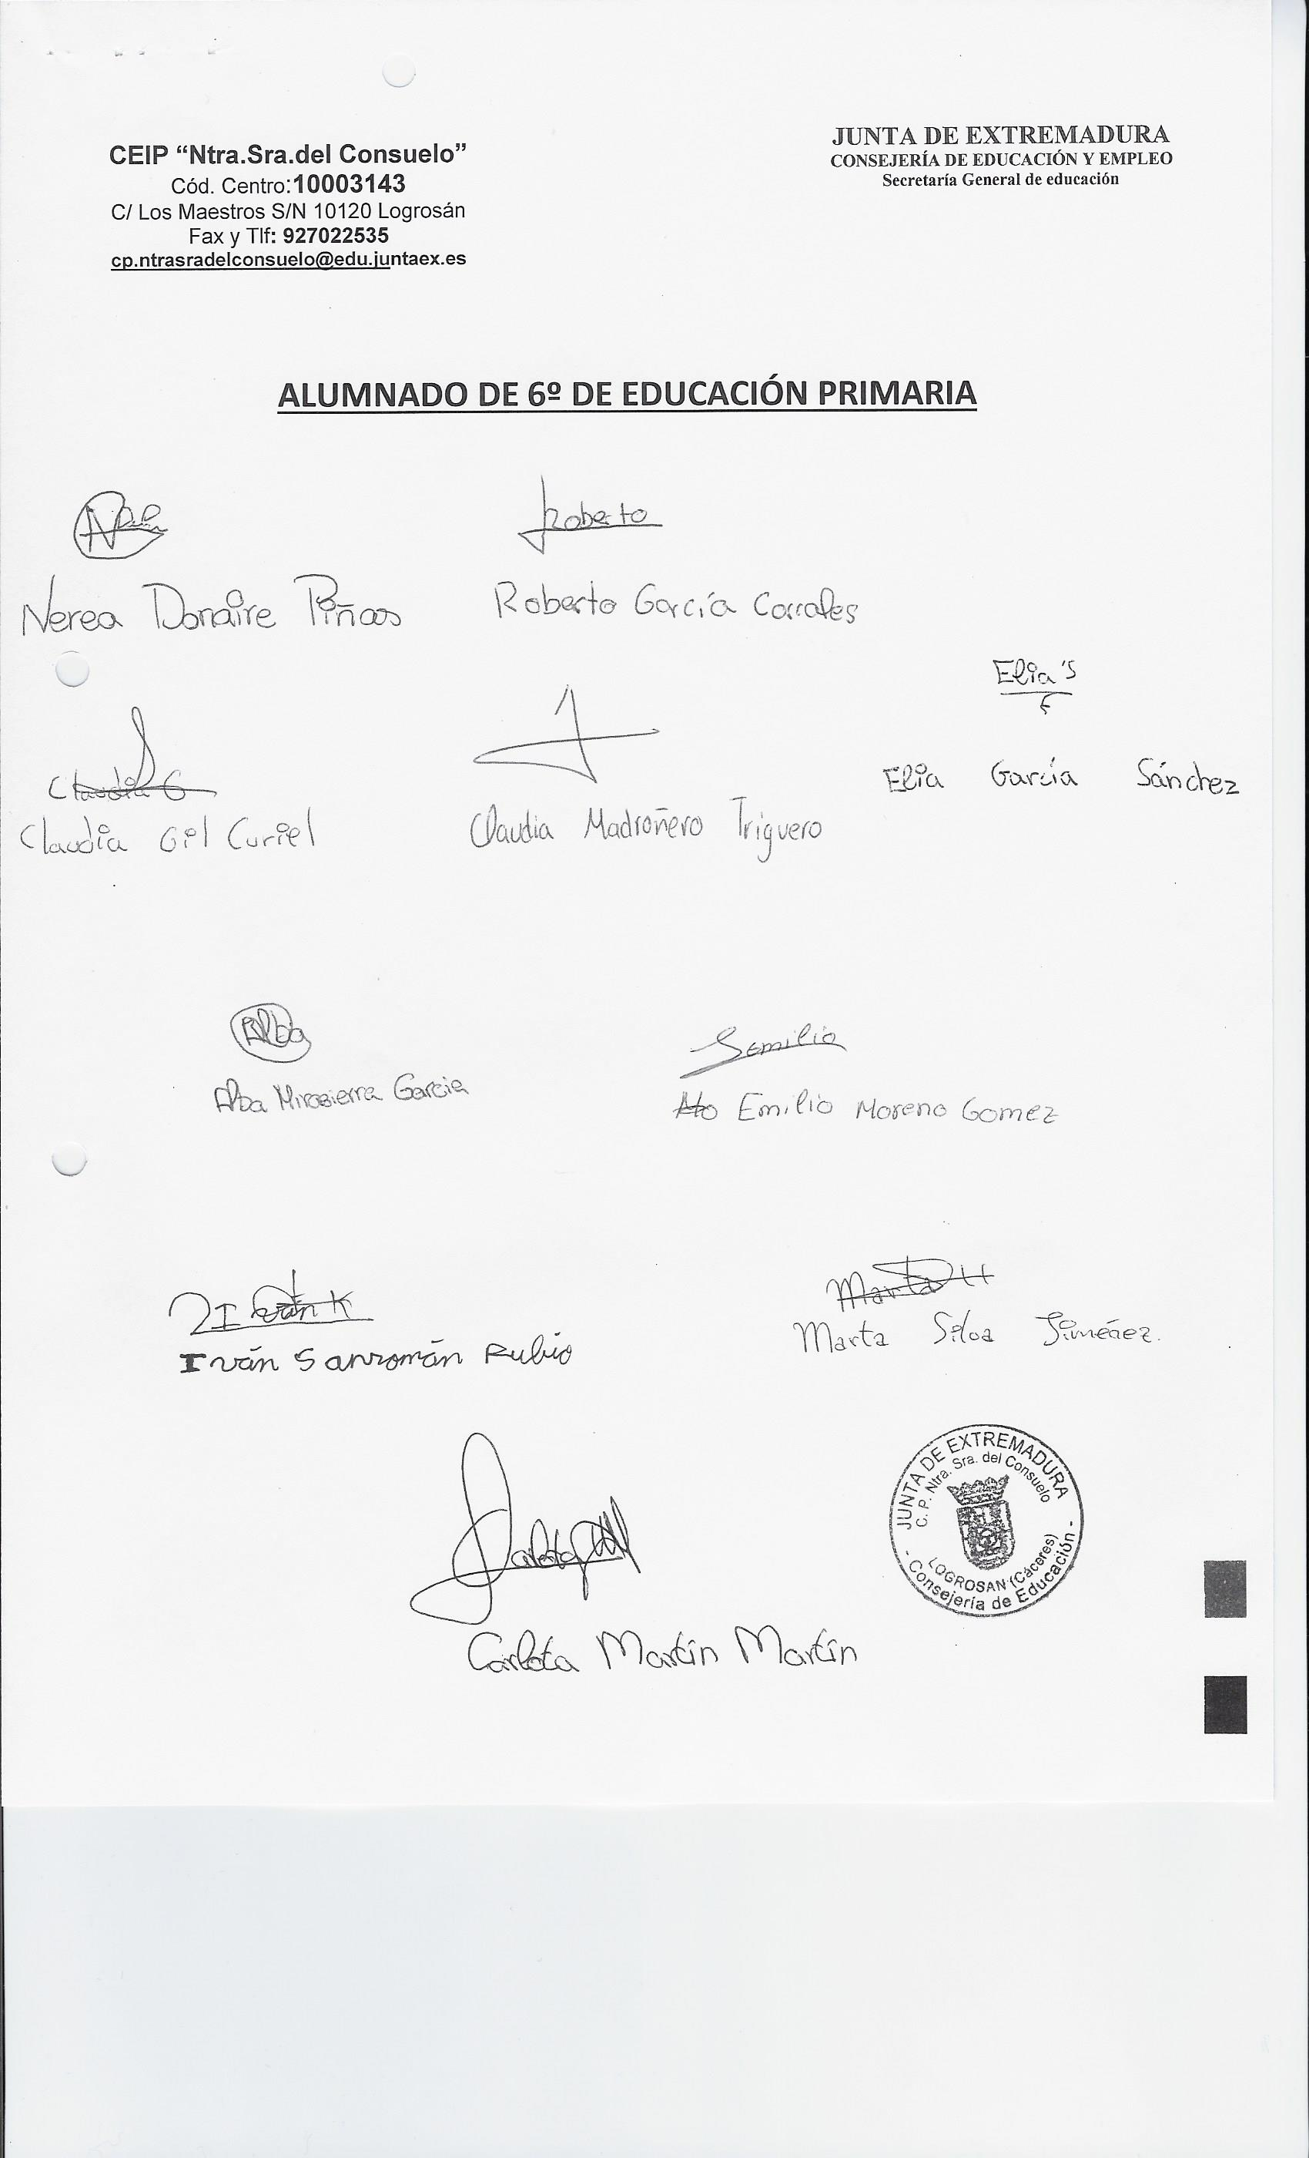

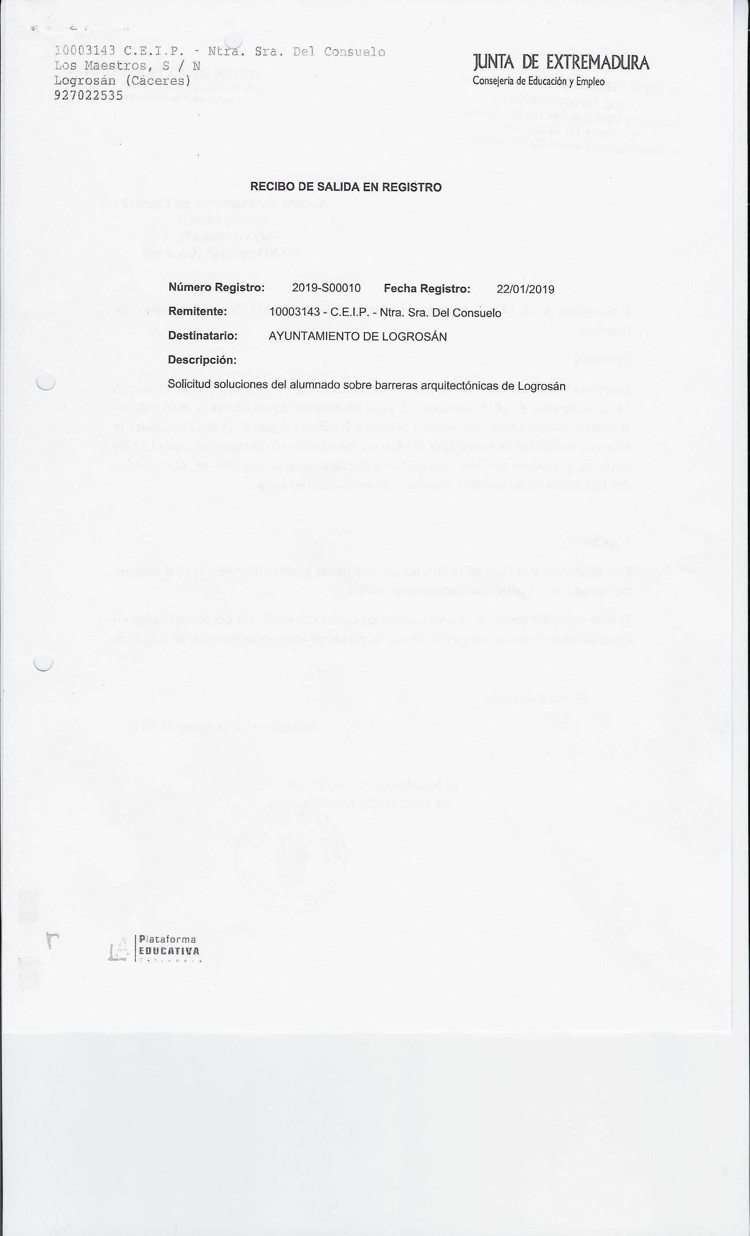

Appendix II

