Hi Girls,
Here is the format on how you should apply for the Quality Label. It’s important that all schools apply for it, because only if at least 2 partners get the National Quality Label can we apply for the European Quality Label, and thus in future be candidates for the European eTwinning prize, in which the teacher and class gets invited to the hosting country!!!
First, go to the eTwinning Live page and click on the projects button:
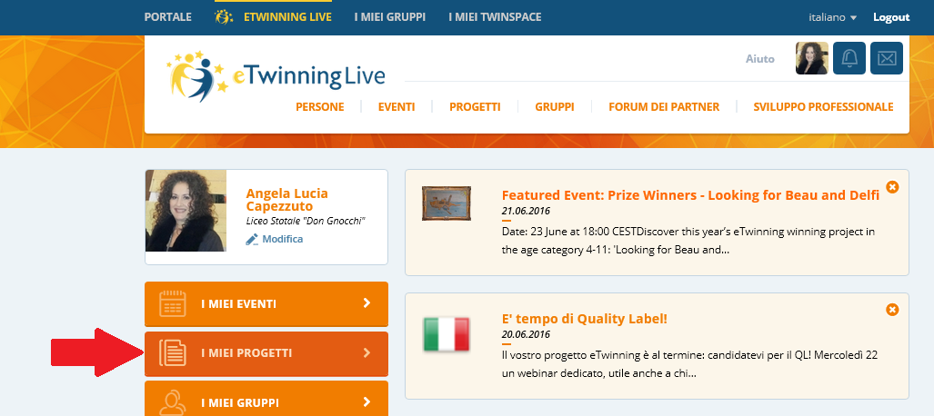
Then on the projects page, find the candidature for quality label link and click:
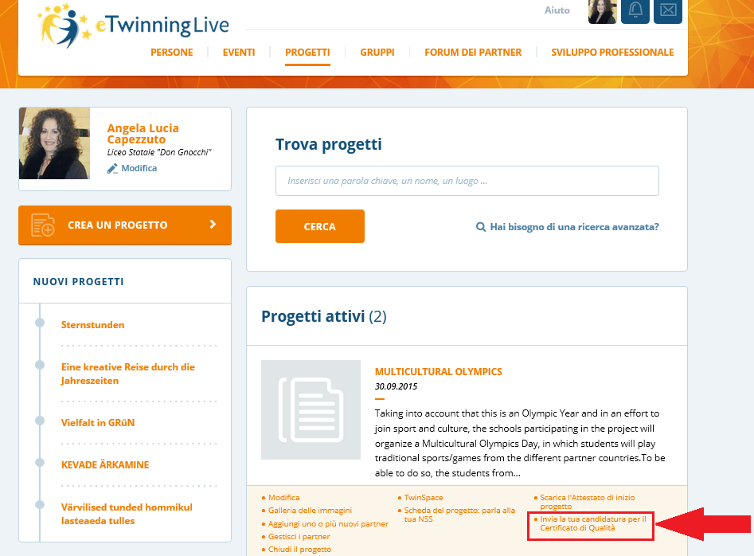

Then on the form page, you should do what I did-take a desktop picture of the form, so you can paste the picture into word, first do a draft of the answers to the various questions, then when you’re ready you can copy and paste the answers directly onto the website form…and that’s it! Good Luck!!!!
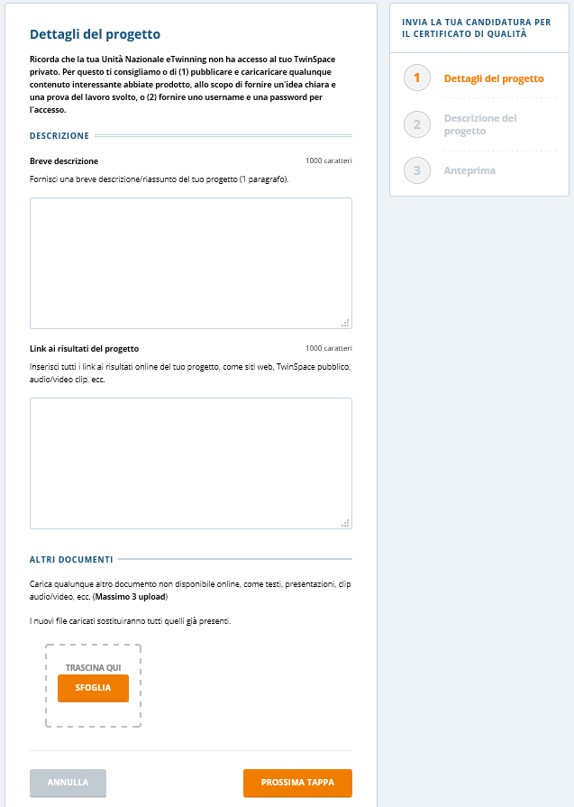
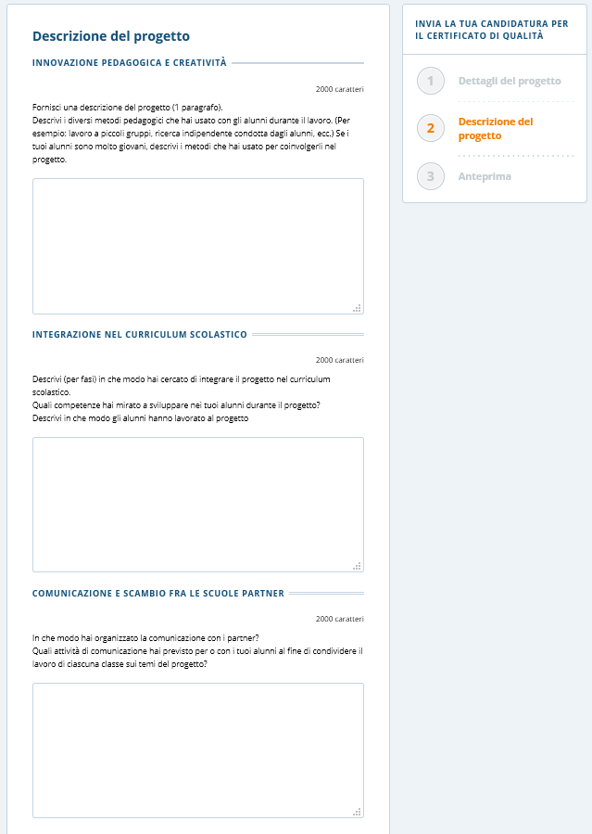
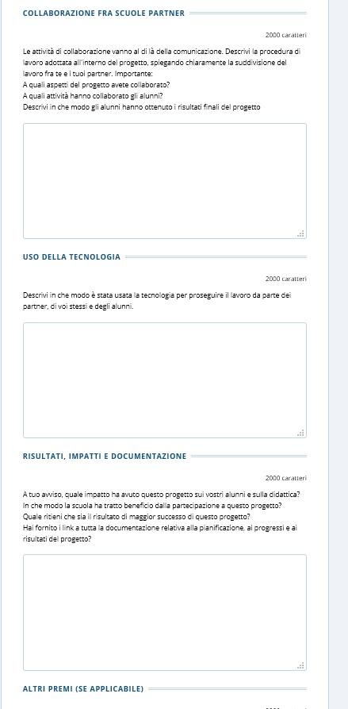
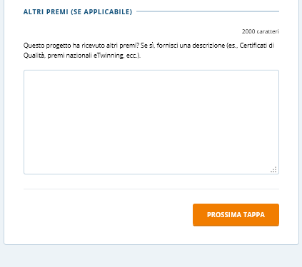
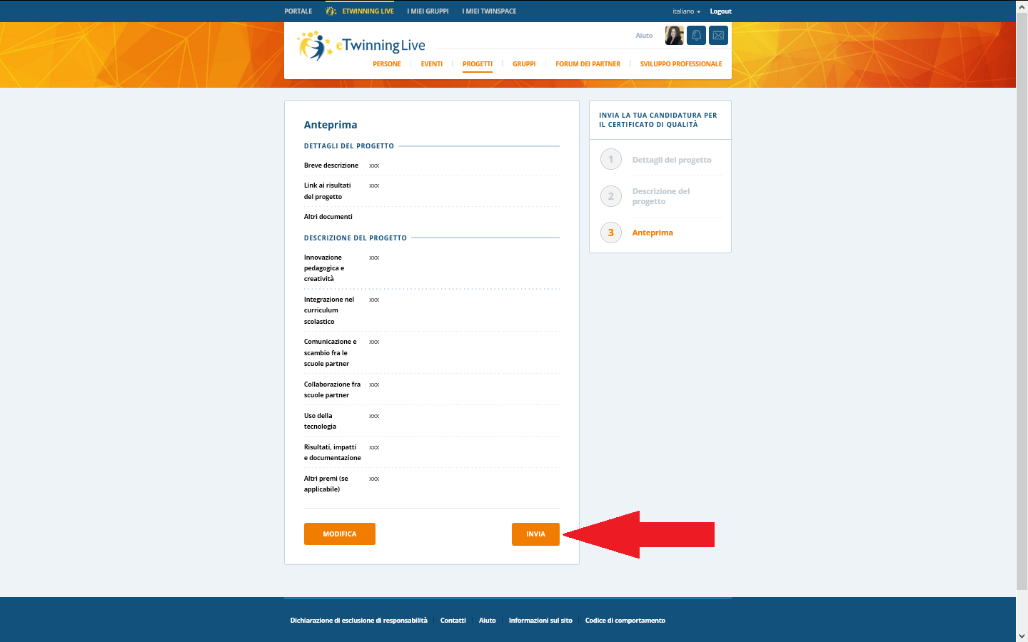
If you’re not sure of something, just ask me!
Oh, and by the way, I was just made ETwinning Ambassador for the Campania Region in Italy!!!!

