French fries: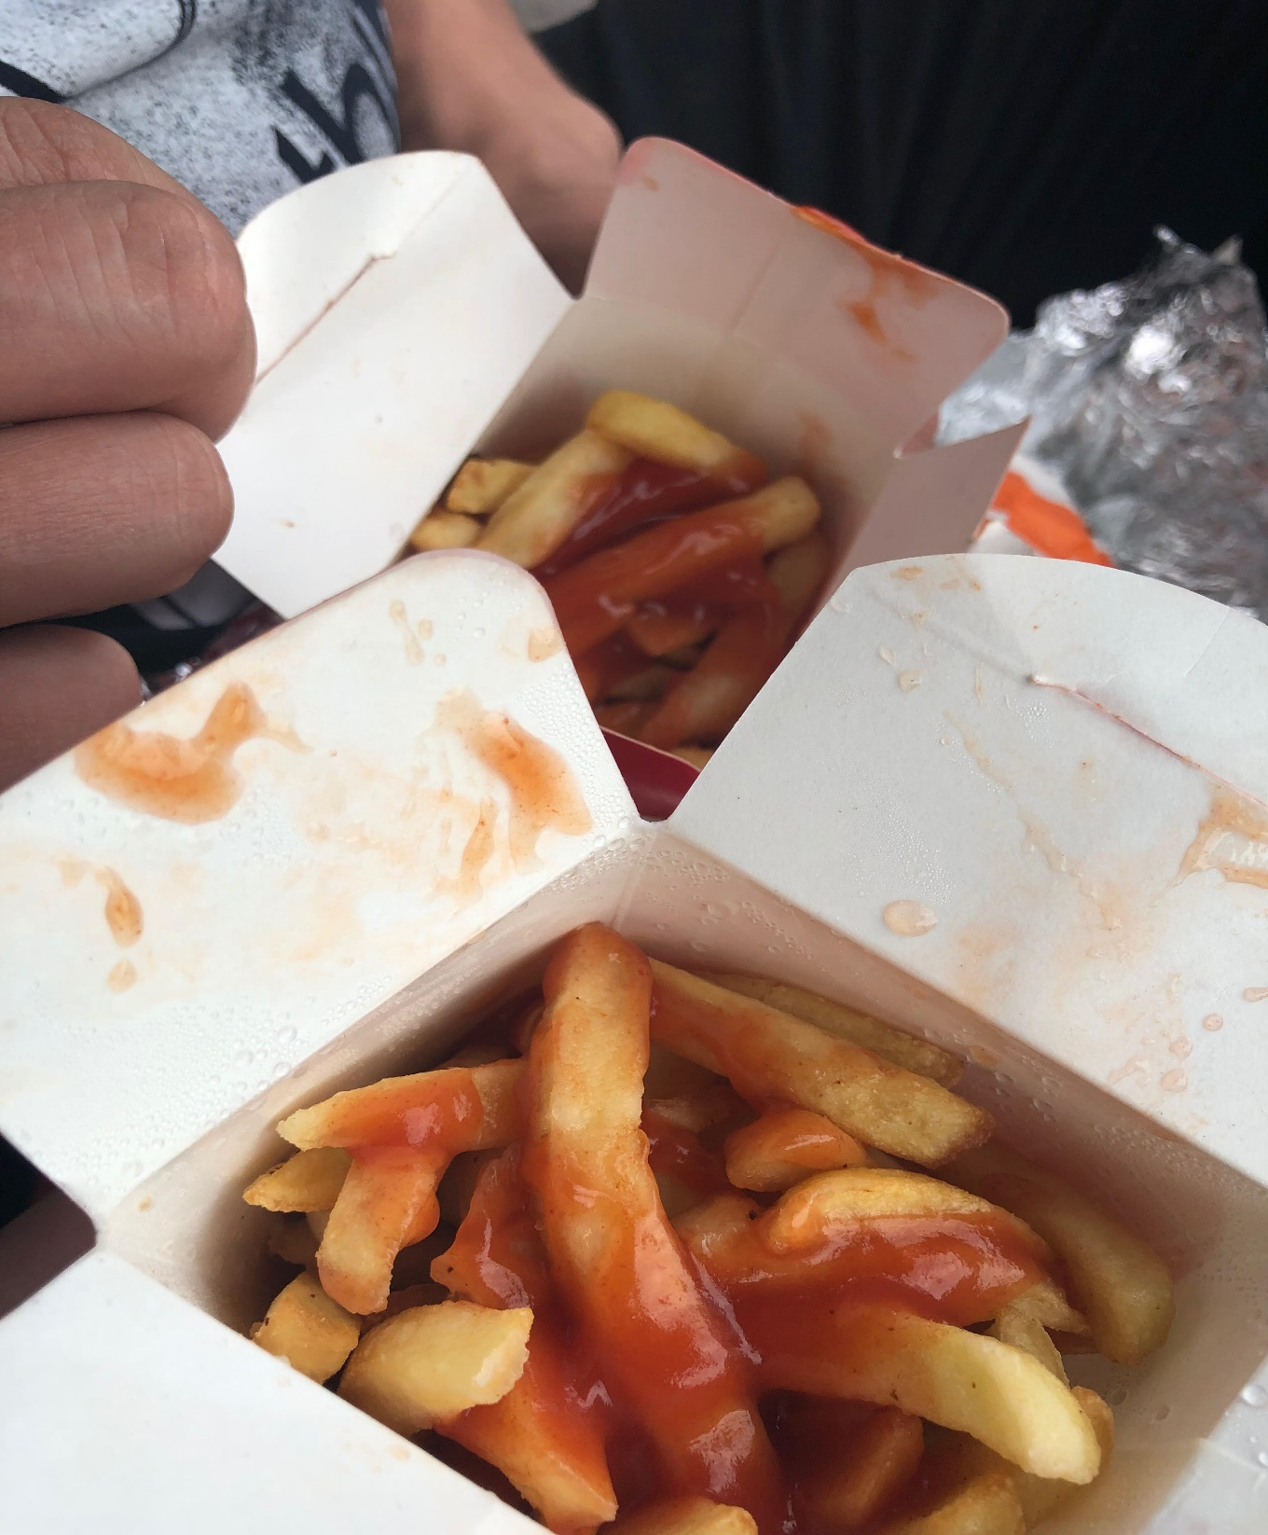
Aspect: 8/10
Taste: 7/10
What you get for the price: 7/10
Overall score: 7,3
Hawaiian pizza:
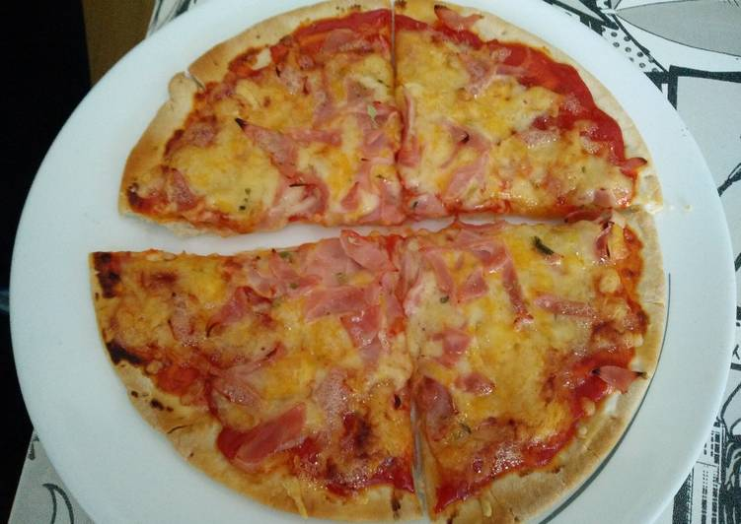

Aspect: 9/10
Taste: 3/10
What you get for the price: 9/10
Overall score: 7

Hamburger:
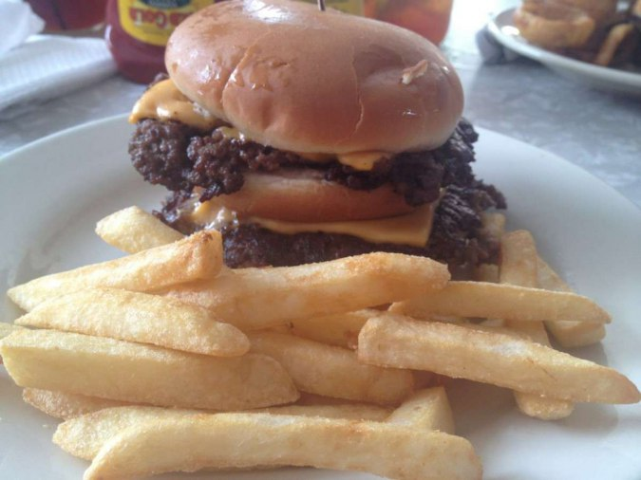

Aspect: 9/10
Taste: 10/10
What you get for the price: 8/10
Overall score: 9

