eTwinning projects: CONSUMERISM
The Romanian Team

USE LESS, SAVE MORE

PICTURES OF CONSUMERISM | IMPROVEMENTS & SOLUTIONS
SAVE LESS OF YOUR TIME BEING THE “TOOL” OF THE MARKET CONCEPT  There are shops on the ground floor of almost every block of flats. People buy and consume way beyond their basic needs. The driving force of the market: buying and selling.  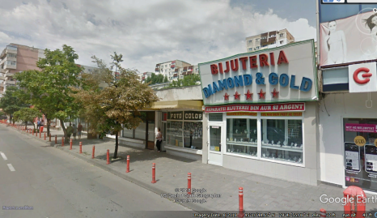  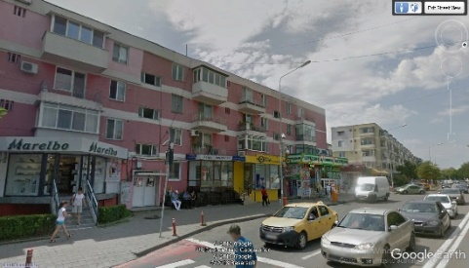  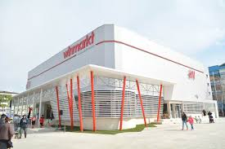  (source: https://jurnaluldeafaceri.ro/hm-a-deschis-un-magazin-in-tulcea/) | SAVE YOUR TIME FOR HEALTH AND NATURE  There should be more green places so that the young are thought to respect and enjoy the nature.  There should be more investments in sport centres. So, the next time one wants to relax they should have more opportunities: doing a sport or reading a book in the park instead of doing shopping or enjoying a juice on a terrace.  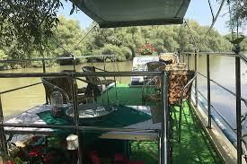  (sourse: https://www.tripadvisor.com.br/Attractions-g295395-Activities-c42-Tulcea_Tulcea_County_Southeast_Romania.html )  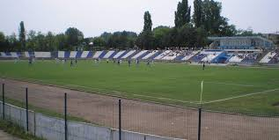  (source: https://www.info-sud-est.ro/stadionul-delta-a-fost-receptionat-si-de-federatia-romana-de-fotbal/)
USE LESS PLASTIC  Every 2 days, on average, both me and my students throw a garbage bag of plastics, in each family. This is, mainly, because of the packaging in the shops. Almost every item we buy is wrapped in plastic.  https://www.youtube.com/watch?v=Xz7zejX86iE  When it rains heavily, there is a lot of garbage in the Danube River:  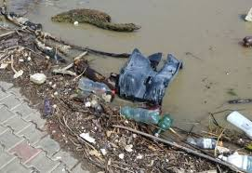  (source: http://subiectivtulcea.ro/malul-dunarii-la-galati-si-tulcea-plin-de-gunoaie-si-cadavre-de-animale/)  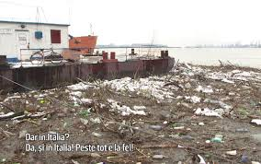  (source: http://subiectivtulcea.ro/malul-dunarii-la-galati-si-tulcea-plin-de-gunoaie-si-cadavre-de-animale/) | SAVE THE PLANET  LOWER THE AMOUNT OF PLASTIC WE USE  https://www.tvnz.co.nz/one-news/new-zealand/foodstuffs-allow-customers-bring-containers-home-deli-products?fbclid=IwAR0XBoiGbMV_7H8tAWSILgoLXYLzzCpzinezcda4CXGqT65MPMO5XJPS-1A  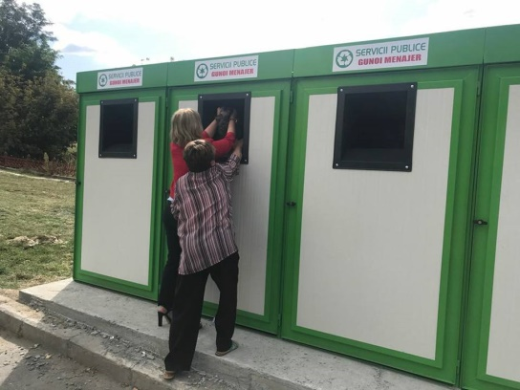  (source: http://www.radioconstanta.ro/etichete/andalizia-luca/)  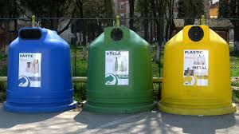
USE OLD GADGETS UNTIL THEY REALLY BECOME UNUSABLE  25% of the students I’ve asked have 2 phones and most of them change their phone within a year, mainly, because they do not pay much attention and they break them. | SAVE ON THE PLANET RESOURCES  We have a national programme for recycling old unusable appliances. You get a voucher in order to buy a new household appliance if you have an old one to give in return.  A good programme. However, the funds are very limited and if you have more gadgets you do not get more vouchers.  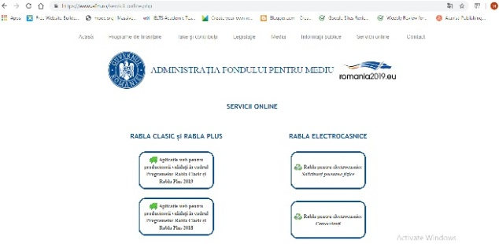  (source: https://www.afm.ro/servicii_online.php)

