Gruppo: Tavarone, Senatore, Mahammedi, Boffelli, Jorgo, Marciano e Dell'Agnello
NOVARA
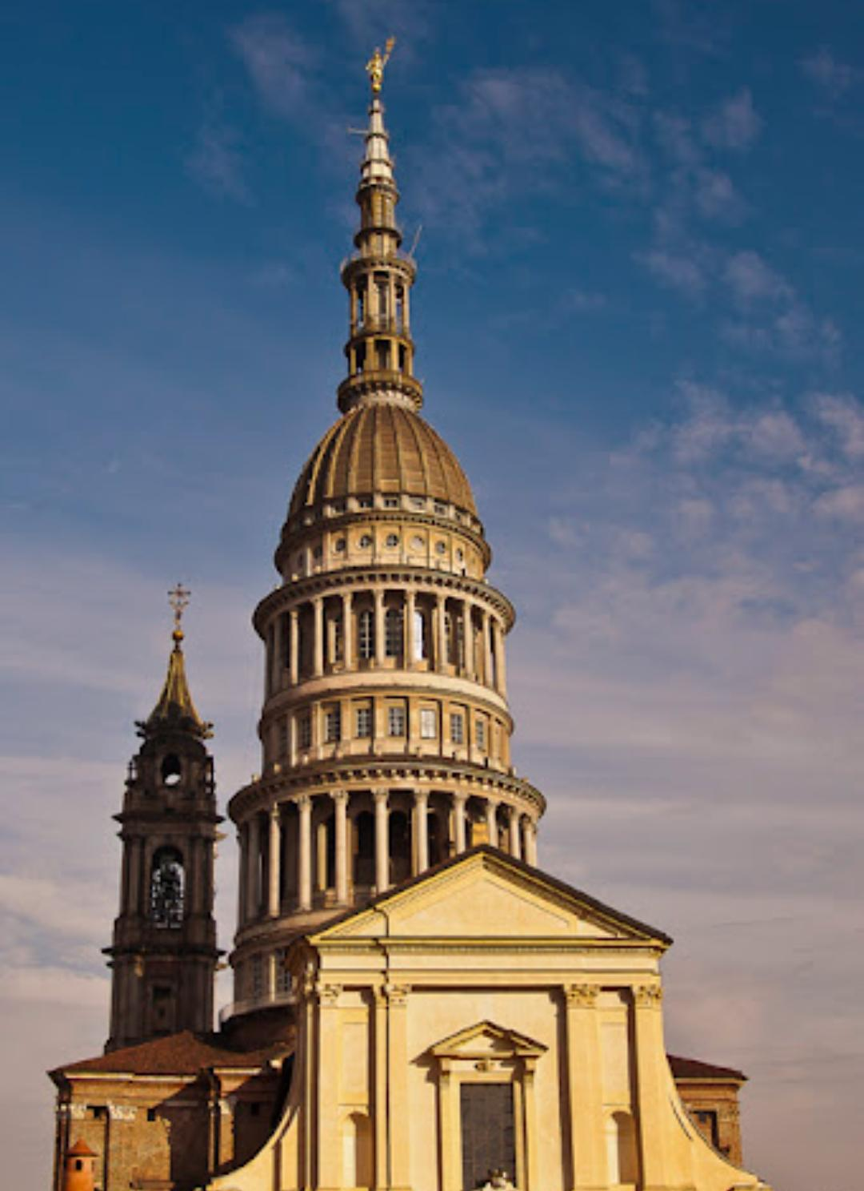
HISTORY OF NOVARA
Novara was a municipium of Cisalpine Gaul.
According to some interpretations, the city was founded by the Ligurians in the preceding descent of the Celts (400 BC). The area would then be called Aria. More recent studies have shown that the Novara area was inhabited in pre-Roman times by Celts who settled between Ticino and Sesia: the Vertamocori
The city plan recalls the Roman origins. It is in fact built around two main streets: the Cardo and the Decumano

With the Roman occupation (196 BC) it was called Novaria. The city was defended by walls built with large river pebbles alternating with brick courses. Sections of these walls are visible in Piazza Cavour and Largo Solaroli. The walls were more than 2 km long, in them there were four doors from which the roads that connected started:
- Novara with Milan
- Novara with Vercelli
- Novara with Tortona and Genoa
- To the north: Novara with the Ossola passes.

ATTRACTIONS
In Novara you can see:
- Basilica of San Gaudenzio, dedicated to San Gaudenzio was built on the highest point of Novara between 1577 and 1690 on a project by Pellegrino Tibaldi. On the other hand, the bell tower, the work of Benedetto Alfieri (uncle of the poet Vittorio), dates back to the second half of the 18th century, and its height of 92 meters has characterized the panorama of the capital for many years, up to the construction of the dome.
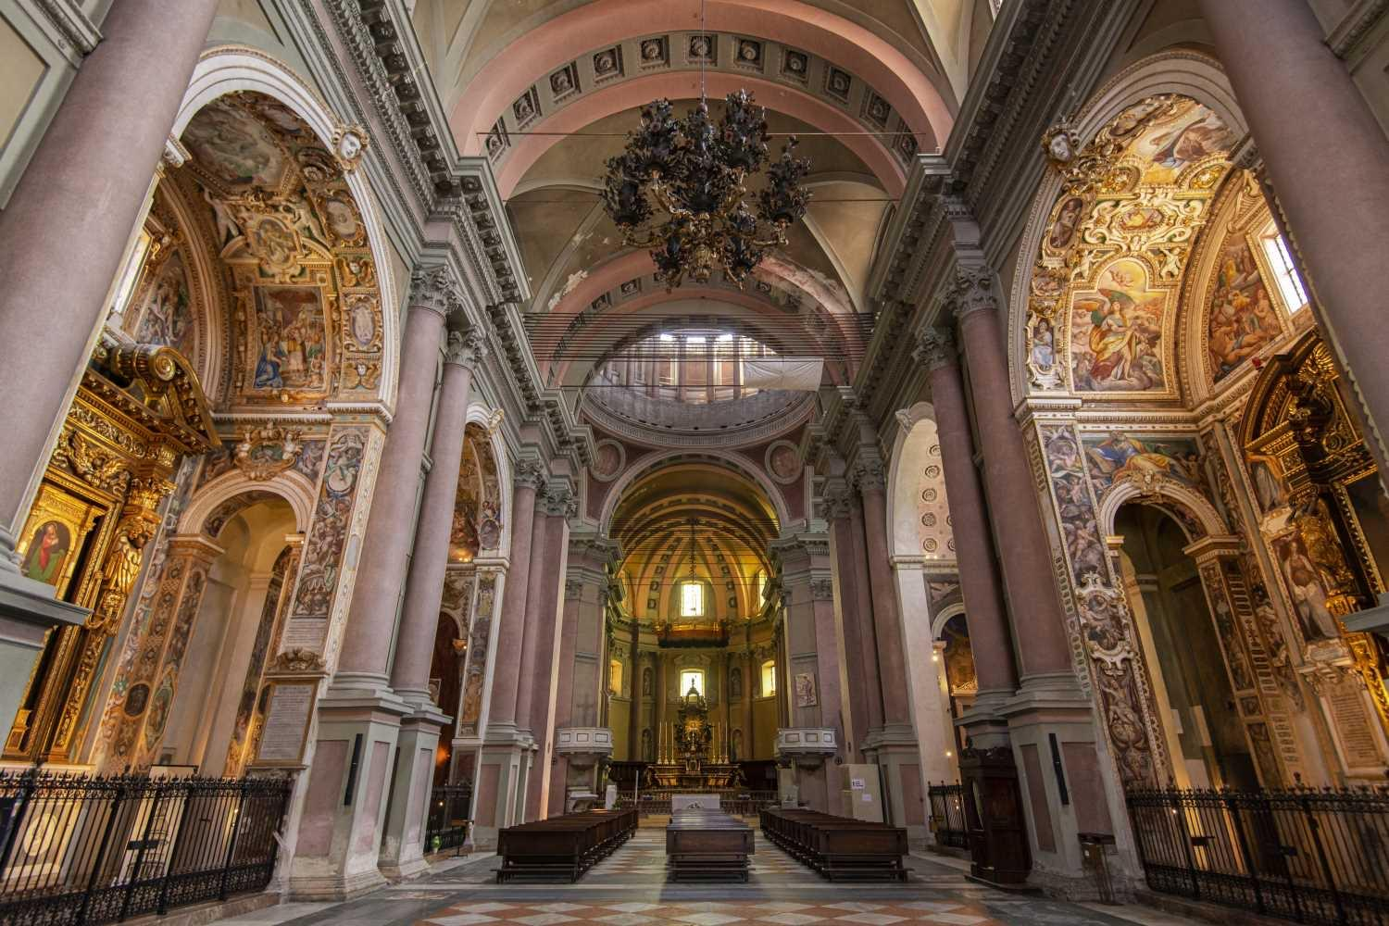
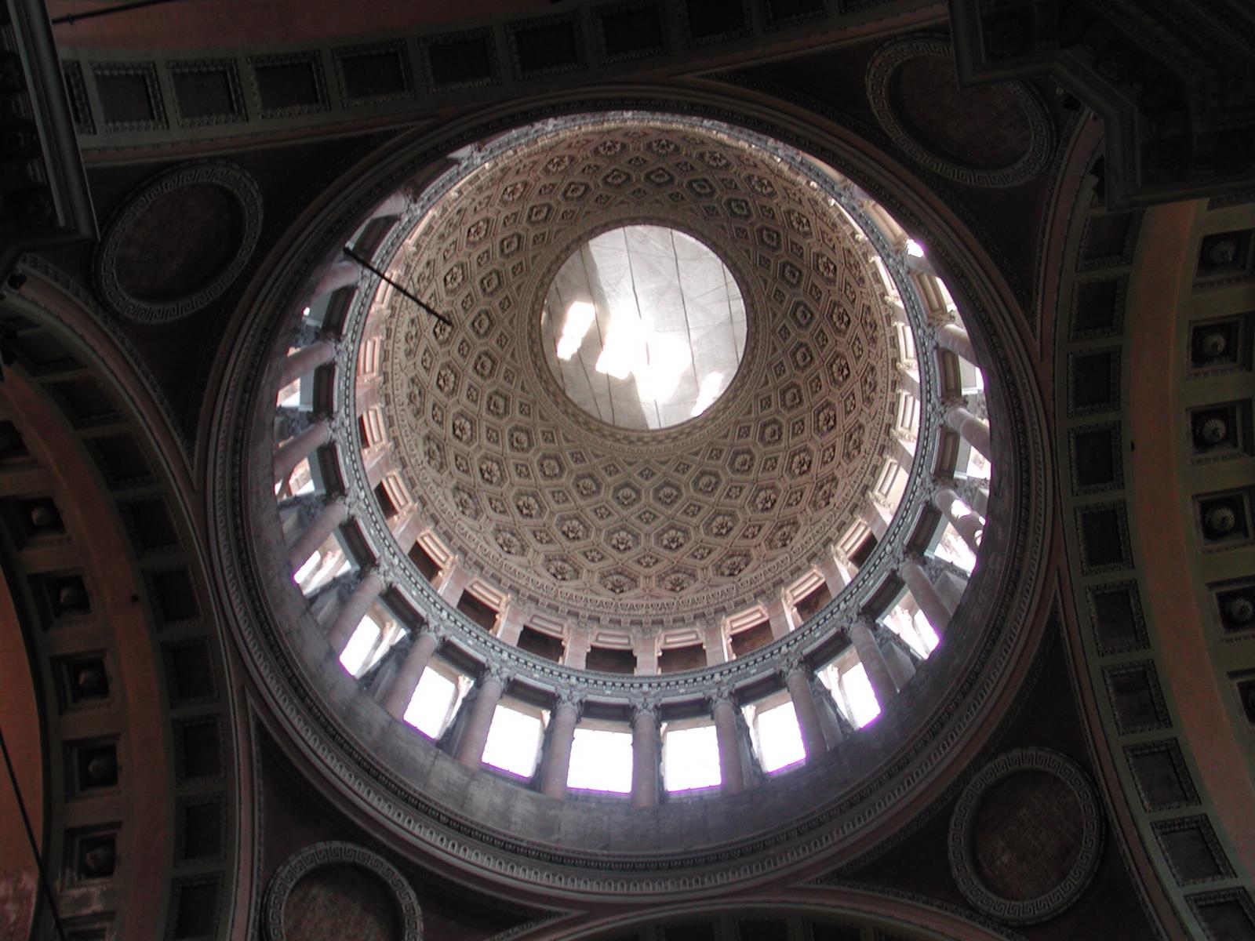

- Roman Walls, The Roman settlement developed in relation to a road junction between the Sesia and the Ticino. From the 1st century BC there is news of Novaria(with the probable meaning of "new city"): it is not certain whether it is a colonial foundation built from scratch as a pole of attraction for several Celtic settlements attributed to the Vertamocori tribe (according to Pliny, belonging to the Insubri Gauls already federated to the Romans from 194 BC) or whether it arose on a pre-Roman center.
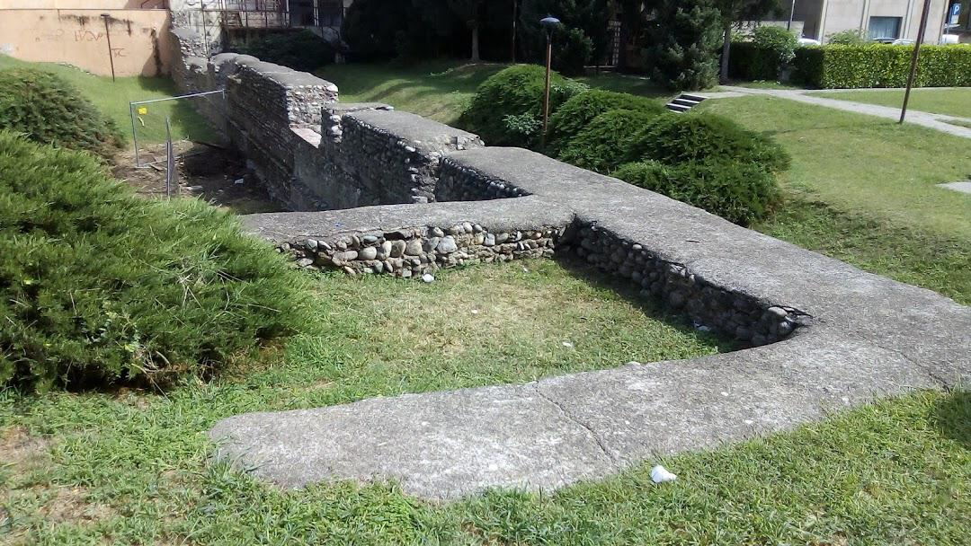

- Art Gallery, is one of the most important art collections in the whole Piedmont region, includes works from the nineteenth century. It is located in the Broletto Monumental Complex, in the historic center of the city.
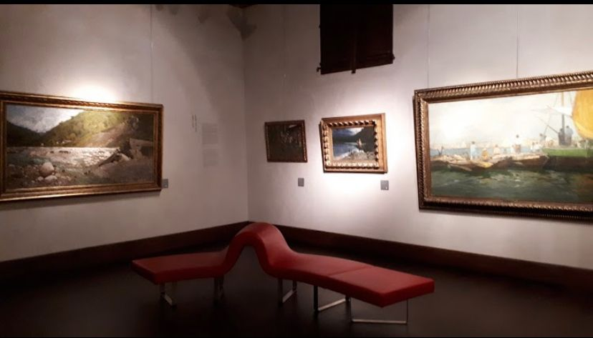

- Biscuit factory, since 1852 Camporelli has distinguished itself in the confectionery sector for its production
Biscottini di Novara, which have now become a real product of excellence.
Five generations and a consolidated centenary experience
guarantee even today the authenticity of the past, thanks to constant attention,
the quality of the raw materials used and the artisanal production.
