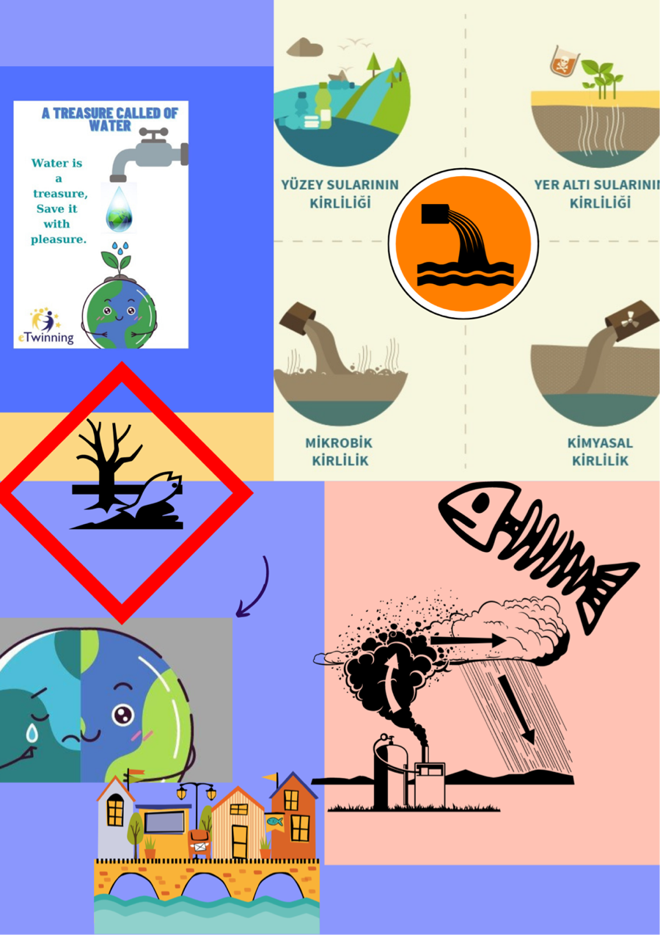

WATER POLLUTION
The level of fresh drinking water is becoming less day by day on the earth. There is a limited availability of drinking water on the earth however that too is getting polluted because of human activities. It is tough to estimate the possibility of life on the earth in the absence of fresh drinking water. Water pollution is the mixing of foreign substances by means of organic, inorganic, biological and radiological in the water degrading the quality and usefulness of water.
Hazardous pollutants may contain various types of impurities including harmful chemicals, dissolved gases, suspended matters, dissolved minerals, and even microbes. All the contaminants reduce the level of dissolved oxygen in the water and affecting the lives of animals and human beings to a great extent. Dissolved oxygen is the oxygen present in water required by the aquatic system to continue the lives of plants and animals. However biochemical oxygen is the demanded oxygen by the aerobic micro-organisms to oxidize organic matters of wastes. Water pollution is caused by two means, one is natural water pollution (due to the leaching of rocks, decay of organic matters, decay of dead matters, silting, soil erosion, etc).

