Voki
tasks are not mandatory

Hi, my name is Philip. I have two tasks for you in this project.
After completing the assignments, your kindergartens (school)
will receive a diploma from us.
1.st Task- create bird houses from recyclabe material.
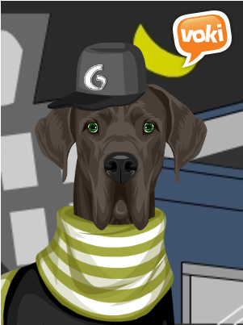
from October to January
2.nd Task- take a photo at least 5 plants or animals (kindergartens)
and at least 10 photos (primary school)
from February to April

I'm holding your thumbs and looking forward to the photos.

