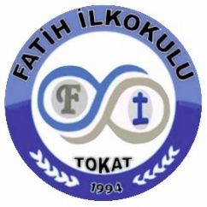
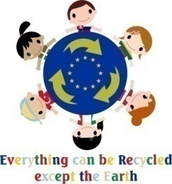

ERASMUS+ K229 STRATEGIC SCHOOL EDUCATION
“Everything can be recycled, except the Earth”
Project number: 2019-SK01-K229-060648_4
5th Learning teaching training activity
Fatih Primary School, TOKAT,
24 - 30 APRIL 2022

23.04.2022 Saturday

Lithuanian team 4 students, 2 teachers
Latvian team 2 teachers
the bus will pick them up at 19:00 o´clock
24.04.2022 Sunday
Slovakian team; 5 students, 3 teachers - the bus will pick them up at 19:00 o´clock
25.04.2022 Monday
08:30- Meeting at the hotel
08:40 - Arrival to school welcoming ceremony
09:00 Fatih Primary School Meeting Hall
Opening Speeches
The introduction and presentation of our city
Presentation for “Turkish National Education System”
10:00-10:30 Tea and coffee break
Visiting the waste products exhibition
10:40- 12:00
*Short movie screening, preschool students recycling fashion Show, “Damat halayı” Show, playback Show, giving madals to eco-friendly kids

13:00- 14:00 Lunch at the hotel
14:15-16:00 The tour of the school and classrooms
16:00 The host families pick up the students
19:30 Dinner at the Angel Garden
22:00- Students return to the hotel
26.04.2022 Tuesday
08:30- Meeting at the hotel garden
08:30-10:30
*Recording a recycling themed music video with the participating students
10:30-10:50- Coffe break
10:50-12.50
*Recording a peace and love themed music video with the participating students
(Students who cannot attend the meeting will attend online.)
13:30 -14:30- Lunch at the hotel
14:30-17:00
Tokat Provincial Directorate of National Education
Tokat Municipality visit
17:00 – Pupils go to families
17:00 – 19:30 free time for teachers – meeting point in the city – going to dinner together (not back to hotel)
19:30 Dinner
22:00- Students return to the hotel

27.04.2022 Wednesday
08:45 -12.00 Sport activities
Water activities (swimming competetion, waterball) – in hotel
Table tennis activities – in hotel
12:30-13:30 Lunch at the hotel
13:30-14:30 visiting TEMA, (an environmental volunteer non-governmental organization)
* A short presentation about the importance of recycling
*Recycle game event
14:45-17:00- Cultural Trip to in Sulu Sokak
- Takyeciler Mosque
- Tokat Museum
- Deveciler Caravansarai
17:00- The host families pick up the students
17:00-19:15- Free time for teachers in Taşhan
19:30- Dinner
22:00- Students return to the hotel

28.04.2022 Thursday
08:20- Meeting at the hotel
08:30-10:00 work shop :Creating post card made of waste paper (Classroom 3/E)
10:00-10:30 break
10:30-12:00 work shop: Making new products from waste products (Classroom 3/E)
(Students who cannot attend the meeting will attend online.)
12:00-13.00 Lunch at the hotel
13:30-21:00
Culturel trip to AMASYA
22:00 Return to the hotel

29.04.2022 Friday
08:30- Meeting at the hotel
08:40-10:00 Playing together Turkish children games at school
10:00-12:00- Coffe break at Tokat Municipality Traffic Training Track
Zero waste education at Tokat Municipality Traffic Training Track
Traffic rules practical training
12:00-13:30 Lunch at the hotel
14:00-17:00 Paintbol event
19:30- Dinner – in conference hall (traditional cuisine)
Certificate ceremony

30.04.2022 Saturday
Departure from Tokat to Sivas airport - teams leave from hotel at 7.00am

Nusret CAMCI
School Coordinator
Erhan ÇARŞAMBALI
Headmaster

