Hearthero

Hero’s diary

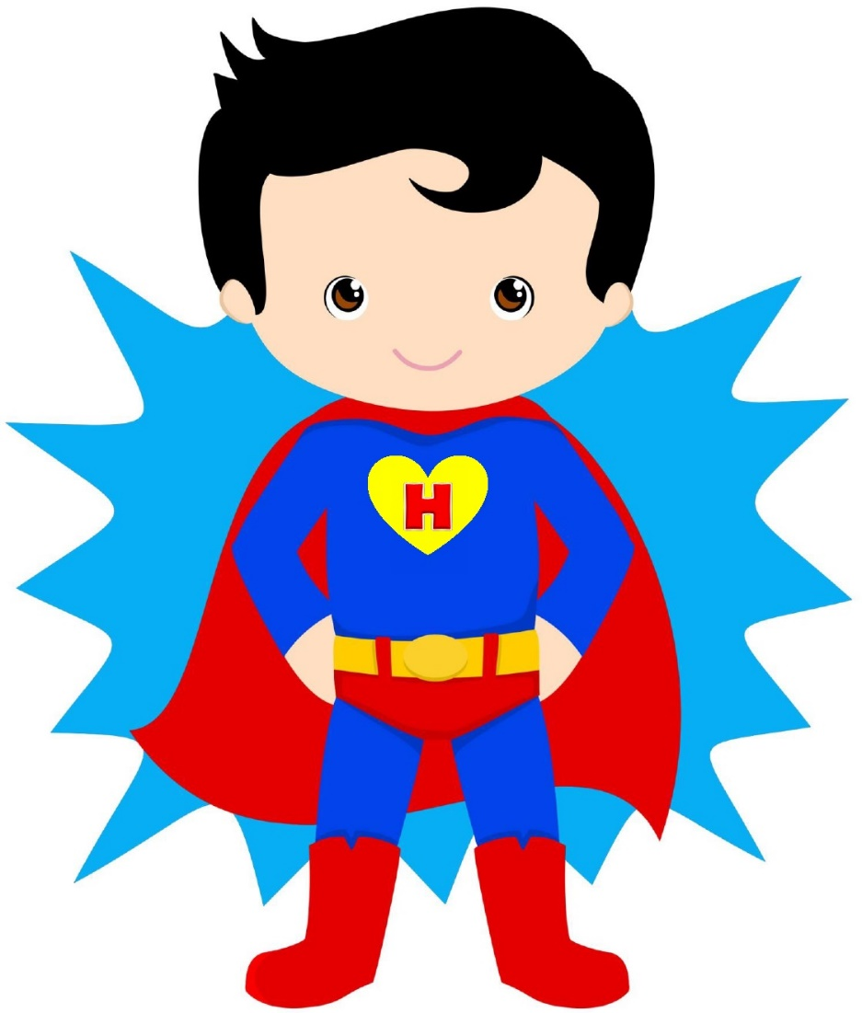

Dear Hero!
My name’s HeartHero and I come from a faraway world called HeartLand. I visit less developed civilisations in the entire Universe and help inhabitants to open their hearts.
Join me, friends, and do good deeds for the benefit of Your Planet, all living creatures and yourself. You don’t need any super powers.
All you need is your good heart.

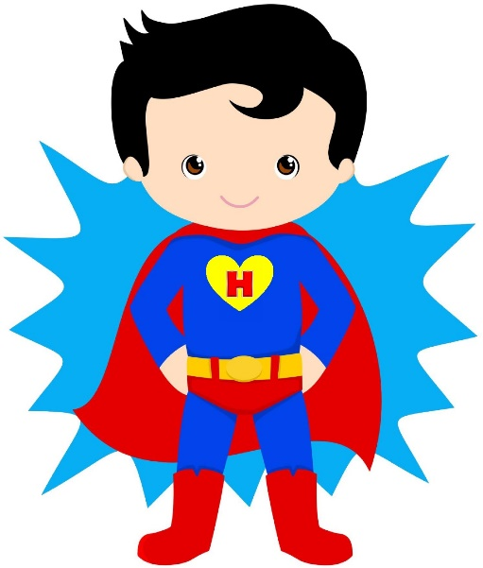

ThIS is me – new hero!

Name:
Year of birth:
About me:

I clean a forest
Environmental campaign
I save water
I recycle
I do not pollute the Planet
I save the Planet

I help and make others happy
I help older people
I help younger ones
I help classmates
I help animals
I help ill people

Better me, better World
I train
I eat healthy food
I read books
I learn something new
I succeeded

My heroic deeds
Don’t forget to note your heroic deeds down. Write down the date, what you did, how and why, how it helped and how you felt when you accomplished it. You can share your deed with others and inspire them to do other good deeds that help.

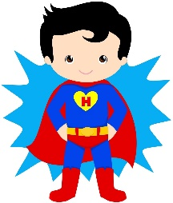
- Date:
- What I did and how I did it:

- Why I decided to do this deed:

- How it helped:

- How I felt when I accomplished it :

