CliMates- Together for the Better

Curriculum Class 9 (10)

Lessons 3 and 4: Watching films

placemat activity

placemat:

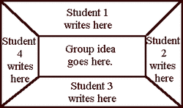

Students are divided into groups of three or four; each group is given a placemat.

Before watching the films, the teacher tells the students that they should think of questions they could ask and that one of their questions (per film) will be answered in a one-minute-video clip.

After having watched film 1, the students give feedback and the teacher makes sure that the students have understood the main points.

Then students in a group write down the questions they can think of, in the section that is directly in front of them. The teacher allows about 1-3 minutes for that. He/she can then tell the students to rotate the placemat. The next person can comment on what is written in the section that is now in front of them, or add something. This rotation continues until everyone has been able to write and read in each section. Then the group chooses the four best questions and writes them in the middle of the placemat.

If there is enough time, two (or three) groups can sit together and choose the four best questions (by crossing out the rest), and then the class decides on the four questions that should be handed in. If there is not enough time, the teacher collects the placemats and chooses the questions later.

For an empty placemat, see the pdf document “PLACEMAT”.

