CliMates - Together for the Better  An Erasmus+ project with partner schools in five EU countries. | 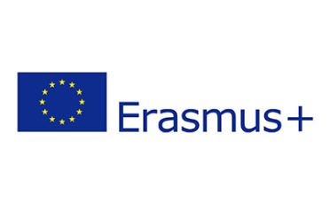
- The home towns of the five partner schools are indicated on the map. Label them with the following terms:
Estonia, Germany, Hungary, Martinique, Tenerife
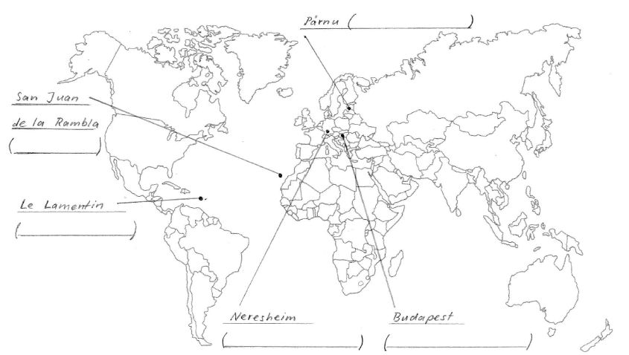

- Listen to the presentations and answer the following questions:

I Estonia

- Estonia has been independent since 1991. Before that, it used to be part of the Soviet Union. How many Estonians and Russians live in Estonia today?
a) one million Estonians b) five million Estonians c) 100.000 Russians d) 300.000 Russians
- How many percent of Estonia is covered by forests? a) 20% b) 30% c) 50%
- How many percent of Estonia is covered by bogs? a) 10% b) 20% c) 30%
- Which statement(s) is/are true?
- Estonia has most internet connections per head worldwide.
- There are bears, wolves and Baltic tigers in Estonian forests.
- The Baltic Sea surrounds Estonia on three sides.

II Germany

- Which is the most important industry in Germany? …………………....
- How many percent of Germany is covered by forests? a) 20% b) 30% c) 50%
- In 2011, the German government has decided the so-called “Engergiewende” (“energy transition”). What is among its aims?
- All nuclear power stations should be switched off by 2022.
- All coal power stations should be switched off by 2022.
- The percentage of renewable energies should be more than 50 % in 2035.
- Which animal died out in Germany in the 18th century, but has been coming back in the last two decades?
a) bear b) wild boar c) elk d) wolf

III Hungary

- Our partner school is in Budapest, the capital of Hungary. How many inhabitants does it have (roughly)?
a) 1 million b) 2 million c) 4 million d) 6 million
- How many percent of the area of Hungary is covered by forests? a) 20% b) 30% c) 50%
- What is the climate of Hungary?
a) oceanic b) continental c) Mediterranean d) subtropical
- Hortobágy National Park in Eastern Hungary is the biggest semi-natural grassland area in Europe. Which statements are true about this national park?
a) There are wild Przewalski horses. b) It is a dark-sky preserve. c) It is a World Heritage Site. d) There are water buffaloes.

IV Martinique

- Which country does Martinique belong to? ……………………………………………….
- Which continent did ancestors of most Martinicans come from? ………………………………
- What are the seasons in Martinique? What is typical of them?
1) …………………………………………………..……….…… 2) ……………………….………………………………..………
- Which animals can you find in Martinique?
a) green iguanas b) dolphins c)mosquitoes that transfer malaria
d) corals e) manatees f) monkeys
- In which respect(s) does or will climate change affect Martinique?
- probably more hurricanes
- rising sea level
- bad-smelling algae pollute beaches
- corals die

V Tenerife

- Which country does Tenerife belong to? ……………………………………..
- In what respects is Tenerife affected by climate change?
- Poisonous microalgae pollute beaches.
- Climate refugees come from Africa.
- Sharks which do not find enough fish attack people.
- Rising sea level.
- ”El Teide“ is a popular tourist attraction in Tenerife. What is it?
a) Spain’s highest mountain b) a volcano c) a Moorish palace d) a saltwater lake
- How many endemic plant species (i.e. species that grow in Tenerife and nowhere else) can you find in Tenerife?
a) 90 b) 140 c) 190 d) 240

Algae, poisonous, endemic, fern, iguana, bog, tarantula, algae

- What is the name of the sea that surrounds Estonia on three sides?
a) 90 b) 140 c) 190 d) 240
Baltic Sea
East Sea
Nordic Sea

