Energy Puzzlehunt*

Our “energy puzzlehunt” is well-tested and great fun! At our schools (in Martinique, Hungary, Germany and Estonia), elder students (aged 13 or older), the “climate ambassadors”, teach it to younger students.
Time  (min-utes) | station | content | material
10 | 1: the best insulation | The first part of this station is done at the beginning because the bottles have more time to cool down then. If you have enough time, you can also do it after station 3.  - fill the bottles with hot water (ca 70°C)  - divide students into groups  - competition: Which bottle stays the hottest?  One bottle: without any insulation  Group 1 wraps their bottle in aluminium foil  Group 2 wraps their bottle in blanket or jacket  If there are more groups, you can use other materials, too (e.g. plastic)  Students check the temperature and write it in a table on the board:  beginning 60 min later  no insulation ca 70°C  aluminium foil ca 70°C  blanket ca 70°C  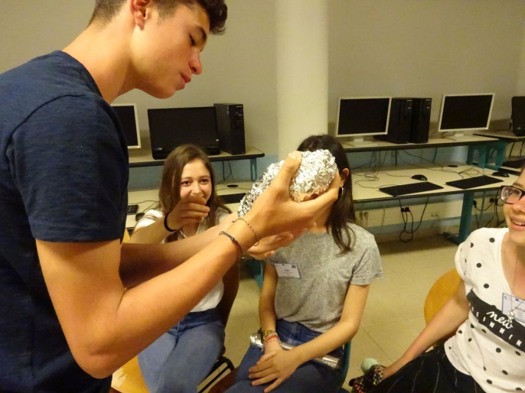  These students called their bottle their “baby” and took really good care of it. | water boiler  thermometer(s)  3 plastic bottles (0,5 l)  aluminium foil  blanket or jacket or …
10 | 2: reasons of the greenhouse effect, greenhouse gases | Draw three pictures:  The earth without any greenhouse gases, 200 years ago, today.  Ask the students which greenhouse gases they know (carbon dioxide, water vapour, methane …) and what effect these gases have on the average temperature on earth. Add the temperatures to the pictures:  -18°C, 15 °C, 15,8°C  Explanations: The light of the sun turns into heat on the surface of the earth, this heat is radiates off. Greenhouse gases reflect this heat back to the earth (→ draw arrows). Without any greenhouse gases at all, it would be much too cold (-18°C).  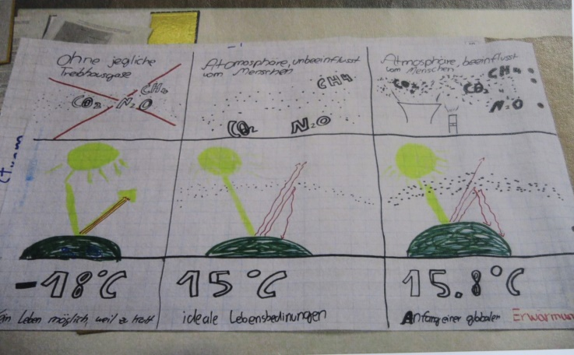  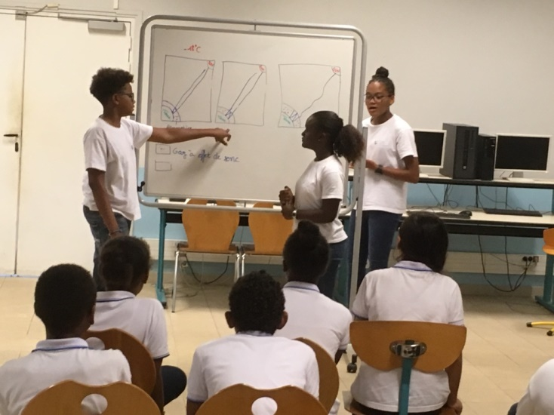  Explaining how the earth heats up | board, different colours
10 | 3: effects of climate change, with a parachute | - students play with the parachute for 2 min;  - students go under the parachute  - measure the temperature  - What do you know about the consequences of climate change?  The person who speaks gets the ball (roll it)  - measure the temperature again  - Why has it become hotter? (because the parachute keeps it from getting out)  What has this got to do with the greenhouse effect? (greenhouse gases keep the heat from getting out)  - ask: Is the greenhouse effect only bad? (No, it is not. Without it it would be -18°C) | enough space;  parachute (Ø 8m for 28 students);  small ball; thermometer
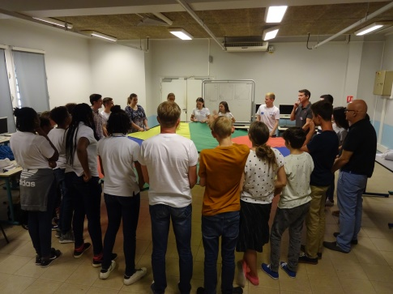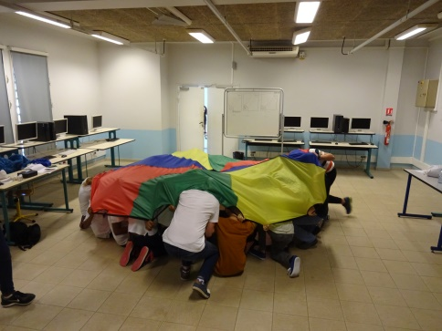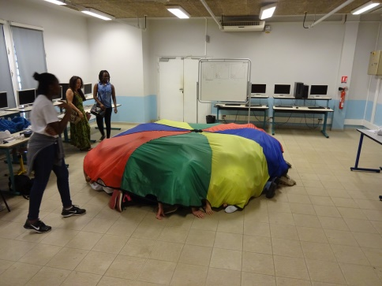
While talking about climate change inside the parachute, you can feel it is getting warmer … .

Stations 4 and 5 are done in smaller groups.
Group 1 starts with station 7, group 2 starts with station 8. After 10 minutes they swap.

10 | 4: luxmeter | You can save electricity if you do not use more light than needed.  Light is measured in lux.  - Tell the students:  for a normal classroom 300 lux is enough,  for a science room 500 lux is enough  - make sure no light from outside comes into the room  - measure the light in the room (put the sensor on a table and go under the table with the display and make sure nobody stands near the sensor)  - try out things (e.g. switch off part of the lights, let in light from outside, …)  - discuss the result  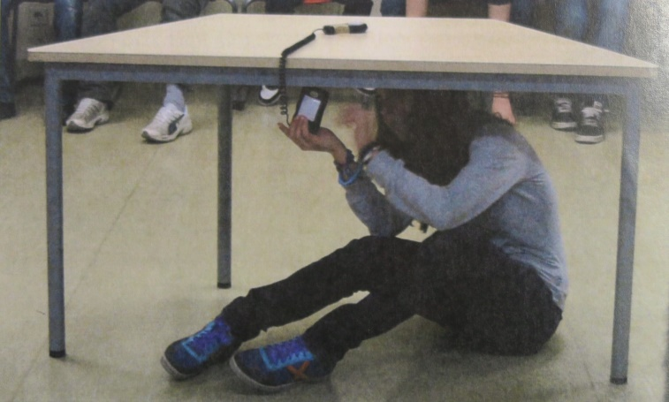  Measuring the light in the room. | luxmeter
10 | 5: saving electricity | - With the power meter, show how you can measure the energy used by a gadget (e.g. mobile phone being charged, water boiler, computer, …)  - Gadgets on standby need around 0,1 to 0,7 watts (our power meter cannot show this). Figure out how much energy could be saved by stopping this.  and / or  - Pick an electronic device of your choice and let the students guess (or figure out) how much energy they need in a year (in a household / in the whole country).  Do the calculation on the board, e.g.  hairdryer TV on standby  power (W) 1000W = 1 kW 0,5 W  hours per day (h/d) 0,1 h/d 22 h/d  days per year (d/y) 365 365  power consumption per year: power x h/d x d/y 1kW x 1/60 h/d x 365 d/y = 6,08 kWh/a 0,5 W x 22h/d x 365 d/y = 4,015 kWh/a  in Germany 6,08 kWh/a x 40 Mio = 244 million kWh/a 4,015 x 40 Mio = 160 million kWh/a  For comparison: A coal power station produces around 5000 million kWh per year, a wind power station around 5 million kWh per year.  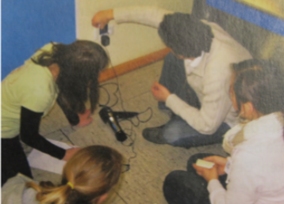  using the power meter | power meter;  electrical devices, e.g. water boiler, hairdryer, computer, gadget on standby (e.g. computer, TV, …)
5 | (1) | Let the students measure the temperature of the water in the bottles & sill in the table – Which group has won? | bottles  thermometer(s)
10 | consolidation | All students stand in a circle. Revise all parts of the puzzlehunt by asking questions. The person who speaks gets the ball (throw it).  - reasons for climate change  - consequences of climate change  - the importance of insulation  - saving light  - avoiding standby power consumption | small ball
ca 65

remarks:
- In Germany, we also do the station “How to air a room properly” (at the same time as stations 4 and 5 – so students are divided into three groups).
- If you are only 2, divide the class into 2 groups (for station 4 and 5). If you are more, make more (and smaller) groups.
- Of course the puzzlehunt should be adapted to the situation in your area (e.g. on Martinique and Tenerife it is more important to keep the heat out, etc.)
- Our climate ambassadors also do little games in-between to increase concentration.

* We adapted this international version of the “energy puzzlehunt” from the “Energierallye” taught to students in the “Umweltmentorenprogramm” (“environmental mentors program”) offered by the German “Jugendstiftung Baden-Württemberg”.

