CliMates- Together for the Better

An Erasmus+ project with partner schools in five EU countries.

- The home towns of the five partner schools are indicated on the map. Label them with the following terms: Estonia, Germany, Hungary, Martinique, Tenerife
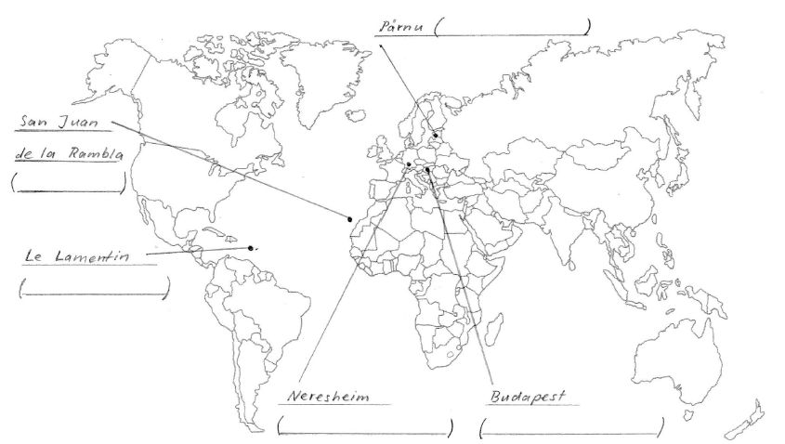

- Listen to the presentations and answer the following questions:

I Estonia
- Estonia has been independent since 1991. Before that, it used to be part of the Soviet Union. How many Estonians and Russians live in Estonia today?
a) one million Estonians b) five million Estonians c) 100.000 Russians d) 300.000 Russians
- Which languages have been official languages in Estonia since 1800 (at different times)?
a) Russian b) Estonian c) Finnish d) German
- How many percent of Estonia is covered by forests? a) 20% b) 30% c) 50%
- How many percent of Estonia is covered by bogs? a) 10% b) 20% c) 30%
- Which statement(s) is/are true?
- Estonia has most internet connections per head worldwide.
- There are bears, wolves and Baltic tigers in Estonian forests.
- Most Estonians are Christians.
- The Baltic Sea surrounds Estonia on three sides.
- There are 2 species of seals in the Baltic Sea. One of them - the ringed seal - has had less and less pups (babies) during the last warm winters. Why?
- there are less fish in the sea
- they are hunted a lot
- they are attacked by several diseases
- they can only pup on ice
II Germany
- Which is the most important industry in Germany? ……………………………………………………………………
- How many percent of the population in Germany is not German? a) 6% b) 11% c) 22%
- How many percent of Germany is covered by forests? a) 20% b) 30% c) 50%
- In 2011, the German government has decided the so-called “Engergiewende” (“energy transition”). What is among its aims?
- All nuclear power stations should be switched off by 2022.
- All coal power stations should be switched off by 2022.
- The percentage of renewable energies should be more than 50 % in 2035.
- Which animal died out in Germany in the 18th century, but has been coming back in the last two decades?
a) bear b) wild boar c) elk d) wolf
- The carbon dioxide emitted by drained bogs in Germany is equivalent to the carbon dioxide emitted by German …
a) air traffic b) cattle c) private households

III Hungary
- Our partner school is in Budapest, the capital of Hungary. How many inhabitants does it have (roughly)?
a) 1 million b) 2 million c) 4 million d) 6 million
- The river that flows through Budapest is the most important river in Hungary. What is its name?
a) Rhine b) Danube c) Thames d) Volga
- The Hungarian language is very different from other European languages. It is only related to one other European language.
Which is it? a) Polish b) Romanian c) Finnish d) Turkish
- What is the climate of Hungary? a) oceanic b) continental c) Mediterranean d) subtropical
- How many percent of the area of Hungary is covered by forests? a) 20% b) 30% c) 50%
- Hortobágy National Park in Eastern Hungary is the biggest semi-natural grassland area in Europe. Which statements are true about this national park?
a) There are wild Przewalski horses. b) It is a dark-sky preserve. c) It is a World Heritage Site. d) There are water buffaloes.

IV Martinique
- Which country does Martinique belong to? ……………………………………………….
- Which continent did ancestors of most Martinicans come from? ………………………………
- Which languages are spoken in Martinique? a) English b) Creole c) French d) Dutch
- What are the seasons in Martinique? 1) …………………………………….…….………………… 2) ……………………….…………….……………….……………
- Which animals can you find in Martinique?
a) green iguanas b) dolphins c) jaguars d) mosquitoes that transfer malaria
e) corals f) manatees g) monkeys h) tarantulas
- What does usually NOT grow in Martinique? a) tree fern b) potato c) banana d) sugar cane
- In which respect(s) does or will climate change affect Martinique?
- probably more hurricanes
- rising sea level
- bad-smelling algae pollute beaches
- corals die

V Tenerife
- Which country does Tenerife belong to? ………………………………….
- Which is the most important industry in Tenerife? …………………………..
- In what respects is Tenerife affected by climate change?
- Poisonous microalgae pollute beaches.
- Climate refugees come from Africa.
- Sharks which do not find enough fish attack people.
- Rising sea level.
- ”El Teide“ is a popular tourist attraction in Tenerife. What is it?
a) Spain’s highest mountain b) a Moorish palace c) a volcano d) a lake
- How many endemic plant species (i.e. species that grow in Tenerife and nowhere else) can you find in Tenerife?
a) 90 b) 140 c) 190 d) 240

