Station 4: Wanted! The best insulation (Nela)

That's the way it works:
Fill three plastic bottles (500ml) with water. Keep them as warm as possible during a longer time. The time is connected with the time of the rally but wait at least a hour.

How to do it:
Fill boiling water (control the temperature, it has to be the same) in the bottles. Write down the exact temperature in each bottle and the beginning of the experiment. Try to isolate them as good as possible. Therefore use materials like foils, jackets and so on, but you are only allowed to warm passively, so do not use for example hairdryers or put it near the heating. After one hour pull the isolation off and control the temperature. In which bottle is the temperature the highest? Can you do a diagram?- What does it say?
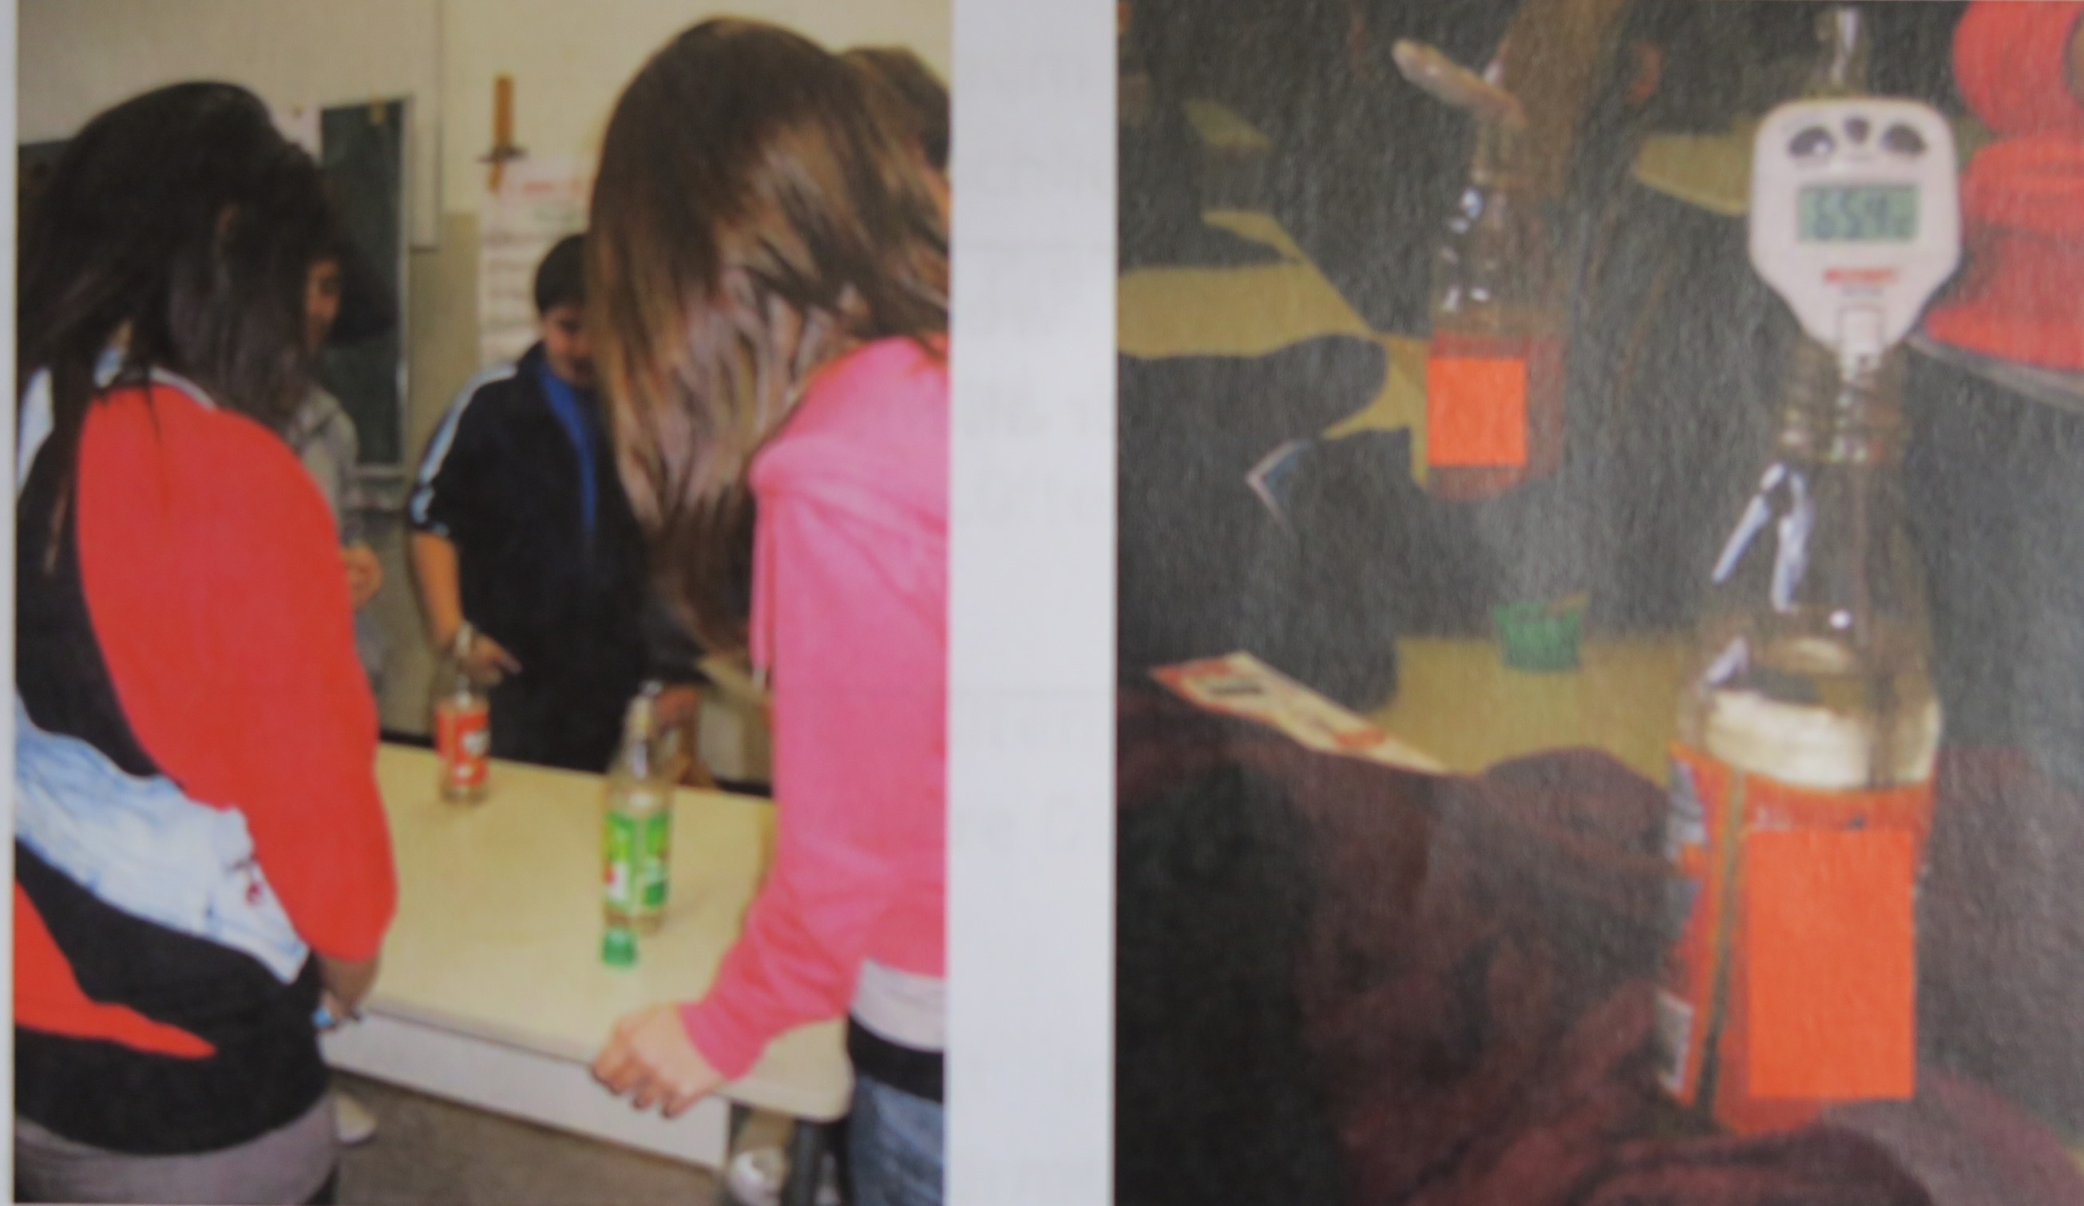
What you need:
Several half-liter hard plastic bottles; hot water (not boiling because bottles would change form); a clock; a thermometer; a pencil; maybe a poster

What you should attend to:
Just use the water cooker when a teacher is around and attend to the distance to electrical outlets.
The start temperature should be as high as possible (not boiling) and approximately the same.
Fill the bottles yourself to avoid accidents.
Let the students help: let them control the temperature and insulate the bottles.
Keep the bottles away from bodies, a heating or other stuff that warms the bottles active (otherwise adulterated solutions). Use jackets, scarps, foils like aluminum foil or plastic foil,...

Tip:
You can insulate one bottle in a special way: do it like a thermos flask (plastic foil, maybe wool, aluminium foil – as straight as possible)

Table:
Draw a table to compare the results. In it should be: temperature at the beginning of the experiment, temperature at end of experiment, difference between these two and maybe which group the winner is.

