STATION 8: WANTED: VAMPIRE POWER CONSUMPTION (Timo)

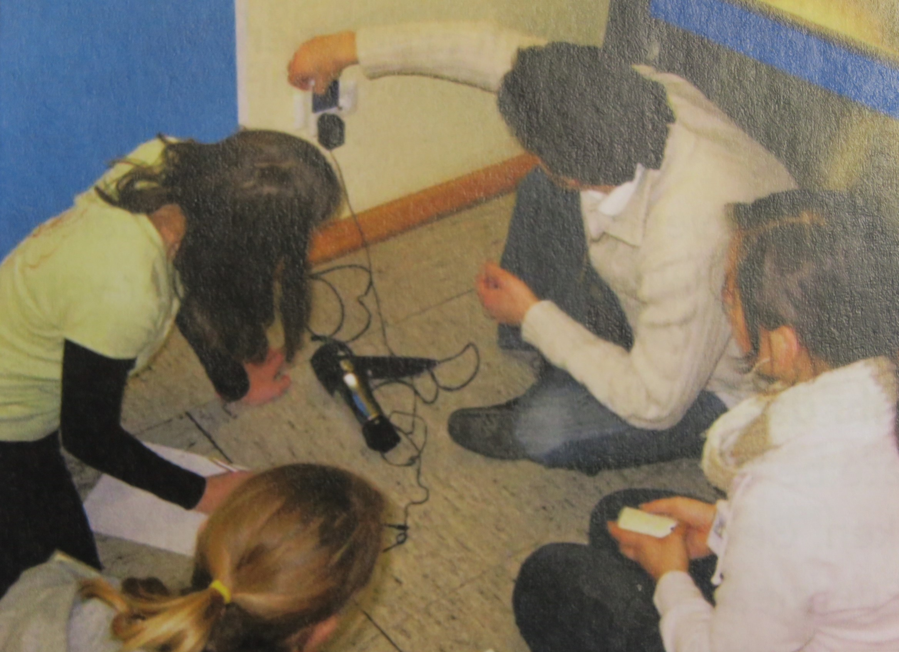
This time we try to find energy wasters. How could we find and stop this energy wasting many people don´t know? Many electrical devices also expend energy when there not powered.
How come? When you have a TV or a rechargeable battery in stand by mode it also needs permanent 6 Watt.
When you think about that, that your TV 20 hours per day the whole year on stand by is. That´s 44 Kilowatthours per year that´s 10 Euro per year you could spend for other things.
When you think that there are milions of households who have more than there TV on stand by the whole year. Experts say that many big energy stations could turned off when the people stop that.
Your task: Search in the classroom and other rooms after devices who are in stand by mode. When you find some make small danger signs.
Which electrical device in your school has the biggest electrical power? You can often find a sign on the device where you can read this. Search for it. A good tip is the main ventilator of your school or an electrical stove when your school have something like that. Now is the question: is this also the biggest energy waster? What do you think?
Your task:
You want to measure how many the different electrical devices expend and how often you use them through the year

How you do this:
Prepare your electrical devices. Put your power meter between your plug socket and the device. Turn the device on and measure the electrical power (in Watt), the energy absorption (in Watthours), the average power (in Watt). Then think how much time you use this machine and estimate the usage throughout the year.
Example:
In every classroom are 30 bulbs with 75 Watt. Per Year there are 200 school days. The bulbs light 2 hours per day.
Calculation:
30 bulbs*0,075kWh*2 hours*200 days=900kWh/a
You can try to calculate the same with 13 Watt energy saving lamps to compare how many energy they need.
Electrical units:
Watt=W
1000W=1Kilowatt=kW
h=hour
d=day
a=year
kWh short for kilowatthours; it says how much energy the machine uses.

Experiment:
What you need:
2 power meters
1 hairdryer
1 computer
1 overhead projector
1 kettle
1 calculator
a pair of sheets and pens

You must do that before the puzzlehunt, because this is a good exercise but you don´t get a completely correct result. So the Group with the result that is near yours should get the points.
You must use the complete same devices for your experiment and for the groups because only in this way are the best results. You should help with the power meters because they can show you different units so help the group so they have the right units.
When you got the annual consumption you will see that when a machine have a high power that don´t mean that it has a big annual consumption, because the annual consumption depends on the term.
Exercise:
Compare the annual consumption of a hairdryer with 1000W and a charger cable for a cellphone with 6W.

 | hairdryer | charger cable
Power (W) | 1000W = 1kW | 6W = 0,006W
Term per day  unit: h/d | ¼ h/d | 24 h/d
Term per year  d/a | 365 d/a | 365 d/a
Power consumption calculation:  power*term per day*term per year | 1kW*¼ h/d*365d/a  91,25 kWh/a | 0,006kW*24h/d*365d/a  52,65 kWh/a

