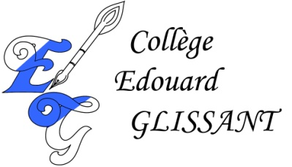
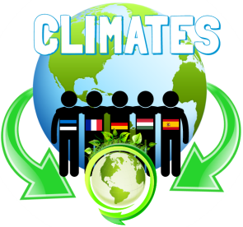
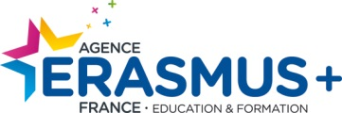
PROGRAMME ERASMUS+ / PARTENARIATS STRATEGIQUES
Projet n° / Project n° :
2017-1-DE03-KA219-035678_4

“CliMates : Together for the Better”
Meeting in Martinique March 17th - 24th 2018

Certificate of attendance

This is to certify that

Xxxxxxx XXXXXXXX

has participated in the ERASMUS+ Meeting in Martinique
on the topic “CliMates : Together for the Better”
March 17th - 24th 2018 in Le Lamentin
at Collège Édouard Glissant
BP-283, 97286 LE LAMENTIN CEDEX 2.

With the support of the Erasmus+ program of the European Union.

Le Lamentin, March 24th 2018
La Principale

Badol Evelyne

