THEORY: What is the greenhouse effect? (Matthias)
Why is it getting warmer on earth? The climate warming is caused by the greenhouse effect. If you go into a greenhouse, you will notice that it is warmer there than outside. In the greenhouse, short solar rays are converted into long-heat waves.

The natural greenhouse effect
You can compare the greenhouse effect of the earth with that of the greenhouse, but the earth has an atmosphere instead of glass panes. The atmosphere consists of different gases, for example nitrogen, oxygen and greenhouse gas. Only throgh them it is so warm on earth, that liefe could develop.

How come? The atmosphere allows a large part of the sun light to pass through to earth. The sun's rays are then converted to heat radiation on the ground. These are now rising, but can only partially leave the atmosphere. The rest of the part is reflected back to earth
So it stays relatively warm under the gas layer. This mechanism is called „natural greenhouse effect“.
The greenhouse effect is a natural phenomenon and vital. The greenhouse effect ensures for an average temperature of 15°C on earth. Without him, it would only be -18°C.
Manmade (anthropogenic) greenhouse effect.
In recent decades, man has emitted more and more greenhouse gases. One consequence is that it is getting warmer and warmer on earth. This phenomenon is called anthropogenic greenhouse effect.
The anthropogenic greenhouse effect causes a temperature increase of 1°C. This can permanently change the climate of the earth
How did that happen?
Industrialization has increased the share of greenhouse gases due to the burning of fossil energy sources.
Fossil energy sources: Fossil fuels have been produced from biomass that died millions of years ago and that has been transformed into coal, natural gas, oil, oil sands and oil shale through geological processes.
Because it takes a long time until new fossil fuels emerge, the human can´t produce new fossil energy sources.
Many human activities produce greenhouse gases, which reinforce the natural greenhouse effect.
This has different consequences: water evaporates, ,more water vapor in the atmosphere enhances the greenhouse effect.
2Thermal energy in the atmosphere causes frequent and severe thunderstorms. The sea level rises and endangers coastal regions.

STATION 1: WHAT IS THE GREENHOUSE EFFECT? (Matthias)
What is the greenhouse effect?
1st step: explain where the term greenhouse comes from
You can use that as an entry:
Global warming is caused by the greenhouse effect. If you go into a greenhouse you will find that it is much warmer there than outside. In the greenhouse, short-wave solar rays are converted into long-wave heat rays and come out only partly.

2nd step: Explain, that the greenhouse effect works in the same way.
Use a blackboard and coloured chalk. Draw the rays of light and the emitted heat rays directly in front of the listeners, so they can follow you.
The panel painting might look like this
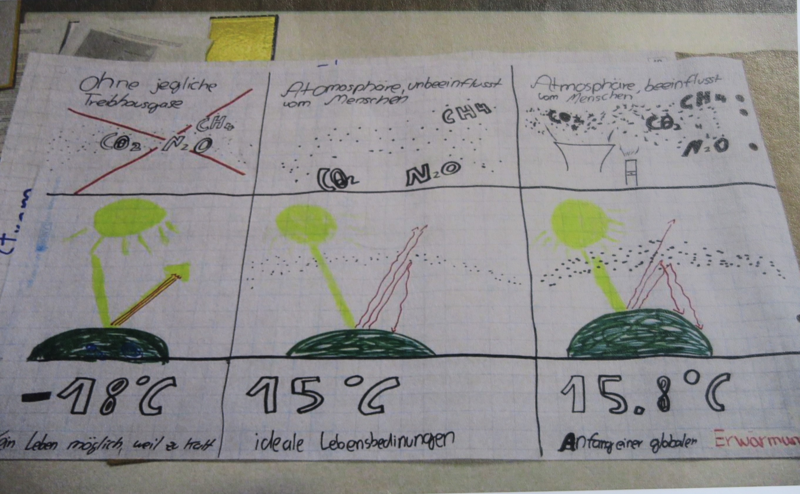
Panel 2a: How does the natural greenhouse effect works?
draw first with yellow chalk
- The earth (round)
- The atmosphere with the natural greenhouse gases (few points around the earth)
- some (yellow) shortwave light rays (UV radiation), which were thrown back into space by the atmosphere
- many more (yellow) shortwave light rays, which reach the surface of the earth and are converted into heat there (you can feel it, when you are in the sun and your skin is getting warm).
Draw now with red chalk
- two, three long-wave heat rays (infrared rays), which emanate from the surface of the earth and enter the space
- two other (red) long-wave heat rays, which emanate from the surface of the earth and be reflected in the atmosphere by the natural greenhouse gases
It is very important that you say, that the natural greenhouse effect is vital for humans, because without the natural greenhouse effect it would only be -18°C on earth. Only by the greenhouse gases, the heat rays can be reflect back at the atmosphere and warm the earth up to an average temperature of 15 ° C.
Natural greenhouse gases are for example carbon dioxide, which is formed in the carbon cycle and becomes free there. Or nitrogen oxides, which is produced during the rotting of plants. Further examples are methane and water vapor.

6 Panel 2a: how has man strengthened the greenhouse effect
draw the picture with the earth and the sunbeams first, but then:
- additional small points (greenhouse gas particles) around the earth, which show that the greenhouse gas layer has become thicker,
- some (yellow) short-wave light rays, which come from the sun and have already been reflected back into space at the atmospheric layer.
- Many more (yellow) light rays, which reach the surface of the earth and are converted into heat there.
Draw now with red chalk
- Two (red) long-wave heat rays, which emanate from the surface of the earth and enter the space
- Many more (red) long-wave heat rays, which also emanate from earth, but they meet the greenhouse gases of human origin and were reflected back from these to the earth
It is very important, that in the case of the people-enhanced greenhouse effect, additional CO2 is released into the atmosphere. This happens when burning fossil fuels. The greenhouse effect caused by humans increases an average temperature to 15.7°C.

