Station 3: In the greenhouse (Verena)
This station is there to show the consequences of the greenhouse effect for everybody.
Under the para-balloon close together you can show the group the consequences off the greenhouse effect period the cloth is the atmosphere with the greenhouse gases. The light goes through the cloth. The students are the producers of carbon dioxide which is getting more and more under the cloth period everybody sees how it is getting warm and uncomfortable period you can now talk about the consequences of global warming again. To show the warming to the children you should measure the temperature outside of the cloth and inside period show the thermometer to the children so they can all look at it.
Please note:
The test with the para-balloon doesn't show the greenhouse effect realistically period under the para-balloon the reason it is getting warmer is the body warm of the children because of it it is getting warmer and warmer.
What you need:
A big para-balloon, a so-called seconds-thermometer. You can get a sweeping Clark in any sports shop or at your school.
How it works:
Builders circle and tell the kids to take the class with both hands on the outside of the class period the kids swing the cloth up and down with their hands. On 3 they all swing the cloth up and move three steps to the middle so they can sit on the end of the cloth.
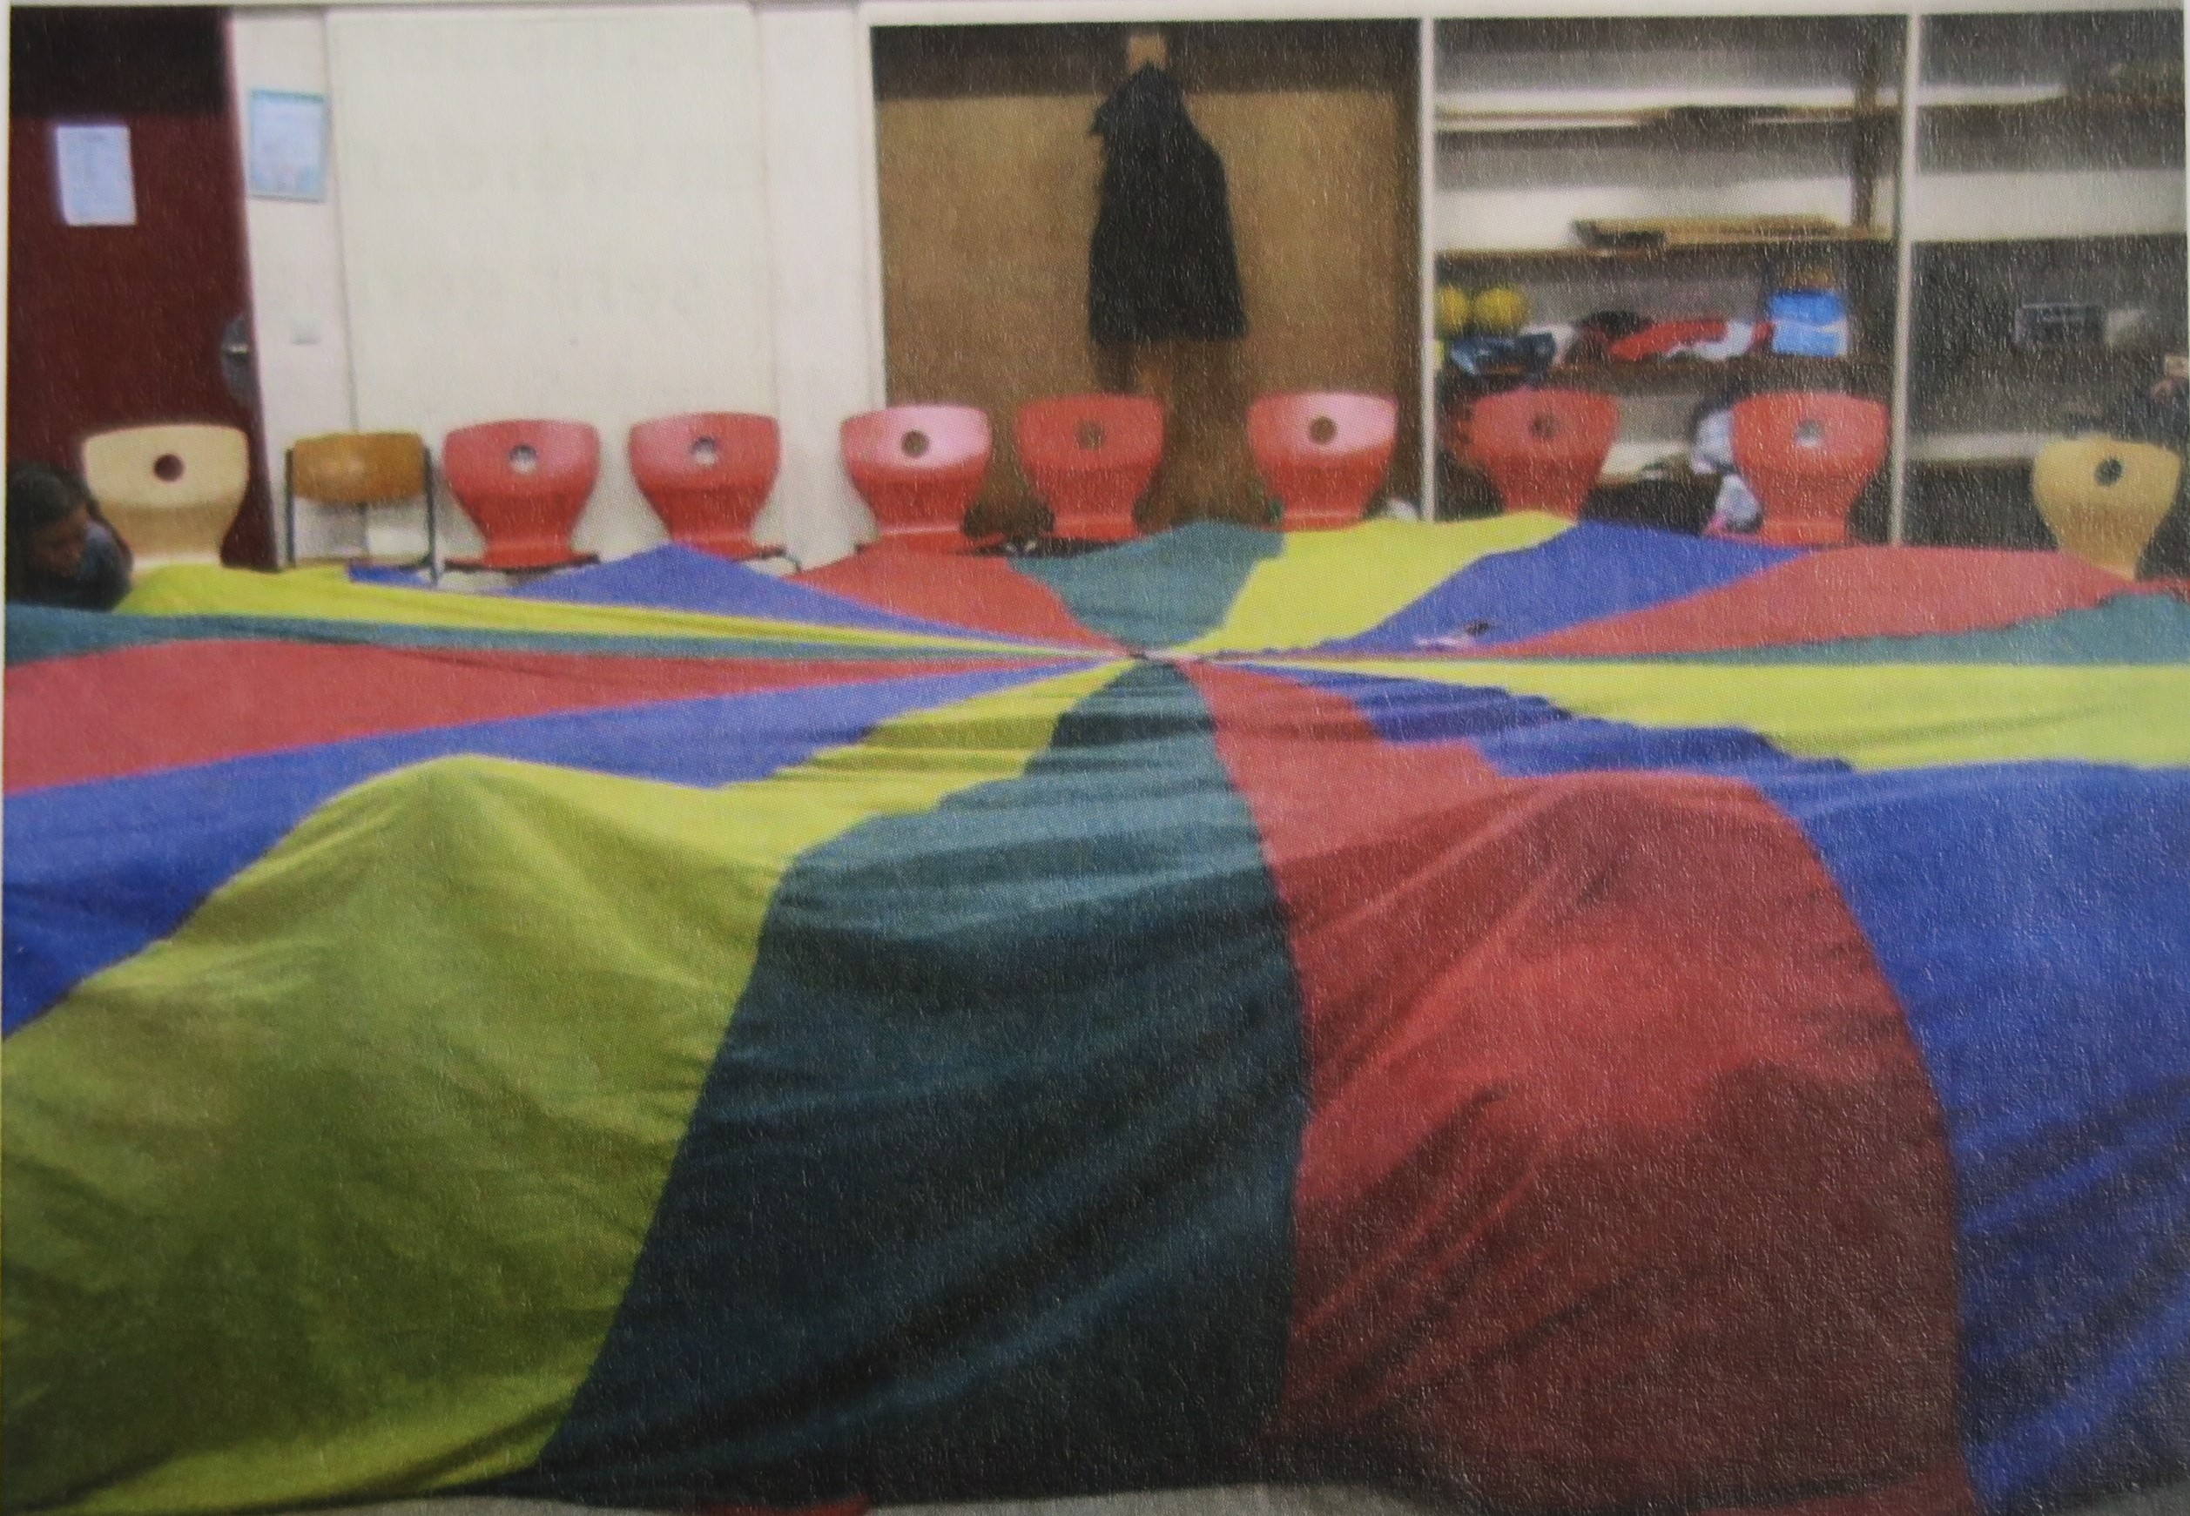
What do you do under the para-balloon? First of all talk and explain.
1. Before you go under the para-balloon measure the temperature and show the thermometer to everybody so they can read the temperature.
2. Under the para-balloon explain the greenhouse effect (para-balloon represents the atmosphere, you and the kids are the cars or fabrics... And a lamp represents the sun). You explain also that it is just a model and not reality.
3. It is getting warmer and more uncomfortable under the cloth. Ask questions to the consequences of the greenhouse effect made by humans. This station is the perfect opportunity to retail the knowledge of the first two stations.

