NERESHEIM
Our school
The „Benedikt-Maria-Werkmeister-Gymnasium“ (a „Gymnasium“ is a secondary school focused on preparing students to enter a university) is attended by around 350 students from Neresheim and the surrounding villages. They all study English as a first foreign language and French, Latin and/or Spanish as a second foreign language. They mostly come from a middle-class background.
Our current year nine students (aged 14 or 15) will definitely be involved in the project, as the topic „sustainability“ will be on their agenda next year (in Biology, which I teach), but also our other students (aged 10-18).
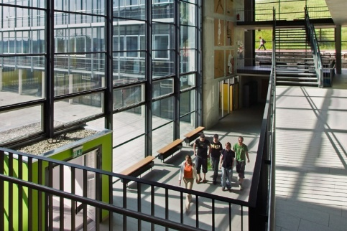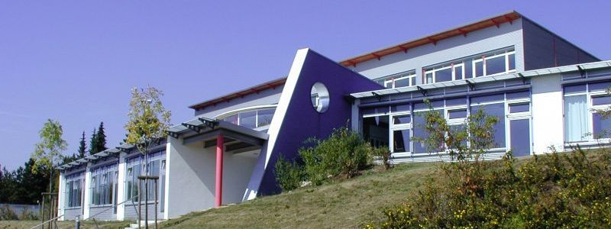

Our team
The seven teachers mainly involved in the project are three men and four women, their subjects are the following: IT/Music, French/German, Spanish/English, English/ PE, Maths/PE, Chemistry/Physics, Biology/English. Four years ago we took part in a Comenius project with a Spanish and an Irish school– very successsfully, getting the best possible rating for our work, and having much fun.

Our town
Neresheim is a small town in Southern Germany (4500 inhabitants) situated in a rural and scenic area within the "Geopark Swabian Alp" and the "Geopark Ries". There is a small, well-integrated Turkish minority and also some well-integrated people of Italian origin. There are some Polish men who come here to work for one oft the companies – those are not integrated at all, because their families are back in Poland, but there aren’t any problems either. There are nearly no refugees. Most oft the inhabitants are Catholic, but there are also several protestants; the collaboration between the two congregations is harmonic. There is very little unemployment. Neresheim is quite famous for its beautiful monestary church. Carnival is very important, with many events and traditional costumes. At the end of June there is a popular village fair „with historical flair“.
Nearby (20 min by car) there is Nördlingen, a town with a medieval center and a complete city wall. Of course is it also possible to organize trips to more touristy destinations like Dinkelsbühl (40 min), Ulm (45 min), Rothenburg ob der Tauber (55 min), Stuttgart (1h 30 min) or Munich (1h 50 min). There are also several castles around, the nearest being medieval „Burg Katzenstein“ (10 min).

Some impressions:
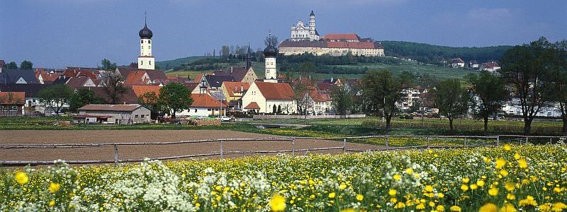
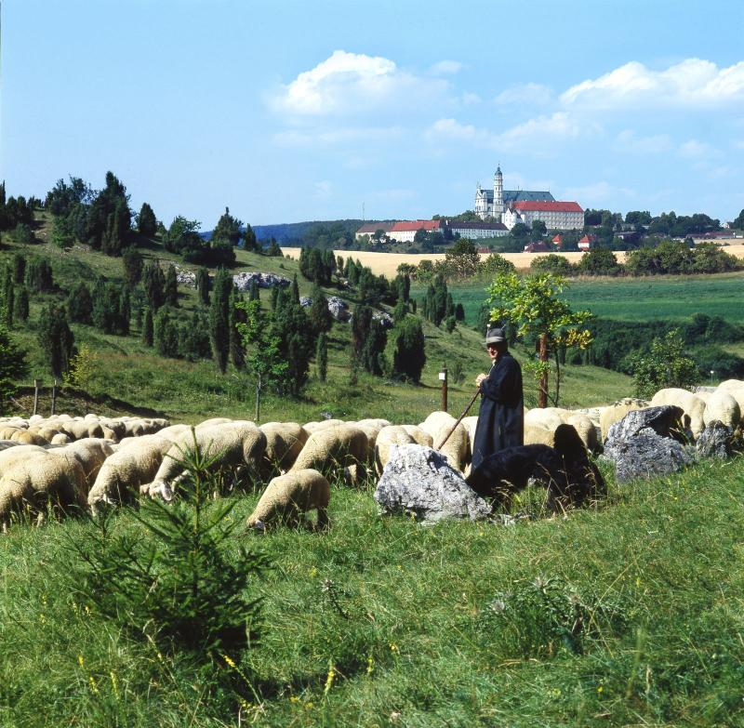

village fair:
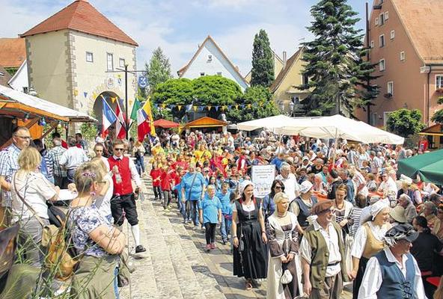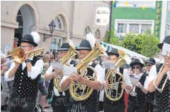
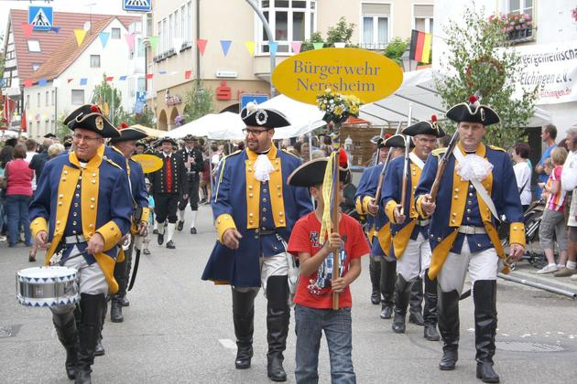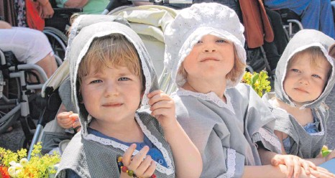

carnival:
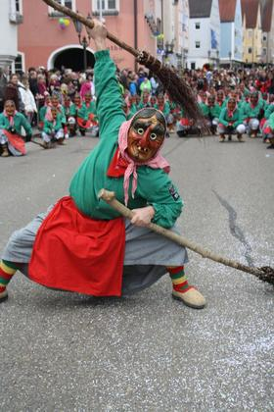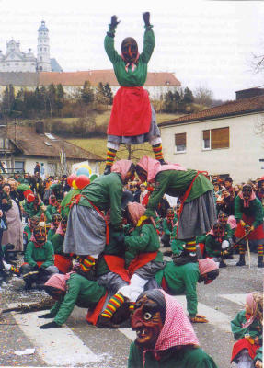

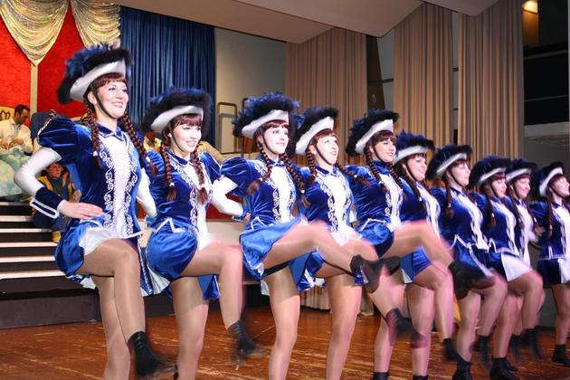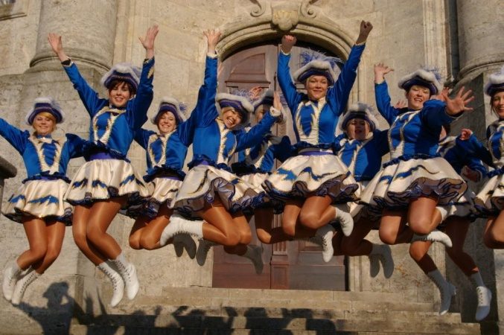

The „Schättere“: one of numerous societies in Neresheim has brought this old locomotive back to life:
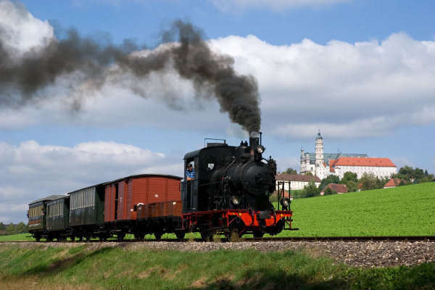
Burg Katzenstein:
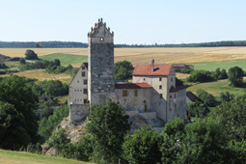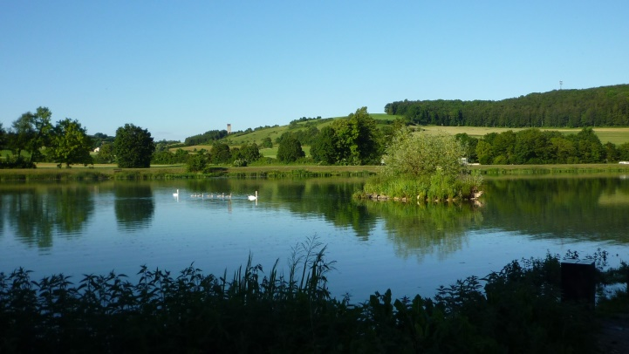
(”Burg Katzenstein“ is in the background)

