DOWNLOADING THE PROGRAM AND STARTING THE PROGRAM IN THE MOBILE PHONE

- Using QR code
The user has to scan the code with the QR-code-reading app and start it.

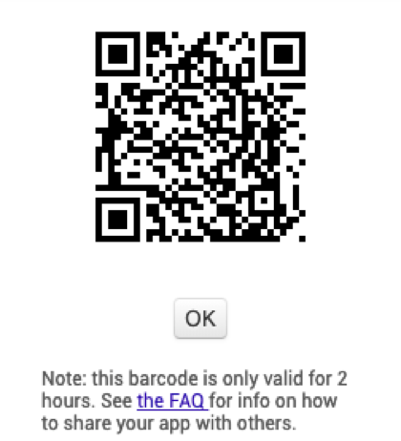

2. Saving the file with the help ph the mobile phone
: Anyone installing your app (which is an ".apk" file) will need to change the setting on their phone to allow installation of non-market applications:
To find this setting on versions of Android prior to 4.0, go to "Settings > Applications" and then check the box next to "Unknown Sources". For devices running Android 4.0 or above, go to "Settings > Security" or "Settings > Security & Screen Lock" and then check the box next to "Unknown Sources" and confirm your choice.
Note: The source code (.aia) files are not executable Android programs -- those are .apk files. The source code is also not Java SDK code -- it can only be loaded into App Inventor.

FILE: https://drive.google.com/open?id=1JH_eQRH4Lb71BpOsj6pxXxFmiuVLNQ5N

