Traditional
Polish food

Chicken soup
Chicken soup is a kind of Polish soup made with chicken meat and bones. Usually, serve with a pasta, sometimes with a home-made traditional Polish pasta.

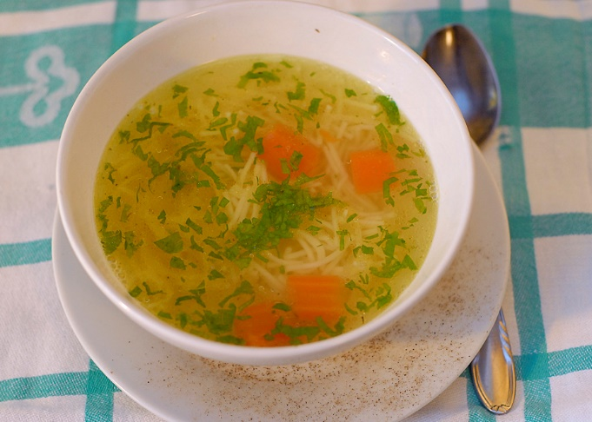

Bigos
Bigos is a tasty and satiating dish make from cabbage.

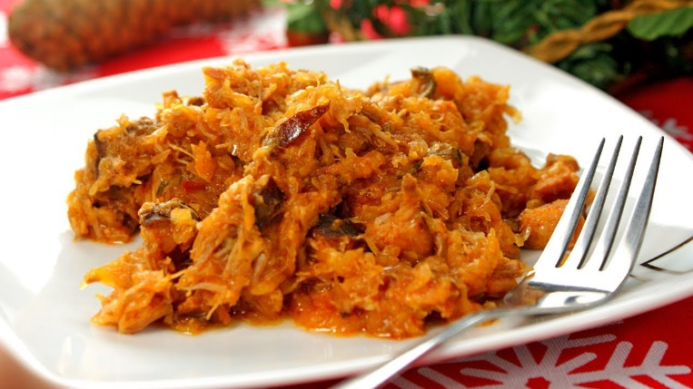

Pierogi

Pierogi are one of the best recognizable Polish foods and they are national dish.

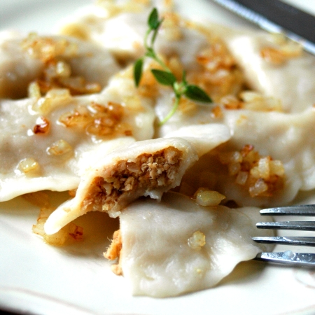

Recipe

Ingrediens:
-400g flours
-1 egg
- 3/5 glas cold water
-Salt
-750g of potatoes
-250g of cottage cheese
-2 onions
-1 clove of garlic
-2 spoons of butter
-1 spoon of oil
-Salt, pepper
Potatoes to peel and to cook in salted water. Onions to peel, to chop and to fry on butter together with crushed garlic. To connect with milled cottage cheese, rubbed with potatoes. To season to taste strongly to taste salt and with pepper. From flours, of vitelluses and waters and particles of salt to knead cake to produce it by about 5 minutes. Then thinly to pin, with large glass to cut out circles. On every from them to put after tea-spoon stuffing and exactly to stick together. To cook in large quantities salted of boiling water with particle of oil to moment till will sail out on top.
Red borscht
Red borscht is a traditional Polish soup made from beetroot. Often surf with raviolis.

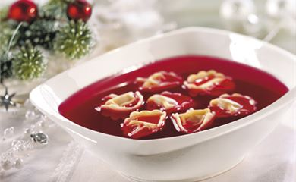
Vegatable salad

Traditional Polish salad, made of vegetables typical for the Polish cuisine: carrot, parsley, potato, celery, sour cucumbers, onion and pea.

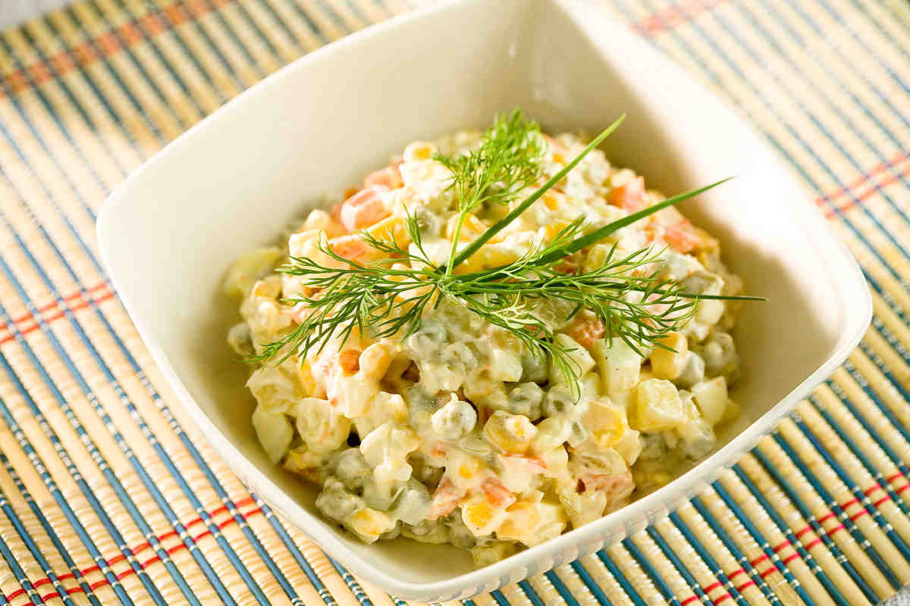
Recipe
Ingrediens:
-2 potatoes, medium-size
-2 carrots
-3 eggs
-1⁄2 apple
-2 cucember
-1 1⁄2 green peas
-1⁄4 cup mayonnaise
-1 tablespoon mustard
-2 tablespoons sour cream
-1⁄2 teaspoon ground nutmeg
-salt and pepper
-1⁄4 cup green onion

Bowl and peel vegatable and mix gently in a large bowl with apple. Add the green peas to the bowl. Add nutmeg and salt and pepper to taste.In a smaller bowl combine mayonnaise, sour cream and mustard. Add to vegetables. Mix all together). Adjust seasoning to taste.
Tomato soup
Tomatou soup is a popular Polish soup made from tomatoes. Surf with rice
or pasta.

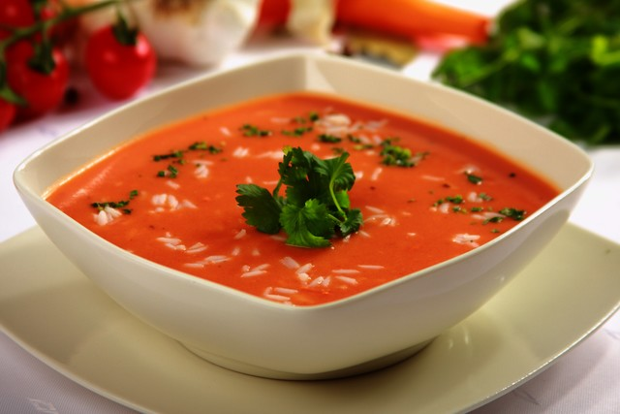

Pork chop
Pork chop is a pork cutlet in a coating, dish up with potatoes or chips and vegetables
.

