This is one of the math’s exersices we work in the fifth grade in Greece
Primary school of Zervohoria
Mr George went to the bank ATM mashineand he took 500 euros from his bank acount.Which paper money the bank gave him if the bank ATM could give only one kind of pa;per money?

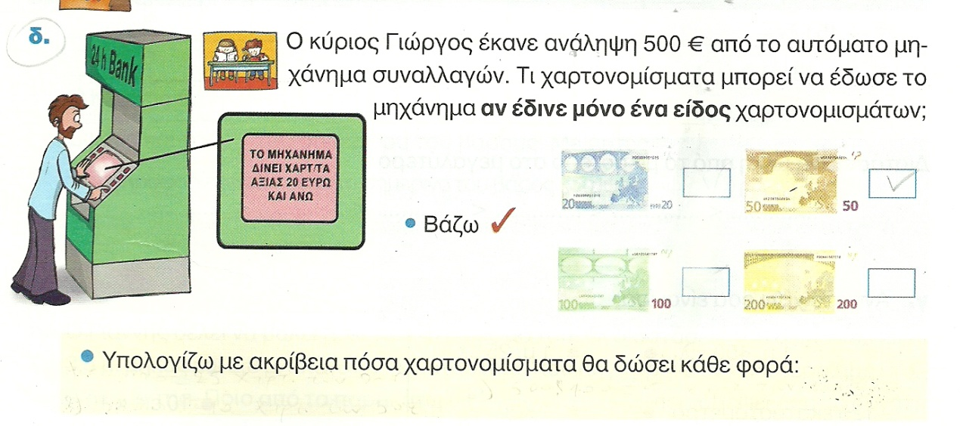
Here I can calculate:

A geometric problem
I calculate the area of each shape
