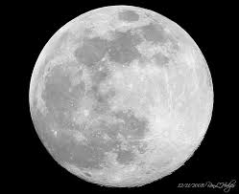
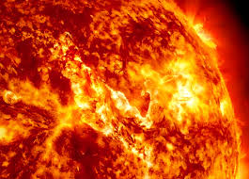
SUN EARTH AND MOON

The sun is
1400 000KM
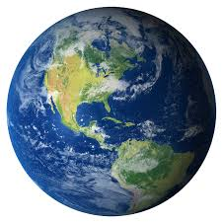
Wide and is 150 000 000 awayFrom the earth and 150 400 000km.

The earth is

