JOURNEY OF SLOVAKIA TO DEMOCRACY
Elections in 1992 indirectly decided about the separation of the Czechoslovak Federation. In July 1992 Slovak National Council adopted a declaration on the sovereignity of the Slovak Republic and in September they approved the Constitution of the Slovak Republic.
On 1st of January 1993 the Slovak Republic came into the world family of independent states. In contrast to the Czech Republic, which kept the most institutions of the former federation, Slovakia had to build most of the institutions from the beginning. The government and the entire country had indeed very serious economic problems.
Slovakia’s Location in Europe:
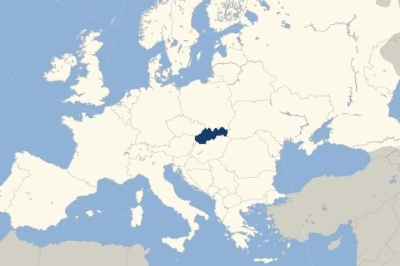
Peaceful divorce gave to the little known Slovakia abroad valuable political capital. Slovak Republic became member of UN, OSCE, IMF, etc. Less satisfactory was development of internal politics and economy, which got into severe crisis.
Compared with 1989 in 1993 GDP dropped to 74%, unknown mass unemployment appeared. Slovak industry, producing until than mainly for the Soviet market collapsed. A great part of military industry was concentrated in Slovakia, which lost its traditional markets, too. Opening of the Slovak market to the world economy decimated producers of the textile and electronics. Necessary reorientation on western markets was long and painful.
The restructuring was slowed down also by lack of capital, the foreign investors were hesitating because of the political climate.
From elections in 1992 to 1998 with short few month break was at power the political party of Vladimír Mečiar – Movement for Democratic Slovakia. In contradiction to parliamentary habits the opposition was pushed out from parliamentary committees and from privatization of the state property. The followers of the ruling party became from one day to the another owners of steel works, chemical factories, hotels, spas, agricultural enterprises with thousands of hectares of soil. Corruption and clientelism made the reforms, functioning of the state administration and courts of justice impossible.
Because of the lack of democratic principles Slovakia was excluded from list of candidates for EU and NATO. There was threat of international isolation, the lagging behind the dynamic developing neighbours was deepening.
This policy mobilized the opposition, which after elections in 1998 formed government headed by Mikuláš Dzurinda. It was formed by broad coalition of left and right parties. In direct elections was elected President Rudolf Schuster. With great effort the lost years were caught up.
The economical reforms made progress, decentralization of the state administration, privatization of banks, insurance companies, telecommunications, large companies. The flow of foreign capital in the country increased. The Government was successful also in breaking through the isolation of the country. In 2000 Slovakia became member of OECD, again was included in the list of candidates for membership in NATO and European Union. With great effort the lost years were overcome.
Even though the elections in September 2002 were won by HZDS, again they did not succeed to form the government. It was formed by Slovak Democratic and Christian Union of Mikuláš Dzurinda together with other three right oriented parties. In the end of 2002 Slovakia received invitation to NATO, few days later the negotiations with European Union were finished.
In present time the country has modern political and economical structures, in human development.
Slovak Republic has succeeded to develop good relations with all neighbours, questions of dispute were always solved by patient negotiations. The history is not such a burden on the present and on the future as well. Slovakia has an over the standard relationship with the Czech Republic, the 10 % Hungarian minority is organic part of the political life and management of the country.
Slovakia has also many unsolved complicated economical, social and political problems inherited from the history as well as fresh ones. Nontransparent privatization left behind the swamp of corruption and clientelism, long time postponed reforms are burden for the schools, health sector, pensions. A long term problem is the life of several hundred thousand of Romas. Slovaks were most affected by economical changes, lack of jobs for nonqualified workers. Fate was always hard, but in the last decade the Roma problem became from social clearly political.
After the velvet revolution the frequent subject of discussion was Slovakia entering Europe. Slovakia was always part of European culture, civilization, its rises and falls. It was never in front rows, but never too long in the last. Its historical ambition was to be in the leading group, if not on the top, than close. This was the fate and objective of many generations. It is tradition, but also present and future.
At present time, the Slovak Republic started the path of economic reforms and progressive changes, which resulted in improving the growth of living standards.
As every country, Slovakia also has to fight with the enemies of democracy. One of them is corruption, political crime and much more. Elections of the president are going to be held in March 2019 which we are sure will be democratic. Elections to the European Parliament will held in May and we hope to increse the particiations of voters on these elections. Next year 2020 there will be elections in the Slovak republic.
We work hard to motivate students to be active citizens and work on this project is also one of the great ways how to bring up and educate active citizens of democratic Slovakia, Europe and the world.
