ERASMUS+ I LOVE SCIENCE!
Form of activitie

Name of the activitie: Checkers
Short description: During the game children will learn to play checkers, follow the game by the rules. Children will teach eachother the rules and tell the difference of up and down, right and left.

Name of the class: Õnneseened Age of the children: 4-5 years
Teachers: Kätrin Pukk and Laura Lisanna Saidla

Purpouse of the activitie: To learn what is and how to play checkers
- The child focuses on the activitie for 20 minutes
- The child follows rules of the game and explanes them to ohter children if needed.
- The child assorts the items by the distinctive features.
- The child knows the right and left
- The child knows the concept of up and down
- The children will be caring towards the ohter players and they understand the consequences of their behaviour toward others.
- The child understands the necessaty of recycling and environmental protection, is caring towards the environment.
Tools: Checkers board with checkers
Tools to build the checkers: ruler, waterproof markers, leftover wooden pillars, black and white paper, wood fiber board of desired size
Detailed description of the activitie:
Before learning to play checkers the children built checkers boards with their teachers. The grid of the game should be drawn on the board, and checkers nobs should be cut out from the wooden pillars. The children can help with writing the numbers, coloring the board and gluing the round shaped papers in the direct colors on the nobs. Our team decided to make life sized boards out of wood, so the game could be played on the ground (indoor or outdoor).
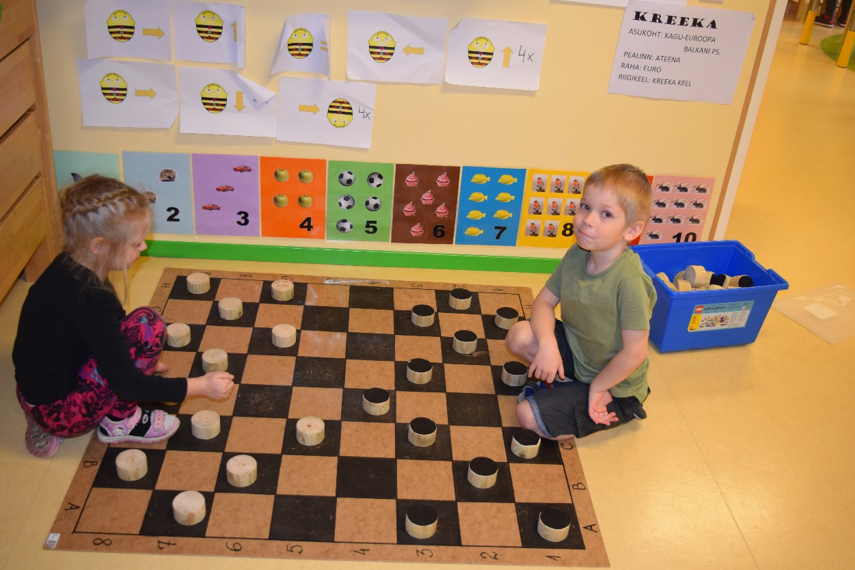
Learning to play:
What is the checkers? Checker is a mind-game or a competition where two partners (parties) compete. Partner in the game can be only one person or a multiplayer team.
Checkers in known from Europe to Asia. In Estonia the most well knows are International checkers and Russian checkers. Estonian championships in international checkers are held since 1955 and Russian checkers since 1949.

The game requires a chess board and 12 nobs for each player. To start the game, the buttons are placed in 3rd row on each side of the starting position, but only in the black fields. Throughout the game, the buttons move on black squares. One player starts and then moves in turn. Each time it is mandatory to complete the gear. The button can be moved only diagonally and only one step at a time, and this square can not be reached with the button already in place. The only exception to this is to knock over the opponent's jump.
If an opponent's button is in the diagonal next to its button and an empty box is behind it, the player can jump over the opponent's button with which it is knocked out and removed from the game. From the new place, you can jump and jump over the buttons and hit the opponent's knobs as long as possible. The game ends when one of the players can no longer move with any buttons or all of his buttons are beaten. In both cases, he has lost the game. It's useful to protect the button so that you always have your own buttons behind them. Then it's not possible to jump over them. It is good to beguile or force the other player so that you can jump over them in the next move. It's especially good if you can jump over several buttons at the same gear.
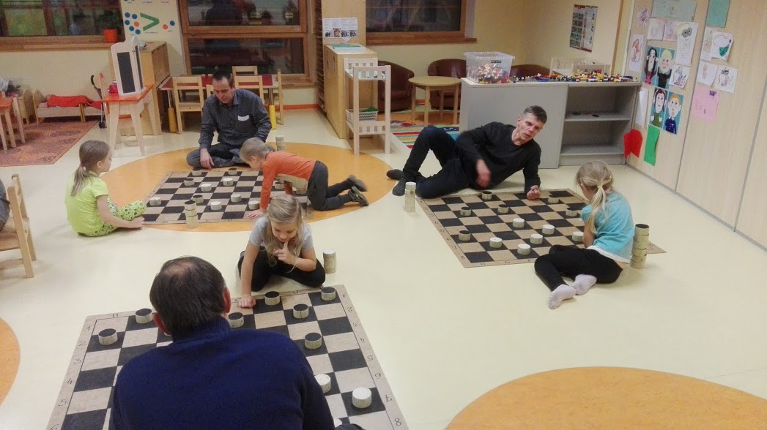

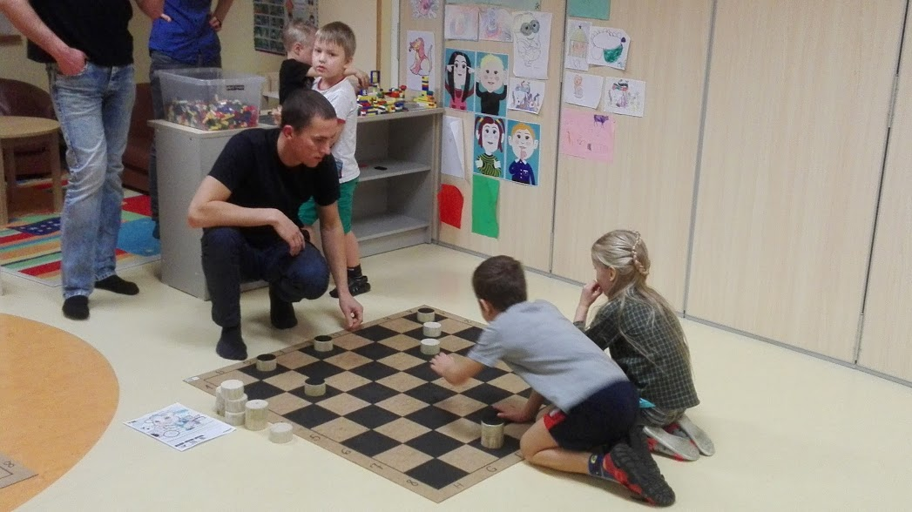
In our class we asked all the parents to join in the game during fathers day. During fathers day all the classes had workshops, so all of our 135 families had the chance to leran to play checkers with their children and also in teams. Also during our Valentines day cafeteria the families had the chance to join in.

