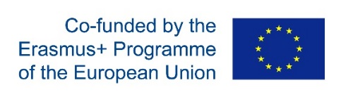

22E00F902CF7A6B2
I LOVE SCIENCE!
Nõlvaku Kindergaten, Estonia, Laagri 20.11.2017
1st Transnational project meeting
MEETING AGENDA
Monday, 20th November
8.15 Meeting at the Baltic station, Tallinn, travelling to Nõlvaku Kindergaten
9.15 Gathering and official welcome at the kindergarten
Introduction of the partners
10.00 Presentation about Nõlvaku Kindergarten
Presentation about the Estonian education system
Excursion at the kindergarten
12.00 Lunch
13.00 Project overview : - the initial check list;
- the initial questionnaire;
- evaluation papers;
- observation documents;
- the work program and types of activities for the clubs;
- format of the science magazine and project magazines.
14.30 Break
14.45 Project overview : - website for the project;
- Twin-space/E-Twinning;
- project logo;
- transnational learning/teaching/training activities;
- formalization of the work in the clubs.
15.50 Break
16.00 Introduction of the Estonian national dance and music by
the dance group Leesikad (Bearberries)
16.30 Early dinner and tasting the Estonian flavours
Teacher presentations
Certificates of Attendance
18.00 Train to the city center
19.00 Excursion in the Tallinn old-town
21.00 Free time
Nõlvaku Lasteaed
Kaselaane 1, Estonia, 76401, Laagri
www.nolvakulasteaed.ee
info@nolvakulasteaed.ee, +372 58 54 6444

