ERASMUS+ I LOVE SCIENCE!
Form of activitie

Name of the activitie: SHAPE BINGO
Short description: During this game the children learn and repeat colors and geometrical shapes thru a bingo-styled activite
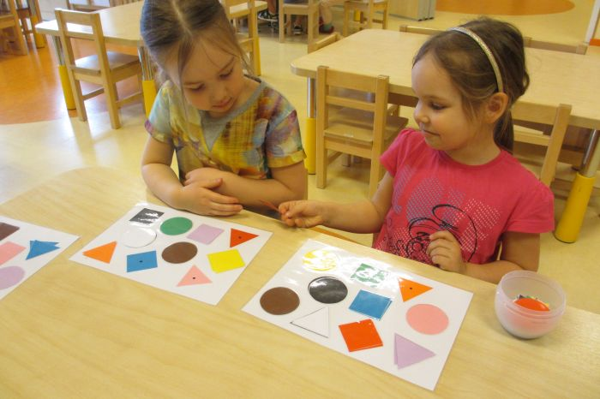
Name of the class: Õnneseened Age of the children: 4-5 years
Teachers: Kätrin Pukk and Laura Lisanna Saidla
Purpouse of the activitie:
- The child is able to watch and notice details, essential features and make logical connections.
- The children work together to achieve the goal
- The child is able to focus on the game.
- The child spells 3-4 syllable words correctly.
- The child tells the names of the geometrical shapes
- The child knows the shapes: circle, triangle, quadrangle
Tools: bingo boards, geometrical shapes

Detailed description of the activitie:
The main rule is everybody to work together, so the goal can be achieved.
To play the game a group of seven children was formed. Out of the seven children one of them is the leader and the other are the players. 6 bingo boards where shared between children.
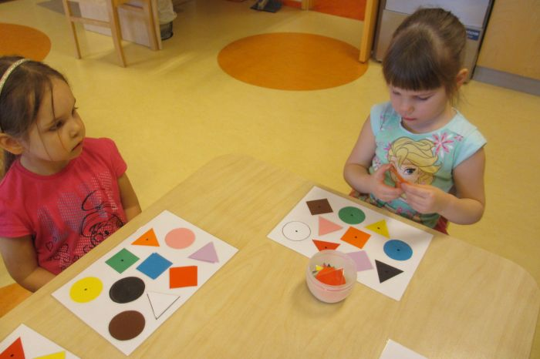
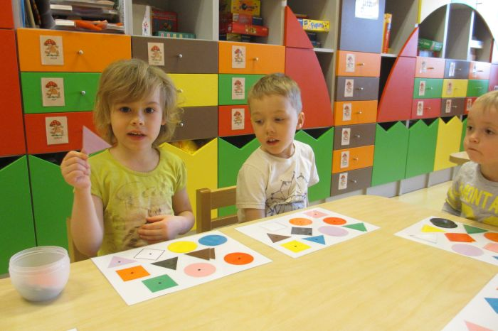
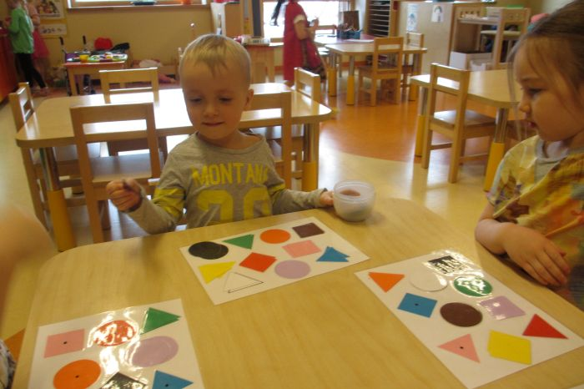
The leader of the game starts to take different geometrical shapes and tells the co-players the name of the shape, and also the color of the shape. Players who has found all the shapes and placed them on the board will yell BINGO – he/she is the winner.
