ERASMUS+ I LOVE SCIENCE!
Form of activitie

Name of the activitie: JOYFUL COLORS
Short description: In this activitie the children learn about colores, expressing the feeling of joy and how to paint with their bodies in a group activitie.
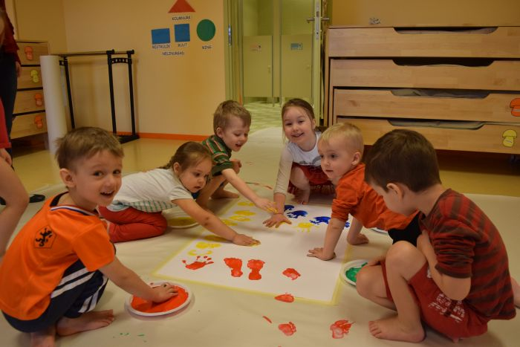

Name of the class:Õnneseened Age of the children: 4-5 years
Teachers: Kätrin Pukk and Laura Lisanna Saidla
Purpouse of the activitie:
- The child can express joy.
- The child enjoy belonging to a group, company of their peer group and joint activities.
- The child co-operates, shares and exchanges tools to achieve the goal.
- The child act creatively, using their knowledge and skills.
- The child can express him/herself.
- The child remembers a poem by his/her heart.
- The child know the meaning of joy.
- The child names colors yellow, blue, green, pink, red.
- The child can apply color to the material by the means chosen by him.
- The child prints with his whole arm and leg.
- The child enjoys participating in art activities.
- The child finds blue, yellow, red and green in the surrounding with the teachers guidance.
Tools: gouache colors, exhange clothes, A1 paper, brushes, cardboard plates, good mood
Detailed description of the activitie:
The theme of the week was "Joyful Colors". With the colors, the teacher and the children could discuss "What is joy?" During the week, we learned poetry and the children chose five colors they would like to discuss/leran about. These were - green, yellow, red, pink and blue. In this regard, we let the children dress daily according to color. Every day a diferent colore was in focuse.
In making the artwork, we divided the children into two groups. In choosing an art activitie the main focus was for the children to be activiely engaged in the painting by using their feet and hands. Each child chose the color he/her liked the most and painted it on the big paper according how he/she wanted – with hands, feet, brushes etc. Through this activity, children expressed their positive emotions.
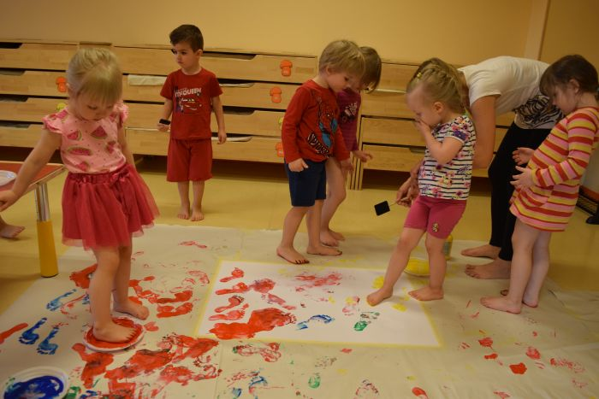
In the activity the children where able to express joy thru painting in a way they like the most. The only thing they needed to concider was ohter childrens artwork and not destroying the painting made by others.
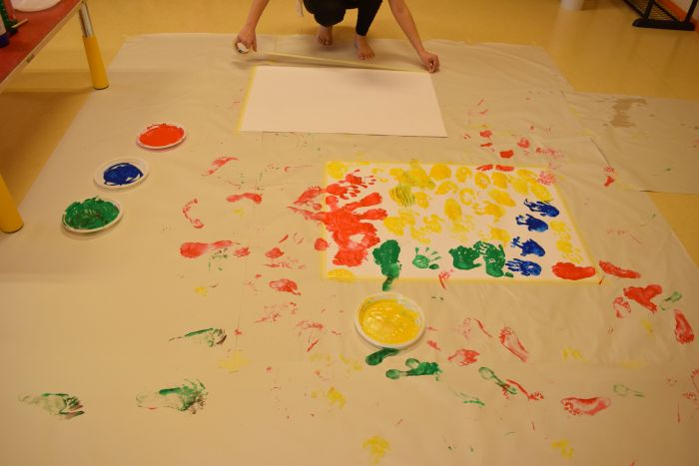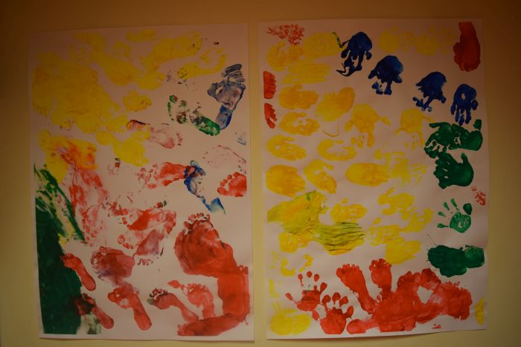

Poem „Ball of happiness“ with movements

I AM A BALL OF COLORES (child squats and shows the shape of a ball with hands)
A COLORFUL BALL OF HAPPINESS (standing up, pointing with the index finger, draws a happy face)
I SIT AND JUMP (child sits and jumps from achair)
AND ALSO SING (says it standing up)
THATS HOW I GROW UP TO BE BIG (lifts hands up above the head)

