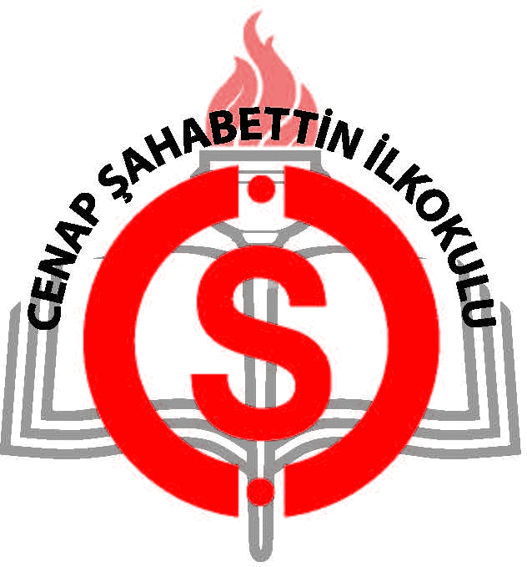

I LOVE SCIENCE!
Cenap Şahabettin İlkokulu, İstanbul, Kadıköy 19-23 March 2018
1st Short Term Teachers Exchange in Turkey

MEETING AGENDA
Monday, 19th March
9.00 Meeting at the Cenap Şahabettin Primary School
9.15 Meeting Ceremony

9.15 Introduction of the partners
Coffee Break

09.30 Cenap Şahabettin School Presentation
12,30 Presentation of Estonian Team ( Presentation of Estonia, Nolvaku Lasteaed and
Science club activities)
Presentation of Romanian Team ( Presentation of Romania, Gradinata cu
Program Prelungit nr.8 and Science club activities)
Presentation of Greek Team ( Presentation of Greek, DES School and
Science club activities)
Presentation of İstanbul with some videos
Presentation of Turkish education system.

12.30 Lunch
Traditional Turkish Cuisine
13.45 Turkish folk dance performance ( Erik Dalı)
Turkish folk dance performance (Zeybek) and Estonian folk dance by
Kindergarden Class B
Turkish folk music(Kindergarden Class A)
’Yine Bir Gülnihal’ Valse Performance ( Kindergarden Class C)
Romanian Folk Dance (Kindergarden Class B)
„Blue Planet“ Musical Drama (Kindergarden Class A)
Greek Folk Dance (Kindergarden Class B)
Turkish marriage dance with all teacher on the stage.
15.30 Tea and Coffee Break
16.00 Presentation of Kindergarden and School in Generally
16.30
16.40 Return to hotel

17.00 Free time
Tuesday, 20th March
8.30 Meeting at the Cenap Şahabettin Primary School
9.20 Turkish Breakfast with Cenap Şahabettin School teachers

9.30 Class Observation
10.10 Kindergarden Class A,B and C

10.10 Tea and Coffee Break
10.30

10.30 Class Observation
11.10 Kindergarden Class A,B and C

11.10 Tea and Coffee Break
11.30

11.30 Class Observation
12.10 Kindergarden Class A,B and C

12.10 Tea and Coffee Break
12.30

12.30 Lunch
13.30 Kardeşim Kebap (Traditional Turkisk Kebap Menu)

13.30 Paper Marbling Atelier Workshop
14.30 at School

14.30 Visiting Maiden’s Tower
15.45

15.45 Walking Harem Coast, Walking around Seaside
16.30 and Tea and Coffe Break

16.30 Return to hotel
17.00 Free time

Wednesday, 21th March
8.30 Meeting at the Cenap Şahabettin Primary School

8.50 Zumba Dance with all students and teachers together
9.10

9.20 Going to Historical Peninsula by bus
10.30

10.30 Blue Mosque
10.50

11.00 Basilica Cistern Tour
11.30

11.40 Haghia Sophia
12.20

12.30 Lunch
13.30 Sultanahmet Restaurant ( Traditional Turkish Meatball Menu)

13.40 Topkapı Palace
15.40

15.40 Archeological Museum
16.40

16.40 Grand Bazaar
17.40

14.30 Visiting Maiden’s Tower
15.45

17.40 Return to hotel
18.40 Free time

Thursday, 22th March
8.30 Meeting at the Cenap Şahabettin Primary School
Going to Beykoz

9.00 Beykoz Glass Atelier Admission and attending a workshop
12.00

12.15 Going to Polish Village ( Polonezköy)
12.40

12.40 Lunch at Barbecue Garden Restaurant
14.00

14.30 Visiting Polonezköy ( 175 years old museum, Church, Glass Art Museum)
16.30

16.35 Bosphorus Tour
17.30

17.30 Return to hotel
Free time

Friday, 23th March
8.00 Meeting at the Kadıköy Adalar Ferry Port Station

8.20 Getting on a boat
9.35 Getting of a boat

10.00 Phaeton Tour
11.15

10.30 Blue Mosque
10.50

11.30 Walking to Aya Yorgi Church
12.30 Visiting Aya Yorgi Church

12.40 Lunch at Yücetepe Restaurant
13.40

15.00 Getting on a boat
16.15 Returning from Büyükada

16.20 Coming to school by Bus

16.30 Certificates of Attendance
17.00 Closing Ceremony

