ERASMUS+ I LOVE SCIENCE!
Dash and Dot go to a festival
Name of the activitie: Dash and Dot go to a festival
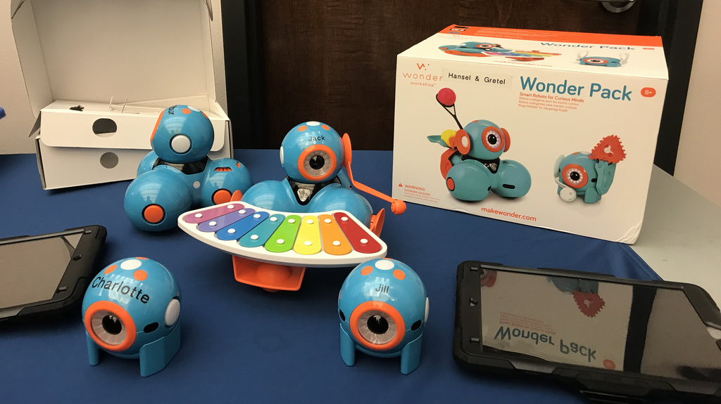

A brief description of the activities: The activities combine different fields: me and the environment, mathematics, reading and writing and art. Each child can create its own special figure – he designs, names and programs it with a tablet using Path for Dash or Go applications.
Group: Vikerkaar
The age of children: 5-6 years
Teacher: Kaisa Heinaplu
Purpouse of the activitie:
- A child must use his creativity to design costumes for the robot.
- A child uses his mathematical skills to sketch out a path for the robot and program it.
- A child has to use verbal communication to present the designed robot for the other kids and record his own speech into the program.
- A child must cooperate with his peers.
Tools:
- Dash and Dot robots,
- Smartphone or a tablet (one smart device for one robot),
- Go application, Path application,
- Handicraft materials and tools – tinfoil, modeling clay, paper glue, colored papers, fabrics etc. scissors.
Detailed description of the activitie:
Teacher divided children into group of two. Every group had its own robot and a smart device. Children crafted together with their partner all the costumes for the robot using various crafting tools. After that kids recorded their own speech into the program, the robot plays the recording when program is launched. For example the robots says: who is he, where he is from, what does he like and etc. The next step was to program the robots movement using Go or Path applications. All applications were introduced to children previously and were familiar with it.

