ERASMUS+ I LOVE SCIENCE!
Form of activitie

Name of the activitie: CREATE YOUR OWN LEGO STORY
Short description: In this activitie the visited Mektory School of Technology, wich offers public courses to all children and students. The children used LEGO StoryStarter kits to learn about mathematics and make up creative stories.
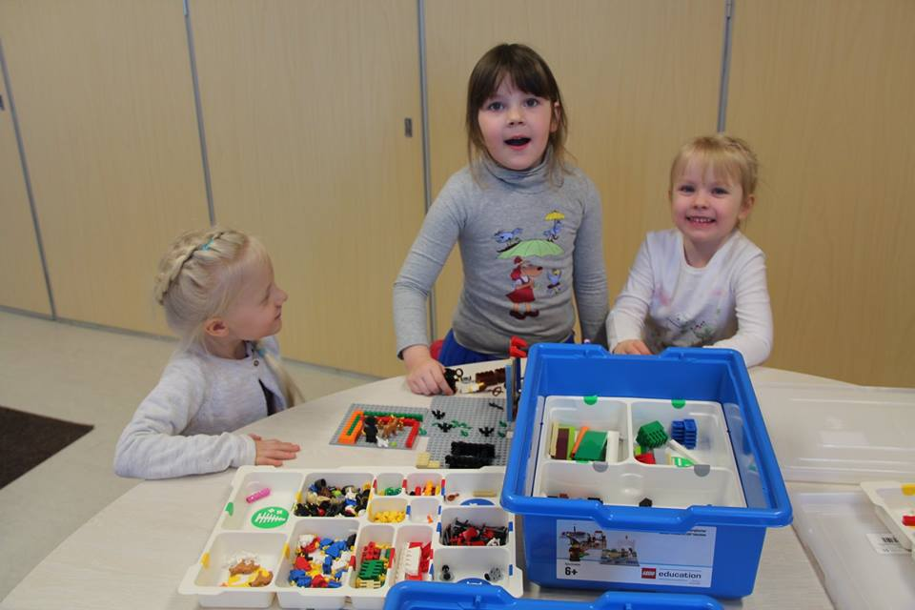

Name of the class: Õnneseened Age of the children: 4-5 years
Teachers: Kätrin Pukk and Laura Lisanna Saidla
Purpouse of the activitie:
The purpose of the educational tool is to develop students' spoken language, reading and writing skills. Students' self-confidence in self-expression and communication with others develops through the character-writing skills and story-thinking skills. The children will learn also about problem solving, accuracy, modeling with geometrical shapes and continuity
Each teaching task supports a specific topic in the language and literature curriculum, but depending on the model being built, it is possible to add tasks to other subjects: mathematics, nature, environment, etc.
Tools: LEGO StoryStarter kit
Detailed description of the activitie:
Children visited Mektory School of Technology to use LEGO StoryStarter learning kits which are used to teach about mathematics (logical thinking, constructing etc), language, speech and literature.
Learn more about using LEGO blocks to teach mathematics: https://education.lego.com/en-us/preschool/intro and https://education.lego.com/en-us/elementary/explore/language-arts
Choose a fairy tale with the children. The fairy tale can be self-designed or modernised actual fairy tale.
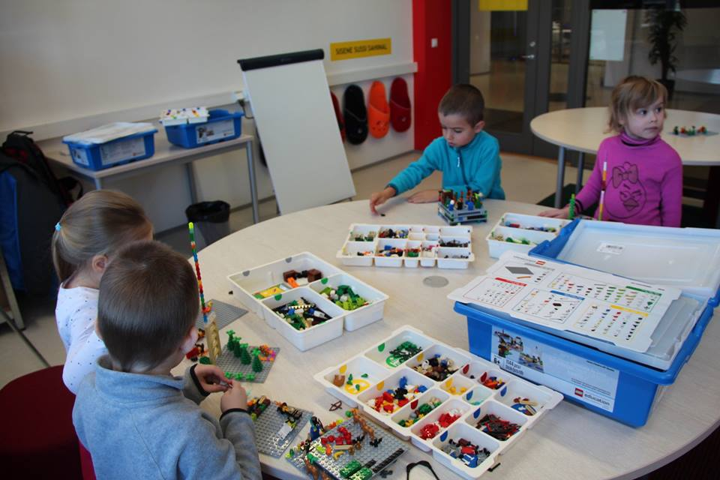
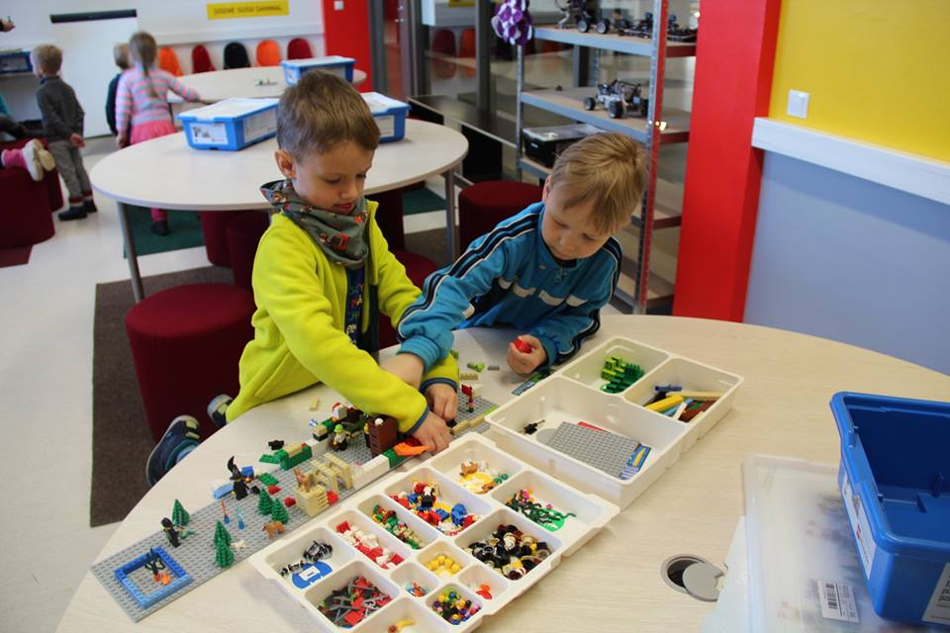
The story begins with the first sentence of the fairy tale and develops from there. Make sure that the scenes reflect the important stages of the story. If the children are old enough use the StoryVisualizer software to add text to the stories.

