ERASMUS+ I LOVE SCIENCE!
Form of activitie

Name of the activitie: ROPE NUMBERS
Short description: In this activitie the child can learn about numbers in a creative way, thru movement and play.
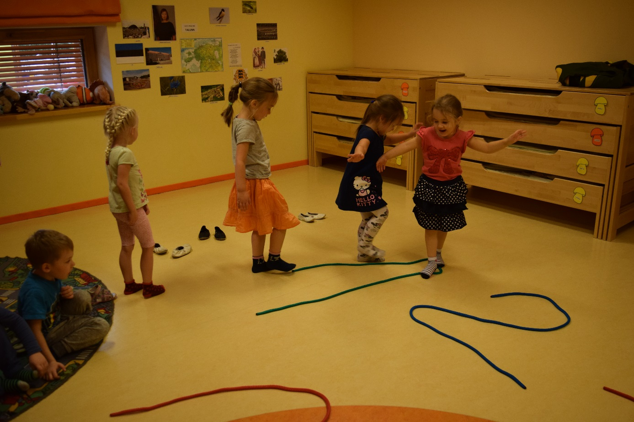
Name of the class: Õnneseened Age of the children: 4-5 years
Teachers: Kätrin Pukk and Laura Lisanna Saidla
Purpouse of the activitie:
- The child can hold his/her balance
- The child learns numbers through physical activity
Tools: colorful ropes or jumping ropes (made into numbers from 1 until 4)
Detailed description of the activitie: In this activitie the child can learn about numbers in a creative way, thru movement and play.
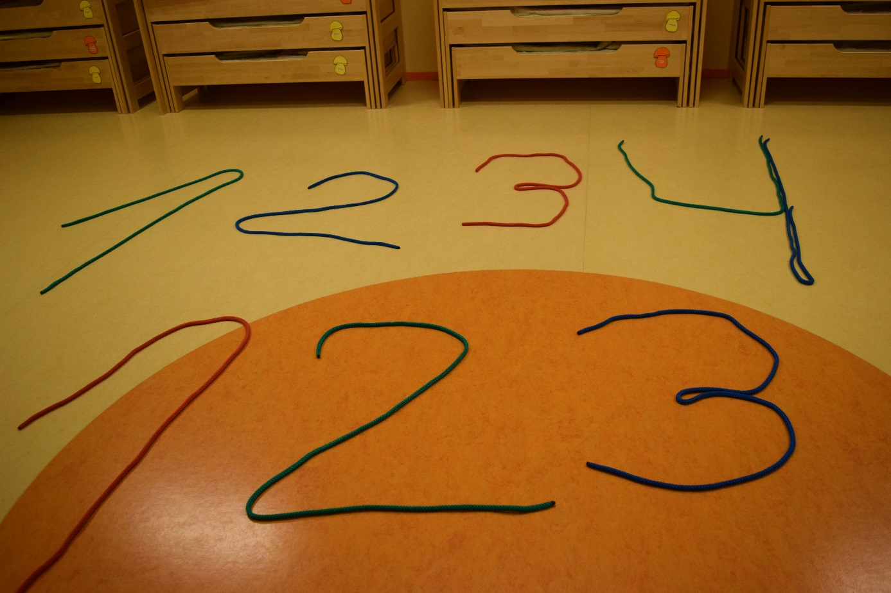
The teacher placed child sized rope numbers from 1 to 4 on the floor. At the same time, she also explaines the children what she is doing.

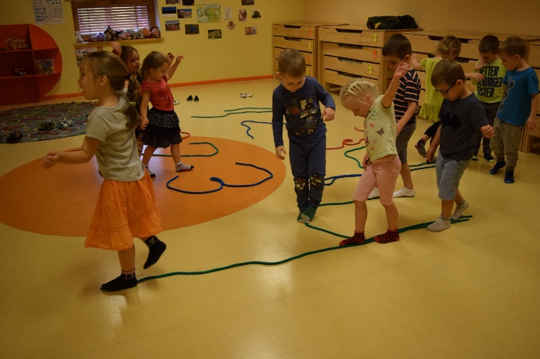
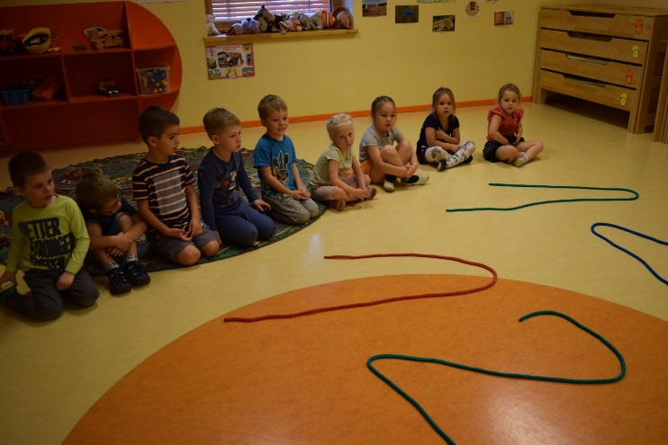
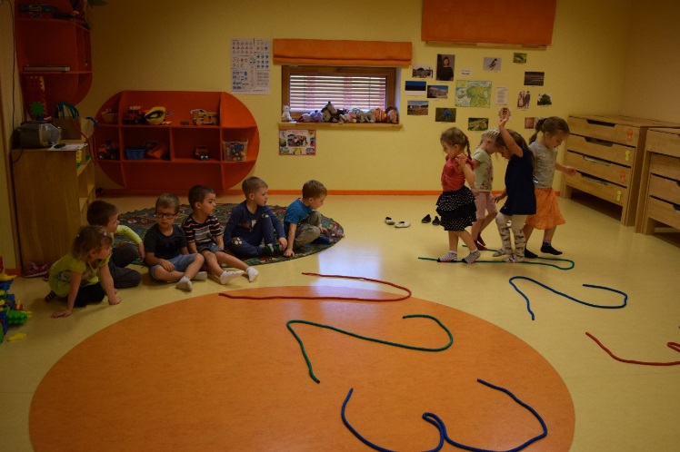
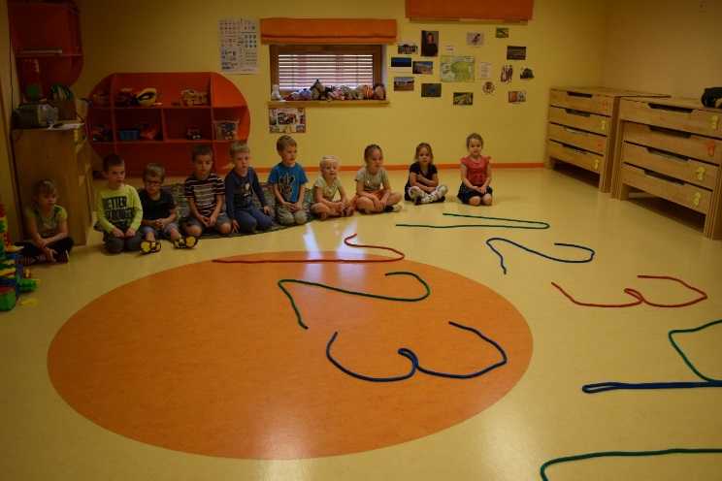
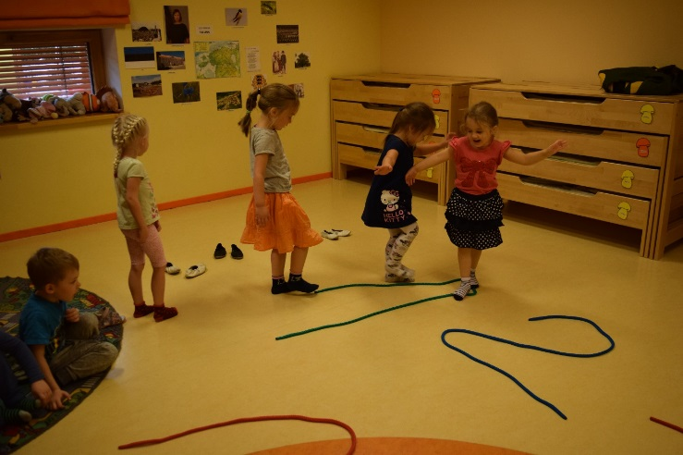
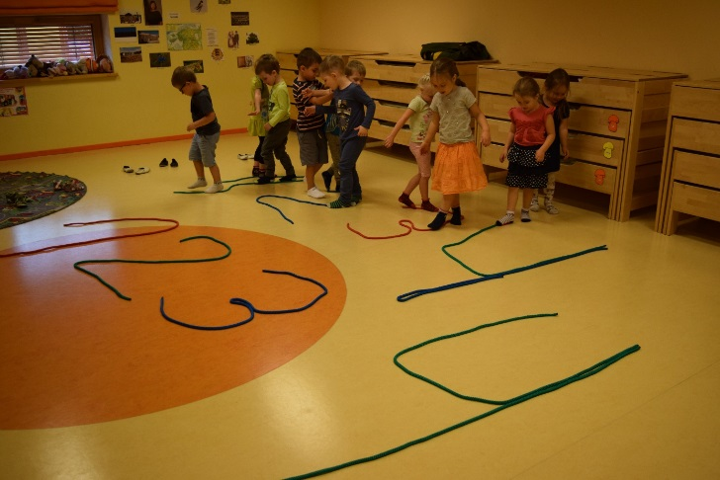
Then, the teacher shows to the children how to balance in the rope, by putting one foot infront of the other and keeping the arms upwards. Then, how to the child, which teaches the children about numbers through physical balance along the number. This is a good balance and coordination exercise for learning numbers thru movement.

Later, the children received colored ropes and they tryed writing rope numbers themselves.
